Expanded Library Research Content: An Area of Critical Need
There is a widening gap between what Cline Library offers and user expectations in the provision of research content. As user needs grow, NAU falls further behind its peers’ investment in research content. NAU is the lowest ABOR peer for materials expenditures “per student” and “per faculty.”
Increased funding for research content impacts:
- NAU’s Research Agenda. Research content supports grant procurement, undergraduate/graduate student research skill development, and recruitment/retention of top faculty and students.
- Growth of Academic Programs. Launching high quality programs requires securing access to high quality resources. New programs without ongoing funding for research content present special challenges.
- Student Success. Studies correlate library usage with student success. Faculty expect student work to include citations from current resources. Library resources increase affordability by reducing students’ need to purchase books and other content.
- Sustainability and Effectiveness. Economic realities and university directions have created added pressures; impacts include: inflation; a low budget compounded over time; a challenging publishing environment; and a diverse and growing spectrum of students served.
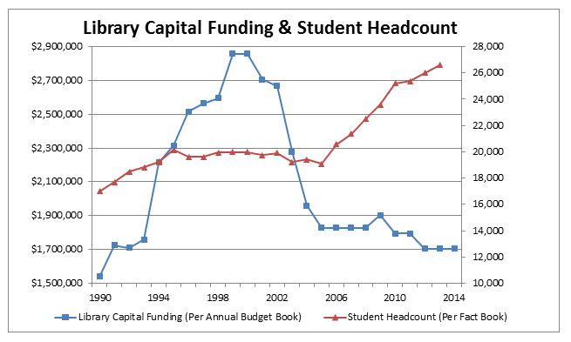
Strategy for Funding Research Content
It is time for NAU to reverse its downward trend of research content funding – and recover to a level that positions NAU researchers at all levels to achieve their research goals more quickly and efficiently.
- Immediate Goal: Shift research content funding “per faculty” from the bottom of our ABOR peers to the median.
Additional ongoing funding to match “Per-Faculty” Median of ABOR Peers: $2 Million
- Long-term Goal: Use benchmarking strategy to move research content funding to a level that is aligned with – or exceeds – the “per faculty” and “per student” investment of our ABOR and Carnegie peers.
Additional ongoing funding to match “Per Student” Median of ABOR Peers: $6.5 Million
- Ultimate Goal: Shift NAU’s investment in research content from an area of urgent need to an area of strength.

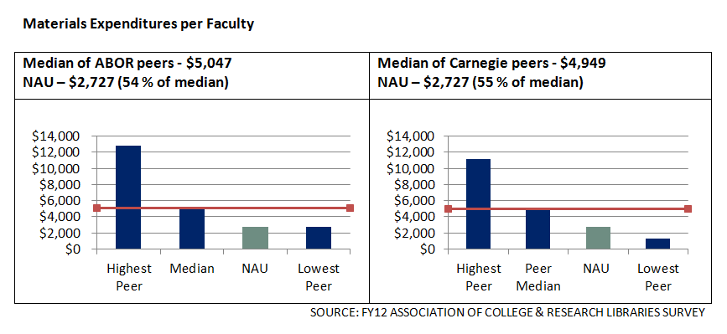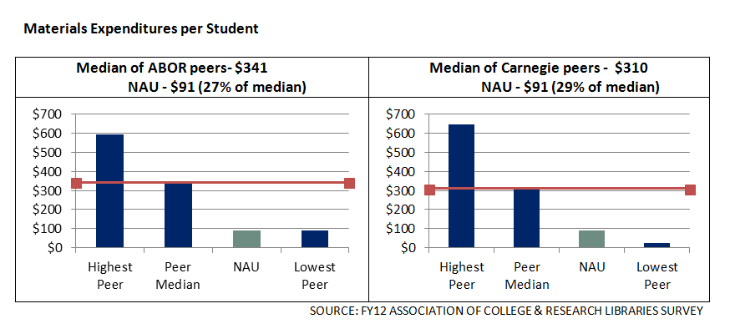
Current Annual Renewal Costs for Selected Resources
Science Direct $294,973
Wiley Online $201,885
JSTOR $57,700
Web of Knowledge $56,315
Films on Demand $28,656

