Northern Arizona University

15
How to Create Keywords and Documents in OnBase
For OnBase Version 15
April Anne Tuomi

Contents
Create new keywords 2
Create drop down menus in keywords 3
Create new Document Types 5
Autofill Keyword Sets 7
Required Keywords 8
Update Document Type name 9

Create new Keywords
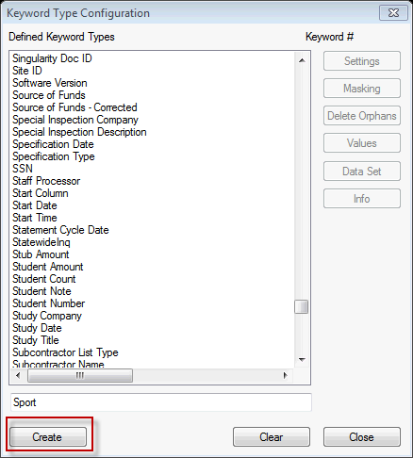
When creating keywords you will want to make sure that the keyword is not already created. For example, the request is to create a first name keyword; this keyword already exists and should not be created. Also, verify that a keyword (with a different name) does not already exist.
- Open configuration module
- Click Keyword
- Click Keyword Type
  - Review keywords that are already created
  - If keyword exists no other action is necessary
  - If keyword does not exist, complete next step
- Type in name in box below keyword types
- Click Create
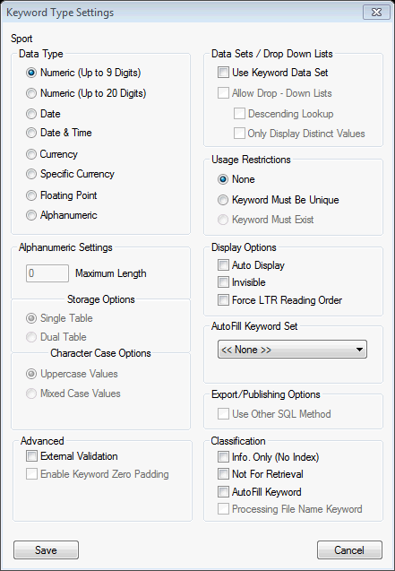
- Keyword Type Settings box opens, this is how you set the different variables for the keyword

- Data Type: choose what type of data will be captured in this field
- Alphanumeric Settings: this setting will allow you to set the maximum length (keep in mind that this number should be small or else the retrieval of the document will be impacted), storage options, and character options. Storage options should remain the same. Character case options should be Uppercase Values.
- Advanced: Allows for the use of special tools with keywords. For example adding zeros into a keyword if the maximum length is not met.
- Data Sets/Drop Down Lists: this option will allow you to assign a drop down list to a specific keyword type
- Usage Restrictions: Sets restrictions on the keyword values before it is indexed
- Display Options: Sets display options for the keyword values on the document.
- Autofill Keyword Set: this option assigns an autofill keyword set to the keyword. This means that if the value meets the criteria of the autofill query the keywords in the document will be completed. For example, if the emplid is type into the keyword the name will be retrieved automatically.
- Classification: Allows user to create special associations with the keyword values.
- Click Save

Create drop down menus in keywords
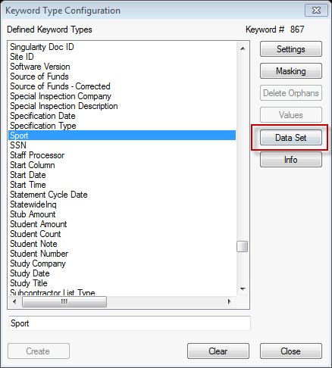
If you selected data sets from above you will be able to create a data set associated with the keyword
- Open configuration module
- Click Keyword
- Click Keyword Type
- Select keyword from Defined Keyword Types
  - The Data Set option should be available
- The Data Set Configuration window opens. Create your data set list.
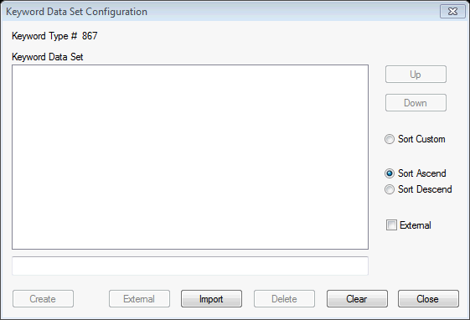
  - Type name in the box below the data set box
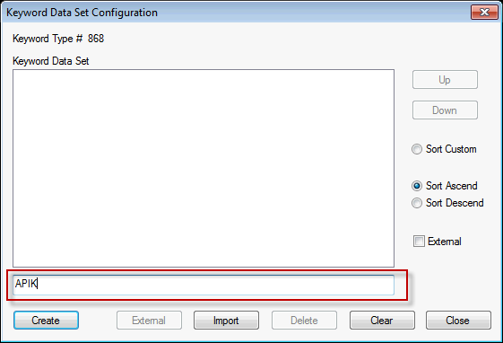
  - Click Create
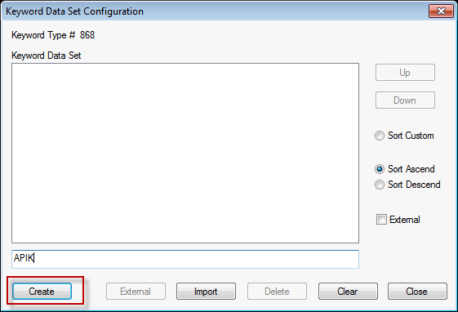
  - Continue creating your dataset
  - Options on the left will allow you to move values up or down. It will also allow you to change the sort of the data set list.
  - When you are finished with all values, click Close

Create new Document Types
When creating new document types, make you are provided a definition and reason for the new document types needing to be created. This will allow you to make sure that the correct document is being created and the correct keywords are being assigned.
- Open the Configuration Module
- Click Document
- Click Document Type
- The Document Type list will open. Make sure that the document type was not already created.
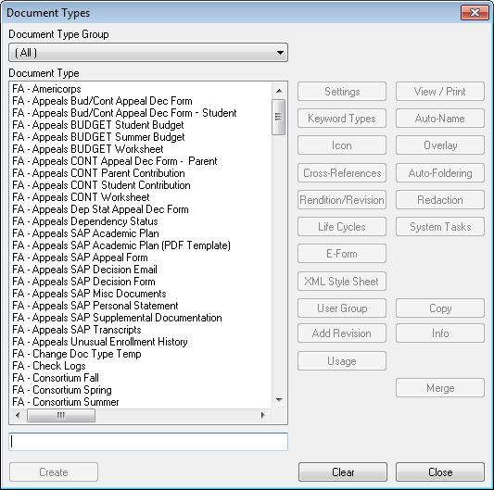
- If the document has not been created
  - Find a document with similar keywords
  - On the right click copy
    - This will allow you to copy keywords and all set up for the document type
    - It is important the security remains the same for every keyword. If you cannot find a document with similar keywords still copy the document type and then adjust the keywords.
  - Type the name of the document in the box provided. The name should start with the department, space, hyphen, space, name of the document. For example: FA – Consortium Summer
  - Make sure to select copy user group security! (if you do not do this step no one will be able to see the document type, not even you)
    - Do NOT select the overrides option
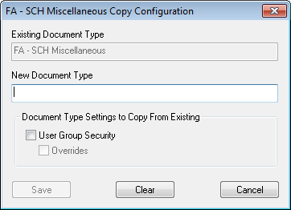
  - Click Save
- In order to change the keywords associated with the document.
  - Find the document in the document list
  - Click Keyword Types
  - The Keyword Type Selection box will open
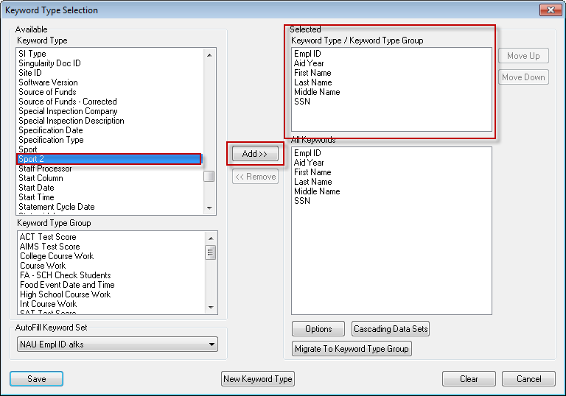
  - Find the keyword under the Keyword Type section
  - Click Add
  - The keyword type will move into the keywords selected box
  - You can move keywords up and down by the option to the right of the keywords selected box
  - To remove keywords
    - Find the keyword in the Keywords selected box
    - Click Remove
    - The keyword will no longer appear in the list
- Once you have completed selecting your keywords click Save

Autofill Keyword Sets
Autofill will fill values in when the initial value meets the criteria of the query. For example, when emplid is entered as a keyword the First Name, Last Name, and SSN are filled in.
- Find the Autofill Keyword Set section
- Select the appropriate query to autofill the complete
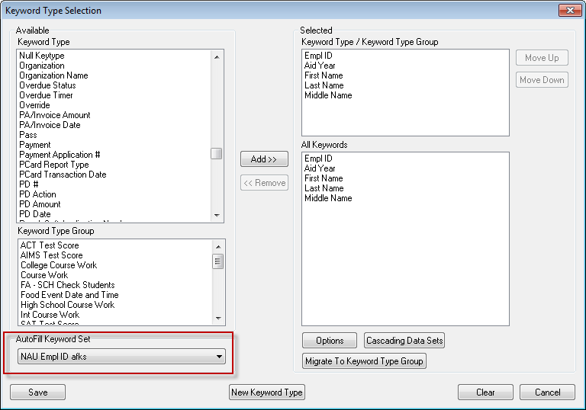
- Financial Aid uses the NAU Empl ID afks query to autocomplete the first name, last name, and SSN when the emplid is entered

Required Keywords
These are the keywords that must be completed in order to index the form.
- Click the Options button
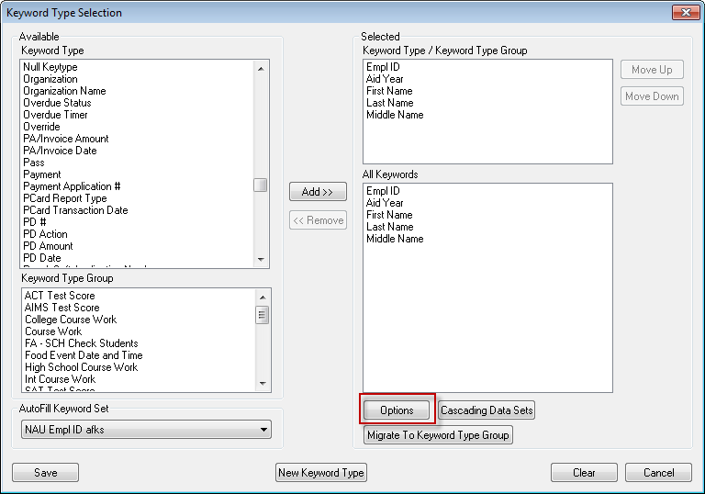
- Find the keyword that you want to be required
- Select the REQN option
- Once you have clicked the appropriate keywords click Close
- On the main Keyword Types page, click Save

Update Document Type name
The document type name is what is displayed when the user retrieves the document.
- Open the configuration module
- Click Document
- Click Document Types
- Click Auto-Name on the side menu
- The Auto-Name configuration box will open
  - The top string shows the name that will display for the document
  - The symbols used section will show you what symbols equate to the symbol in the name
  - The keyword type drop down will let you choose which keyword type to put in the name
  - You can preview the name by clicking Preview Auto-Name
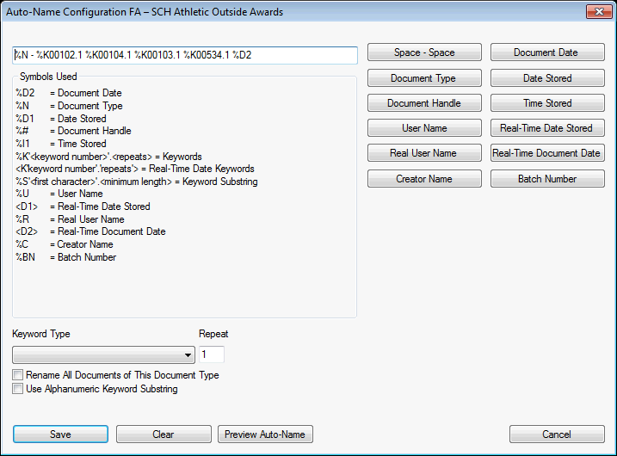
- If the document type already has documents you will need to select the “Rename All Documents of this Document Type” box
- Click Save (all documents will be renamed)

Adding a Document Type to a Scan Queue
The user must identify which document types to the appropriate scan queue.
- Open the OnBase Configuration Module
- Under the Import menu, click Scan Queues
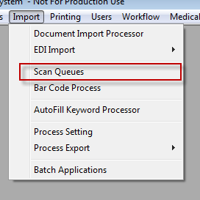
- Select the appropriate Queue Name
- Click on the Document Types button on the right
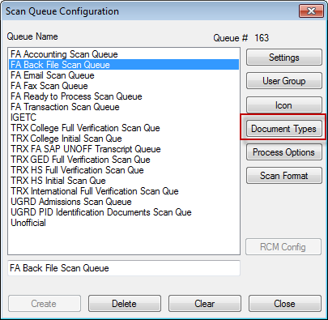
- Find the appropriate available document type
- Click Add>>
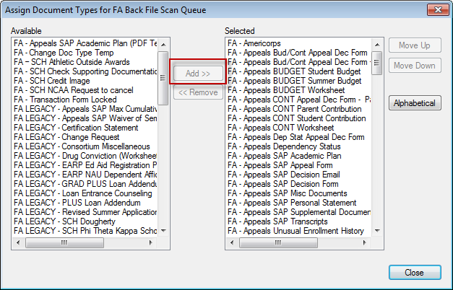
- Click Alphabetical
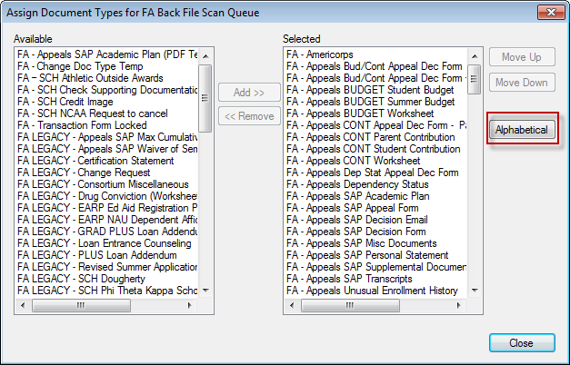
- Click Close

