Hopefully these instructions are helpful when building classes for Fall 2021 and Spring 2022.
Please feel free to reach out to Cory Quackenbush, Cory.Quackenbush@nau.edu or (928)523-6761 if you have any questions.
The goal of this report is to aid and inform your course build, there are three categories of action:
Red = under built by 10% or more
Green = overbuilt by 25% or more
Orange = sections built with a cap set at 0
Courses with no fill or highlighting are deemed okay and require no action.
_____________________________________________________________________________________________________
General overview/Initial steps
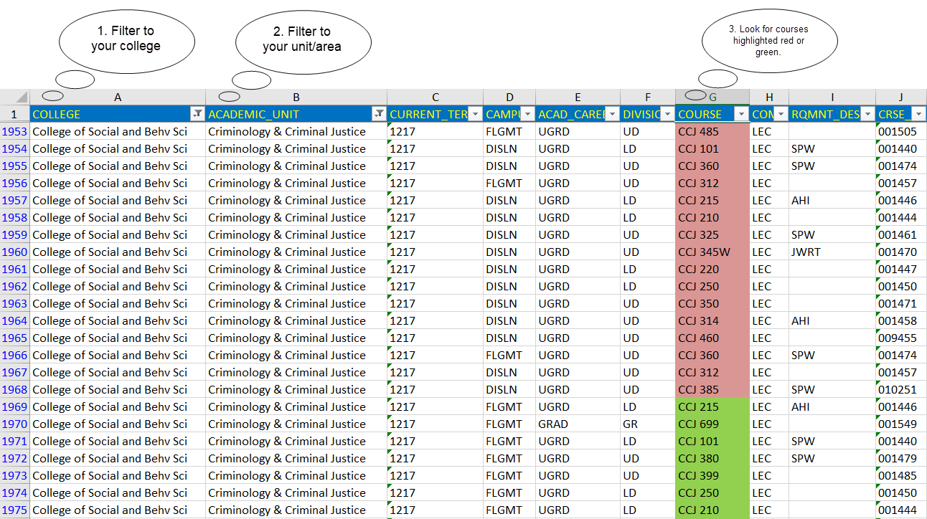
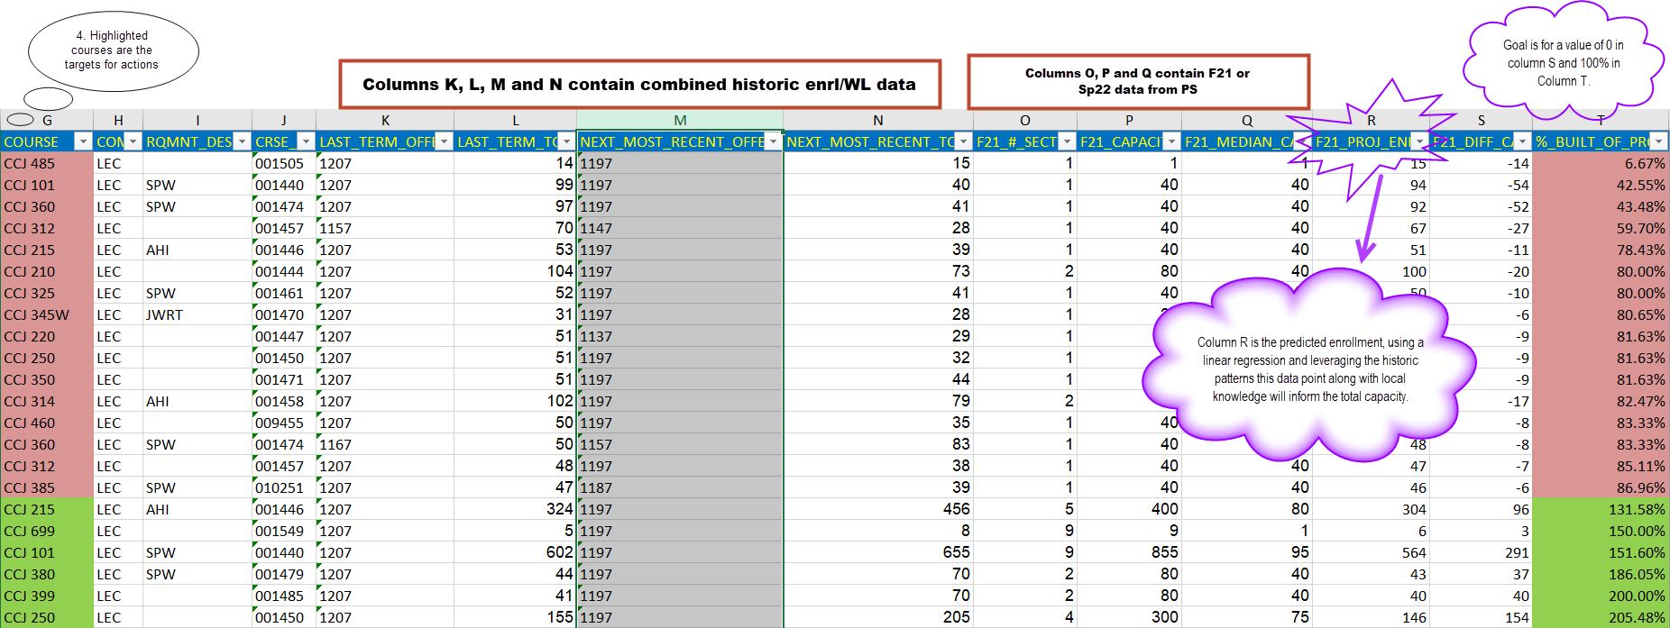
Examples of under and over built courses
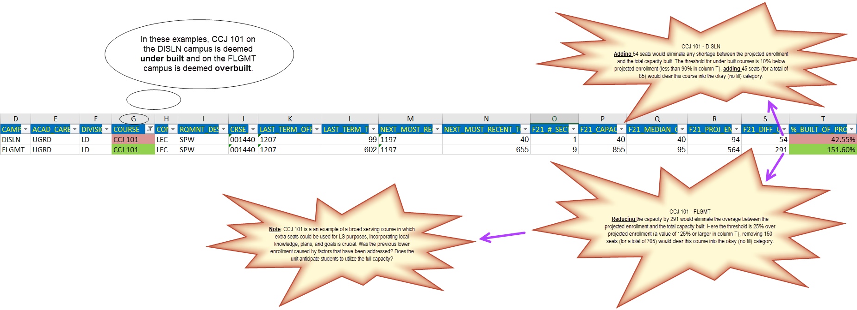

Example of action that would clear the above courses

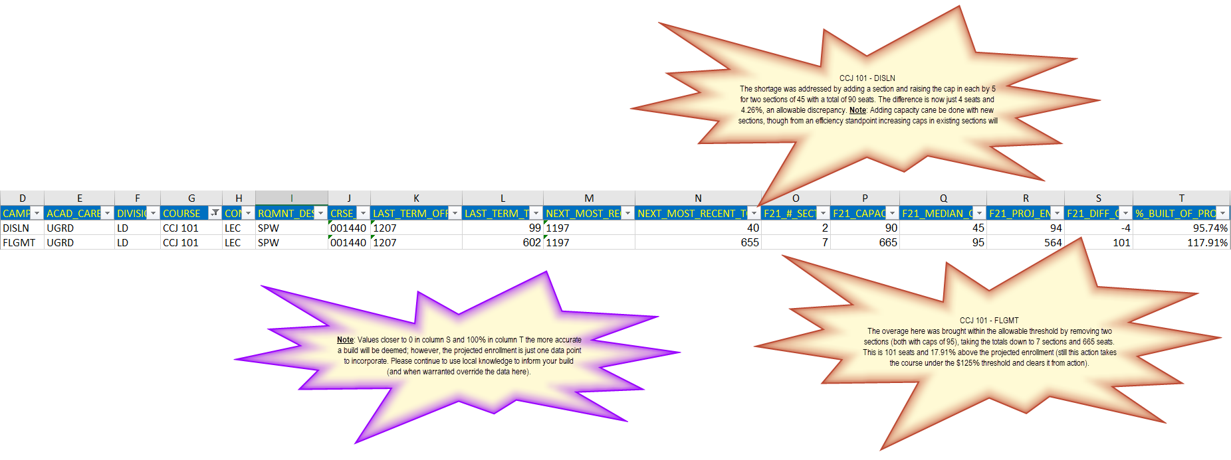

Courses built without capacity
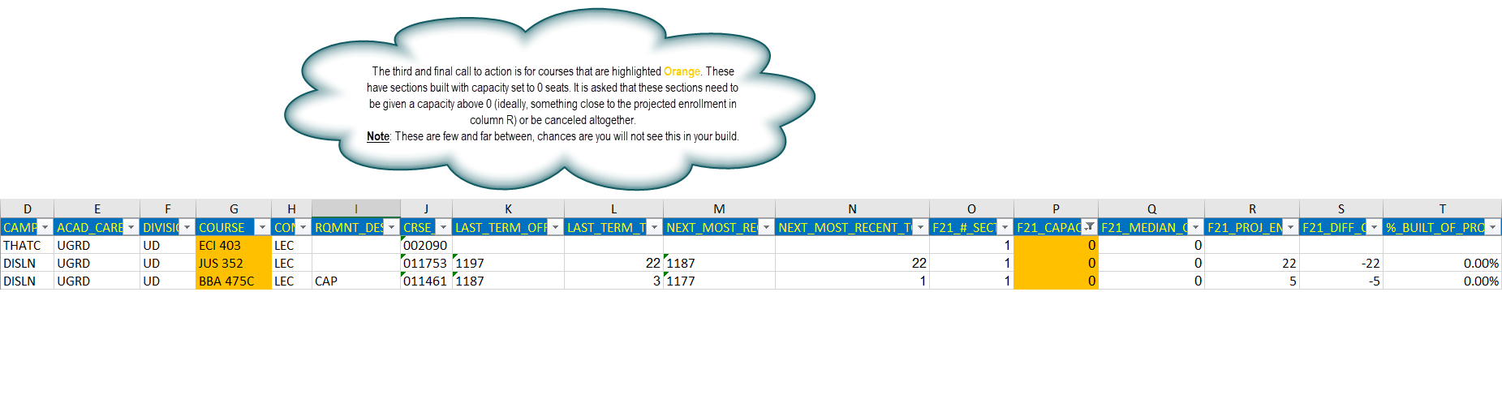
A last note on courses with blank projection data
