**Initiator Guide for Course Fee Requests**

Table of Contents

Introduction 1

Logistics 1

How long will this take? 1

Get it right the first time 1

Deadlines 2

Timeline for University and ABOR approvals 2

Checklist 2

Starting Documentation 3

Expense Inventory 3

Shared Accrual Details 3

*Starting Resources* 3

Cancelling a fee? 3

Section by Section 4

Approvals 4

Course Information 4

Fee Information 5

Campuses 6

Enrollment Information 6

Expense Categories 7

Personnel 7

Travel/Third Party [includes Trips, Entry Fees, Rentals] 8

Materials/Software [includes Lab/Studio Supplies, Online access] 9

Accrual Category 10

Specialized Equipment 10

Shared Accruals 11

Specialized Equipment Per Student Cost Total 11

Manual Cross-Check 12

Budget Information 12

Account Information 12

Details- 13

Purpose 13

Justification 13

Exclusive Use 14

Summaries for University Committee members are truncated for inclusion in reports. 14

Appendix 15

Cancel a Fee 15

Combined Courses 15

Course Fee Variables 15

Appendix 16

Course ID 16

Where to find the course ID for an existing fee 16

Where to find the course ID for courses without an existing fee (new fee requests) 17

Details 18

Enrollment Information 19

Exclusive Use and Controls 20

Expense Inventory 21

Purchase new equipment: specialized equipment purchase and accruals *Return to Guide – Accrual click here* 22

Request Reasons 22

Shared Accruals 24

Typical Expenses and Additional Guidelines 25

Personnel 25

Travel/Third Party 25

Materials/Software Additional Guidelines 25

Accruals- Specialized Equipment 26

# Introduction

This guide assists initiators in understanding and completing each section of the course fee audit worksheet required to initiate a course fee request. Click any link in the guide to jump to more details in the appendix or relevant resources posted on websites. Available resources and consultants are identified for each section.

# Logistics

How long will this take?

Transitioning to an accounting-based management system for course fees requires more detailed information than in the past. Figuring out the new documentation and worksheet will add much time to preparation. Consultation to confirm data will add time to completion. You will also navigate new business processes for how to submit the worksheet and obtain local approvals. The first time with any multi-step process will naturally take longer. Consider the following when planning for a recommended Sept. 15, 2020 deadline:

* Obtain or complete the expense inventory for the course fee (NEW).
  + Find out who is the best source for budget information in your unit, you will likely need to consult with them throughout the process.
  + Examine the last year’s expenses to determine if adjustments are necessary.
* Complete the worksheet (NEW). With a good expense inventory and a simple request, this might be completed in half an hour.
  + Using paper versions of the course fee audit worksheet is *highly discouraged*. This will result in the loss of critical calculations built into the worksheet, and slow the process for approvers and submitters.
  + Computer and audiovisual purchases need to be cleared by ITS to confirm they are not part of the Central IT Tech Fee.
* File documents and forward for approvals (New process). Each unit is determining its process for local approvals. Consult with your chair/director to determine how this process will work.
  + Expense inventories will likely go into a central file.
  + Worksheets need to progress to the chair/director approver.
  + If your fee requires shared accruals, you will also provide a shared accruals details document to the fiscal operations manager.
* The complexity of the fee adds to the time it takes to prepare a request. The following elements are listed from simplest to most complex.
  + Cancel
  + Expense only fees.
  + Accrual fees.
  + Shared accrual fees.
  + Combined courses fees *co-convened or cross-listed courses require additional compilation of enrollment data and coordinated effort to ensure each course has filed a course fee request.*

## Get it right the first time

Think of course fees like you would taxes: a lot of detail to document; prohibitions to consider; unforgiving deadlines; and consultation up front could be the difference between success and failure. Shortcuts are ill-advised. Answer all questions and discuss any concerns with relevant consultants *before* turning this document over for approval and submission. Once a course fee request is submitted into Peoplesoft, it cannot be corrected or revised within the system. Edits and corrections not only create more work, but heighten the risk of missing deadlines.

Deadlines -- Sooner is always better. There are no exceptions to missed deadlines for course fee requests.

Sept. 15 – all worksheets complete and provided to the first approver.

Oct. 1 – all worksheets to submitter *this date is recommended; check with your submitter to confirm.*

Oct. 30 – all submissions complete *accuracy checked; denials require resubmission.*

Nov. 30 – all resubmissions (corrections) complete.

## Timeline for University and ABOR approvals

**Dec. 31** – NAU committee aprovals complete *denials at this stage are final*.

Jan. 29 – Pending ABOR approvals posted in system.

February – Students can see pending data in class information.

**April** – ABOR approvals complete denials at this stage are final.

April/May – Approval activated in system.

June – New fees reflected in student tuition calculation and billing.

If a request is denied by the University Committee or ABOR, there is no appeal. An amended request cannot be filed until the next cycle, which will be for the 22-23 academic year. If a request is denied by local approvers, ITS, Comptroller, or Academic Affairs, amendments may be possible. If the amendment changes the expense inventory or expense information, then the request will have to go through the entire approval process again.

## Checklist

* Expense Inventory complete.
* Manual cross-check of per student costs confirmed.
* Computers and audiovisual confirmed as *not covered* by the Central IT Tech Fee.
* Worksheet complete.
* Additional documents or documentation of approvals included with worksheet.
* Shared accruals information sent to the fiscal operations manager, if applicable.
* Approvals complete.
* Submission complete.

Starting Documentation

Expense Inventory – a compete, detailed inventory of course fee expenses is required. It is also the best starting place for organizing information to complete the worksheet. Start with existing expense reports if your unit has them. A blank expense inventory is available for aggregating information in one place or for starting an inventory for a new course fee request- located on [*Course Fees web*](https://in.nau.edu/academic-affairs/program-course-fees/). How to make the most out of an expense inventory. *Reminder: click any link to jump to more details.*

Shared Accrual Details – required if an accrual will be shared across multiple courses. Start with existing expense/accrual reports if your unit has them. A blank Shared Accrual Details form is available for aggregating information in one place or for starting documentation- located on [*Course Fees web*](https://in.nau.edu/academic-affairs/program-course-fees/). How to calculate and document shared accruals.

Starting Resources at *[Course Fees web](https://in.nau.edu/academic-affairs/program-course-fees/)*

* **Course Fee Audit Worksheet**- required for 21-22 continuation of all existing course fees. Use the same worksheet for continuing fees, edits, cancellations, and request for new fees.
* **Master Course Fees List** – provides current data for existing course fees. Filter for your existing course fees. This data cannot substitute for an expense inventory because it lacks the required line item details.
* **Course Fee Enrollment** – enrollment figures to calculate cost per student are standardized across Summer 2019-Spring 2020. Overrides of enrollment are accepted only if explanations are provided.

## 

Cancelling a fee? **Click here for cancel instructions**

Updated expense inventories are *not* required for cancellation requests.

|  |  |
| --- | --- |
| Section by Section Approvals and Course Information          Fee Information      Campuses and Enrollment Information      Expense Categories and Personnel      Travel/Third Party    Materials/Software    Accrual Category and Specialized Equipment          Shared Accruals and Per Student Coset      Manual Cross-Check and Budget/Account Info      Details: Purpose and Justification      Exclusive Use and Summaries | Approvals **Consult** Check with your department chair for details concerning worksheet completion; appropriate approvals and how to obtain them; and who is the designated submitter.   1. “Initiated By”- name the point person completing the worksheetform. Indicate start date. 2. Chair and Dean Designee Approval- both are required. Approvals can be recorded by initials or attachment- must select one method. Date is the date of approval.   Approvals communicated in emails must be submitted with the final worksheet.   1. Other Dept. Approval- only if required by the department; complete in the same fashion.  Course Information  1. Course ID- this is *not* the same as a class number.  * **Resource** find course ID for an *existing* fee in the Course Fee Enrollment Report or Master Course Fees List. Both are available at [*Course Fees web*](https://in.nau.edu/academic-affairs/program-course-fees/) . * **Resource** find course ID for a *new* fee in the Course Fee Enrollment Report or the academic catalog at[*Catalog web*](https://catalog.nau.edu/)   + - What if the course doesn’t appear in the search? * Do not enter course ID’s for Honors sections. Honors sections are automatically configured to mirror the fee on the primary course and do not require a separate worksheet.  1. Subject Catalog # is the course prefix and number as it would appear in class search, e.g., PSY 101, CHM 360L, FRE 495C. Include letter suffixes for labs, capstones, etc. where applicable. 2. Topic Title- fees on a topics course can vary by title. Topic ABC 123: *Title abc* can have a different fee than Topic ABC 123: *Title xyz*. Include the title if the fee will be unique to the title. It is also possible for a baseline fee to be applied to every title in a topics course, except those that have a unique fee by title. In this instance do not include a topic title.   *Each cross-listed or co-convened course must have its own course fee audit worksheet. Use  combined enrollment across all courses to correctly identify cost per student. Missing  worksheets or inconsistent per student costs may result in denials. Click here for  more about combined courses. For questions contact [Melinda.Treml@nau.edu](mailto:Melinda.Treml@nau.edu) Fee Information  1. Effective Term- defaults to the first upcoming Fall term regardless of course offering.    * **Consult** [Coursefees@nau.edu](mailto:Coursefees@nau.edu)if you think a change to Effective Term is necessary. 2. Fee Type- defaults to Flat Fee.    * **Consult** [Coursefees@nau.edu](mailto:Coursefees@nau.edu)if considering a per unit fee. 3. Current Fee Amount    * **Source** use Master Course Fees List for *existing* fee amount. [*Course Fees we*b](https://in.nau.edu/academic-affairs/program-course-fees/)    * For a new fee request, enter “0”. 4. Proposed Fee Amount  * Will fee be the same amount? Re-enter the current fee amount. * Will fee amount change or is it a new fee? Enter the proposed fee amount. * Is this a cancellation? Enter ‘0’.  1. Request Types- choose one.  * *New:* a course fee does not exist for this *configuration*. Requires ABOR approval.   + Some courses have more than one course fee. See course fee variables. * *Edit-Increase:* any increase in the fee amount of an existing fee. Requires ABOR approval. * *Edit-Decrease:* any decrease in the fee amount of an existing fee. Included in ABOR report. * *Edit-Same:* the fee amount remains unchanged but other elements are changed.   + Other elements may be edited, e.g., campus, budget information.   + Use for initial input into the new system where there are no perceived changes from the existing course fees.   + Use for sunset reviews when course fees expire and must be resubmitted. * *Cancellation:* requires only specific information on pages 1 and 2 of the worksheet.   1. Reasons- Go to reason matching the request type; select one reason from drop down   menu. See List for further explanations.   1. New Fee Reason- choose one; will be reviewed by the University Committee. 2. Fee Increase Reason- choose one; will be reviewed by the University Committee. 3. Fee Decrease Reason- choose one; will be included in the ABOR report. 4. Edit-Same Reason- identifies changes other than fee amount. If no changes, then select “Initial Input”; will be included in ABOR report. 5. Cancellation Reason- choose one; will be included in the ABOR report.   Campuses Campuses- Click each campus where students will pay the fee.   * If the course fee is different for different campuses (i.e., $10 for Flagstaff; $5 for Online), complete separate worksheets. See course fee variables. * Yuma- If fee will apply to Yuma and Flagstaff Mountain campuses, separate worksheets are required. *A submitter cannot check both campuses on the same submission, so the submission will fail.*   Enrollment Information **Source** use the Course Fee Enrollment data from Course Fees Enrollment report at  [*Course Fees we*b](https://in.nau.edu/academic-affairs/program-course-fees/)  **Consult** [Coursefees@nau.edu](mailto:Coursefees@nau.edu) if there are questions about estimated enrollment.   1. Est. Annual Enrollment – enter the enrollment from the Course Fees Enrollment report. See how to use the report.    * Honors section enrollment is listed separately and will have to be manually added to the course enrollment.    * Estimated enrollment is a tool for calculating an appropriate per student cost. Actual revenue is always determined by the number of enrolled students who paid the fees. 2. Enrollment Data from CF Enrollment Report- Select Yes or No. Choose ‘No’ if you are not using the enrollment numbers from the report.  * A new course without any prior enrollment will not appear on the report, so an enrollment number would be guesstimated based on other information or data. * Combined courses always choose ‘No’ since enrollment is aggregated.  1. If you do not use the CF Enrollment Report data, explain how enrollment was calculated. A new course might be calculated from enrollment in similar courses. An increase might be derived from confirmed program admission data.  Expense CategoriesPersonnel  **Consult** with the department accounting specialist. A detailed list of all expenses for the course fee will be required to complete the worksheet.  **Use *annual* figures**- descriptions and dollar amounts should reflect an entire academic year.  See typical expenses and additional guidelines.  **Specified Guest Instructors** may only be used to address a curriculum requirement that the assigned instructor cannot provide. For example, third-party certifications.   1. Description- provide enough detail that an auditor can find the expense in accounting records.  * Identify the role/title of the individuals, e.g., student worker, lab aide. Include per term details, if space allows. * If more than 5 entries, group similar items under a sub-category. See how to use expense inventory to create and document sub-categories for audit.  1. Total- this figure should equal the cost for an academic year. 2. Subtotal- this field will auto-calculate [sum of entered Totals]. 3. Per Student Cost- this field will auto-calculate [Subtotal/course enrollment].  * This field will not work if Est. Annual Enrollment is empty or ‘0’ on page 1 of worksheet.  1. Check box- must be checked. Department assumes responsibility for  * Paying all costs by the end of the academic year per policy at [*Comptroller policy 401-11*](https://nau.edu/university-policy-library/comptroller-policies/)   + No accruals.   + Excessive balances may flag a course fee for review. * Exclusive use of the services for the students who paid the fee.   + Consult [Kristi.Markey@nau.edu](mailto:Kristi.Markey@nau.edu) in the Comptroller’s Office for documenting use of personnel outside of the course. * Not funding prohibited personnel expenses.  Travel/Third Party [includes Trips, Entry Fees, Rentals] **Consult** with the department accounting specialist. A detailed list of all expenses for the course fee will be required to complete the worksheet.  **Use *annual* figures**- descriptions and dollar amounts should reflect an entire academic year. See typical expenses and additional guidelines.   1. Description- provide enough detail that an auditor can find the expense in accounting records.  * Identify the expense. Include per term details, if space allows. * If more than 5 entries, group similar items under a sub-category. See how to use expense inventory to create and document sub-categories for audit.  1. Total- this figure should equal the cost for an academic year. 2. Subtotal- this field will auto-calculate [sum of entered Totals]. 3. Per Student Cost- this field will auto-calculate [Subtotal/course enrollment].  * This field will not work if Est. Annual Enrollment is empty or ‘0’ on page 1 of worksheet.  1. Check box- must be checked. Department assumes responsibility for    * Paying all costs by the end of the academic year per policy at [*Comptroller policy 401-11*](https://nau.edu/university-policy-library/comptroller-policies/)    * No accruals.    * Excessive balances may flag a course fee for review  * Exclusive use of the services for the students who paid the fee.   + Consult [Kristi.Markey@nau.edu](mailto:Kristi.Markey@nau.edu) in the Comptroller’s Office for documenting incidents of use of services outside of the course. * Not funding prohibited travel/third party expenses.  Materials/Software [includes Lab/Studio Supplies, Online access] **Consult** with the department accounting specialist. A detailed list of all expenses for the course fee will be required to complete the worksheet.  **Use *annual* figures**- descriptions and dollar amounts should reflect an entire academic year. See typical expenses and additional guidelines.   1. Description- provide enough detail that an auditor can find the expense in accounting records.  * Identify the expense. Include per term details, if space allows. * If more than 5 entries, group similar items under a sub-category. See how to use expense inventory to create and document sub-categories for audit.  1. Total- this figure should equal the cost for an academic year. 2. Subtotal- this field will auto-calculate [sum of entered Totals]. 3. Per Student Cost- this field will auto-calculate [Subtotal/course enrollment].  * This field will not work if Est. Annual Enrollment is empty or ‘0’ on page 1 of worksheet.  1. Check box- must be checked. Department assumes responsibility for    * Paying all costs by the end of the academic year per policy at [*Comptroller policy 401-11*](https://nau.edu/university-policy-library/comptroller-policies/)    * No accruals.    * Excessive balances may flag a course fee for review  * Exclusive use of the materials for the students who paid the fee.   **Consult** [Kristi.Markey@nau.edu](mailto:Kristi.Markey@nau.edu) in the Comptroller’s Office for documenting incidents of use of materials outside of the course.   * Not funding prohibited material/software expenses.  Accrual CategorySpecialized Equipment  **Consult** with the department accounting specialist. A detailed list of all expenses for the course fee will be required to complete the worksheet.  **Resource** Additional Accrual Descriptions page found at [*Course Fees we*b](https://in.nau.edu/academic-affairs/program-course-fees/)  **Resource** Shared Accrual Details (costs shared across multiple courses) page found at [*Course Fees we*b](https://in.nau.edu/academic-affairs/program-course-fees/)  **Course fee accruals** must benefit the students paying the fee. See considerations for purchasing new equipment.  See typical accruals and additional guidelines.   1. Description- provide enough detail that an auditor can find the expense in accounting records.  * Identify the specialized equipment; include property number if available. * If similar items have different costs per unit, for example, microscope A costs $500 and microscope B costs $800, create separate entries.  1. Computers or A/V- check box if the equipment is computer (laptops and tablets included) or AV equipment.   **Consult** with ITS [Kegan.Remington@nau.edu](mailto:Kegan.Remington@nau.edu) to confirm that specialized equipment is **not** covered by the IT Central Tech Fee. *Course fees cannot be used for IT Central Tech Fee responsibilities.*   1. Number of units- enter total number of units required for the course(s). 2. Cost per Unit- list the current cost of equipment including all taxes and any extra fees for delivery or installation. Capture total cost per unit so funding does not come up short. 3. Total Amount- this field will auto-calculate [# of units x cost per unit] 4. Expense Date- enter the fiscal year the next purchase will be made. Fiscal year is July 1-June 30. 5. Useful Life in years- the number of years the equipment typically lasts before requiring replacement. 6. Per Student Cost- this field will auto-calculate [(total amount/useful life)/enrollment)].  * This field will not work if Est. Annual Enrollment is empty or ‘0’ on page 1 of worksheet. * Use this field when adding up the total for Accrual Per Student Cost.  1. Primary Room- enter building and room information identifying where the equipment can   be found.  **Consult** with Submitter about the format of the primary room information. Shared Accruals **Review shared accruals details** before you begin.  **Consult** with accounting specialist for your unit is required. *Click on review link for details.*  **Additional filing of documentation** by your college fiscal operations manager is required.  *Click on review link for details.*   1. Shared Accruals – list the item(s) to be funded by multiple courses. 2. Check box – Must be checked. Department confirms the per student cost is the same for all students in each course sharing the cost. 3. Per student cost – Total cost must be divided by total enrollment of all students sharing the equipment. *Using a single course’s enrollment or dividing by the number of courses will calculate incorrect per student cost.* 4. Primary Room - enter building and room information identifying where the equipment can be found.   **Consult** with Submitter about the format of the primary room information. Specialized Equipment Per Student Cost Total  1. Specialized Equipment Per Student Cost- **manually** add the per student cost from each accrual entry. *This field does* not *auto-calculate.*  * Include per student costs from Additional Accrual Descriptions in the calculation and attach the additional accrual information to the worksheet for submission, if applicable. * Include per student costs from Shared Accruals in the calculation.  1. Check box- must be checked. Department assumes responsibility for  * Confirming multi-year use that requires accrual. * Exclusive use of the materials for the students who paid the fee.   **Consult** [Kristi.Markey@nau.edu](mailto:Kristi.Markey@nau.edu) in the Comptroller’s Office for documenting incidents  of use of equipment outside of the course.   * Not funding prohibited accruals.   Manual Cross-Check The purpose of the cross-check is to confirm the originally proposed fee matches the total amount of the per student costs across each expense.   1. Personnel Per Student Cost- enter amount from page 3 of worksheet. 2. Travel/Third Party Per Student Cost- enter amount from page 4 of worksheet. 3. Materials/Software Per Student Cost- enter amount from page 5 of worksheet. 4. Specialized Equipment Per Student Cost Total- enter amount from page 7 of worksheet.  * Don’t forget Description 1 on page 6 of worksheet in this total. * Include additional description accrual or shared accruals in this total.  1. Total Per Student Cost- this field will auto-calculate [sum lines 1 through 4]. 2. Proposed Fee- this field should match the amount of the proposed fee entered on page 1 or worksheet.   **Line 5 and Line 6 must match**.   * If line 5 and 6 do not match, confirm entries on lines 1-4 are correct. * If lines 1-4 are correct, check accuracy of all per student costs on pages 4-8. * If there are no corrections to Per Student Cost, update the Proposed Fee on page 1 to match line 5.   **If updating the Proposed Fee Amount on page, check for other updates.**   * Does the request type need to change? * If request type changes, also update the Reason.  Budget Information **Consult** with the department accounting specialist to complete this section. Account Information  1. Department ID- a 7 digit number. 2. Department Name- accounting identifier unique to each department. 3. Fund Code- a 4 digit number.   Details-Purpose  1. Purpose ABOR- 1000 characters (~150 words) to provide a *broad overview* of **instructional tools** that will be provided, the **outcomes**, and the **student benefit**. Identify the anticipated **annual cost** (multiply the annual enrollment by the proposed fee amount for the annual cost).   ***Eight thousand dollars*** *funds five expenses proven to improve overall student performance in the class and in the field. First, classroom support and experiment manipulatives increase engagement in classroom sessions via hands on experiential learning and have reduced the DFW rate for the course. Next, field trips deepen understanding of critical principles in (the class discipline) covered in XYZ certification resulting in improved scores. Also, guaranteed online access to the XYZ certification has improved completion rates necessary for accreditation. Finally, exposure to industry-standard technology in the classroom improves students’ general marketability in the field.* This entry is 93 words/676 characters Justification  1. Justification ABOR- 1000 characters (~150 words) to provide **specific expenditure details** justifying the **annual cost** and the **percentage** course fees will provide for necessary funding. If room allows include more student benefit details.   *Course fees fund* ***100%****. 1. Three thousand dollars funds three in-class peer mentors each term. Peer mentors support primary instruction. Examples of activity include augmenting weekly group sessions and conducting exam reviews. The DFW rate has dropped 25% since starting the peer mentor program. 2. One thousand dollars funds materials like example a, example b for in-class experiments. 3. Two thousand dollars covers trip field trip expenses each term (e.g., transport and entry) where students work through field experiences related to XYZ certification with discipline experts. Average certification scores have improved 10% since the field trip was initiated. 4. One thousand dollars funds the online XYZ certification, ensuring that each student completes the course with this professional requirement. 5. And one thousand dollars maintains tablets using industry standard software deemed a minimum requirement for employment in the field.* This entry is 138 words/952 characters  Tips-   * Use a chart to help translate expenses and data into details. * Use a numbering format instead of paragraphs. Spaces eat up character count. * Consider ABOR and audit as an ‘outside’ audience- use general descriptors versus discipline specific language or acronyms. * Write in flexibility for potential changes in categories. Note the broad descriptions in the purpose and use of ‘examples’ in the justification that leave room for additions or changes in a category.  Exclusive Use  1. Exclusive Use AUDIT- 1000 Characters (~100 words). Assume details from the ABOR purpose and justification are known when explaining the**controls** used to assure only students paying the fee benefit from the services or materials purchased with the fee. Detail *how* the controls will work.   ***Enrollment*** *in NAU 350 is required for students to receive assistance from the course peer mentors, attend the XYZ field trip, or access online XYZ certification. Course materials are stored in a* ***locked cabinet*** *and maintained for exclusive use of NAU 350 students. Tablets are a shared expense across multiple courses but are managed through* ***inventory control*** *for the exclusive use of students enrolled in NAU 350, 450, and 550.*  This entry is 69 words/428 characters. Summaries for University Committee members are truncated for inclusion in reports.  * Copy and paste if original description is 250 characters or less. * If summarizing, start with bare bones, then flesh out details as character limit allows.  1. Purpose Summary- 250 characters (~35 words). If summarizing, prioritize **instructional tools** and **student benefits** from the full descriptions.   **Bare bones:** *classroom support & manipulatives: reduced the DFW rate; field trips: improved certification scores; certification access: improved completion rates; industry-standard technology: improved marketability.* This entry is 22 words/203 characters.  **Final:** *Increased engagement via hands on experiential learning, 25% reduced DFW rate, improved scores and completion rate for XYZ certification required by accreditation, and standard technology usage improving marketability.* This entry is 28 words/220 characters.   1. Purpose Justification- 250 characters (~35 words). If summarizing, prioritize **specific expenditure details** from the full description.   **Bare bones:** *Peer mentors, experiment materials, field trip, XYZ certification access, tablets.*  This entry is 10 words/82 characters.  **Final:** *Six peer mentors, in-class experiment materials, XYZ field trip, access XYZ online certification, and class set of tablets with industry standard technology.* This entry is 22 words/158 characters.   1. Exclusive Use Summary- 250 characters (~35 words). If summarizing, prioritize **controls**.   **Bare bones:** *Enrollment, locked storage, inventory controls.* This entry is 5words/47 characters.  **Final:*****Enrollment required*** *for access to class peer mentors and the XYZ field trip. Materials kept in* ***locked storage*** *accessible to instructors. Tablets are managed through* ***inventory control*** *for the exclusive use of students enrolled in NAU 350, 450, and 550.* This entry is 40 words/250 characters |

# **Appendix**

Cancel a Fee Return to Cancelling a Fee *click here*Return to Fee Information *click here*

Complete the following sections on pages 1 and 2 of the worksheet for cancellations.

Enrollment Information is not necessary. No other pages necessary.

#### Approvals- all fields

#### Course Information- all applicable fields

#### Fee Information

* Proposed Fee Amount- enter 0
* Request Type- Cancellation
* Cancellation Reason- choose most appropriate description

#### Campuses- all applicable

## 

Combined Courses Return to Course Information *click here*

Cross-listed or co-convened courses (combined courses) require a course fee for each course involved in the combination to generate the appropriate revenue. If the combined courses are within your department, submit a course fee worksheet for each course. If there are combined courses in another department, consult and coordinate with that department to assure all courses have appropriate fee requests. Missing worksheets or inconsistent information across enrollment, fee amount, or purpose for combined courses may result in denials.

To identify an equitable cost per student, use the total enrollment number across all combined courses. Even though you will use the Enrollment Report to identify the enrollments, enter ‘No’ in the enrollment section and write a note that enrollment has been adjusted for combined courses. This will let the submitter know to override the enrollment that will be generated for the single course.

It is assumed that everyone enrolled in combined courses will benefit from course fee funding. No course in a combination is exempt, nor should any students be excluded.

Combined courses must be approved through curriculum. The Combined Courses List at [*Course Fees we*b](https://in.nau.edu/academic-affairs/program-course-fees/) identifies all approved combinations and their type of combination: Cross-listed (CLST) or Co-convened (CNVN). If you have questions regarding this list, a Co-convened or Cross-listed course please contact [Melinda.Treml@nau.edu](mailto:Melinda.Treml@nau.edu)

Course Fee Variables Return to Fee Information *click here* Return to Campuses *click here*

The following variables require separate course fees to ensure appropriate funding. Use the *New* request type if requesting a course fee for a new configuration.

* Different campuses have different fee amounts: Flagstaff is $10 and Online is $5.
* Different campuses have different purposes: Flagstaff is $10 for field trip; Online is $10 for software.
* Different titles in a topics course have different fee amounts: Topic 101 has a $5 fee; Topic 102 has a $10 fee. It is also possible for some topic titles to have a fee while others do not.
* Yuma Campus and Flagstaff campus CANNOT be on same course fee worksheet – you will need a separate worksheet for each.

## **Appendix**

## Course ID

Where to find the course ID for an existing fee Return to Course Information click here

The Course ID is unique and constant for the course. Do not confuse it with class numbers that are used to identify the available sections of a course each term. **Do not** look for a Course ID in the schedule of classes.

There are three options for finding course ID information for courses with existing fees.

1. The Master Course Fees at [*Course Fees we*b](https://in.nau.edu/academic-affairs/program-course-fees/) list includes Course ID information for all courses *with an existing fee*. It also contains all current details of a fee (campuses, amounts, uses) so the Master Course Fees list is the best reference for existing fees.

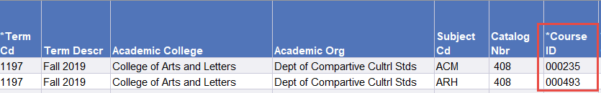

1. The Course Fee Enrollment Report at [*Course Fees we*b](https://in.nau.edu/academic-affairs/program-course-fees/) displays course ID’s after prefix/catalog number.

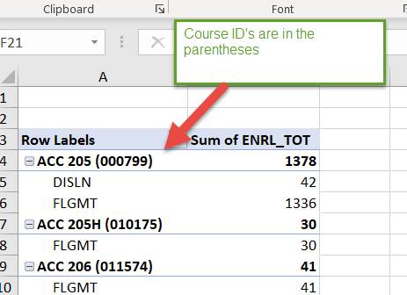

1. The Course Fee Enrollment Report found at [*Course Fees we*b](https://in.nau.edu/academic-affairs/program-course-fees/) also lists course ID’s in the RAW data tab.

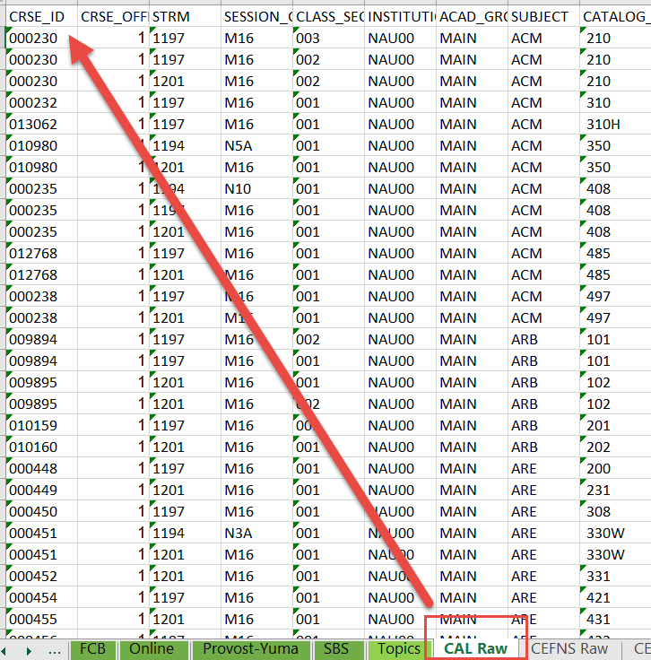

Appendix

## Where to find the course ID for courses without an existing fee (new fee requests)

There are three ways to find course ID’s for courses without an existing fee.

Sources 1 and 2: The Course Fee Enrollment Report at [*Course Fees we*b](https://in.nau.edu/academic-affairs/program-course-fees/) displays course ID’s after prefix/catalog number and also on the Raw Data tab. Scroll to previous page (16) for screen shots.

3. The Academic Catalog at [*Catalog web*](https://catalog.nau.edu/) 1.) Search for a course. 2.) In search results, click on the course title. 3.) On the course details page, find the Course ID in the url. Return to Course Information *click here*

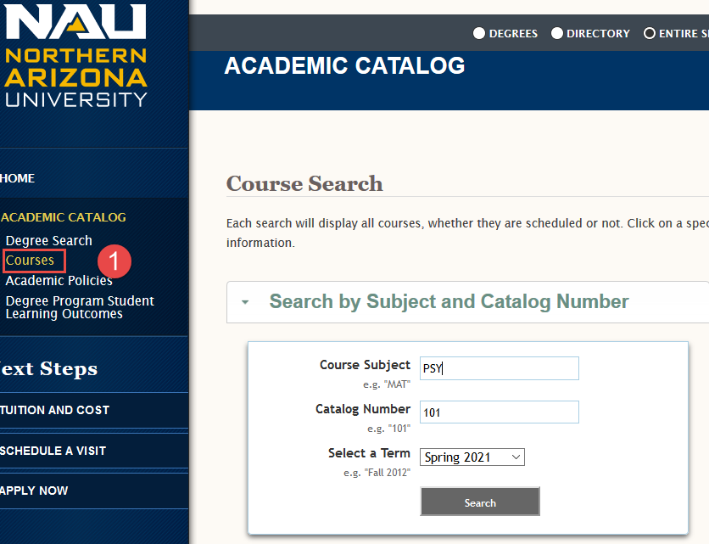 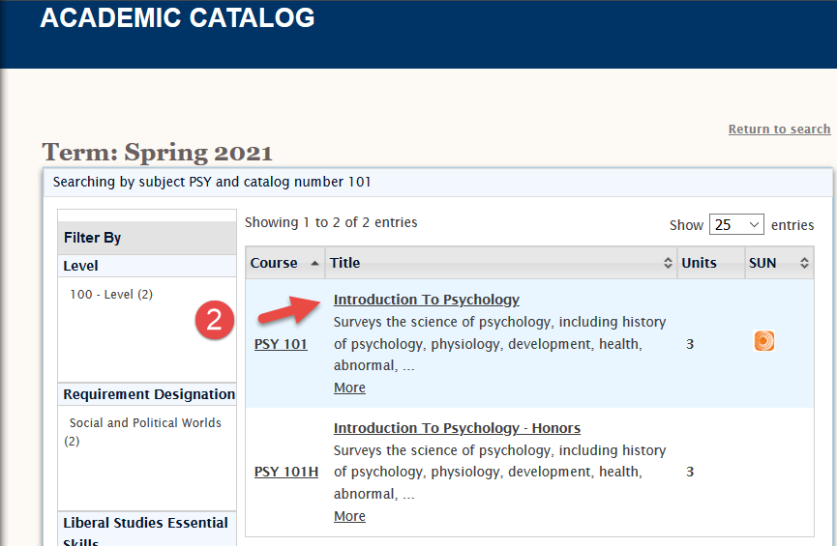

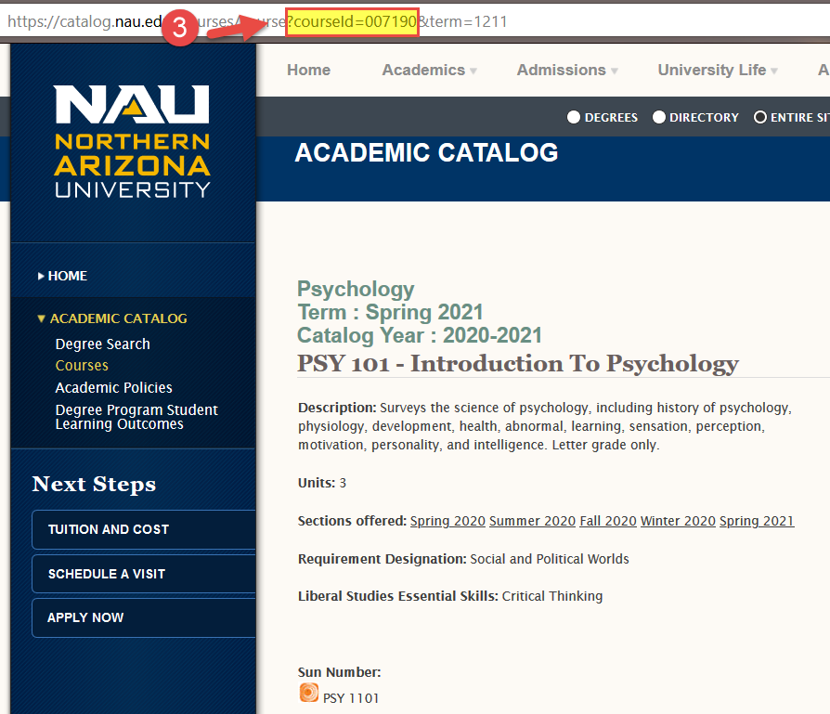

If the course doesn’t show up in the search, then it is not active in the catalog.

If you don’t see Course ID in the url, check that you are on the course details page.

**Appendix**

Details Return to Details*click here*

Organize expenses and data for ABOR, audit, and university committee. ABOR explanations start with the broad overview of the Purpose statement and conclude with the more specific Justification statement.

For the chart, start with the expense details that will be used in the justification. Next, translate expenses into broader instructional tools/approaches for the purpose statement. These broader categorizations potentially build in flexibility and the ability to account for changes as needed. For example, if a field trip were canceled one term due to extenuating circumstances a substitute activity could be funded (just be sure to document on the expense inventory). Next identify the expected outcome of the instruction, also part of the purpose statement. Finish with direct benefits available to students. Include data regarding student benefits in the justification, if available.

|  |  |  |  |
| --- | --- | --- | --- |
| **Expense/ cost (Justification)** | **Instructional Tools (Purpose)** | **Outcomes (Purpose)** | **Student Benefits (Both)** |
| Peer mentors/ $3,000 | Classroom support | Increased engagement and individual support | Reduced DFW/25% drop since start |
| Materials a; materials b/ $1,000 | Experiment manipulatives | Experiential learning | Deeper understanding |
| Transport and entry/2,000 | Field trips | Deepen understanding of XYZ certification principles | Improved scores Improved on XYZ certification/average up 10% |
| Online certification/ $1,000 | Online access XYZ | Improved certification completion | Improved completion rates of XYZ certification/ 95% |
| 5 tablets/ $1,000 | Technology | Familiarity with industry technology | Improved marketability |
|  |  |  |  |
|  |  |  |  |

The **University Committee Summaries** are included in a report format that limits character count to 254 characters. It is okay to list elements for the summaries instead of attempting a narrative. University Committee members may reference the ABOR descriptions if questions arise requiring more detailed explanation.

**Appendix**

Enrollment Information Return to Enrollment Information*click here*

When the course fee request is entered into Peoplesoft, the annual enrollment is automatically calculated to add the enrollment from each campus indicated for the prior Summer, Fall, Winter, and Spring terms. The Course Fee Enrollment Report at [*Course Fees we*b](https://in.nau.edu/academic-affairs/program-course-fees/) provides the same basic information but might require some additional manipulation depending on campuses and Honors.

**Using the report**

1. Select the green tab for your college. For topic courses use Topics tab; enrollment listed by topic titles.
2. Use Row Labels to filter for the course prefix, e.g. ACC, BIO, EGR.

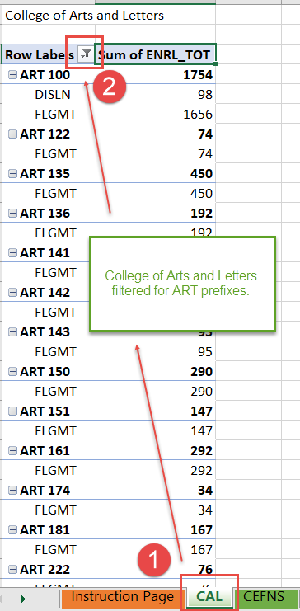

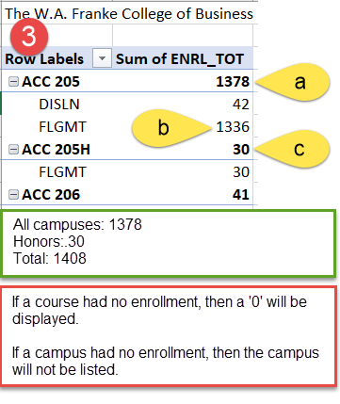

See Instruction Page for campus abbreviations.

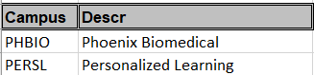

1. Determine enrollment
   1. Numbers in bold indicate total enrollment and details are listed below. In this example DISLN (42) and FLGMT (1336) have been added together. If the course fee applies to both campuses, then enrollment is 1378.
   2. If the course fee is only for FLGMT, then use the campus breakdown numbers; the enrollment is 1336.
   3. Honors enrollment is recorded separately on the report but will be included in the Peoplesoft calculation, so include it in the total on the worksheet. In the example for ACC 205, Honors enrollment of 30 is added to total enrollment of 1378 for a total enrollment of 1408. Students in Honors sections are charged the same fee as students in the main course.

**Appendix**

Exclusive Use and Controls Return to Details*click here*

Exclusive use refers to the requirement that course fees benefit only the students paying the fee. Conversely, students who did not pay the fee should not benefit from expenses paid by other students. For example, a cart with a classroom set of tablets maintained by course fees paid by students in Course A, B, and C may not be used in Course D (a class without a course fee).

Controls ensure that services and materials funded by course fees are regulated for the exclusive use by students who paid the course fees. Using the example of the cart and tablets, controls could be the instructors of Course A, B, and C are the only personnel with keys to unlock the cart or that the cart is kept in locked storage and controlled through approved check out. Include enough details that an auditor or outside party can understand *how* the control is working.

Types of Controls Return to Exclusive Use*click here*

* **Course Enrollment-** only those students enrolled in the course have access to the service or materials.
* **Accounting**- documentation confirms personnel are paid appropriately from course fees. A lab aide assists in two classes with a course fee and one without a course fee. The accounting control ensures that only 2/3 of the lab aide’s salary is paid from course fee funds.
* **Locked storage; inventory control; instructor control**- explain how materials are stored when not in use and only available to instructors of eligible course(s).
* **Classroom**- only courses paying the course fee are scheduled in the classroom where the materials or services are kept or provided.

**Appendix**

Expense Inventory Return to Starting Documentation – *click here* Return to Expense Categories – *click here*

Check with your accounting specialist for existing documentation and how best to document course fee expenses. This documentation will not be submitted, but the information is critical for:

* Identifying the most accurate costs of the course and the most accurate course fee for the students.
* Creating consolidation categories for courses with a long list of expenses- necessary if a course fee category (Personnel, Travel, Materials) has more than 5 expenses.
* Connecting the audit trail between the course fee worksheet information and the department accounting.
* Documenting the logic and history for anyone reviewing or working with the course fee in the future.

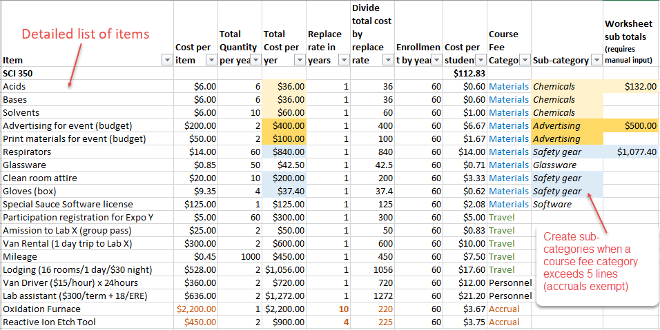

Whether or not you use this expense inventory, local documentation must contain the following:

* A detailed list of all items/services the course fee will pay fund.
* How much an item costs (include secondary costs: ERE for eligible personnel; taxes; other applicable fees); quantity necessary in a year; and total expense for the item in a year.
* The replace rate (useful life) in years. An expense with a rate of 2 or more years should be categorized as accrual.
* Each item’s cost per student based on annual enrollment and the cost per replace rate.

#### How to create sub-categories

A sub-category is only used when there are more than 5 line items in the expenses for Personnel, Travel, and Materials.

First, identify items that group together and create a sub-category name. In the highlighted example, acids, bases and solvents group naturally as *Chemicals.* Use sub-category names that will make sense to others outside of your department. Next, add together all the total cost per year for the items in the new sub-category. In the example, the cost per student for the sub-category *Chemicals* is $132. On the worksheet, the description will be Chemicals and the Total will be $132. The entire entry for Materials would look like the following:

**Appendix**

#### How to create sub-categories continued

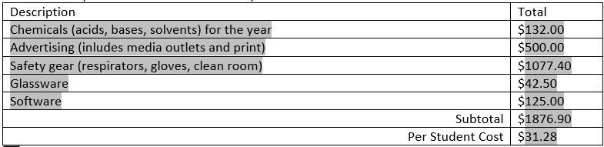

Return to Starting Documentation – *click here* Return to Expense Categories – *click here*

## Purchase new equipment: specialized equipment purchase and accruals Return to Accrual*click here*

Fees can maintain equipment and course fees can be accrued to replace equipment because the students paying the fee are benefiting from the existing equipment in the course. However, a course fee accrual cannot be created for the purchase of new equipment. For example, students in Course A in 2020 cannot be charged a fee that will be accrued to purchase new equipment in 2023 because the currently enrolled students would not benefit. NAU administration requires the use of other funding (such as grants) to purchase equipment necessary in these situations. Once the equipment is purchased, course fees can be used to maintain and replace going forward.

Request Reasons Return to Fee Information*click here*

#### New Fee Reasons

* What does “required for curriculum delivery” mean? The course fees would fund services, materials, or equipment *necessary* to fulfill curriculum requirements: a lab course needs experimental equipment to complete the curriculum requirements.
* What does “enhanced student experience” mean? The course fees would fund services, materials, or equipment that would add to and benefit the student experience but are not necessary to fulfill curriculum requirements: a field trip would be more interactive and engaging, but it is not a requirement of the course like field work.
* What if items are a mix of requirements and enhancements? Select the appropriate ‘required’ descriptor.

**1. New course: required for curriculum delivery.** For a newly approved course requiring funding to support requirements of the curriculum.

**2. Existing course: required for curriculum delivery.** For an existing course that now requires course fees to support requirements of the curriculum. This would likely be the result of a recent curriculum change or some other change that could justify why course fees weren’t required in the past.

**3. Other funding lost: required for curriculum delivery.** For an existing course that lost a source which historically supported requirements of the curriculum. The curriculum requirements have not changed and course fees are deemed a viable replacement for funding.

**4. Correction: fee cancelled or omitted in error.** For instances where a course fee was erroneously cancelled in the past or a fee was not requested when other courses with the same requirements were put forth for course fees.

**5. New course: enhanced student experience.** For a newly approved course requesting funding to support enhancements to the student experience.

**6. Existing course: enhanced student experience.** For an existing course requesting funding to support enhancements to the student experience.

*Continued next page*

**Appendix**

#### New Fee Reasons continued

**7. Other funding lost: enhanced student experience.** For an existing course that lost a source which historically supported enhancements to the student experience.

**8. Multiple campuses: differs from other fee(s).** For a new configuration of an existing course fee. For example, a $10 fee exists for Flagstaff Mountain campus funding a field trip and necessary software; now an online version of the course is starting and will require a $5 fee because these students do not participate in a field trip. Each campus will have its own version of the fee. *\*If these two examples were submitted simultaneously as new requests, this reason is no longer applicable. The reason would be selected from the other options for new or existing courses.*

#### Increase Reasons

**1. Existing expenses increased.** When there are no changes to the services, materials, or equipment other than an increase of the cost of one or more of these items.

**2. New expenses added.** When new services, materials, or equipment are being proposed.

**3. Both: new and increased expenses.** For any combination of new and increased expenses.

#### Decrease Reasons

**1. Expenses decreased.** When there are no changes to the services, materials, or equipment other than a decrease in the cost of one or more of these items.

**2. Expenses eliminated.** When existing services, materials, or equipment will no longer be used or need course fee funding.

**3. Both: expenses decreased and eliminated.** For any combination of decreased or eliminated expenses.

**4. Other funding established.** When a portion of existing services, materials, or equipment will still be in use, but no longer require course fee funding.

#### Edit-Same Reasons

**1. Change campus.** When the only change to the fee is the addition or deletion of a campus(es).

**2. Initial input: no change to existing fee.** For the purpose of migrating into the new system when the following elements of the existing fee *will not change*: amount, campus, or purpose/use.

**3. Change purpose/use.** When the only change to the fee is in the services, materials, or equipment. *Likely rare, since most changes to expenses result in changes to the amount of the fee.

#### Cancellation Reasons

**1. Expense(s) eliminated.** All services, materials, or equipment will no longer be used in the course.

**2. Program Fee established.** Program fee funding will replace course fee funding for services, materials, or equipment.

**3. Other funding established.** Other funding will replace course fee funding for services, materials, or equipment.

Return to Fee Information*click here*

**Appendix**

Shared Accruals Return to Starting Documentation *click here* Return to Shared Accruals *click here*

A shared accrual is an accrual that is calculated across multiple course fees because the specialized equipment is shared by students in multiple courses.

To ensure the per student cost is equitable and correct, the calculation for a shared accrual must divide the costs by the *total enrollment* *of all students enrolled in the courses* sharing the equipment.

* Dividing the cost by the number of classes can result in unequal costs to students.
* Assessing the cost to a single course will result in unequal costs to students and some students not paying the fee.

Shared accrual information has specific requirements.

1. **Consult** with the accounting specialist for your department to determine if the required information listed below is already available in an existing department/unit report.
   1. Item description
   2. Item location- room number(s)
   3. Item cost per unit
   4. Number of units in inventory
   5. Total amount (Item cost per unit x number of units)
   6. Useful life
   7. Next scheduled purchase (fiscal year)
   8. List of all courses sharing the use and cost
   9. Total enrollment for all courses sharing the use and cost
   10. Per student cost- calculated as (Number of units*Cost per unit)/Useful Life/Total Enrollment)
2. Determine with the accounting specialist for your department if your unit will use an existing report or the Shared Accrual Details spreadsheet at [*Course Fees we*b](https://in.nau.edu/academic-affairs/program-course-fees/) Screen shot shown here.

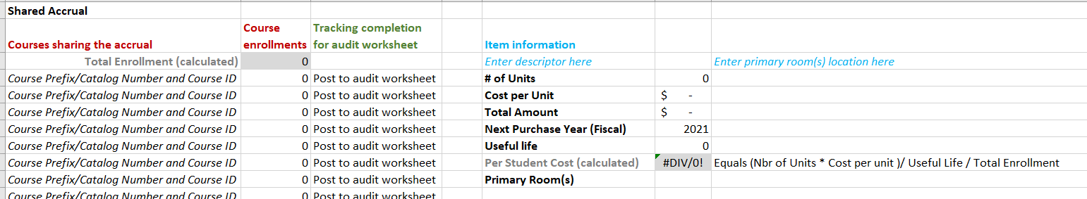

1. Calculate and document all shared accruals for the course in question and complete the Shared Accruals section of the worksheet.
2. **Provide** updated information to the **fiscal operations manager** of your unit for secured filing. Shared accruals information will be retained in a secure VPAA shared file that can be accessed by internal and external auditors. Only a college’s fiscal operations manager will have the security to upload documents into this file. Any course fee indicating shared accruals must have detailed information on file.

Return to Starting Documentation *click here* Return to Shared Accruals *click here*

**Appendix**

## Typical Expenses and Additional Guidelines

These lists are for reference of examples; they are ***not*** exclusive.

Personnel Return to Personnel – *click here*

Personnel should directly benefit the students paying the fee.

Always include ERE where applicable.

#### Personnel Examples

|  |
| --- |
| In class support: Lab aides, peer facilitators, GA/TA (not instructor of record), tech support, etc. |
| Temporary hire: Models, mock patients, field trip drivers and cooks, etc. |
| Supervisory Instruction: clinical/practicum support; internship maintenance, etc. |
| Program coordination: Lab coordinator, program support, etc. |
| Specified Guest Instructor: must provide curriculum requirement(s) that instructor cannot, e.g., certification |
|  |

Travel/Third Party Return to Travel/Third Party *click here*

All travel expenses must comply with NAU travel policies.

All travel/third party expenses must be applicable to all students enrolled in the course.

#### Travel/Third Party Examples

|  |
| --- |
| Entry fees: events; tours, programs, etc. |
| Transportation: rental, gas, and mileage |
| Lodging |
| Rentals/use fees: special equipment, boat rentals, deposits, etc. |
|  |

Materials/Software Additional Guidelines Return to Materials/Software *click here*

Generally, materials purchases match one of the following and are purchased each year:

1. Can be purchased in bulk or commercially for significant cost savings to the students.
2. Assure necessary standardization or conform to certain specifications necessary for the curriculum.
3. Are of a specialized nature not readily available for student purchase.

And cover needs such as:

1. Assessment materials.
2. Lab/Studio materials and tools.
3. Materials for production of student work or student performances.
4. Materials essential to instruction in the course objectives.
5. Online access to materials necessary for the course and paid for each term or year.
6. Specialized software licenses necessary for the course; not provided by university software licensing; and paid for each term or year.

**Qualifying food expenses** Food items used in labs or for curriculum requiring food preparation; food for field trips/fieldwork in remote areas where food is not readily available.

**Printing/copies** Confirm Jacks Print and NAU Printing Services (for Course Packs) cannot provide the print needs. Items printed/copied must provide cost savings to the students and cannot violate copyright laws.

**Appendix**

#### Materials Examples

|  |  |  |
| --- | --- | --- |
| Classroom Manipulatives | Memory cards/batteries | Chemicals |
| Maps | Online archives access | Assistive technology tools |
| GPS units for fieldwork | Media for in class instruction | Cleaning supplies for labs/studios |
| Microscope slides | Hand tools | IncludEd textbooks/licenses |
| Specimens and samples | Safety gear for labs/fieldwork | Classroom models |
| Annual software renewals | Scheduled annual maintenance |  |
|  |  |  |

Return to Materials/Software *click here*

Accruals- Specialized Equipment Return to Accruals *click here*

Technically, course fees are not allowed to carry balances because the fees are to provide benefit to the student in the term the student paid the fee. However, intentional accrual is allowed for the repair and replacement of specialized equipment with multi-year life spans. Scheduled annual maintenance should be listed in Materials expenses.

Accrual for specialized equipment requires the setup of an accrual sub-department. Consult and coordinate with your accounting specialist to confirm the proper accounting is in place.

Generally, specialized equipment

1. Is a necessity for curriculum requirements.
2. Should be tracked in inventory control.
3. If computers or audio equipment, items must **not** be eligible for funding with the Central IT Tech Fee.

#### Accrual Examples

|  |
| --- |
| Computers, tablets, ipads: not eligible for Central IT Tech Fee |
| Specialized furniture: required for instruction: dental hygiene chairs, tents, etc. |
| Tools: welding equipment, media production equipment, etc. |
| Discipline technology/lab equipment: microscopes, kilns, 3D printers, CAD, cameras, treadmills, etc. |
| Models and samples (must have multi-year life spans) casts of fossils, demonstration models, props, etc. |
| Multi-year licenses: software licenses or online access renewing every 2 years or more |
|  |