Submitter Guide for Course Fee Requests
Table of Contents
Introduction 2
Course Fee Audit Worksheet Preview 3
Unit Workflow 3
Course Information 4
Enrollment Information 4
Fee Information 5
Campuses 6
Expense Categories 7
Personnel 7
Accrual Category 8
Specialized Equipment 8
Shared Accruals 9
Specialized Equipment Per Student Cost Total 9
Manual Cross-Check 10
Account Information 10
Details 11
ABOR 11
Summaries 11
Peoplesoft Course Fee Request Pages 12
Edit an existing fee 12
Search 12
Course Fee Tab 13
Course Fee Tab Navigations 14
Financials Tab Expenses 15
Financial Tab Accruals and Financial Information 16
Additional Accruals Information 17
ABOR Tab 18
Summary Tab 19
Document Upload 20
Submit 20
New Fee 21
Search 21
Entry 21
Cancel a Fee 22
Search 22
Course Fee Tab 22

Introduction
This documentation is organized in two sections reflecting the submission process. The first section is the Course Fee Audit Worksheet Preview covering what a submitter should review upon receipt of a worksheet. This preview can identify issues that would invalidate a submission into the Peoplesoft pages. The second section is PeopleSoft Course Fee Request pages covering all data entry, documentation upload, and cross-checks within the system. This section also covers potential variations in data entry. For any questions regarding this guide or course fees in general, contact CourseFees@nau.edu .

Course Fee Audit Worksheet Preview
This section covers what to look for in each segment of a course fee audit worksheet. It is recommended that submitters preview a worksheet before attempting entry into the PS Course Fee Request. Identifying and resolving known issues up-front could improve submission approvals and prevent wasted time starting entries that cannot validate. It is not possible to save a partial submission; each request must be completed upon entry, with documentation and validation, for a successful submission.

Unit Workflow
Initiated By: |  |  |  |  |  | Date
Chair Approval (print name) |  | Initial |  | Approval via Attachment* |  | Date
Dean Designee Approval |  | Initial |  | Approval via Attachment* |  | Date
Other Dept. Approval |  | Initial |  | Approval via Attachment* |  | Date
*Approvals documented by email must be uploaded with the Course Fee Worksheet.
Is there any missing information?
Is the Initiator name listed?
Do all approvers indicate
-name
-initial OR attachment
-date
If any names, initials, or dates are missing, either return the worksheet to the individual or contact the individual for permission to edit. If you are permitted as an editor to make changes to the worksheets for your unit, you must save the document after making changes to preserve the edits.

Attachments provided?
If Approval via Attachment is indicated, you should have received the attachments. Approval attachments will be uploaded with documentation.

Contact worksheet initiator for missing attachments.

Course Information
Use the Master Course Fee List for existing fee information
Subject Catalog # (Ex. PSY 101)
Course ID (Ex. 006445)
Topic Title if fee is only applied to this title
*Each cross-listed or co-convened course must have its own course fee audit worksheet.

Topic Title blank?
Topic Title only applies to topics courses and will only be listed if a title is to have a unique fee. It is okay for the Topic Title to be blank unless you have knowledge that it should be completed.

Enrollment Information
AY 20-21 estimated annual enrollment is calculated from actual enrollment in 2019 Summer, Fall, Winter and 2020 Spring. Use the Course Fees Enrollment report to determine Est. Annual Enrollment.
Est. Annual Enrollment
Enrollment Data from CF Enrollment Report?
If No, explain how enrollment was calculated

Is Est. Annual Enrollment is empty?
Does ‘Choose from Drop down’ appear in the second field (as shown). It should display Yes or No.
Is the explanation field empty when ‘No’ appears in the second field?

Edit or return to the worksheet initiator for an edit.

Fee Information

Effective Term
Fee Type | Flat Fee
Current Fee Amount zero if New fee: |  | $ | Proposed Fee Amount: | $
Request Type
New Fee Reason
Fee Increase Reason
Fee Decrease Reason
Edit- Same Reason
Cancellation Reason
*If pursuing a per unit fee, email Coursesfees@nau.edu before completing the worksheet.
Is the Current Fee or Proposed Fee Amount blank?
Is a Request Type identified?
Does the Request Type match the logic of the Current and Proposed Fee Amounts?
New should be zero for Current Fee Amount.
Edit Increase should have a Current Fee Amount smaller than the Proposed Fee Amount.
Edit Decrease should have a Current Fee Amount larger than the Proposed Fee Amount.
Edit Same should have matching Fee Amounts.
Cancel should be zero for Proposed Fee Amount
Does the Reason selected match the Request Type? For example, an item from the drop-down menu for New Fee Reason has been selected for a Request Type of New.

Any edits to Proposed Fee Amount affect cost per student- return to worksheet initiator.
All other issues can be edited or returned to the worksheet initiator for edit.

Campuses

Campuses (Select all applicable)
Flagstaff Mountain |  | Online |  | *Yuma - if selected see Guide
Statewide Campuses
Central Arizona College |  | Chandler-Gilbert Cmty Coll |  | Eastern Arizona College
Estrella Mountain Cmty Coll |  | Glendale Cmty Coll |  | Mesa Cmty Coll
Mohave Cmty Coll |  | NAU - East Valley |  | NAU - North Valley
NAU - Yavapai |  | Navajo-Hopi |  | Northland Pioneer College
Paradise Valley Cmty Coll |  | Phoenix Biomedical |  | Phoenix College
Pima Cmty Coll, Downtown |  | Pima Cmty Coll, West |  | Scottsdale Cmty Coll
South Mountain Cmty Coll |  | Yavapai College
*If fee applies to both Yuma and Flagstaff Mountain campuses, separate worksheets are required. …….…
Do not check Yuma and Flagstaff Mountain on the same form; provide submitter with two worksheets.
Are Flagstaff Mountain and Yuma campuses selected?
Return to worksheet initiator with notification that separate worksheets are required.

Have you been asked to add or delete a campus?
Changes to campus might affect estimated enrollment and cost per student.
If edits to campus affect cost per student, return to the worksheet initiator.

Expense Categories
The following applies to all Personnel, Travel/Third Party, and Materials/Software expenses.
Fees collected must be spent in full each year-- for accrued expenses see Accrual Category.
- Course fees are for exclusive use. Fees are course specific, benefit only the students paying the fees, and benefit all students enrolled in the course. See Guide for details.
- Prohibited use of course fee funding: per NAU policy, the listed prohibitions may not be funded with course fees. Please note these items are not discouraged or prohibited from use; however, funding must come from a source other than course fees.
See Guide for typical expenses in this category.

Personnel
Prohibited use of course fees for personnel:
Only one expense category is shown here. The same questions apply to Travel/Third Party and Materials/Software categories.

Is any dollar entry missing a description?
Are any prohibited use items listed in a description?
Is the checkbox blank?
Edit or return to the worksheet initiator for an edit.

  - Any instructor of record including GA’s and TA’s.
  - Reader-graders, problem set graders, or similar.
  - Guest speakers, presenters, or similar. See Guide for qualifying Specified Guest Instructor.
  - See Guide for typical expenses in this category.
In the Description, indicate costs per term (include ERE where applicable) and then record total expense for the year.
Example Descriptor: Peer facilitators (3@$300) each Fall, Spring, Summer.
Total: $2700
Check compliance when this section is complete.
Description | Total
 | $
 | $
 | $
 | $
 | $
Subtotal | $0.00
Per Student Cost | $
Checking this box, the person preparing this worksheet confirms compliance in all Personnel costs with (1) expenditure within the academic year, (2) assurance of exclusive use, and (3) prevention of prohibited use.

Accrual Category
The following applies to all accruals.
- Expense must require an accrual of funds for more than one year and have a useful life of more than one year.
- Exclusive use: course fee accruals must be course specific, benefit only the students paying the fees, and benefit all students enrolled in the course.
  - An accrued expense may be shared across multiple courses (e.g., computers in a lab, special equipment in a clinical classroom).
  - And an accrued expense may be in multiple rooms (e.g. 2 treadmills located in 2 different classrooms).
- Prohibited use of course fee funding: per NAU policy, listed accruals may not be funded with course fees. Please note these items are not discouraged or prohibited from use; however, funding must come from a source other than course fees.
The following apply to all entries with a numbered Description.

Is the description missing?
Are any prohibited use items listed in the description?
If computers or audiovisual equipment is referenced in the description, is the Computers checkbox checked?
Are all fillable fields complete? ‘# of Units’ through Primary Room

Edit or return to the worksheet initiator for an edit.

See Guide for explanation on completing data fields below.

Specialized Equipment
Prohibited use of accrual:
  - Any items intended for general use and not specific to the student’s benefit from enrollment in the course, e.g., items for department/program use, general printing/copiers, multi-use/classroom furniture, whiteboards, or similar.
  - Any items with useful life one year or less.
  - Technology or Audiovisual covered by the IT Central Tech Fee.
  - Software covered by general university licensing.
  - Improvements requiring reconstruction of spaces.
For accruals funded by and used by more than one class, do not enter individually; use Shared Accruals entry.
See Guide for explanation on completing data fields below. Check compliance when section is complete.

Description 1:
Computers or A/V include laptops, tablets, etc. |  | # of Units | Cost per Unit include all taxes, extra fees | Total Amount | Expense Date – Enter fiscal year of purchase | Useful Life in years | Per Student Cost | Primary Room
☐ |  |  | $ | $0.00 |  |  | $

Description 2:
Computers or A/V include laptops, tablets, etc. | # of Units |  | Cost per Unit include all taxes, extra fees | Total Amount | Expense Date - Enter fiscal year of purchase | Useful Life in years | Per Student Cost | Primary Room  For Description 2-4 see prior page.  For Shared Accruals  Is the item list missing?  Are any prohibited use items listed in the description?  Is the per student cost verification checkbox checked?  If computers or audiovisual equipment is referenced in the description, is the Computers checkbox checked?  Is Per Student Cost or Primary Room missing?  For Specialized Equipment Per Student Cost Total  Does the Total reflect the sum of all Per Student Cost entries for accruals?  Is the checkbox blank?  Edit or return to the worksheet initiator for an edit.
☐ |  |  | $ | $0.00 |  |  | $

Description 3:
Computers or A/V include laptops, tablets, etc. | # of Units |  | Cost per Unit include all taxes, extra fees | Total Amount | Expense Date - Enter fiscal year of purchase | Useful Life in years | Per Student Cost | Primary Room
☐ |  |  | $ | $0.00 |  |  | $

Description 4:
Computers or A/V include laptops, tablets, etc. | # of Units |  | Cost per Unit include all taxes, extra fees | Total Amount | Expense Date - Enter fiscal year of purchase | Useful Life in years | Per Student Cost | Primary Room
☐ |  |  | $ | $0.00 |  |  | $

Shared Accruals
Shared Accruals list items with accrual used by multiple courses
Verify per student cost is the same for each student in all classes listed |  | Computers or A/V include laptops, tablets, etc. | Per Student Cost | Primary Room
☐ |  | ☐ | $

Specialized Equipment Per Student Cost Total
Specialized Equipment Per Student Cost Total  (This field does not auto-calculate – please add Specialized Equipment per student costs) | $0.00

Checking this box, the person preparing the worksheet confirms compliance in all Accrual Costs with (1) necessity to accrue, (2) assurance of exclusive use, and (3) prevention of prohibited u

Manual Cross-Check

Enter the Per Student Cost from each section and compare with Proposed Fee.
Is your total fee amount correct?
 |  | Personnel Per Student Cost | $
 |  | Travel/Third Party Per Student Cost | $
 |  | Materials/Software Per Student Cost | $
 |  | Specialized Equipment Per Student Cost Total | $
 |  | Total Per Student Cost | $0.00
 | Proposed Fee  (If discrepancy, check per student costs or update Proposed Fee Amount) |  | $0.00
Do Total Per Student Cost and Proposed Fee match?

Request edits from the worksheet initiator.

Account Information

Department ID
Department Name
Fund Code
Is any account information missing?

Request edits from the worksheet initiator.

Details

ABOR
- Purpose ABOR (1000 characters or less) – will be duplicated in ABOR form.
Provide a general picture of what the course fees will provide and the proposed outcomes that will result in added student benefit. Include the annual cost amount. See Guide for annual cost calculation and tips and examples.
Does the Purpose Statement or Justification exceed 1000 characters?

Request edits from the worksheet initiator.

- Justification ABOR (1000 characters or less) – will be duplicated in ABOR form.
Provide specific details about itemized costs that support the annual cost and identify if funding will be 100% course fees or augmented by other sources. If space allows include more details about student benefit. See Guide for tips and examples.

- Exclusive Use AUDIT (1000 characters or less) – required for Audit
Describe the controls used to guarantee that only the students paying the fee benefit from the services or materials purchased with the fee.
Does the Exclusive Use statement exceed 1000 characters?
Does the controls description explain how exclusive use is guaranteed? An external reader (auditor) should be able to visualize how the control works.

Request edits from the worksheet initiator.

Summaries
If entries above are 250 characters or less, copy and paste into corresponding field below.
If entries exceed 250 characters, list critical elements for University Committee consideration below.

- Purpose Summary for University Committee (250 characters or less)
Do any summaries exceed 250 characters?

Request edits from the worksheet initiator.

- Justification Summary for University Committee (250 characters or less)

- Exclusive Use Summary for University Committee (250 characters or less)

Peoplesoft Course Fee Request Pages
This section covers how to navigate to the Course Fee Request Pages in Peoplesoft (LOUIE). How to search for an existing fee, edit fees, create a new fee, cancel a fee, upload documents, validate, and submit. To open the Course Fee Request, sign-in to LOUIE- Campus Solutions. From the Main Menu, select Curriculum Management, then NAU Course Fees, then Course Fee Request. If you do not see NAU Course Fees, check that your NAU_SR CF User role is active.

Edit an existing fee

Search

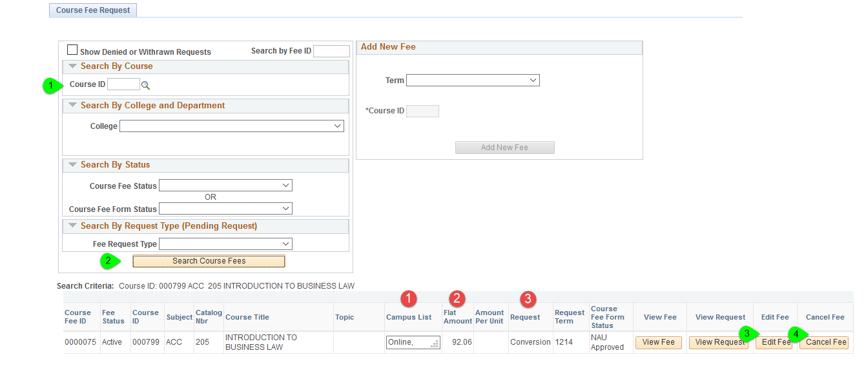
Navigation
- Enter course ID number from worksheet
- Click ‘Search Course Fees’
- Select ‘Edit Fee’
- Or ‘Cancel Fee’
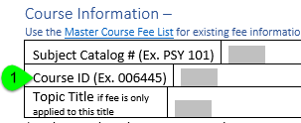

Notes
- A comma after a campus in the search results indicates additional campuses; pull window to view all.
- Campus and Flat Amount can help identify the correct version of a fee when multiple versions exist.
- Conversion is the status assigned to all existing fees that were pulled over from the old system.

Course Fee Tab

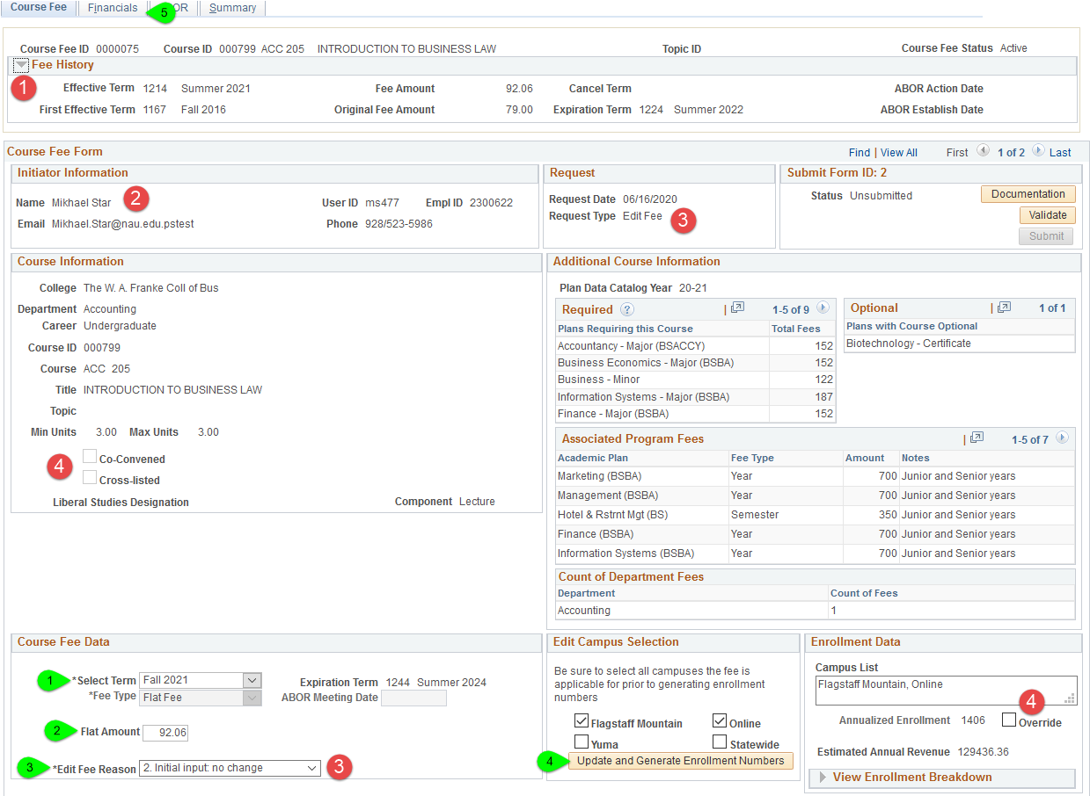
Where to find on the worksheet
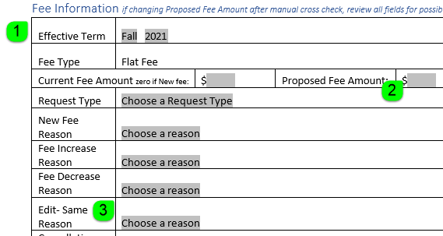

- Select Term (default on the worksheet is Fall 2021)
- In Flat Amount enter Proposed Fee Amount from the worksheet
- Select Fee Reason
- Click Update and Generate Enrollment Numbers
- Click Financials tab to move to the next page

- Current fee amount is in Fee History (click to expand).
- Your information will appear in Initiator Information.
- Type and Reason will update after amount is entered for edit (no change), increase, decrease.
- If Co-convened or cross-listed data appears, expect to override the enrollment: click override, enter enrollment from worksheet, and then click Financials tab to move to next page.

Course Fee Tab Navigations

Reason drop down menu is changing
The Reason defaults as Edit and then adjusts based on the Flat Amount entered as it compares to the History’s Fee Amount. Each Reason then displays the assigned items for the drop-down menu.

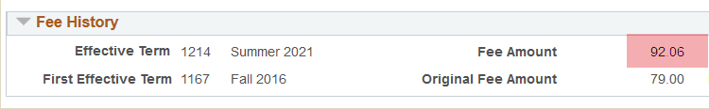
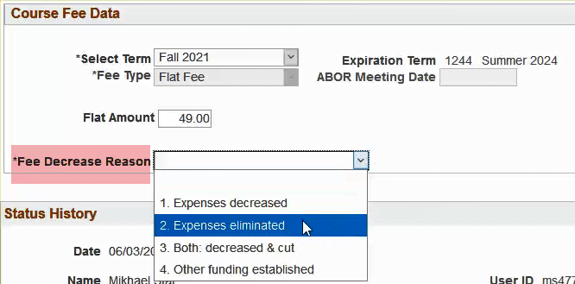

How to override enrollment
If the worksheet indicates that the enrollment was not pulled from the Enrollment report and a justification has been given for a different enrollment count, then submitters can override enrollment. After campuses are selected, click the Override box. The Adjust Annualized Enrollment field will become editable. Type in enrollment from worksheet and click enter to update Estimated Annual Revenue. Move on to the next tab.
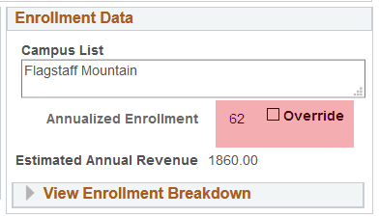

Financials Tab Expenses
This screenshot is only the upper half of the Financials tab view

If Applicable
- Enter Personnel cost per student and check audit confirmation
- Enter Travel/Third Party cost per student and check audit confirmation
- Enter Materials cost per student and check audit confirmation
4-8 on next page
- Click ABOR tab to move to the next page

Where to find on the worksheet
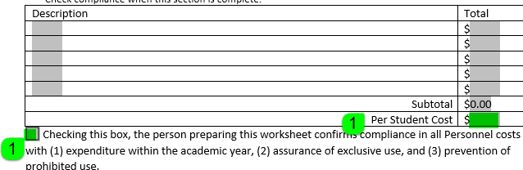

Financial Tab Accruals and Financial Information
This screenshot is only the lower half of the Financials tab view
If Applicable
- Enter Specialized Equipment cost per student (from bottom of page 7) and check audit confirmation
- Enter Description 1 and all details (from page 6). Repeat for all entries with a description.
  - The A/V or Tech checkbox may or may not be applicable.
  - The Shared Expense checkbox will remain blank for a numbered description.
  - The last 5 entries are required (Cost Per Unit through Primary Room).
  - If there is more than one specialized equipment detail, click the ‘+’ button to add rows.
- If the fee indicates Shared Accruals (page 7), enter the list and limited details.
  - The A/V or Tech checkbox may or may not be applicable.
  - The Shared Expense checkbox must be checked.
  - Enter Primary Room.
- Edit Department number only if it is different. Listed Department Name should match.
- Edit Fund Code only if it is different.
- (Not shown in this screenshot)- Click on ABOR tab to move to the next page.

- Only one Shared Accruals entry per request. Shared Expense must be checked.
- Use the ‘+’ to add a new row. Use ‘-‘ to delete a row.
- For existing fees, the Financial Information will already be populated; check for edits.

Additional Accruals Information

Primary Room
It is recommended that submitters preview the Primary Room Look Up, determine best descriptors for worksheet initiators to use and communicate that information to worksheet initiators prior to completion of the worksheets.
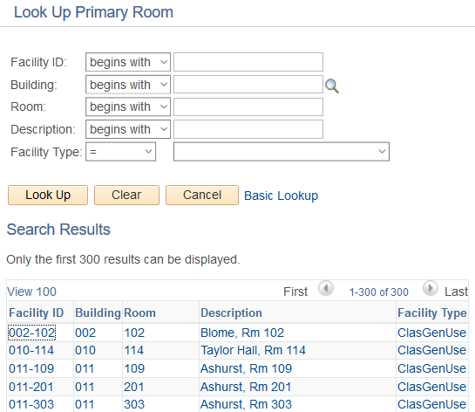

Multiple Rooms
In the event more than one room is listed on the worksheet, enter the first room number in the Primary Room field and copy the remaining rooms into Comments at the bottom of the page.
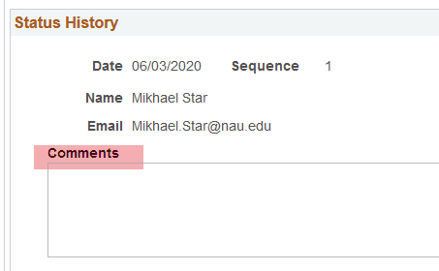

ABOR Tab

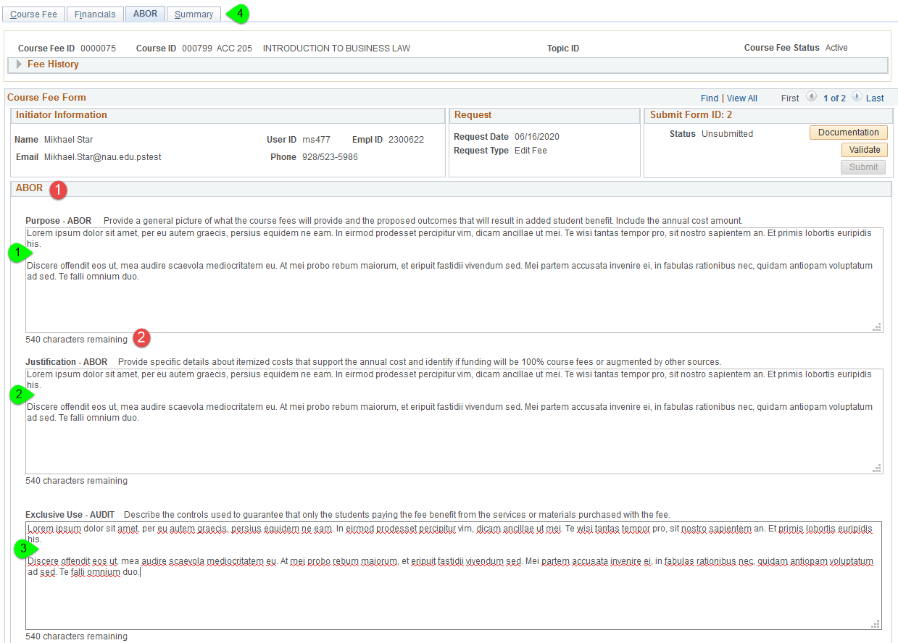
- Enter text for Purpose- ABOR
- Enter text for Justification- ABOR
- Enter text for Exclusive Use- ABOR
- Click Summary tab to move to the next page

- Text fields allow for copy and paste.
- Character countdown for each text field.

Summary Tab

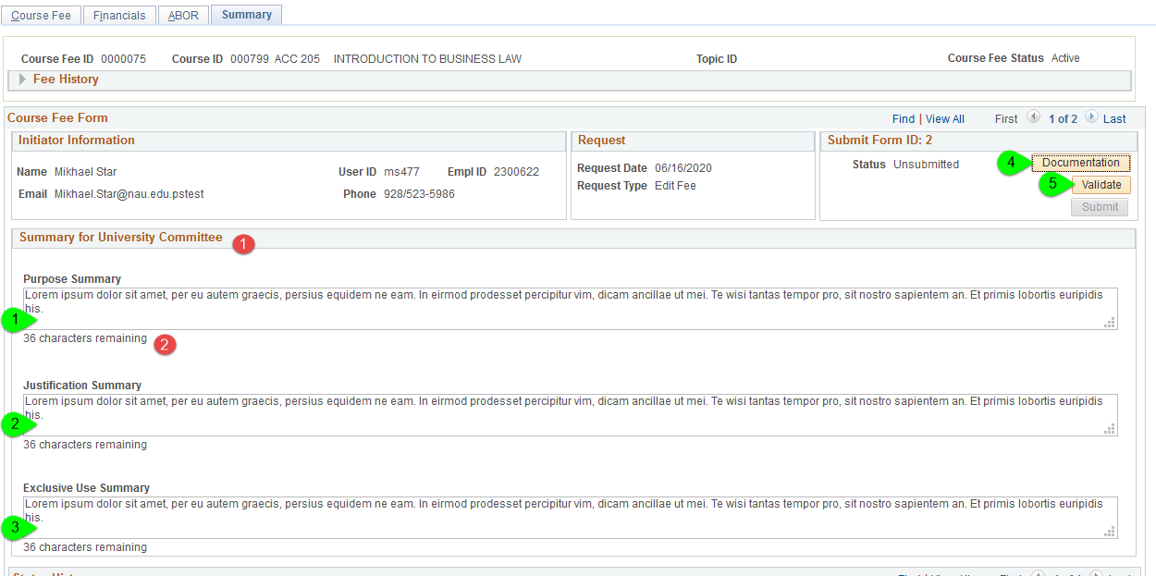
- Enter text for Purpose Summary
- Enter text for Justification Summary
- Enter text for Exclusive Use Summary
- Click Documentation to upload required documents (details on next page)
- Click Validate to confirm all required fields are complete and Flat Amount on Course Fee tab matches Total Est Annualized Cost per Student on Financials tab. A list of missing/incorrect information will display if the validation fails.

- Text fields allow for copy and paste.
- Character countdown for each text field.

Document Upload
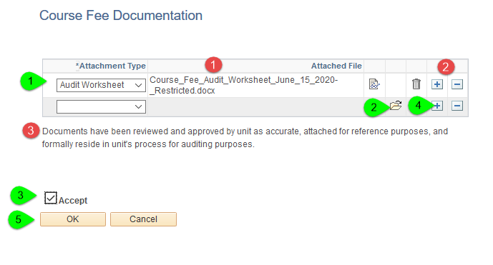
- Select Document Type: Audit Worksheet or Other
- Click folder to browse files for upload
- Check Accept to acknowledge documentation requirements
- If necessary, click ‘+’ to add another row and attach more documentation
- Click OK to finish upload and return to page

- Document name will display upon successful upload.
- Use ‘+’ and ‘-‘ to add or delete rows.
- Documentation statement for the ‘Accept’ checkbox.

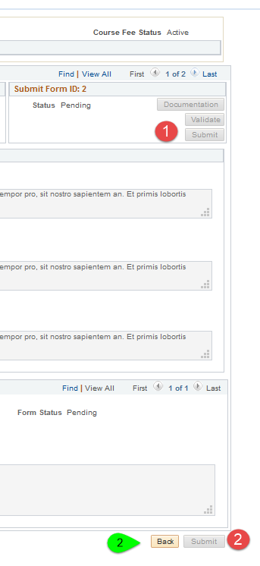

Submit
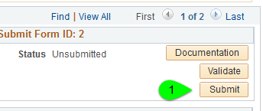

- When documentation and validation are fulfilled, the Submit button will become active. Click to Submit.
- Submission is successful when Submit button grays out. Click Back at the bottom of the page to return to Search page and start another submission.

- Document, Validate, and Submit go gray when submission is completed.
- Submit button at bottom of the page also goes gray when submission is complete.

New Fee

Search
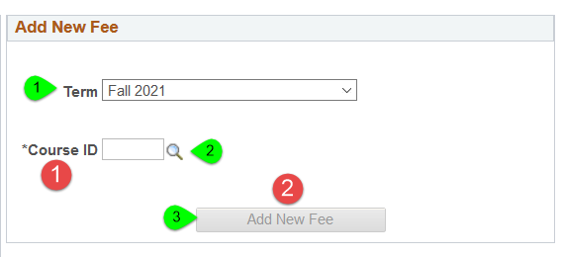
- Select Term
- Enter Course ID from worksheet
- Click Add New Fee

- Click enter after typing in Course ID. If valid, course title will appear.
- Button becomes active with valid course entry.

Topics Course
If a course has topics, the Topic ID box will display. If the fee will apply to all titles assigned to the course, then leave the field blank. If the fee will apply to a single title, select that title from the drop-down menu. If the title does not appear, return the worksheet to the initiator to confirm the title is active.

Entry
Entry of information is the same as for existing fee edits. See pages 13-20 for details.

Cancel a Fee

Search
Search for existing fee.

Course Fee Tab
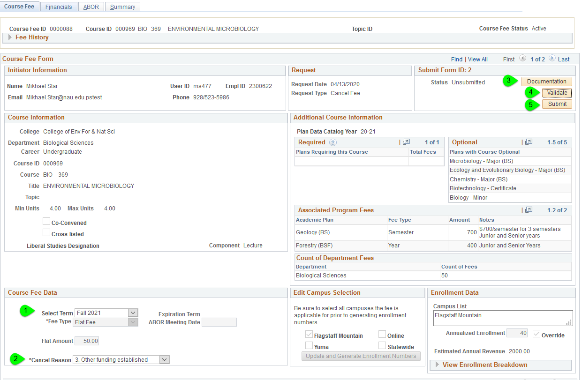
- Select Term
- Enter Reason
- Upload worksheet
- Validate
- Submit
- [Not shown] Click Back at the bottom of the page to return to search

