Guide to completing the Course Fee Audit Worksheet
Using the Guide  - Click any link to jump to more details.  - Available resources and consultants will be identified in each section.  Deadlines Sooner is always better. There are no exceptions to missed deadlines for course fee requests.  - Oct. 1 – all worksheets to submitter this date is recommended; check with your submitter to confirm.  - Oct. 30 – all submissions complete form accuracy checked; denials require resubmission.  - Nov. 30 – all resubmissions (corrections) complete.  Before handing off to submitter  - Answer all questions and discuss any concerns with consultants before turning this document over for submission.  - Submissions into Peoplesoft cannot be corrected or revised; only resubmitted.  Timeline  - Dec. 31 – NAU committee aprovals complete denials at this stage are final.  - Jan. 29 – Pending ABOR approvals posted in system.  - February – Students can see pending data in class information.  - April – ABOR approvals complete denials at this stage are final.  - April/May – Approval activated in system.  - June – Tuition calculation and billing with new fee amounts.  PAGE 1: APPROVALS AND COURSE INFORMATION  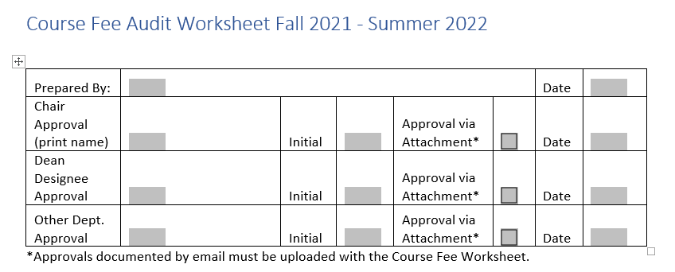  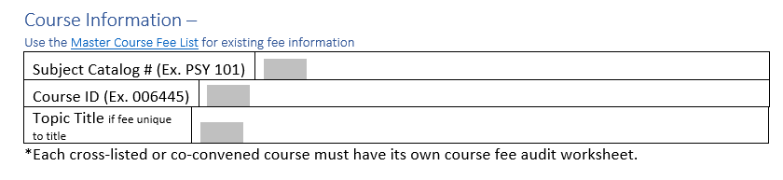  PAGE 2: ENROLLMENT AND FEE INFORMATION  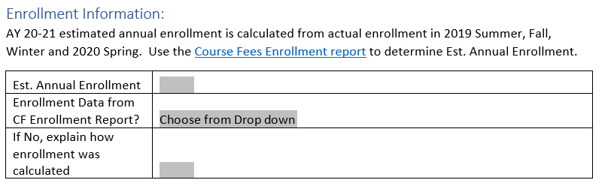  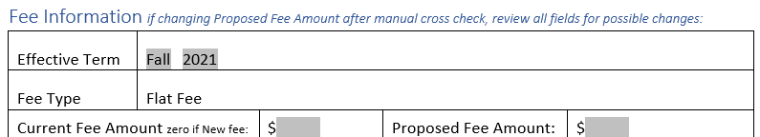  PAGE 3: FEE INFORMATION continued  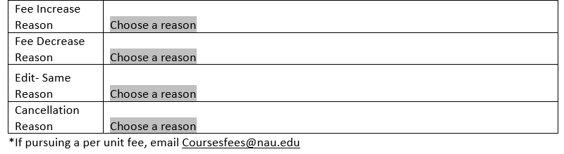  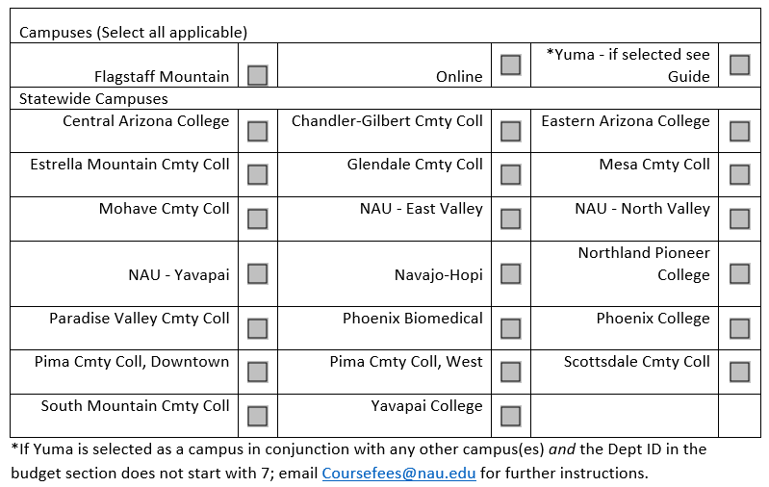  PAGE 4: COST BREAKDOWN EXPENSES AND EXPENSES: PERSONNEL  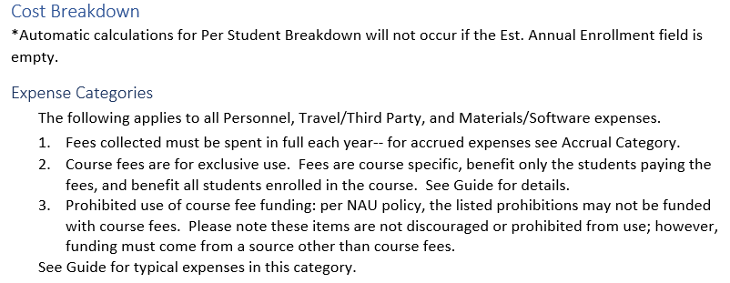  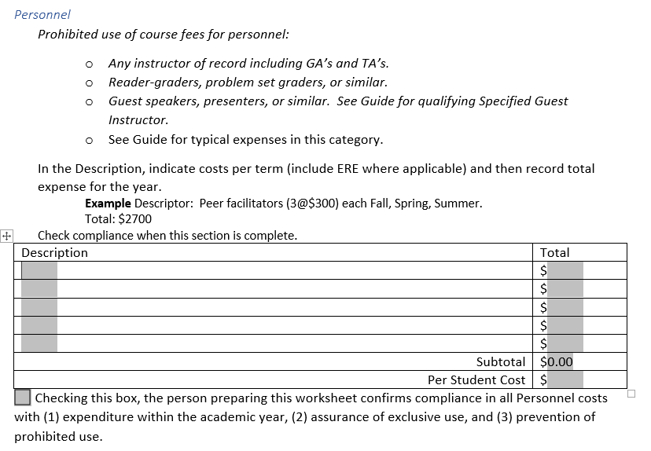  PAGE 5: EXPENSES: TRAVEL/THIRD PARTY (includes trips, entry fees, rentals)  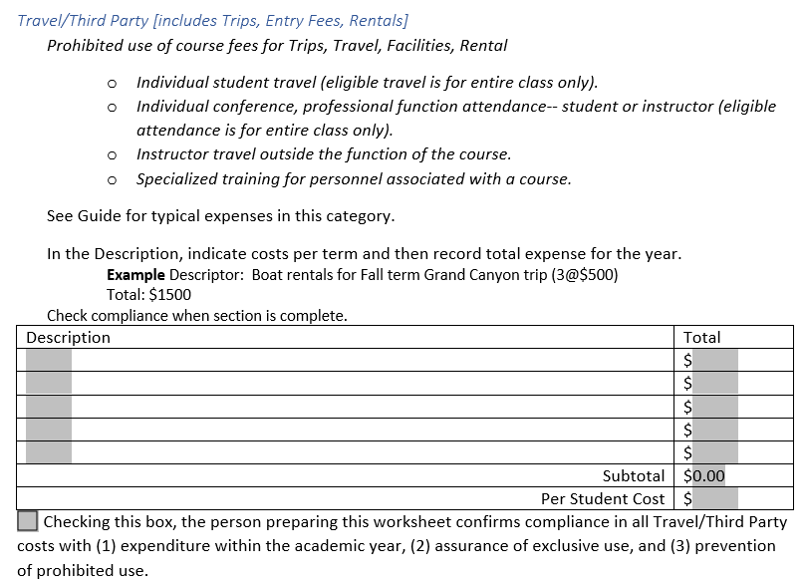  PAGE 6: EXPENSES: MATERIALS/SOFTWARE  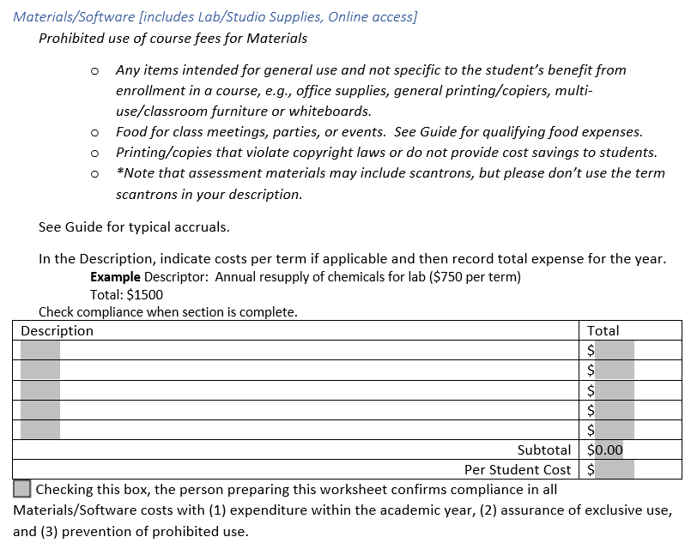  PAGE 7: EXPENSES: ACCRUAL  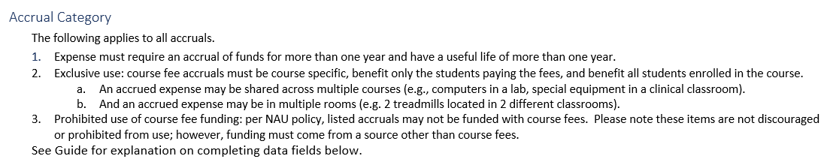  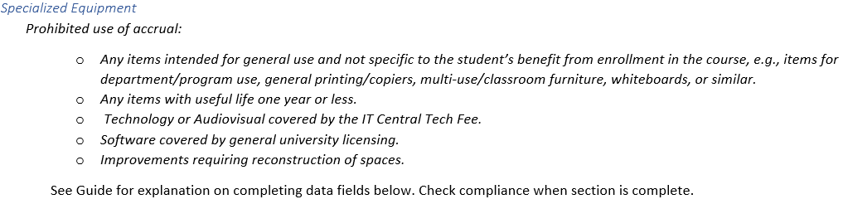  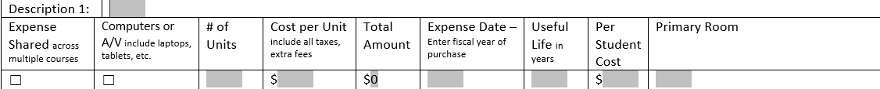  PAGE 8: ACCRUAL continued  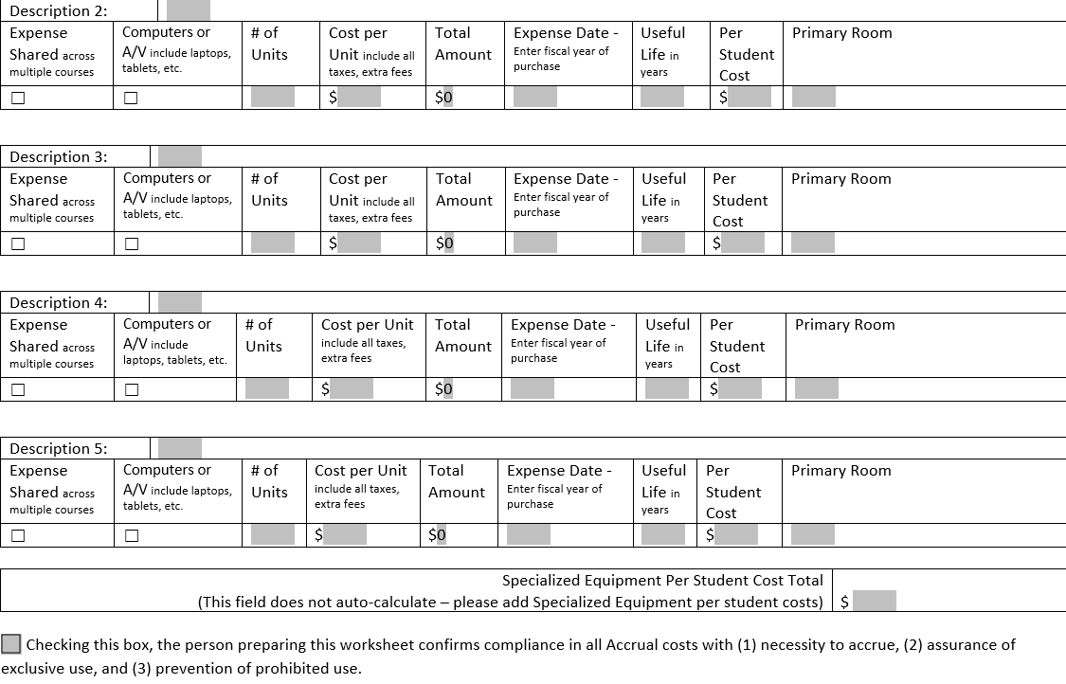  PAGE 9: MANUAL CROSS-CHECK AND BUDGET INFORMATION  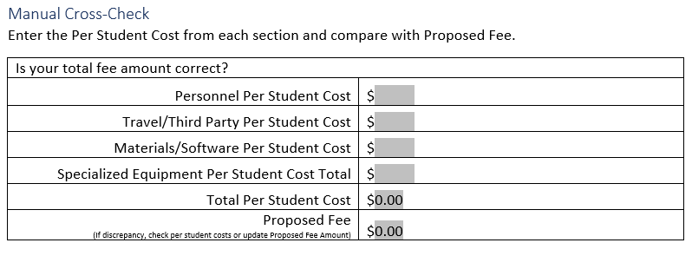  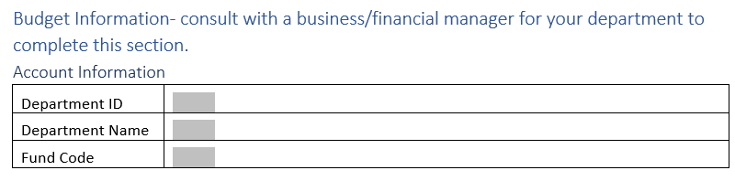  PAGE 10: DETAILS  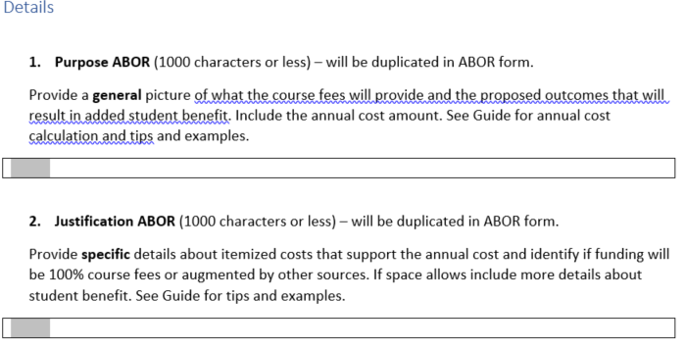  PAGE 11: DETAILS continued  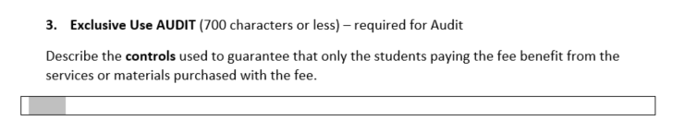  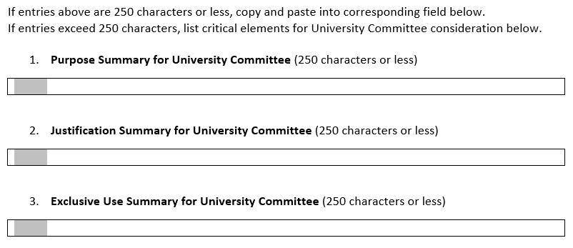 | Getting Started  This worksheet is designed to provide auditable documentation for a budget driven approach to course fee requests.  - Expense Inventory – a compete, detailed inventory of course fee expenses is the best starting place for organizing the necessary information to complete the worksheet. If your unit has local documentation, start with that. A blank expense inventory is available for aggregating information in one place or for starting an inventory for a new course fee request. How to make the most out of an expense inventory. Click any link to jump to more details.  Starting Resources at https://in.nau.edu/academic-affairs/program-course-fees/  - Master Course Fees List – provides current data for existing course fees. Filter for your existing course fees.  - Course Fee Enrollment – enrollment for all courses Summer 2019-Spring 2020.  How long will this take?  Workflow (approvals) for this worksheet are specific to each unit. First, consult with your Chair about the following  - Should you use electronic or print version? ELECTRONIC HIGHLY RECOMMENDED to take advantage of auto-calculations and drop-down menus.  - Who knows the required budget information?  - Who are the approvers in your department and how will their approval be obtained and documented?  - Who is the submitter- the one who receives final documentation to enter into Peoplesoft?  - Block time for completing the form, verifying information, consulting when applicable, and obtaining approvals.  Final checks  - Form complete.  - Manual cross-check correct.  - Computers and audiovisual confirmed as not covered by the Central IT Tech Fee.  - Approvals complete.  - Additional documents or documentation of approvals attached to worksheet  - Hand in worksheet and attachments to the submitter.  Cancelling a fee? Click here for special instructions  APPROVALS  Consult Check with your department chair for details concerning worksheet completion; appropriate approvals and how to obtain them; and who is the designated submitter.  - “Prepared By”- name the point person completing the form. Indicate start date.  - Chair and Dean Designee Approval- both are required. Approvals can be recorded by initials or attachment- must select one method. Date is the date of approval.  Approvals communicated in emails must be submitted with the final worksheet.  - Other Dept. Approval- only if required by the department; complete in the same fashion.  COURSE INFORMATION  - Course ID- this is not the same as a class number.  - Resource find course ID for an existing fee in the Master Course Fees List.  - Resource find course ID for a new fee in the academic catalog https://catalog.nau.edu/  - What if the course doesn’t appear in the search?  - What if there is no course ID number in the url?  - Do not enter course ID’s for Honors sections. Honors sections are automatically configured to mirror the fee on the primary course and do not require a form.  - Subject Catalog # is the course prefix and number as it would appear in class search, e.g., PSY 101, CHM360L, FRE495C. Include letter suffixes for labs, capstones, etc. where applicable.  - Topic Title- fees on a topics course can vary by title. Topic: Title A can have a different fee than Topic: Title B. Always include the title if the fee will be specific to the title. If every title in the topics course will have the same fee, then a title is not necessary.  *Each cross-listed or co-convened course must have its own course fee audit worksheet. Click here for more about combined courses.  ENROLLMENT INFORMATION  Source use the Course Fee Enrollment data at https://in.nau.edu/academic-affairs/program-course-fees/  Consult Coursefees@nau.edu if there are questions about estimated enrollment.  - Est. Annual Enrollment – enter the enrollment from the Course Fee Enrollment report.  - Honors section enrollment is listed separately and will have to be manually added to the course enrollment.  - Estimated enrollment is a tool for calculating an appropriate fee. Actual revenue is always determined by the number of enrolled students who paid the fees.  - Enrollment Data from CF Enrollment Report- Select Yes or No . Choose ‘No’ if you are not using the enrollment numbers from the report. For example, a new course without any prior enrollment will not appear on the report, so an enrollment number would be guesstimated based on other information or data.  - If you do not use the CF Enrollment Report data, explain how enrollment was calculated. A new course might be calculated from enrollment in similar courses. An increase might be derived from confirmed program admission data.  FEE INFORMATION  - Effective Term- defaults to the first upcoming Fall term regardless of course offering.  - Consult Coursefees@nau.edu if you think a change to Effective Term is necessary.  - Fee Type- defaults to Flat Fee.  - Consult Coursefees@nau.edu if considering a per unit fee.  - Current Fee Amount  - Source use Master Course Fees List for existing fee amount. https://in.nau.edu/academic-affairs/program-course-fees/  - For a new fee request, enter “0”.  - Proposed Fee Amount  - Will fee be the same amount? Re-enter the current fee amount.  - Will fee amount change or is it a new fee? Enter the proposed fee amount.  - Is this a cancellation? Enter ‘0’.  FEE INFORMATION continued  - Request Types- choose one.  - New: a course fee does not exist for this configuration. Requires ABOR approval.  - Some courses have more than one course fee. See course fee variables.  - Edit-Increase: any increase in the fee amount of an existing fee. Requires ABOR approval.  - Edit-Decrease: any decrease in the fee amount of an existing fee. Included in ABOR report.  - Edit-Same: the fee amount remains unchanged but other elements are changed.  - Other elements may be edited, e.g., campus, budget information.  - Use for initial input into the new system where there are no perceived changes from the existing course fees.  - Use for sunset reviews when course fees expire and must be resubmitted.  - Cancellation: requires only specific information on pages 1 and 2 of the worksheet.  - Reasons- Go to reason matching request type; select one reason from drop down  menu See List for further explanations.  - New Fee Reason- choose one; will be reviewed by the University Committee.  - Fee Increase Reason- choose one; will be reviewed by the University Committee.  - Fee Decrease Reason- choose one; will be included in the ABOR report.  - Edit-Same Reason- identifies changes other than fee amount. If no changes, then select “Initial Input”; will be included in ABOR report.  - Cancellation Reason- choose one; will be included in the ABOR report.  - Campuses- Click each campus whose students will pay the fee.  - If the course fee is different for different campuses (i.e., $10 for Flagstaff; $5 for Online), create separate course fee requests. See course fee variables.  - Yuma- check the following for any course fee used at Yuma.  - Is Yuma the only campus? If yes, no action required.  - Is Yuma selected with another campus and does the Dept ID in Account Information start with a 7? If yes, no action required.  - Is Yuma selected with another campus and does the Dept ID in Account Information start with a number other than 7? Consult Coursefees@nau.edu for clarification and potential additional documentation.  COST BREAKDOWN  Expense Categories  Personnel  Consult with the department accounting specialist. A detailed list of all expenses for the course fee will be required to complete the worksheet.  Use annual figures- descriptions and dollar amounts should reflect an entire academic year.  See typical expenses and additional guidelines.  Specified Guest Instructors may only be used to address a curriculum requirement that the assigned instructor cannot provide. For example, third-party certifications.  - Description- provide enough detail that an auditor can find the expense in accounting records.  - Identify the role/title of the individuals, e.g., student worker, lab aide. Include per term details, if space allows.  - If more than 5 entries, group like items under a sub-category. See how to use expense inventory to create and document sub-categories for audit.  - Total- this figure should equal the cost for an academic year.  - Subtotal- this field will auto-calculate [sum of entered Totals].  - Per Student Cost- this field will auto-calculate [Subtotal/course enrollment].  - This field will not work if Est. Annual Enrollment is empty or ‘0’ on page 1 or worksheet.  - Check box- must be checked. Department assumes responsibility for  - Paying all costs by the end of the academic year per policy CMP 401-11.  - No accruals.  - Excessive balances may flag a course fee for review.  - Exclusive use of the services for the students who paid the fee.  - Consult Kristi.Markey@nau.edu in the Comptroller’s Office for documenting use of personnel outside of the course.  - Not funding prohibited personnel expenses.  COST BREAKDOWN  Expense Categories continued  Travel/Third Party [includes Trips, Entry Fees, Rentals]  Consult with the department accounting specialist. A detailed list of all expenses for the course fee will be required to complete the worksheet.  Use annual figures- descriptions and dollar amounts should reflect an entire academic year. See typical expenses and additional guidelines.  - Description- provide enough detail that an auditor can find the expense in accounting records.  - Identify the expense. Include per term details, if space allows.  - If more than 5 entries, group like items under a sub-category. See how to use expense inventory to create and document sub-categories for audit.  - Total- this figure should equal the cost for an academic year.  - Subtotal- this field will auto-calculate [sum of entered Totals].  - Per Student Cost- this field will auto-calculate [Subtotal/course enrollment].  - This field will not work if Est. Annual Enrollment is empty or ‘0’ on page 1 of worksheet.  - Check box- must be checked. Department assumes responsibility for  - Paying all costs by the end of the academic year per policy CMP 401-11.  - No accruals.  - Excessive balances may flag a course fee for review  - Exclusive use of the services for the students who paid the fee.  - Consult Kristi.Markey@nau.edu in the Comptroller’s Office for documenting incidents of use of services outside of the course.  - Not funding prohibited travel/third party expenses.  COST BREAKDOWN  Expense Categories continued  Materials/Software [includes Lab/Studio Supplies, Online access]  Consult with the department accounting specialist. A detailed list of all expenses for the course fee will be required to complete the worksheet.  Use annual figures- descriptions and dollar amounts should reflect an entire academic year. See typical expenses and additional guidelines.  - Description- provide enough detail that an auditor can find the expense in accounting records.  - Identify the expense. Include per term details, if space allows.  - If more than 5 entries, group like items under a sub-category. See how to use expense inventory to create and document sub-categories for audit.  - Total- this figure should equal the cost for an academic year.  - Subtotal- this field will auto-calculate [sum of entered Totals].  - Per Student Cost- this field will auto-calculate [Subtotal/course enrollment].  - This field will not work if Est. Annual Enrollment is empty or ‘0’ on page 1 of worksheet.  - Check box- must be checked. Department assumes responsibility for  - Paying all costs by the end of the academic year per policy CMP 401-11.  - No accruals.  - Excessive balances may flag a course fee for review  - Exclusive use of the materials for the students who paid the fee.  Consult Kristi.Markey@nau.edu in the Comptroller’s Office for documenting incidents of use of materials outside of the course.  - Not funding prohibited material/software expenses.  COST BREAKDOWN  Accrual Category  Specialized Equipment  Consult with the department accounting specialist. A detailed list of all expenses for the course fee will be required to complete the worksheet.  Resource Additional Accrual Descriptions page found at https://in.nau.edu/academic-affairs/program-course-fees/  Resource Shared Accruals (expense shared across multiple courses) page found at https://in.nau.edu/academic-affairs/program-course-fees/  Course fee accruals must benefit the students paying the fee. See considerations for purchasing new equipment.  See typical accruals and additional guidelines.  - Description- provide enough detail that an auditor can find the expense in accounting records.  - Identify the specialized equipment; include property number if available.  - If similar items have different costs per unit, for example, microscope A costs $500 and microscope B costs $800, create separate entries.  - Computers or A/V- check if the equipment is computer (laptops, tablets included) or AV equipment.  Consult with ITS Kegan.Remington@nau.edu to confirm that specialized equipment is not covered by the IT Central Tech Fee. Course fees cannot be used for IT Central Tech Fee responsibilities.  - Number of units- enter total number of units required for the course(s).  - Cost per Unit- list the current cost of equipment including all taxes and any extra fees for delivery or installation. Capture total cost per unit so funding does not come up short.  - Total Amount- this field will auto-calculate [# of units x cost per unit]  COST BREAKDOWN  Accrual Category continued  - Expense Date- enter the fiscal year the next purchase will be made. Fiscal year is July 1-June 30.  - Useful Life in years- the number of years the equipment typically lasts before requiring replacement.  - Per Student Cost- this field will auto-calculate [(total amount/useful life)/enrollment)].  - This field will not work if Est. Annual Enrollment is empty or ‘0’ on page 1 of worksheet.  - Use this field when adding up the total for Accrual Per Student Cost.  - Primary Room- enter building and room information identifying where the equipment can  be found.  Consult with Submitter about the format of the primary room information.  - Specialized Equipment Per Student Cost- manually add the per student cost from each accrual entry. This field does not auto-calculate.  - Include per student costs from Additional Accrual Descriptions in the calculation and attach the additional accrual information to the worksheet for submission.  - Include per student costs from Shared Accruals in the calculation an attach the shared accrual information to the worksheet for submission.  - Check box- must be checked. Department assumes responsibility for  - Confirming multi-year use that requires accrual.  - Exclusive use of the materials for the students who paid the fee.  Consult Kristi.Markey@nau.edu in the Comptroller’s Office for documenting incidents  of use of equipment outside of the course.  - Not funding prohibited accruals.  Manual Cross-Check  The purpose of the cross-check is to confirm the originally proposed fee matches the total amount of the per student costs across each expense.  - Personnel Per Student Cost- enter amount from page 3 of worksheet.  - Travel/Third Party Per Student Cost- enter amount from page 4 of worksheet.  - Materials/Software Per Student Cost- enter amount from page 5 of worksheet.  - Specialized Equipment Per Student Cost Total- enter amount from page 7 of worksheet.  - Don’t forget Description 1 on page 6 of worksheet in this total.  - Include additional description accrual or shared expense page(s) in this total.  - Total Per Student Cost- this field will auto-calculate [sum lines 1 through 4].  - Proposed Fee- this field mirrors the amount of the proposed fee entered on page 1 or worksheet.  Line 5 and Line 6 must match.  - If line 5 and 6 do not match, confirm entries on lines 1-4 are correct.  - If lines 1-4 are correct, check accuracy of all per student costs on pages 4-8.  - If there are no corrections to Per Student Cost, update the Proposed Fee on page 1 to match line 5.  If updating the Proposed Fee Amount on page, check for other updates.  - Does the request type need to change?  - If request type changes, also update the Reason.  Budget Information  Consult with the department accounting specialist to complete this section.  Account Information  - Department ID- a 7 digit number.  - Department Name- accounting identifier unique to each department.  - Fund Code- a 4 digit number.  Details  - Purpose ABOR- 1000 characters (~150 words) to provide an overview of what will be provided, the outcomes, and the student benefit. Identify the anticipated annual cost (multiply the annual enrollment by the proposed fee amount for the annual cost).  Eight thousand dollars funds five expenses proven to improve overall student performance in the class and in the field. First, classroom support and experiment manipulatives increase engagement in classroom sessions via hands on experiential learning and have reduced the DFW rate for the course. Next, field trips deepen understanding of critical principles in (the class discipline) covered in XYZ certification resulting in improved scores. Also, guaranteed online access to the XYZ certification has improved completion rates necessary for accreditation. Finally, exposure to industry-standard technology in the classroom improves students’ general marketability in the field. This entry is 93 words/676 characters  - Justification ABOR- 1000 characters (~150 words) to provide specific expenditure details justifying the annual cost and the percentage course fees will provide for necessary funding. If room allows include more student benefit details.  Course fees fund 100%. 1. Three thousand dollars funds three in-class peer mentors each term. Peer mentors support primary instruction. Examples of activity include augmenting weekly group sessions and conducting exam reviews. The DFW rate has dropped 25% since starting the peer mentor program. 2. One thousand dollars funds materials like example a, example b for in-class experiments. 3. Two thousand dollars covers trip field trip expenses each term (e.g., transport and entry) where students work through field experiences related to XYZ certification with discipline experts. Average certification scores have improved 10% since the field trip was initiated. 4. One thousand dollars funds the online XYZ certification, ensuring that each student completes the course with this professional requirement. 5. And one thousand dollars maintains tablets using industry standard software deemed a minimum requirement for employment in the field. This entry is 138 words/952 characters  Tips  - Highlight text as you draft to confirm inclusion of critical elements.  - Use a numbering format instead of paragraphs. Spaces eat up character count.  - Consider ABOR and audit as an ‘outside’ audience- use general descriptors versus discipline specific language or acronyms.  - Write in flexibility for potential changes in categories. Note the broad descriptions in the purpose and use of ‘examples’ in the justification that leave room for additions or changes in a category.  Details continued  - Exclusive Use AUDIT- 700 characters (~100 words). Assume details from the ABOR purpose and justification are known when explaining the controls used to assure only students paying the fee benefit from the services or materials purchased with the fee.  Enrollment in NAU 350 is required for students to receive assistance from the course peer mentors, attend the XYZ field trip, or access online XYZ certification. Course materials are stored in a locked cabinet and maintained for exclusive use of NAU 350 students. Tablets are a shared expense across multiple courses but are managed through inventory control for the exclusive use of students enrolled in NAU 350, 450, and 550.  This entry is 69 words/428 characters.  Summaries for University Committee members are truncated for inclusion in reports.  - Copy and paste if original description is 250 characters or less.  - If summarizing, start with bare bones, then flesh out details as character limit allows.  - Purpose Summary- 250 characters (~35 words). If summarizing, prioritize outcomes and student benefits from the full descriptions.  Bare bones: increased engagement via experiential learning, reduced DFW, better scores and completion of certification, industry standard technology. This entry is 16 words/138 characters.  Final: Increased engagement via hands on experiential learning, 25% reduced DFW rate, improved scores and completion rate for XYZ certification required by accreditation, and standard technology usage improving marketability. This entry is 28 words/218 characters.  - Purpose Justification- 250 characters (~35 words). If summarizing, prioritize specific expenditure details from the full description.  Bare bones: Peer mentors, experiment materials, field trip, XYZ certification access, tablets.  This entry is 10 words/82 characters.  Final: Six peer mentors, in-class experiment materials, XYZ field trip, access XYZ online certification, and class set of tablets with industry standard technology. This entry is 22 words/158 characters.  - Exclusive Use Summary- 250 characters (~35 words). If summarizing, prioritize controls.  Bare bones: Enrollment, locked storage, inventory controls. This entry is 5words/47 characters.  Final: Enrollment required for access to class peer mentors and the XYZ field trip. Materials kept in locked storage accessible to instructors. Tablets are managed through inventory control for the exclusive use of students enrolled in NAU 350, 450, and 550. This entry is 40 words/250 characters.

Appendix

Cancel a Fee Return to Guide – Cancelling a Fee click here Return to Guide – Fee Information click here
Complete the following sections on pages 1 and 2 for cancellations.
Enrollment Information is not necessary. No other pages necessary.

Approvals- all fields

Course Information- all applicable fields

Fee Information
- Proposed Fee Amount- enter 0
- Request Type- Cancellation
- Cancellation Reason- choose most appropriate

Campuses- all applicable

Combined Courses Return to Guide – Course Information click here
Cross-listed or co-convened courses require a course fee for each course involved in the combination to generate the appropriate revenue. If the combined courses are within your department, submit a course fee request for each course. If there are combined courses in another department, consult and coordinate with that department to assure all courses have appropriate fee requests.

It is not acceptable for any students enrolled in combined courses to be excluded from the course fee. It is assumed that everyone enrolled will benefit from the course fee funding, therefore all students must share in the costs.

Combined courses must be approved through curriculum. The Combined Courses List identifies all approved combinations and their type of combination: Cross-listed (CLST) or Co-convened (CNVN).

Course Fee Variables Return to Guide – Course Information click here Return to Guide – Fee Information click here
The following variables require separate course fees to ensure appropriate funding. Use the New request type if requesting a course fee for a new configuration.
- Different campuses have different fee amounts: Flagstaff is $10 and Online is $5.
- Different campuses have different purposes: Flagstaff is $10 for field trip; Online is $10 for software.
- Different titles in a topics course have different fee amounts: Topic 101 has a $5 fee; Topic 102 has a $10 fee. It’s also possible for some topic titles to have a fee while others do not.

Course ID

Course with existing fee- where to find the course ID Return to Guide – Course Information click here
The Course ID is unique and constant for the course. Do not confuse it with class numbers that are used to identify the available sections of a course each term. Do not look for a Course ID in the schedule of classes.

The Master Course Fees list includes Course ID information for all courses with an existing fee. It also contains all current details of a fee (campuses, amounts, uses) so the Master Course Fees list is the best reference for existing fees.
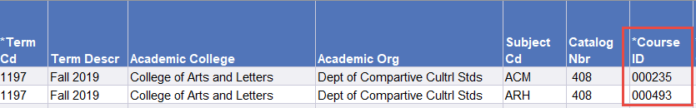
Appendix

Course without an existing fee- where to find the course ID Return to Guide – Course Information click here
There are two options for finding course ID information.
1. Use the RAW data tab in the Course Fee Enrollment Report.
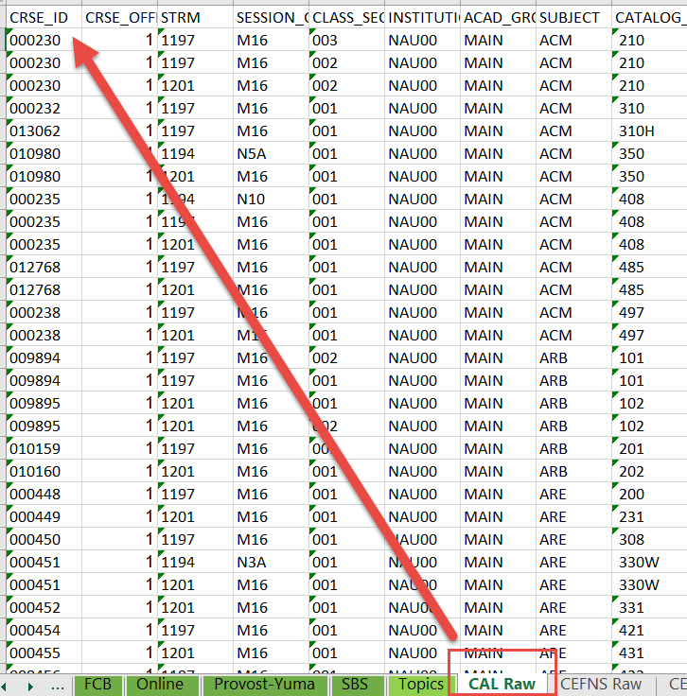
2. Use the Academic Catalog. 1.) Search for a course. 2.) In search results, click on the course title. 3.) On the course details page, find the Course ID in the url.
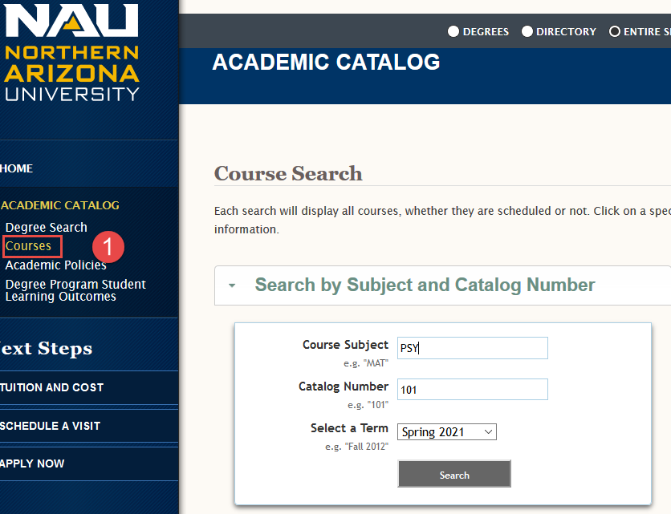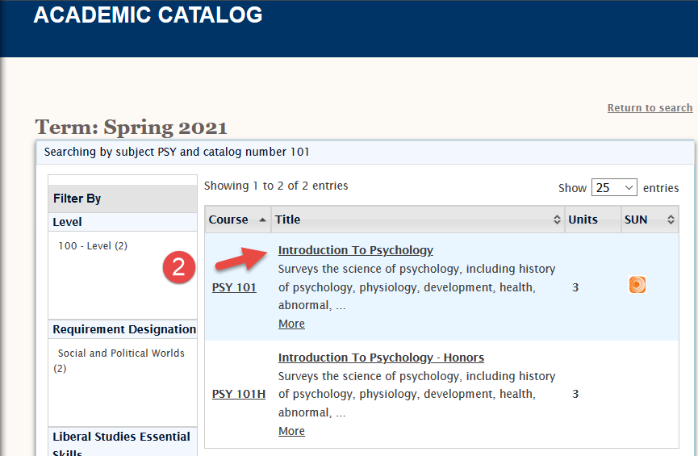
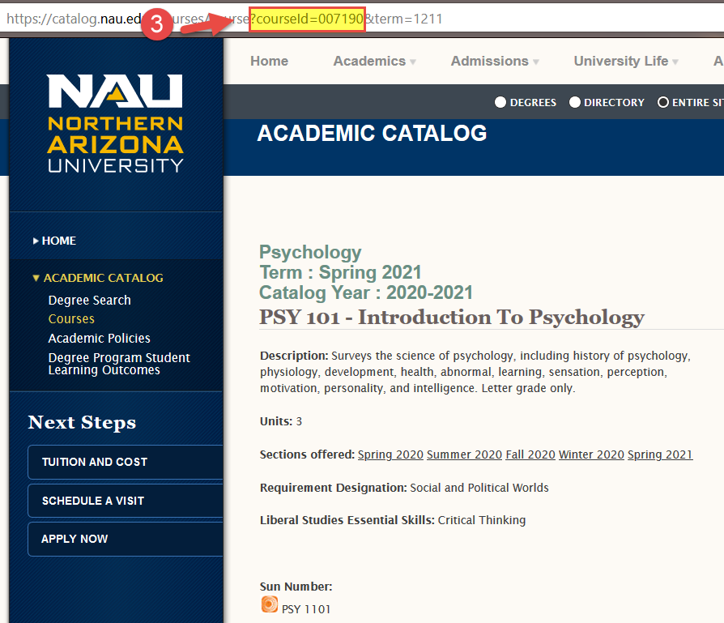 Return to Guide – Course Information click here
If the course doesn’t show up in the search, then it is not active in the catalog.
If you don’t see Course ID in the url, check that you are on the course details page.

Appendix

Enrollment Information Course Fee Enrollment Report Return to Guide – Enrollment Information Click here

When the course fee request is entered into Peoplesoft, the annual enrollment will be automatically calculated to add the enrollment from each campus indicated for the prior Summer, Fall, Winter, and Spring terms. The Course Fee Enrollment Report provides the same basic information but might require some additional manipulation depending on campuses and Honors.

Using the report
- Select the green tab for your college. Use Topics tab for enrollment by topic and topic titles.
- Use Row Labels to filter for the course prefix, e.g. ACC, BIO, EGR.
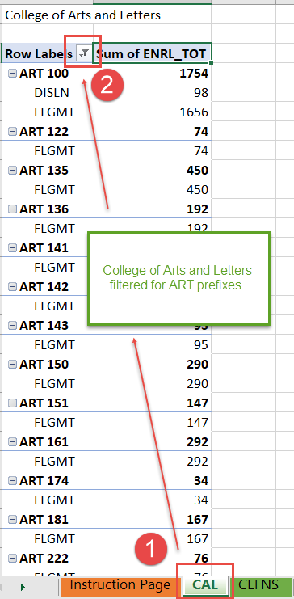
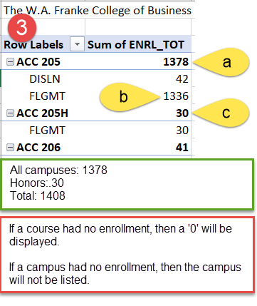
See Instruction Page for campus abbreviations.
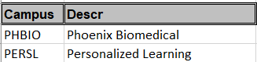

- Determine enrollment
  - Numbers in bold indicate total enrollment. In this example DISLN and FLGMT have been added together. If the course fee applies to both campuses, then enrollment is 1378.
  - If the course fee is only for FLGMT, then use the campus breakdown numbers; the enrollment is 1336.
  - Honors enrollment is recorded separately on the report but will be included in the Peoplesoft calculation, so include it in the total on the worksheet. In the example for ACC 205, Honors enrollment of 30 is added to total enrollment of 1378 for a total enrollment of 1408. Students Honors section are charged the same fee as students in the main course.

Exclusive Use and Controls Return to Guide - Details Click here
Exclusive use refers to the requirement that course fees benefit only the students paying the fee. Conversely, students who did not pay the fee should not benefit from expenses paid by other students. For example, a cart with a classroom set of tablets maintained by course fees paid by students in Course A, B, and C may not be used in Course D (a class without a course fee).
Controls ensure that services and materials funded by course fees are regulated for the exclusive use by students who paid the course fees. Using the example of the cart and tablets, controls could be the instructors of Course A, B, and C are the only personnel with keys to unlock the cart or that the cart is kept in locked storage and controlled through approved check out.
Appendix

Types of Controls Return to Guide - Details Click here
- Enrollment in a course- only those students enrolled in the course have access to the service or materials
- Accounting- documentation that personnel are paid appropriately from course fees. A lab aide assists in two classes with a course fee and one without a course fee. The accounting control ensures that only 2/3 of the lab aide’s salary is paid from course fee funds.
- Locked storage or inventory control- documentation of how materials are only available to instructors of eligible course(s).
- Classroom- only classes paying the course fee are scheduled in the classroom where the materials or services are provided.

Expense Inventory Return to Guide Getting Started – click here Return to Guide - Cost Breakdown – click here
Check with your accounting specialist for existing documentation and how best to document course fee expenses. This documentation will not be submitted, but the information is critical for:
- Identifying the most accurate costs of the course and the most accurate course fee for the students.
- Creating consolidation categories for courses with a long list of expenses- necessary if a course fee category (Personnel, Travel, Materials) has more than 5 expenses.
- Connecting the audit trail between the course fee worksheet information and the department accounting.
- Documenting the logic and history for anyone reviewing or working with the course fee in the future.
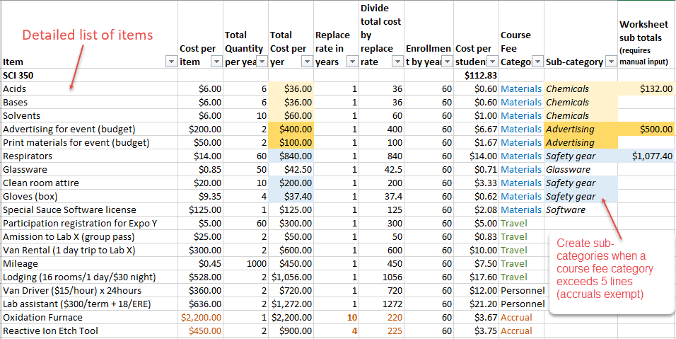

Whether or not you use this expense inventory, be certain to document the following:
- A detailed list of all items/services the course fee will pay fund.
- How much an item costs (include secondary costs: ERE for eligible personnel; taxes; other applicable fees); quantity necessary in a year; and total expense for the item in a year.
- The replace rate (useful life) in years. An expense with a rate of 2 or more years should be categorized as accrual.
- Each items cost per student based on annual enrollment and the cost per replace rate.
Appendix

How to create sub-categories
A sub-category is only used when the expense category entries for Personnel, Travel, and Materials are more than 5.
First, identify items that group together and create a sub-category name. In the highlighted example, acids, bases and solvents group naturally as Chemicals. Use sub-category names that will make sense to others outside of your department. Next, add together all the total cost per year for the items in the new sub-category. In the example, the cost per student for the sub-category Chemicals is $132. On the worksheet, the description will be Chemicals and the Total will be $132. The entire entry for Materials would look like:

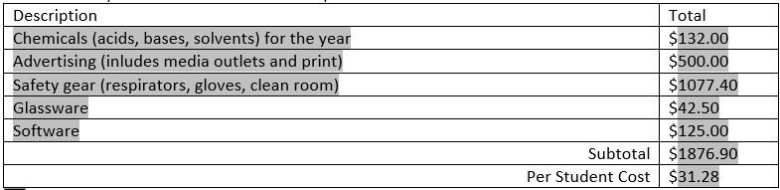
Return to Guide Getting Started – click here Return to Guide - Cost Breakdown – click here

New specialized equipment purchase and accruals Return to Guide – Accrual click here
Fees can maintain equipment and course fees can be accrued to replace equipment because the students paying the fee are benefiting from the existing equipment in the course. However, a course fee accrual cannot be created for the purchase of new equipment. For example, students in Course A in 2020 cannot be charged a fee that will be accrued to purchase new equipment in 2023 because the currently enrolled students would not benefit. NAU administration requires the use of other funding (such as grants) to purchase equipment necessary in these situations. Once the equipment is purchased, course fees can be used to maintain and replace going forward.

Reasons for Requests Return to Guide – Fee Information click here

New Fee Reasons
- What does “required for curriculum delivery” mean? The course fees would fund services, materials, or equipment necessary to fulfill curriculum requirements: a lab course needs experimental equipment to complete the curriculum requirements.
- What does “enhanced student experience” mean? The course fees would fund services, materials, or equipment that would add to and benefit the student experience but are not necessary to fulfill curriculum requirements: a field trip would be more interactive and engaging, but it is not a requirement of the course like field work.
- What if items are a mix of requirements and enhancements? Select the appropriate ‘required’ descriptor.
New course: required for curriculum delivery. For a newly approved course requiring funding to support requirements of the curriculum.
Existing course: required for curriculum delivery. For an existing course that now requires course fees to support requirements of the curriculum. This would likely be the result of a recent curriculum change or some other change that could justify why course fees weren’t required in the past.
Other funding lost: required for curriculum delivery. For an existing course that lost a source which historically supported requirements of the curriculum. The curriculum requirements have not changed and course fees are deemed a viable replacement for funding.
Appendix
Correction: fee cancelled or omitted in error. For instances where a course fee was erroneously cancelled in the past or a fee was not requested when other courses with the same requirements were put forth for course fees.
New course: enhanced student experience. For a newly approved course requesting funding to support enhancements to the student experience.
Existing course: enhanced student experience. For an existing course requesting funding to support enhancements to the student experience.
Other funding lost: enhanced student experience. For an existing course that lost a source which historically supported enhancements to the student experience.
Multiple campuses: differs from other fee(s). For a new configuration of an existing course fee. For example, a $10 fee exists for Flagstaff Mountain campus funding a field trip and necessary software; now an online version of the course is starting and will require a $5 fee because these students do not participate in a field trip. Each campus will have its own version of the fee. *If these were submitted simultaneously as new requests, then the reason would be selected from the other options for new or existing courses.

Increase Reasons
Existing expenses increased. When there are no changes to the services, materials, or equipment other than an increase of the cost of one or more of these items.
New expenses added. When additional services, materials, or equipment are being proposed.
Both: new and increased expenses. For any combination of new and increased expenses.

Decrease Reasons
Expenses decreased. When there are no changes to the services, materials, or equipment other than a decrease in the cost of one or more of these items.
Expenses eliminated. When existing services, materials, or equipment will no longer be used or need course fee funding.
Both: expenses decreased and eliminated. For any combination of decreased or eliminated expenses.

Edit-Same Reasons
Initial input: no change to existing fee. For the purpose of migrating into the new system when the following elements of the existing fee will not change: amount, campus, or purpose/use.
Change campus. When the only change to the fee is the addition or deletion of a campus(es).
Change purpose/use. When the only change to the fee is in the services, materials, or equipment. *Likely rare, since most changes to items result in changes to the amount of the fee.

Cancellation Reasons
Expense(s) eliminated. All services, materials, or equipment will no longer be used in the course.
Program Fee established. Program fee funding will replace course fee funding for services, materials, or equipment.
Other funding established. Other funding will replace course fee funding for services, materials, or equipment.

Return to Guide – Fee Information click here
Appendix

Typical Expenses and Additional Guidelines
These lists are for reference of examples; they are not exclusive.

Accruals- Specialized Equipment To return to Guide – Accruals click here
Technically, course fees are not allowed to carry balances because the fees are to provide benefit to the student in the term the student paid the fee. However, intentional accrual is allowed for the maintenance, repair, and replacement of specialized equipment with multi-year life spans. The specialized equipment is available for student use in the term the student is paying the fee.
Accrual for specialized equipment requires the set up of an accrual sub-department. Consult and coordinate with your accounting specialist to confirm the proper accounting is in place.
Generally, specialized equipment
- Is a necessity for curriculum requirements.
- Should be tracked in inventory control.
- If computers or audio equipment, items must not be eligible for funding with the Central IT Tech Fee.

Accrual Examples
Computers, tablets, ipads: | Not eligible for Central IT Tech Fee
Specialized furniture: | Required for instruction: dental hygiene chairs, tents,
Tools: | Welding equipment, media production equipment
Discipline technology/lab equipment: | Microscopes, kilns, 3D printers, CAD, cameras, treadmills,
Models and samples: | Must have multi-year life spans: casts of fossils,
Multi-year licenses: | Software or online access lasting 2 years or more

Materials/Software Additional Guidelines Return to Guide – Materials/Software click here
Generally, materials purchases match one of the following:
- Can be purchased in bulk or commercially for significant cost savings to the students.
- Assure necessary standardization and conform to certain specifications necessary for the curriculum.
- Are of a specialized nature not readily available for student purchase.
And cover needs such as:
- Assessment materials.
- Lab/Studio materials and tools.
- Materials for production of student work or student performances.
- Materials essential to instruction in the course objectives.
- Online access to materials necessary for the course.
- Specialized software necessary for the course and not provided by university software licensing.
Qualifying food expenses Food items used in labs or for curriculum requiring food preparation; food for field trips/fieldwork in remote areas where food is not readily available.

Appendix
Printing/copies Confirm Jacks Print and NAU Printing Services (for Course Packs) cannot provide the print needs. Items printed/copied must provide cost savings to the students and cannot violate copyright laws.

Materials Examples
Classroom Manipulatives | Memory cards/batteries | Chemicals
Maps | Online archives access
GPS units for fieldwork | Media for in class instruction
Microscope slides | Hand tools
Specimens and samples | Safety gear for labs/fieldwork
Classroom models | IncludEd textbooks/licenses
Cleaning supplies for labs/studios | Assistive technology tools

Personnel Return to Guide – Personnel – Click here
Personnel should directly benefit the students paying the fee.
Always include ERE where applicable.

Personnel Examples
In class support: | Lab aides, peer facilitators, GA/TA (not instructor of record), tech support
Temporary hire: | Models, mock patients, field trip drivers and cooks
Supervisory Instruction: | Clinical/practicum support; internship maintenance
Program coordination: | Lab coordinator, program support
Specified Guest Instructor: | Provides curriculum requirement that instructor cannot, e.g., certification

Travel/Third Party Return to Guide – Travel/Third Party click here
All travel expenses must comply with NAU travel policies.

Travel/Third Party Examples
Entry fees
Transportation | Rental, gas, mileage
Lodging
Facilities rental/use fees

