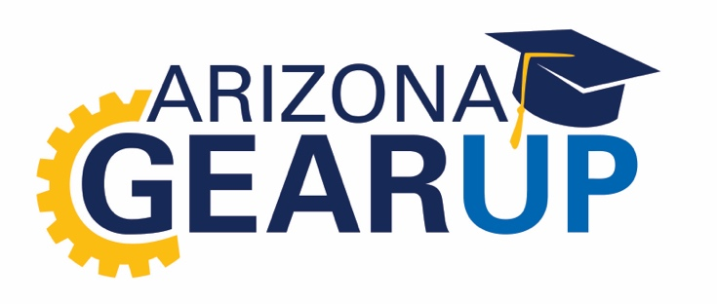

Gov. Doug Ducey proclaims Sept. 21-25 Arizona GEAR UP Week

Arizona Gov. Doug Ducey issued a proclamation announcing Sept. 21-25 as GEAR UP Week, honoring commemorates the continuing success of Gaining Early Awareness and Readiness for Undergraduate Programs (GEAR UP), a national program intended to help increase high school graduation rates and college attainment for students in low-income communities.

The proclamation coincides with the celebration of National GEAR UP Week. GEAR UP is a federally funded program that aims to foster partnerships and collaborations between NAU, high-poverty high schools and organizations throughout the state that are committed to enhancing education in Arizona. GEAR UP provides college awareness and readiness to students beginning in seventh grade and continuing through high school and into the first year of college.

Northern Arizona University has led the Arizona GEAR UP program since 2000. The project has helped increase high school graduation rates, helped create a college-going culture and increased the college-going rate among Arizona students. More than 15,000 students have benefited from Arizona GEAR UP in the past two decades.

“NAU’s successful track record in leading GEAR UP in the state, which spans 20 years, stands as one of the many ways NAU contributes to addressing the critical issues of our state,” said NAU President Rita Cheng. “I am pleased at the collaboration among NAU and with our sister institutions as we all work toward our shared goals of a thriving economy, an educated citizenry and a robust workforce.”

Current grant goals include:

- Increase academic performance and postsecondary preparation.
- Increase high school graduation and postsecondary enrollment rates
- Increase educational expectations for students and increase knowledge of postsecondary options for students and their families.

In addition to $32 million in funding from the U.S. Department of Education, Arizona GEAR UP receives a dollar-for-dollar match in services and resources from local and state partners. These partnerships leverage resources, build capacity and support grant priorities to help level the playing field in college access and attainment.

