Sample 9 - Student Prep Information for teachers
Preparing your students for the College and Career Fair on MM/DD/YY
Teachers: Thank you for your support of our college and career fair this year. Please use the information in this document, along with the student handouts provided, to prepare your students for the fair. Your work will help ensure the experience is meaningful for your students and that the fair has its intended impact. If you have access to a projector, consider showing a few pictures of a College and Career Fair for students to have a visual while you are presenting. Pictures from the 20XX-20XX College and Career Fair can be found here (insert link of dropbox folder/google drive/social media page where your school has posted college and career fair pictures from past years).
Please cover this information with your XX period class 1-2 days before the College and Career Fair. After the fair, there are debriefing notes that we also ask you to facilitate in your class. See Debriefing Notes for more details.
Objective: Students will understand the logistics and benefits of the upcoming college and career fair, the expected fair etiquette, and will prepare ahead of time in order to best utilize their time during the event.
Facilitate a discussion with each of the questions below. You may read aloud the information in blue.
Handouts needed (attached) are:
- Bell Schedule
- Sample Questions
- Participation Card
- Preparing for the College and Career Fair student hand-out
- College and Career Fair diagram/map
Note for Coordinators: Provide sufficient handouts for all the students in each teacher’s class.
What is the purpose of the College & Career Fair?
On date, XHS and GEAR UP will be hosting a College and Career Fair in the location. Our class will be attending this event during X period. The purpose for this fair is to provide you with an opportunity to talk with representatives from a variety of careers about their jobs, and the education and training needed to get into that field. This fair will also have college representatives that you can meet, and ask questions, especially those questions that cannot be answered simply by online resources.
What does a College & Career Fair look like?
College and Career Fairs typically have several tables or booths in which college representatives and career representatives display handouts, pictures, and visuals about their school or business / organization. Students can walk around to each table and talk to the representatives to learn more about a specific career or institution. Some booths have handouts and free giveaways.
Attending this fair is an opportunity to learn about career options and to find out the steps you can take to be competitive for positions that interest you. You’ll be able to learn about the education needed for specific careers then talk to college representatives to see which colleges offer the program of study needed for the careers that interest you.
During the fair, you will have the opportunity to talk with both career representatives and college representatives all in the same location. The time will go by very fast. It is, therefore, important for you to prepare so that you prioritize your time with the careers that most interest you, and so that you make the most of your conversations with the representatives.
You have probably already covered some of the information we will cover today with your counselor or GEAR UP Coordinator, but let’s review to make sure you remember!

What types of postsecondary schools will be represented at the fair?
Community college – a public postsecondary institution that offers courses to residents in the surrounding area. Students may attend community colleges to obtain associate’s degrees or technical certificates, or may take courses there towards a bachelor’s degree, before transferring to a four-year university. The community colleges that will be at the fair are: Fill in your participating community colleges here.
Four-year University – A postsecondary institution/ school that offers undergraduate (bachelor’s) degrees. Many four-year universities also offer graduate (master’s) degrees. The universities that will be at the fair are: Fill in your participating universities here.
Technical school – Private schools that provide training for skilled labor, such as welding and culinary arts. These programs generally take no more than two years to complete. The technical schools that will be at the fair are: Fill in your participating technical schools here.
College representatives may have contact cards for you to fill out, please remember to bring a writing utensil with you and to write legibly (use your legal name and appropriate email address).
Consider asking students to share examples of the types of schools they intend to talk with.

What types of careers will be represented at the fair?
There will be at least one representative from each of these career clusters:
1. Agriculture, Foods & Natural Resources | 7. Government & Public Administrations | 13. Manufacturing
2. Architecture & Construction | 8. Health Services | 14. Marketing Sales and Services
3. Arts, A/V Technology & Communications | 9. Hospitality and Tourism | 15.Transportation, Distribution & Logistics
4. Business Management & Administration | 10. Human Services | 16. Science, Technology, Engineering & Mathematics
5. Education & Training | 11. Information Technology
6. Finance | 12. Law, Public Safety, Corrections & Security

What to expect at the college and career fair (handouts needed – fair diagram/map)
Pass out the list of representatives and a fair diagram/map (attached). Give students time to look at the college and career fair participants and their location.
I am passing out a fair diagram/map that shows where each of the participating businesses and schools will be set up.
I encourage you to look at the fair map and prioritize which tables you would like to visit.

College and Career Fair Etiquette. (Consider reading the list below or asking for input from students).
- Standard school policies apply during the fair
- Ask representatives questions; the more you engage, the more you’ll learn at this event
- Listen attentively to the speakers, especially when you ask questions
- Feel free to take notes when needed
- When asking career representatives about salary information, ask the question sensitively, for example – how much does a veterinarian typically make in this area - versus - how much do you make. Some people are happy to share their salary, but others might feel this information is private
- Make good use of your time
- Some booths may have giveaways (like - candy, pens, stickers or brochures); take only one item per table, if available. If you do take flyers or brochures, do not throw them on the floor.
- Dress appropriately – include school-specific dress code. See example below.
How to dress:
Insert dress code. If your school has uniforms, this section may not be necessary. If not, we suggest students be encouraged to dress ‘nicely’ – as they might for church or a job interview. There is no need to go out and purchase new clothes, but students want to dress to impress. Who knows? – a job or college admission could come out of their interactions at this event.

Questions students can ask (handout needed- Sample questions)
As we shared before, in order to maximize what you get out of this opportunity, you will want to ask each representative questions.
I am passing out sample questions you can ask organization and college representatives at the fair.
Give students time to review the questions and/or draft their own and/or ask them to review the sample questions at home.

Participation Cards/Booklets – What are they, and how do you use them during the fair (Show students one sample Participation Card, hand them out to each student on the day of the Career Fair).
The Participation Cards are booklets in which you will keep track of the tables you have visited. As you go from table to table, selecting those that most interest you, you should fill in the Company or College name in the designated spot on the card/booklet. After talking to each representative and learning more about their career or college, ask the representative at the table to sign or stamp in the area marked “Representative”, then, before you move on to the next table, jot down a sentence or two summarizing what you learned during the conversation with that representative.
We encourage you to visit at least three career tables and three college tables, however, if you want to visit more of one type and less of the other type, that’s ok too. You can mark up the Participation Cards, as needed to accommodate this change.
Keep your Participation Booklets and bring them to class on XX day. We’ll have a discussion on what you learned the day after the fair, then I will collect them and turn in your participation booklets to GEAR UP because every student who met with at least six representatives will be entered into a drawing. After the drawing, your participation cards will be returned to you.

Event Logistics (handout needed – bell schedule)
Share copy of bell schedule with your students.
On date, after X period, please meet me here in this classroom. I will take attendance and pass out your student participation cards that you will bring with you to the fair so that you can have them signed/stamped by number representatives. I will escort you to the location and will be walking around during the fair in case you have any questions. All students that complete X signatures on their participation cards will be entered in a drawing for prizes! When the bell rings, you will need to report to your X period class. Don’t forget to bring your participation cards to class on XX date so that I can collect them and turn them in for the drawing.

Student Handout 1- Questions for students to consider in preparation for the College and Career Fair
Questions for College Representatives:
- What do students like most about your school?
- What is the biggest complaint from students?
- What kinds of students are happiest at your school?
- Where do students hang out on campus?
- Do students mostly live on or off campus?
- What financial aid programs does your college offer?
- What academic programs are the most popular at your college?
- Do admission officers make decisions solely on numbers and stats, or do extracurricular activities matter for admission to your school?
- How would you describe the academic pressure and workload at your school?
- What are the faculty like and how accessible are they outside of class?
- Is there job placement help for graduates?
- Are you able to give me the names of a few students that I can talk to about their experience at your school?
Add your questions
1.
2.
3.
Questions for career representatives
- Tell me about your career and how you got into the field?

- What does your typical workday look like and what type of equipment or tools do you use?

- How much money does someone in your field make?

- What was your educational path to your career?

- What high school courses were essential to your career?

- What type of certificate and or degree is needed for your career at this time?

- What does your company make/do?

- Does your company have any internships or job opportunities?

- What is the job outlook in your career field?

Add your questions
1.
2.
3.

Student Handout 2- Student Prep Information for Students
Preparing for the College and Career Fair on MM/DD/YY
On date, XHS and GEAR UP will be hosting a College and Career Fair in the location. Our class will be attending this event during X period.
What is the purpose of the College & Career Fair?
The purpose for this fair is to provide students with an opportunity to talk with representatives from a variety of careers about their jobs, and the education and training needed to get into that field. This fair will also have college representatives that students can meet, and ask questions, especially those questions that cannot be answered simply by online resources.
What does a College & Career Fair look like?
College and Career Fairs typically have several tables or booths at which college representatives and career representatives display handouts, pictures, and visuals about their school or business / organization. Participants walk around to each table and talk to the representatives to learn more about specific careers, businesses and schools.
During the fair, you will have the opportunity to talk with both career representatives and college representatives all in the same location. The time will go by very fast. It is, therefore, important for you to prepare so that you prioritize your time with the careers that most interest you, and so that you make the most of your conversations with the representatives.
What types of careers will be represented at the fair?
There will be at least one representative from each of these career clusters:
1. Agriculture, Foods & Natural Resources | 7. Government & Public Administrations | 13. Manufacturing
2. Architecture & Construction | 8. Health Services | 14. Marketing Sales and Services
3. Arts, A/V Technology & Communications | 9. Hospitality and Tourism | 15.Transportation, Distribution & Logistics
4. Business Management & Administration | 10. Human Services | 16. Science, Technology, Engineering & Mathematics
5. Education & Training | 11. Information Technology
6. Finance | 12. Law, Public Safety, Corrections & Security

What types of postsecondary schools will be represented at the fair?
Community college – a public postsecondary institution that offers courses to residents in the surrounding area. Students may attend community colleges to obtain associate’s degrees or technical certificates, or may take courses there towards a bachelor’s degree, before transferring to a four-year university.
Four-year University – A postsecondary institution/ school that offers undergraduate (bachelor’s) degrees. Many four-year universities also offer graduate (master’s) degrees.
Technical school – Private schools that provide training for skilled labor, such as welding and culinary arts. These programs generally take no more than two years to complete.
College representatives may have contact cards for students to fill out. Students should bring a writing utensil and write legibly (use your legal name and appropriate email address).

College and Career Fair Etiquette.
- Standard school policies apply during the fair
- Ask representatives questions; the more you engage, the more you’ll learn at this event
- Listen attentively to the speakers, especially when you ask questions
- Feel free to take notes when needed
- When asking career representatives about salary information, ask the question sensitively, for example – how much does a veterinarian typically make in this area - versus - how much do you make. Some people are happy to share their salary, but others might feel this information is private
- Make good use of your time
- Some booths may have giveaways (e.g., candy, pens, stickers or brochures); take only one item per table, if available. If you do take flyers or brochures, do not throw them on the floor.
- Dress appropriately – include school-specific dress code. See example below.

How to dress:
Insert dress code. If your school has uniforms, this section may not be necessary. If not, we suggest students be encouraged to dress ‘nicely’ – as they might for church or a job interview. There is no need to go out and purchase new clothes, but students want to dress to impress. Who knows? – a job or college admission could come out of their interactions at this event.

How to Engage with Representatives
See the sample questions handout for ideas. Feel free to create your own questions too!

Participation Cards/Booklets – What are they, and how do you use them during the fair
The Participation Cards are booklets in which students will keep track of the tables they have visited. As you go from table to table, selecting those that most interest you, you should fill in the company or college name in the designated spot on the card/booklet. After talking to each representative and learning more about their career or college, ask the representative at the table to sign or stamp in the area marked “Representative”, then, before you move on to the next table, jot down a sentence or two summarizing what you learned during the conversation with that representative.
We encourage you to visit at least three career tables and three college tables, however, if you want to visit more of one type and less of the other type, that’s okay too. You can mark up the Participation Cards, as needed to accommodate this change.
Keep your Participation Booklets and bring them to class on XX day. In class, you will have a discussion about what you learned at the fair, then Mr.MS XXX will collect them and turn in your participation booklets to GEAR UP because every student who met with at least six representatives will be entered into a drawing. After the drawing, your participation cards will be returned to you.

Event Logistics
On date, after X period, please meet at location. Mr.MS XXX will take attendance and pass out your student participation cards. Mr.MS XXX will escort you to the location and will be walking around during the fair in case you have any questions. All students that X signatures on their participation cards will be entered in a drawing for prizes! When the bell rings, you will report to your X period class. Don’t forget to bring your participation cards to class on XX date so that Mr.MS XXX can collect it and turn it in for the drawing.

Student Handout 3– Participation Card/Booklet
On the next page, you will find a Participation Book that could be printed for every student’s use during your College and Career Fair. On the following page, is an alternative “Passport” Design. For either version, simply fold the printed document in quarters to create a “booklet” style document.
If you have funds available, there are companies that print customized passport design booklets, which might encourage students to take the assignment more seriously and to keep their passport.

Consider soliciting donations from the businesses and colleges that participate, items that could be given out in a drawing of all students who completed the Participation Book.

- Teacher instructions for distribution, use and collection of passports are included in Sample 7.
- Student instructions for use of passports are included as a handout.

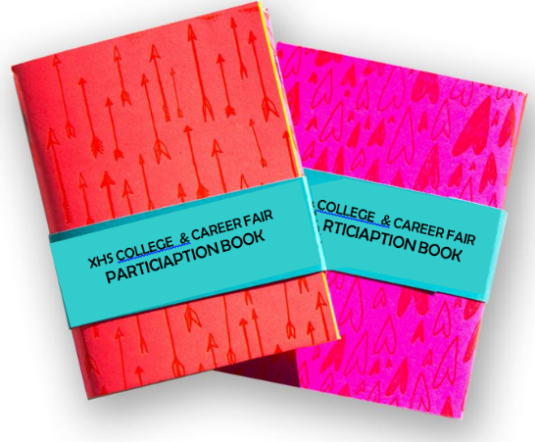

Name:  Date: | Career Stop #1  Company:  Representative:  What I learned: |  | College Stop #1  School:  Representative:  What I learned: | College Stop #2  School:  Representative:  What I learned:
Career Stop #2  Company:  Representative:  What I learned: | Career Stop #3  Company:  Representative:  What I learned: |  | College Stop #3  School:  Representative:  What I learned: | My Next Steps:  (Check all that apply)  - Visit a college (specify):  - Talk to my counselor about classes I need:  - Research other careers (specify):  - Other (specify):

Insert Logo Here

Name:  Date: | Career Stop #1  Company:  Representative:  What I learned: |  | College Stop # 1  School:  Representative:  What I learned: | College Stop # 2  School:  Representative:  What I learned:
Career Stop #2  Company:  Representative:  What I learned: | Career Stop #3  Company:  Representative:  What I learned: |  | College Stop # 3  School:  Representative:  What I learned: | My Next Steps:  (Check all that apply)  - Visit a college (specify):  - Talk to my counselor about classes I need:  - Research other careers (specify):  - Other (specify):
Student Handout 4
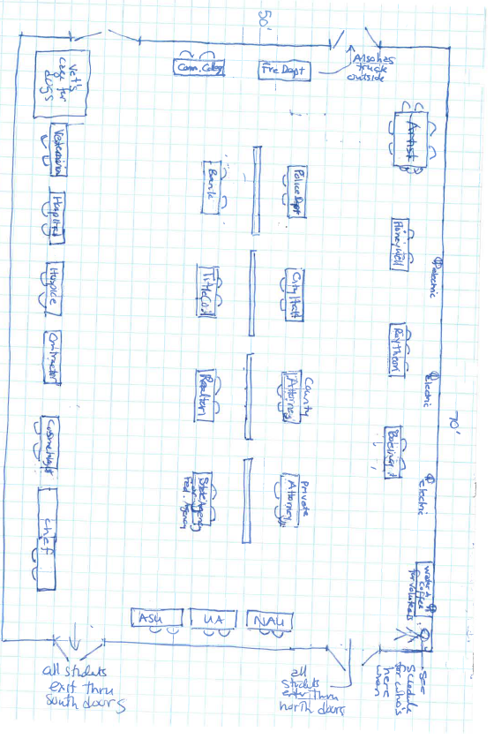

These questions are from the Princeton Review and can be found on their website along with other great tips at www.princetonreview.com/college-advice/college-fairs

