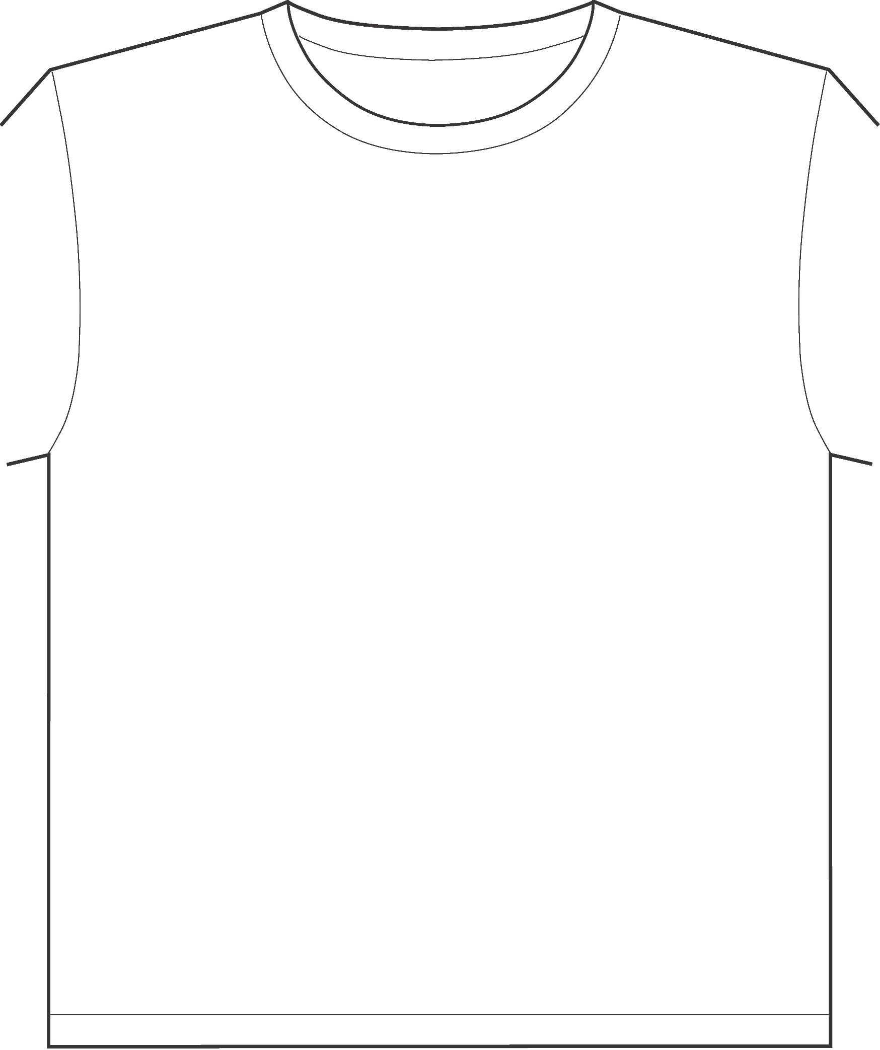
GUSLA 2017
T-SHIRT DESIGN CHALLENGE
DEADLINE TO ENTER
APRIL [insert date], 2017

