ARIZONA GEAR UP

15451 N. 28th Avenue Suite 216
Phoenix, AZ 85053

Phone: 602.776.4616
Fax: 602.776.4619

May 13, 2015

Dear ,

Thank you for your interest in the 2015 GUSLA Ambassador Student Program (GASP). We appreciate the time you spent on completing your application for the program. Since all students who attended the GEAR UP Summer Leadership Academy (GUSLA) last June were eligible to apply for GASP this year, it was a very competitive process to fill only 20 slots available for GASP students in June 2015. NAU GEAR UP received a large number of excellent GASP applications this year, making the decision process very difficult for our selection committee. Although you have many of the skills we believe are important to be a leader at your school, you were not one of those selected for GASP this year.

The good news is that you will be eligible to apply for GASP again next year. We encourage you to remain active in GEAR UP at your school next year, and to continue developing your leadership skills. Keep your GUSLA spark alive – and continue to be the awesome person you are!

Sincerely,

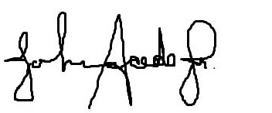
John “Tie Guy” Acedo GUSLA/GASP Program Director

