Flagstaff Family Food Bank - Kitchen

Tim Joyce, Programs/Facility's Manager/Volunteer Coordinator.
3805 E Huntington Dr.
Flagstaff, AZ 86004
Office (928) 526-2211
Cell (928) 380-3340

7:45am – Load bus in front of the University Union

8:00am – Arrive at Flagstaff Family Food Bank - Kitchen

9:45am – Load bus at Flagstaff Family Food Bank - Kitchen

10:00am – Arrive back at University Union. Go to your classroom for you Socratic Seminar

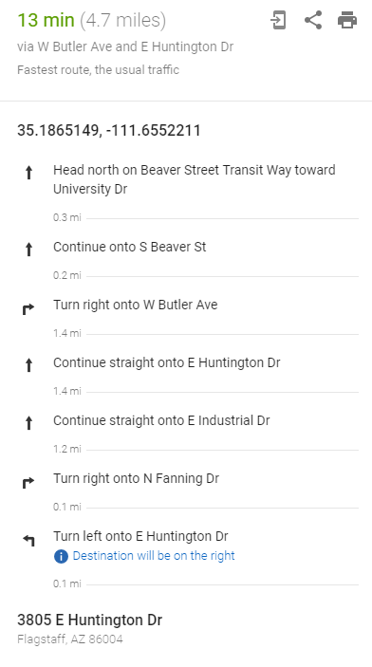

Flagstaff Family Food Bank - Warehouse

Monica Foos, Operations Manager
1903 N 2nd St.
Flagstaff, AZ 86004
Cell (928) 202-2075

7:45am – Load bus in front of the University Union

8:00am – Arrive at Flagstaff Family Food Bank - Warehouse

9:45am – Load bus at Flagstaff Family Food Bank - Warehouse

10:00am – Arrive back at University Union. Go to your classroom for you Socratic Seminar

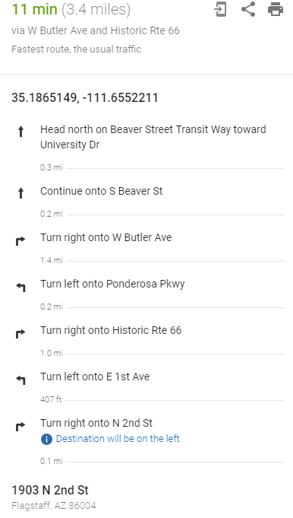

Riordan Ranch Mansion Clean Up

Jeff DeGraff, Groundskeeper
3805 E Huntington Dr.
Flagstaff, AZ 86004
Office (928) 526-2211
Cell (928) 380-3340

7:45am – Walk to Riordan Ranch Mansion

8:00am – Arrive at Riordan Ranch Mansion

9:45am – Walk back to COE

10:00am – Arrive back at COE. Go to your classroom for you Socratic Seminar

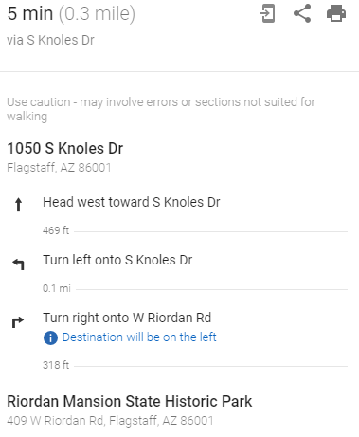

The Sunshine Rescue Mission

Carlos Nixon, Operations Manager
124 S San Francisco St.
Flagstaff, AZ 86001
Cell (928)221-8520

7:45am – Load bus in front of the University Union

8:00am – Arrive at The Sunshine Rescue Mission

9:45am – Load bus at The Sunshine Rescue Mission

10:00am – Arrive back at University Union. Go to your classroom for you Socratic Seminar, COE Room #216

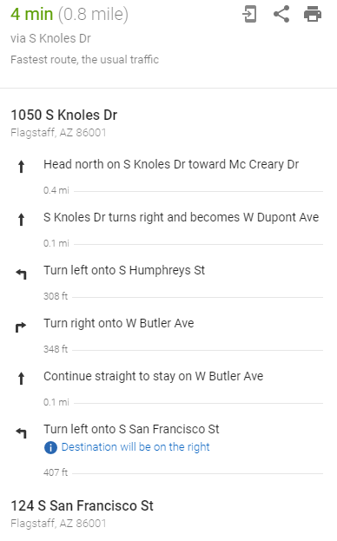

College of Education - Giving Back

Garrett Ellsworth, Program Coordinator
COE Front Entrance
Cell (928) 607-7717

7:45am – Walk to COE

8:00am – Arrive at COE Front Entrance

9:45am – Let the kids have a break

10:00am – You have your Socratic Seminar in COE Room #170

Kid Activity Kits

Tie Guy, GUSLA Director & all around AWESOME person!
COE Room #174
Cell (602) 505-0003

7:45am – Walk to COE

8:00am – Arrive at COE Room #174

The students will be putting together 150 Kid Activity Kits that will be donated to The Hope Cottage, Women & Children Shelter, in Flagstaff. The kit are for children who arrive at the shelter to have a welcoming gift during a hard time.

The Students will be stapling together coloring books, they can color the cover and sign the back with their first name and the city they are from. In addition, there are boxes of toys, toothpaste & other fun stuff that the students will fill in gallon-size ziplock bags to complete the Kid Activity Kits.

9:45am – Let the kids have a break and help clean up the service project

10:00am – You have your Socratic Seminar in this room, COE Room #174

Operation Holiday Cards

Mariah Acedo, CEO of the Acedo Family Household
COE Room #205
Cell (602) 810-1956

7:45am – Walk to COE

8:00am – Arrive at COE Room #205

Mariah will run this activity. Just support her and ask her how you can help.

9:45am – Let the kids have a break and help clean up the service project

10:00am – You have your Socratic Seminar in this room, COE Room #205

Flagstaff Montessori Switzer Mesa Campus

Rena Traslavina, 4th -6th Grade Teacher
Flagstaff Montessori Switzer Mesa Campus
850 N Locust Dr,, Flagstaff, AZ 86001

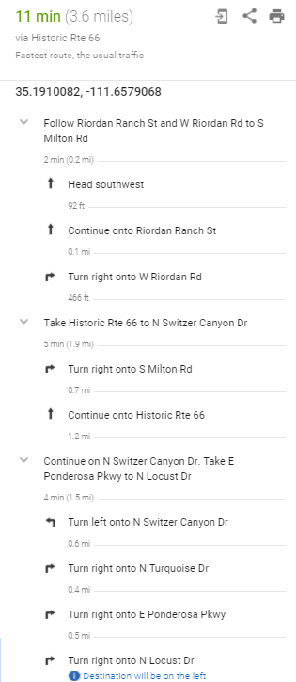

7:45am – Load bus in front of the University Union

8:00am – Arrive at Flagstaff Montessori Switzer Mesa Campus

9:45am – Load bus at Flagstaff Montessori Switzer Mesa Campus

10:00am – Arrive back at University Union. Go to your classroom for you Socratic Seminar, COE Room #211

Walnut Canyon

Steven Rossi,
Walnut Canyon
3 Walnut Canyon Rd, Flagstaff, AZ 86004

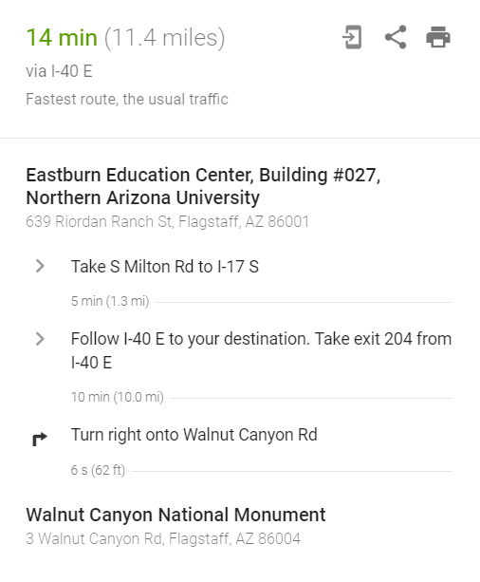

7:45am – Load bus in front of the University Union

8:30am – Arrive at Walnut Canyon

11:30am – Eat Lunch

2:00pm – Load bus at Walnut Canyon

2:45pm – Arrive back at University Union. Go to your classroom for you Socratic Seminar, COE Room #174

