Where’s my money???  You received a notice that you have a balance on your account, but you thought that the scholarships you were awarded would cover all of your tuition and fees.  Where would you go on campus to ask about your account and scholarships?  Scenario #1 | Scenario #1 – Facilitator cheat sheet  You are at the financial aid office  Say “welcome to financial aid, how can I help you?”  - Wait for student to explain problem  Hand the student the Student’s financial info.  -Wait for students to review and discuss as a group (prompt them to do so if they don’t check-in with their team members.)  Engage in conversation with student.  Answer questions as best as possible. You can create information, if needed.  Give the student these three options:  - You can take out a loan. Your Student Aid Report shows you could borrow up to $5,000.  - You can request a payment plan, and we can charge you the $900.00 over a period of three months.  - You can drop your classes.  There is no right or wrong answer – but provide these insights to the student based on the student’s response  - If you borrow, only borrow what you need. In this case do not borrow 5k, only $900.00. Go for subsidized loans, if available. Start paying as soon as you can. DO NOT EVER OVER BORROW  - This is a great option. With a job (work-study or not), or by applying to more scholarships, a three-month payment plan is realistic!!!  - DROPPING OUT OF COLLEGE IS NOT THE FIRST OPTION!! Explore your options, like going part-time, choosing an inexpensive meal plan, work part-time, etc.
Student’s financial info
Tuition | 11,000
Housing & Meals | 9,000
Student Fees | 400
Total | $20,400

Deans Award | 7,000
Pell Grant | 5,000
Next Step Scholarship | 6,000
Lefty Scholarship | 1,500
Balance | 900

Scenario #1

#worstroomateever  You and your roommate, Sam, met when you moved-in to the campus dorms. You got along well until…. Sam started playing video games all night, invited friends without asking, and does not respect your study time!!!  Who could help you figure out how to approach your roommate?  Scenario #3 | Scenario #3- Facilitator cheat sheet  You are the Resident Hall Assistant (RA).  Inform the student of the policies: there are no roommate changes (unless extenuating circumstance)  Ask student to review the roommate contract. Remind student the roommates signed that at the beginning of the semester at move-in.  - Wait for student to review contract, and ask if he/she has done Step 1  Encourage student to role play the conversation he/she would have at STEP 1 in contract.  Offer feedback, as applicable  Schedule an appointment with the student to follow up after he/she meets with roommate.  Scenario #3
ROOMATE CONTRACT
When there is a conflict, I agree to follow this process:
- Talk to my roommate about the issue
- If no solution is reached, then I will file a roommate incident report with the RA. Subsequently, I will participate in a mediation meeting with my RA and my roommate.
- If step 2 does not resolve the issue, I will file a roommate solution report with the Hall Director. The Hall Director will facilitate a meeting to resolve the issue. Further action will be decided at this meeting.

Whoops, I guess I ate a lot  During college orientation, you purchased the meal plan that allows you to eat about two meals per day at the dining hall. One month before the end of the semester, you realize you spent all your meal plan money.  Where do you go to see what your meal plan options are?  Scenario #5 | Scenario # 5 – Facilitator Cheat Sheet  You are in the meal plan office  After student describes the problem, present him/her with these three options:  - Increase your meal plan now for $1000 (this will give you 125 more meals - ‘flat rate’)  - Increase your meal plan now for $500 (this will give you 62 more meals – ‘flat rate’)  - Do not purchase a meal plan… so this means you’ll pay out of pocket every time you eat. Meals can range from $6.50-10.50 every time you eat.  Wait for student to respond  Help the student through the math…  There are 30 days before the end of the semester.  Option 1 – 1000/125= $8.00 per meal. This also means that the student could eat 4 meals per day.  Option 2 – 500/62= $8.06 per meal. This also means that the student could eat about 2 meals per day.  Option 3 – price could range between $6.50 to $10.50 per meal. The student doesn’t have a limit on meals.  Encourage the student to choose the option that is most cost effective and realistic for their eating patterns. Ask students questions to consider about any travel plans home that would decrease the number of days on campus… how many times student typically eats, student’s access to lump sum to pay cash. Etc.  There is no right or wrong answer…  Scenario #5

When I grow up, I want to be a…  You are majoring in Anthropology. You love your major and your classes. As a sophomore in college now, you are half-way done with your program and one day you realize you don’t know what types of jobs you can get with an anthropology degree!  Who can you speak to about your future career options?  Scenario #7 | When I grow up, I want to be a…  You are in the career center  Share Career Opportunities hand out with student  Tell students your center offers:  - On-campus interviews for future jobs  - Resume writing workshops and support  - On-campus job fairs  - Career advisors that help students find prospective jobs  - Help finding internships  - And more…  To sign-up to receive relevant info and to meet with an advisor, you have to complete an online registration online.  Scenario #7
Career Opportunities  The demand in the job market for people with an anthropology background is stimulated by a growing need for researchers and analysts with keen thinking skills who can manage, evaluate and interpret large amounts of data. As the many spheres of human interaction expand globally, people trained in anthropology will increasingly be sought for their broad, holistic knowledge and perspective, which are the hallmarks of anthropology. Some career opportunities include:  - acting as legal advocates in international cases  - analyzing and proposing policies  - conducting postgraduate academic research  - consulting for large and small private and public organizations  - curating cultural resources  - directing nonprofit organizations  - directing programs in the private or public sector  - managing cultural resources in public and private sectors | 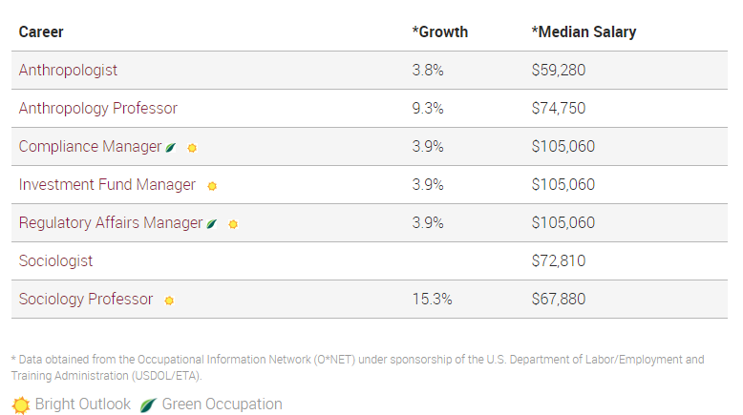

Better have my money!  When you filed the FAFSA your senior year in high school, your GEAR UP Coordinator told your to click “YES” on a question about being considered for work-study. Now that you have been in college for a month, you want to know more about work-study, how it works. Where’s your work-study money? Where’s your job?!?!  Who can help answer your work-study questions?  Scenario #9 | Better have my money!  You are in the Financial Aid office.  See additional hand out to give students some facts about how work-study works.  Tell students they have to go online to www.college.edu/studentjobs to search for openings on campus.  Emphasize that students must search for a job, apply, compete, and interview just like they would need to do for an outside job. Students are responsible for telling the employer (college department) that they have work-study.  Once they obtain a job… the paycheck will come as agreed upon with employer.  Scenario #9
See additonal hand out for more
Work-study info

Homesick  Now that you are in college and you are settling into the semester, you’re feeling strange… like you don’t fit in and little sad. You miss home.  Is this normal???  Where would you go on campus to talk to someone about how you are feeling?  Scenario #11 | Scenario #11- Facilitator Cheat Sheet  You are a Peer Mentor at the Gateway Student Center  Wait for the student to tell their issue…  Inform them the feelings are normal and that it happens to a lot of freshman. The feelings do typically go away if student is able to connect with someone or a group of people…  Explain Colleges have centers where students can get support, mentoring, and help finding their way on campus. Encourage them to find that center in the first few weeks of college – wherever they go!  Also recommend the student visit:  - Student life – find a club that they would enjoy and connect with people  - Greek life – find a sorority/fraternity that they would like to join  - Student government  - Residence Halls Council  - Cultural Center or first-year centers to get a mentor  - Campus health – speak with a mental health professional, if necessary  Ask the student if he/she is able to connect with a roommate or suitemate for dinner?  Ask student to consider doing morning and afternoon 5minute check-ins with RA  Invite student to a walk around campus tomorrow to check out the offices you mentioned.

Scenario #11

Fail, Drop and Retake  You are failing your English 101 class and after talking to your professor, you decided to drop the class and retake it next semester.  Where would you go on campus to talk to someone about dropping a class?  Scenario #13 | Scenario #13- Fail, Drop and Retake  You are at the registrar’s office:  Say- “Welcome to the registrar office, how can I help you?”  Wait for the student to explain their issue/request.  Hand-the student the add/drop paper request and explain that they will need to fill out the full request with their course information and submit the form before the course drop date of June 21st.  Encourage them to fill in the form now and provide them with the needed information. See below:  Term- Summer  Year- 2017  Session- 16 Weeks  Class Number- 12345  Subject and Catalog Number- ENG 101  Section- 001-LEC Mtn Reg  Units- 3 credit hours  Permission Number- 12345GU  Once they have filled in the form- ensure the filled in the DROP section- correctly they can prepare to move on.
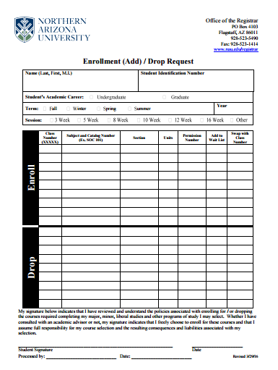

Scenario #13

I need friends…  You are new to the area and are looking to meet new people and get involved on campus.  Where would you go on campus learn more about campus activities and student events?  Scenario #15 | Scenario #15- Facilitator Cheat Sheet  You are in the Student Life Office:  After the student present you with their request present them with the different options below for more information on how to get connected:  - Show them the list of recognized clubs on NAU campus and help steer them to a club or organization that they might be interested in.  - Provide students with information on how to connect to the True Blue Connects-an online forum that allows students to learn about all of the organizations on campus and upcoming events they can join. Or encourage the students to check out the schools Facebook and Twitter for upcoming campus events.  - If the students does not see a club that they would like to join- ask them to consider creating their own. Students can start by going to True Blue Connections to get started.  Before the student can move on have them identify at least 2 clubs/organization they would like to join or create. If the student is not sure of how to find a club, as them to think about what they like to do as a hobby/ for fun. There is no wrong answer.

Scenario #15

Major and Minor…  After much thought you have decided on majoring in Business, but are still unsure of what your minor should be.  Who should you talk to, to get more guidance on majors and minors?  Scenario #17 | Scenario #17- Facilitator Cheat Sheet  You are an advisor in the business department:  After hearing about what the student has planned for a major, ask them to tell you about class(es) they enjoyed in high school and how they can consider learning more about minors that might fit this interest.  Encourage the students to take time to look at the NAU Academic Catalog online to compare different minors. Hand the student a sample of what the comparison information will look like.  Students can also go online to the business department page and look at the salary information for majors and other information on careers and business pathways.

Scenario #17

Tell me more…  Your biology lecture just ended and you are feeling like you need some clarification on an upcoming assignment.  Where should you go to get clarification on you assignment for this class?  Scenario #19 | Scenario #19- Facilitator Cheat Sheet  You are a representative from the Academic Success Center:  After the students talks to you about what their issue is, let the student know they have a few different options for getting help with their biology course:  - Stop by your professor’s office hours and get clarification on anything you might not understand or get additional resources to help you. (Explain to students what office hours are).  - Encourage students to consider signing up for One on One Tutoring with a peer tutor. Students can learn more about working with a tutor at the North or South Academic Success Center.  - Students can also take part in Drop-in tutoring- no appointment is needed and students can show up at the tutoring center at the listed time (see Biology and Chemistry schedule to the left.)
Biology and Chemistry at the North ASC
- Tuesdays 5 - 8 p.m. - CHM 130, 151, 152, 235, 238, 320, 341
- Wednesdays 5 - 8 p.m. - BIO 181, 182, CHM 235, 238
- Thursdays 5:30 - 8 p.m. - BIO 181, 182, CHM 235, 238

Sprained ankle…  While playing in an intermural soccer game you fall and twist your ankle. Now it is swollen and painful to walk on.  Where can you go on campus to get your ankle looked at?  Scenario #21 | Scenario #21- Facilitator cheat sheet  You are a representative from Campus Health Services:  Say- Welcome to Campus Health Services, how can I help you?  After the students explain what their issue is provide them with the information let them know that CHS is able to help them and with the health insurance they have they are eligible or the below services:  - Chronic care  - Psychiatric mental health  - Nutrition  - Massage  - Nursing services  - Allergy Clinic  - Physical therapy  - Lab work and immunization  Provide them with the CHS hours of operation handout as well as guide them to the campus Health Online links to make an appointment, talk with a provider as well as request medical records.
Give students the Campus Health Services Handout.

Scenario #21

