txtGU Guidelines Year 6 (July 2017- June 2018)
- Purpose
Student engagement is a hallmark of GEAR UP’s success in ensuring that all students are prepared to enter and succeed in postsecondary education; key to that engagement, increasingly, is the need to communicate with students using methods that are efficient for GEAR UP staff and also popular with students. With the aim to foster student success through expanding avenues of efficient and student-friendly communication, NAU GEAR UP launched a texting initiative (“txtGU”) using the Signal Vine platform in January 2017.
The txtGU initiative in grant Year 6 (July 2017- June 2018) is intended to serve the following purposes:
- Increase student and family participation in identified Year 6 work plan activities for which the use of nudging, reminder, and motivational texts are applicable;
- Help ensure students take specific senior year action steps necessary to achieve their postsecondary goals for which the use of nudging, reminder, and motivational texts are applicable; and
- Accustom students to the use of txt GU and instill in them a strong belief and understanding that txtGU can be a valuable resource in their first year of postsecondary education.
Cautions, and Caveats
Texting is NOT a replacement for in-person conversations, telephone calls or written notices sent home with students or mailed to students’ homes. Rather, texting is a supplement to existing modes of communication. It is important to remember that not all students participate in txtGU (no cellphone, etc.)

- Overview of the Signal Vine Platform
  - Web and App Interfaces

The Signal Vine (SV) Platform is designed to facilitate texting through use of a web-connected laptop or desktop computer. Texts may also be sent and/or received by cell phone through use of the Signal Vine app. Coordinators who choose to use the Signal Vine app to send or receive text messages, must use their personal cell phone to do so, which is entirely optional.
  - Student Profiles
One benefit of texting, over other forms of communication such as writing or making telephone calls, is the ability to easily and quickly communicate a common, relevant message to a large number of individuals. The primary benefit of Signal Vine specifically (over other ‘regular’ texting programs) is its capacity for storing student ‘profiles’ which allows Coordinators to strategically text subgroups of students with messages relevant only to the chosen groups. In the case of GEAR UP, by uploading student data (i.e., ‘characteristics’ like postsecondary plan, career interest area, FAFSA status, etc.) into Signal Vine-- and associating each student’s ‘characteristics’ with the student’s name, school and cell phone number, an infrastructure of individual ‘student profiles’ is established within Signal Vine. More on how to use this function in Section VI.D, below.
The following ‘characteristics’ were uploaded into Signal Vine for each student in Year 5:
- school
- postsecondary plan (per PEPS)
- career interest area (per PEPS)
- 1-3 college choices (per PEPS)
- birthday
- end of semester GPA
- date entered GEAR UP
- GUSLA Alumni (yes or no)
- Mentor (yes or no)
- ELL (yes or no)
- IEP (yes or no)
- Ethnicity

Other characteristics will be added in Year 6, as they are identified and become available (e.g., submitted FAFSA (yes or no), applied to college (yes or no), etc.
- Signal Vine Training & Support
- Nontechnical: The AZ GEAR UP State Office will provide training to Site Coordinators and Assistants at the Annual Coordinator Meeting in July 2017 on these guidelines and on the State Office plans for messaging students directly in Year 6 and Year 7.
- Technical: The GEAR UP Technology Project Manager will provide refresher training to GEAR UP Coordinators and Assistants on the use of the Signal Vine platform at the Annual Coordinator Meeting in July 2017. In addition, throughout the year, the GEAR UP Technology Project Manager serves as the resource for all AZ GEAR UP staff (State Office and Site based) for any technical questions and issues related to Signal Vine.
- Demonstration: A 5-minute Signal Vine demo video, is available on-line at www.signalvine.com/demovideo/. Enter the password TextingWorks16
- Collection and updating of Cell Phone Numbers
- New Students: When new students join the cohort, Coordinators will solicit their cell phone numbers during the required Orientation to GEAR UP, following district policies, as applicable, regarding parental consent. (Attachment #1 is a text messaging notice coordinators may customize and use to communicate with parents about txtGU, if needed. The notice can be used as a resource, given to students to take home, or mailed to parents.) Coordinators will inform new students of the purpose of the use of the texting tool, encourage new students to ‘sign on’ by completing the “New Student Cell Phone Information” form (Attachment #2), with the understanding they will have the opportunity to opt-out later if they wish to do so, and answer any questions they may have about sharing their phone number with GEAR UP. The Coordinator must provide the student’s SAIS number on the cell phone collection form prior to submitting it. If a SAIS has not been assigned to the new student at the time the student completes the cell phone form, the Coordinator will inform the student that they will wait to submit their completed cell phone form until a SAIS is assigned. New students will receive the first GEAR UP text message within approximately two weeks of when the Coordinators submit a completed cell phone number to the State Office. The Coordinator will submit the new students’ completed Cell Phone Number Form, by scanning and emailing it to the Site Support Specialist (SSS) with the next scheduled WISL.
- Changes in Students Cell Phone Numbers: When Coordinators learn that a student’s cell phone number has changed, they will submit the updated cell phone number on the “Cell Phone Change and/or Parent Information” Form, by scanning and emailing the completed form to the SSS with the next scheduled WISL. (Attachment 3)
- “Opting in” in Year 6: When Coordinators learn that students who elected not to provide a cell phone number to GEAR UP in Year 5 (for whatever reason) want to do so in Year 6, they will submit the students’ cell phone number on the “Cell Phone Change and/or Parent Information” Form, by scanning and emailing the completed form to the SSS. Students who opted out via an opt-out response to a text message, can opt back in at any time by texting the Signal Vine number and requesting to be reinstated as a participant or by notifying their Coordinator. Upon being notified that a student wants to be reinstated as a participant of txtGU or noticing a student has opted in by texting the Signal Vine cell phone number, Coordinators will re-activate the student’s account on the Signal Vine platform.
- Parent Opt-in: Parents who are interested in receiving messages may do so. Coordinators must inform parents who request signal vine (txt GU) services, that: 1) the intended audience for all GEAR UP text messages is students (i.e., they will be receiving the exact same message their student is receiving); 2) they will receive the first GEAR UP text message within approximately two weeks of providing their cell phone number to the Coordinator; and 3) standard text messaging rates may apply based on their plan with their mobile phone provider. Coordinators will collect the parents’ information using the “Cell Phone Change and/or Parent Information” Form then submit by scanning and emailing the completed form to the SSS with your next scheduled WISL.
- Clarifying Expectations with Students Re: Communication Protocols
- Coordinators must clearly communicate with students the hours students can expect to be texted, and when students can expect to receive responses to any texts they (students) send to Coordinators. For example, Coordinators may want to inform students that they (coordinators) will only be checking their GEAR UP Texts during regular school days/hours and on those evenings and weekends when a GEAR UP Event is taking place.
- Coordinators must clearly communicate that they are available, as always, in person, and that follow up questions from a text can be asked in person or by phone or email.
- Coordinators must explain to students that they are working with the GEAR UP “State Office” staff this year to create some of the text messages that students will receive; and that those same “State Office” staff will be available via txt GU to help them after graduation from high school, through the summer of 2018 and the students’ first year of college.
- Implementing Text Messaging
A. Preparing to Use txtGU in Year 6
- Coordinators must review their Year 6 work plan to identify events or college-preparation actions students must take in Year 6 that can be supported by sending text messages with reminders and/or information. Such events may include but are not limited to: FAFSA Assistance Workshops/Events, College Application Workshops, Next Steps Scholarship Information Events, etc. Additionally, Coordinators must review the State Office txtGU scheduled messages (provided at the Annual Coordinator Meeting) to coordinate the timing and content of general messages, bulk messages, and site-specific messages.
- AZ GEAR UP Event Standards require Site Coordinators to take a variety of steps to maximize participation at GEAR UP events, and the Event Notification Form solicits Coordinators’ planned actions. Txt GU is one strategy, among others, that coordinators can employ to publicize events - and remind students of the date, time and location of events - with the goal of maximizing participation. Other outreach strategies must exist to avoid excluding students who opted out of the texting service, and/or are not able to participate in texting for other reasons. Other outreach strategies can include but are not limited to emails, Facebook posts/messages, announcements, all calls, written notices/flyers, phone calls, etc. Texting is used as an additional means of communication, not as a replacement for other outreach strategies.
- GEAR UP Coordinators will consult with their SSS to review the Year 6 events and initiatives that will be publicized through the use of text messages to get feedback, and brainstorm content of messages.
B. Text Message Content
- Each text message is limited to 160 characters. Any messages longer than 160 characters will be split into two or more messages. Therefore, Coordinators should strive to limit each message to no more than 160 characters.
- The Signal Vine platform allows for images and web links to be sent via text, if desired.
- Messages shall be crafted using proper spelling, grammar, punctuation, and sentence structure, with the understanding that short-hand terms commonly used in text messaging can be used when appropriate. Some common abbreviations within texts are: TY, FYI, txt, school initials, “u” instead of “you,” etc.
- Generally, messages to large groups of students that are not pre-scheduled (referred to as bulk messages in the SV platform) shall be written in a manner that does not invite responses via text, and does not pose open-ended questions. Actions that are solicited through the large group text will be possible without an exchange of messages between student and Coordinator, however, such text messages can encourage students to visit the GU office if they need assistance or more information.
- Messages will likely fall under one of these categories:
a. Invitations to upcoming events
(e.g. ASU Rep in the Computer Lab 8-5,Tuesday Oct. 17. You can fill out your ASU app with help AND without having to pay the application fee. See U there!”
b. Reminders about upcoming events or deadlines
(e.g. “Student Name” - FAFSA Workshop 6:00 Tonight – Computer Lab! Bring your parents and u could get free $$ for college!”)
c. Information regarding a college preparation topic or resource
(e.g. “ACT test is coming up. Get free prep here: http://www.act.org/content/act/en/products-and-services/the-act/test-preparation.html. Go 2 GU office 4 more info.”)
d. Discuss with your SSS ideas for other types of messages
C. Txt Nudges
A key task of the GEAR UP Coordinator in Year 6 is monitoring and documenting (tracking) students’ progress on action steps – FSA ID, FAFSA submittal and completion, college application submittal, re-taking ACT, college acceptance, etc… TxtGU can be used to nudge students when monitoring indicates they have not taken necessary steps, or have not let the GEAR UP Coordinator know they have finished the step. Example message, based on FAFSA Finishline data: “Student Name - Your FAFSA still needs a parent signature. See me ASAP. No Financial Aid possible without it! – Mrs. Coordinator”)
- Targeting Messages to Subgroups of Students
Coordinators will determine the student profile ‘characteristics’ that will be used to select students who will be targeted to receive each text message. For example, all students who have indicated a desire/plan to apply to NAU, but who have not yet done so, could be reminded via txtGU when the NAU Admissions Representative will be on campus, and ‘nudged’ to go to them for assistance in completing their NAU application. Of course, for some events, impending deadlines, etc., texting “all GEAR UP students” at your school will be appropriate.
- Pre-programmed Messages

The State Office will provide Coordinators with a schedule of pre-programmed text messages, along with the profile characteristics that will be used to target those messages to sub-groups of students. Coordinators will work with the State Office to coordinate site-specific messages and to provide site-specific information that would be important to include in the pre-programmed messages.

- Text Message Frequency
Best practice, for texting, based on research, is to send no more than 10 texts to any one student per month; any more than that, and students begin to ignore the messages, or even opt-out of the service. It’s entirely acceptable in Year 6, for any one student to receive no more than one or two texts per month. GEAR UP Coordinators must be mindful and strategic about the scheduling of text messages for events/initiatives that will be supported by the use of text messages. Text messages should be spaced out and kept to a number that will ensure each student does not receive more than ten messages in one month. It is also important for Coordinators to coordinate, as much as possible, with others on campus using Remind 101 or another texting service to minimize duplicate information.
VII. Logging/Documenting/Reporting Services
A. Most messages sent to students can be documented on the Weekly Individual Service Log as a virtual NOS 190 (Disseminated printed information e.g. news, upcoming events, updates, invitations etc.) with a duration of 1 minute. Parent services must be noted as such.
B. If a message sent through Signal Vine results in an interactive conversation with a student that is advising in nature, and if the duration is 5 minutes or longer, then these interactions can also be documented on the WISL as virtual services with the appropriate code and duration. (These interactions are commonly a type of counseling/advising such as NOS 133, NOS 129, or NOS 136).

ARIZONA GEAR UP
Attachment #1 – this document is available on Haiku for Coordinators to download and customize; highlighted words require customization.

Gaining Early Awareness and Readiness for Undergraduate Programs

*** GEAR UP Parent / Guardian Notice ****
TO: Parents/Guardians of GEAR UP Students
FROM: [name], GEAR UP Coordinator – [high school name]
DATE: [month 2017]
REGARDING: Text Messaging Service

In an effort to best serve the Class of 2018 during the final leg of their journey through high school graduation and into the first year of postsecondary education, GEAR UP has expanded the ways it communicates with students to include the use of text messaging. Text messaging has increasingly proven to be an effective tool for assisting students in achieving their goals, and GEAR UP is excited to offer this service.
I/we understand that not all students have cell phones; that some phone plans may include texting charges, and/or that students may have limited texting ability. Therefore, the use of texting will not take the place of other forms of communicating about GEAR UP services (individual meetings, workshops etc.), but simply provide an additional means to inform and remind students of important activities, deadlines, events, etc.
I/we imagine we’ll be texting students about 3-4 times a month through the 2017-18 school year, (no more than ten times in a month), and in most cases, the messages will not require responses from students via text. For example, a ‘Reminder Text’ about an upcoming event might say: “FAFSA Workshop 6:00 Tonight – Computer Lab! Bring your parents and u could get free $$ for college!”
Students may opt-out from receiving text messages at any time, by simply texting “STOP”.
Thank you as always for the privilege to serve and support your student’s successful preparation for college and career. If you have any questions, please don’t hesitate to contact me/us.

ARIZONA GEAR UP
Attachment #1 – continued

Gaining Early Awareness and Readiness for Undergraduate Programs

***Aviso a Padre / Guardián de GEAR UP ****
A: Padres/Guardianes de Estudiantes de GEAR UP
DE: [nombre], Coordinador(a) de GEAR UP – [nombre de la preparatoria]
FECHA: [mes 2017]
RESPECTO A: Servicio de Mensajes de Texto

En un esfuerzo de servir mejor a la Clase de 2018 durante el tramo final de su jornada a través de la graduación de preparatoria (high school) y dentro del primer año de educación pos-secundaria, GEAR UP está expandiendo las diferentes formas en que se comunica con estudiantes para incluir la mensajería de texto, empezando el segundo semestre de este año escolar (2016-17). Mensajería de texto ha probado cada vez más ser una herramienta efectiva para ayudar una multitud de estudiantes a lograr sus metas y GEAR UP está entusiasmado de empezar a ofrecer este servicio.
Yo/nosotros entendemos que no todos los estudiantes tienen teléfonos celulares; que algunos planes de teléfono podrían incluir cargos por texto, y/o que estudiantes podrían tener limitada habilidad para textos. Por lo tanto, el uso de enviar textos no va a tomar el lugar de otras formas de comunicación acerca de los servicios de GEAR UP (juntas individuales, talleres, etc.), sino simplemente proporciona formas adicionales de informar y recordar a los estudiantes de actividades importantes, fechas límites, eventos, etc.
Hasta el final de este año escolar, la frecuencia de mensajería a estudiantes es calculado de tres a cuatro textos por mes (pero no más de diez) y en la mayoría de los casos, la naturaleza y contenido de los mensajes no esperará respuestas de los estudiantes vía texto. Por ejemplo, un texto para recordar acerca de un evento futuro podría decir: “Ven al taller de FAFSA hoy a las 6:00pm – en el salón de computación. Invita a tus padres para recibir dinero gratis para la uni.”
Los estudiantes pueden decidir salirse del servicio de texto en cualquier momento respondiendo con un mensaje que diga “STOP.”
Gracias como siempre por el privilegio de servir y apoyar la exitosa preparación de su estudiante para la Universidad y su Carrera. Si tiene alguna pregunta, por favor no dude en ponerse en contacto conmigo.

Attachment #2 – New Student Cell Phone Information Forms

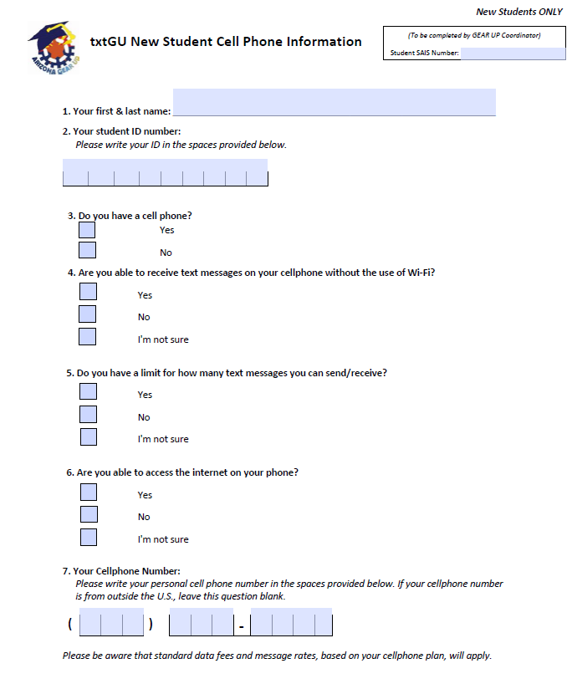

Attachment #3 – Cell Phone Change and/or Parent Information Form

