[SCHOOL LETTERHEAD]
[Month, Year]

Dear Parents,
I am delighted to inform you that every [Insert name of School] High School senior will receive a “Launch” guidebook this year. [Insert distribution plan, e.g., they will be distributed during their first hour class or in advisory period, or each student will receive a copy of this guide at the school bookstore when they pick up their textbooks]. This Guide is a valuable resource that will serve to support your child through the many important steps that must be taken senior year, as they ‘launch’ into life after high school. Whether your student plans to go away to university, attend the local community college, enlist in the military or join the workforce, this guide has information, forms and checklists that can help ensure a successful transition. Information on scholarships, FAFSA, careers, and job and college applications are just a few examples of the materials included in this book. [Insert info on how parents can access the Guide, e.g., We hope that you will review the various sections together with your student to become familiar with the many resources that are available. Or – this book will remain in your child’s [economics] classroom where it will be used and referenced regularly. We will have copies of this book in the library and at the front table during parent teacher conferences for parents to view. And/Or –a copy of this guide is also available to view on our website.] The guidebook includes sections and tabs for easy access to information, resources, and deadlines that are critical during the senior year, as shown below.
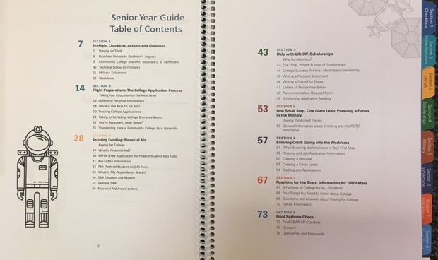
Please be aware that the Guide provides space for students to record personal information such as passwords and social security numbers. Students are advised to keep their guidebooks secure and warned of the risks of recording confidential information anywhere. This creates an opportunity for you to talk to your student about these topics and to come up with an organizational system and strategies that work best for your individual student. This might also be a good time to encourage your child to memorize their social security number, as they prepare to enter the adult world.
We are pleased to offer this resource to you and your family and we are happy to answer any questions you might have as the senior year progresses. Please feel free to direct those questions to the counseling department at the number listed below.
Thank you,
[Insert Signature / Name]
Principal
[Insert Counseling Department phone number]

