MIDDLE GRADE INITIATIVE
College and Career
C O N N E C T I O N S

C O R A L B L E A C H I N G
Marine Biology is a highly competitive field, where careers vary from aquaculture to research, and working conditions often involve sunscreen! This C O N N E C T I O N ties Statistics Standards from eighth grade to courses at Scripps Institute of Oceanography.
AZCCRS addressed in this C O N N E C T I O N:
Mathematics; Statistics and Probability Grades 6 - 8
Scripps Institute of Oceanography
From their website:
http://www.scrippscollege.edu/departments/
“As a department of UC San Diego, Scripps Institution of Oceanography offers degrees, minors, and more than 45 undergraduate courses covering a wide breadth of earth and marine sciences on several different levels.
Scripps Research Vessels
Research training is a fundamental element of the Scripps mission, and our commitment to practical research training is exemplified by the UC Ship Funds Program. Made possible by support from the University of California and Scripps Institution of Oceanography, this program provides more than $1 million per year to enable graduate and undergraduate students, postdoctoral researchers and early career faculty to pursue independent research and instruction at sea aboard Scripps ships.
Shipboard experience is also an important element in undergraduate and graduate classroom instruction at Scripps. Professors use field trips aboard Scripps research vessels to underscore the content of their curricula, to demonstrate field methods, and to introduce students to practical aspects of the science. During the period between 2005-2009, 630 graduate students and 253 under-graduate students obtained first-hand experience at sea aboard Scripps research vessels.”
Degree Program:
Bachelor of Science in Marine Biology (Courses Include:)
101; California Coastal Oceanography - This course emphasizes oceanographic connections between physical and climate forcing and marine ecosystem responses using examples from and activities in the California coastal environment. The approach is inquiry-based, combining classroom and experiential learning to build critical and quantitative thinking and research insights and abilities.
138; The Coral Reef Environment - Assessment of the physical, chemical, and biological interactions that define the coral reef system; essential geography and evolutionary history of reefs; natural and human perturbations to the coral reef ecosystem; aspects of reef management and sustainability.

Lesson:
The Colors of Coral
Assume that you are part of a group of Scripps students studying off the coast of Central America on a research vessel. Part of your mission is to collect information so that oceanographers can assess the impact of recent stresses on local coral reefs.
A couple of factors affect the color of coral. The first, and most relevant, is zooxanthellae algae. The body of a coral polyp is clear, and zooxanthellae algae are pigment cells that take up residence inside the coral's tissue. It's an innate mixture of these cells that give coral its generous display of color. Several million zooxanthellae can inhabit a single square inch of coral. Another factor that distinguishes coral color is light. With the help of the sun, zooxanthellae cells release chlorophyll by the process of photosynthesis. The coral's color is then determined by how much chlorophyll is released, as well as the amount of available light.
http://animals.mom.me/corals-bright-colors-10948.html
Coral Bleaching
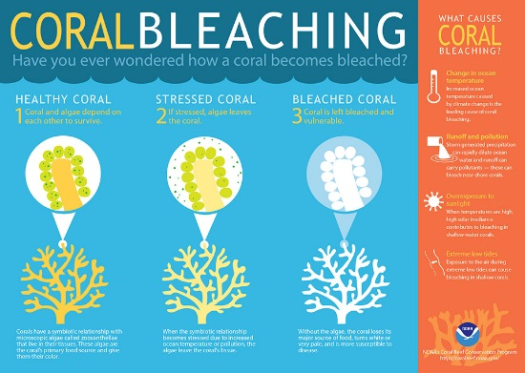
Warmer water temperatures can result in coral bleaching. When water is too warm, corals will expel the algae (zooxanthellae) living in their tissues causing the coral to turn completely white. This is called coral bleaching. When a coral bleaches, it is not dead. If the stress-caused bleaching is not severe, coral have been known to recover. If the algae loss is prolonged and the stress continues, coral eventually dies.

http://oceanservice.noaa.gov/facts/coral_bleach.html
The Measurement Tool
You will be comparing the colors of the subject coral to a set of gradient cards, numbered from zero to five. (Zero is the expected color of the coral and five is white.)
0
2
3

4
5
1

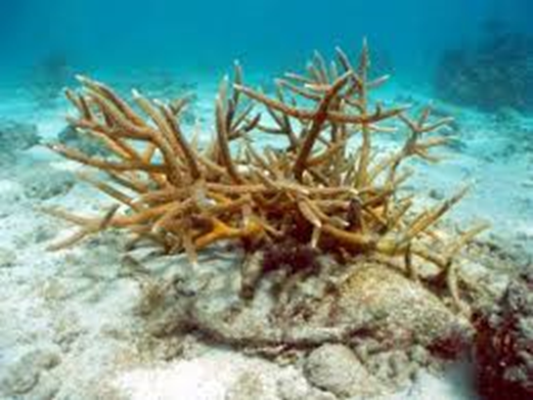
Coral that is assessed to be 0 or 1, is considered to be healthy.

https://www.fau.edu/facilities/ehs/info/elkhorn_staghorn_corals.php
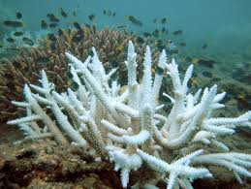
Scoring of 2 or more on this
scale indicates a problem.

https://en.wikipedia.org/wiki/Coral_bleaching
Collecting Data
The students are broken into groups, and the head researcher asks each group to suggest a method for collecting data.
- Group A suggests splitting up and having each of the member collect ten assessments from a different section of the reef.
- Group B suggests creating a grid on the ocean floor and using a random number generator to choose grids from which you would collect data from fifty sections throughout the coral reef.
- Group C suggests considering each section in the grid and flipping a coin to determine whether to collect the data in that section, and then stopping after fifty sections are identified.
- Group D suggests numbering all of the sections in the grid and then collecting data from all of the sections that are multiples of three.
Write an argument to the head researcher that compares the four collection methods and make a recommendation for how the team should proceed.
Once a consistent method of collection is chosen and data is gathered, each group records their findings as follows:
Group D
2,2,1,0,1,0,1,0,2,4,0,3,2,0,1,0,1,0,1,1,1,1,2,1,0,3,0,4,0,5,0,2,1,1,0,1,0,3,0,2,1,0,0,0,4,0,1,5,2,0,

Group C
0,0,1,1,2,1,3,2,0,0,1,1,0,0,4,0,0,3,0,0,1,0,1,3,0,2,0,2,5,0,1,4,2,0,3,5,2,1,0,0,1,1,2,1,0,2,3,5,0,2,5,1,4,2

Group B
0,3,2,2,1,0,0,5,0,1,2,0,0,1,1,5,1,0,3,2,4,1,0,0,1,0,3,3,2,0,4,1,1,3,1,2,2,5,0,0,0,1,1,2,1,3,2,1,0,0,

Group A
2,4,5,2,1,1,0,0,3,3,
0,1,1,2,3,4,3,2,2,1,
1,0,1,0,2,3,1,1,0,1,
2,3,1,4,1,0,1,0,1,0 0,2,0,5,0,1,3,1,3,2,

Organizing and interpreting the data
Consider the following list of statistical tools. Discuss which are appropriate for this data and which would be useful for reporting your team’s findings to the head researcher:
mean, median, mode, range, standard deviation,
boxplot, histogram, scatter plot, pictograph
For each tool, describe why it would or would not be applicable for this data.
In your research group, create a graph that appropriately illustrates the data collected.
Write a brief report (One paragraph) to the head researcher describing you data and interpreting what you have found. Be sure to defend your conclusions by explaining your reasoning.
Deliverables and Assessment
Standards by assignment
Random Sampling Argument -
Mathematics, 7.SP.A.1. Understand that statistics can be used to gain information about a population by examining a sample of the population;
Mathematics, 7.SP.A.2. Use data from a random sample to draw inferences about a population;

Language Arts, 6-8.WHST.1. Write arguments focused on discipline-specific content.

Tool Analysis
Mathematics, 6.SP.A.3. Recognize properties of a measure of center and a measure of variation.

Graph
Mathematics, 6.SP.A.3. Recognize that a measure of center for a numerical data set summarizes all of its values with a single number,
Mathematics, 6.SP.B.4. Display numerical data in plots on a number line, including dot plots, histograms, and box plots.

Interpretation of Data
Mathematics, 6.SP.A.1. Recognize a statistical question as one that anticipates variability in the data related to the question and accounts for it in the answers.
Mathematics, 6.SP.B.5. Summarize numerical data sets in relation to their context,

Language Arts, 6-8.WHST.1. Write arguments focused on discipline-specific content.

From the Arizona Department of Education Website:
AZCCRS for Mathematics, Statistics and Probability, Grades 6 - 8
Grade 6
6.SP.A.1. Recognize a statistical question as one that anticipates variability in the data related to the question and accounts for it in the answers.
6.SP.A.3. Recognize that a measure of center for a numerical data set summarizes all of its values with a single number, while a measure of variation describes how its values vary with a single number.
6.SP.B.4. Display numerical data in plots on a number line, including dot plots, histograms, and box plots.
6.SP.B.5. Summarize numerical data sets in relation to their context, such as by:
- Reporting the number of observations.
- Describing the nature of the attribute under investigation, including how it was measured and its units of measurement.
- Giving quantitative measures of center (median and/or mean) and variability (interquartile range and/or mean absolute deviation), as well as describing any overall pattern and any striking deviations from the overall pattern with reference to the context in which the data were gathered.
- Relating the choice of measures of center and variability to the shape of the data distribution and the context in which the data were gathered.
Grade 7
7.SP.A.1. Understand that statistics can be used to gain information about a population by examining a sample of the population; generalizations about a population from a sample are valid only if the sample is representative of that population. Understand that random sampling tends to produce representative samples and support valid inferences.
7.SP.A.2. Use data from a random sample to draw inferences about a population with an unknown characteristic of interest. Generate multiple samples (or simulated samples) of the same size to gauge the variation in estimates or predictions.

Grade 8
8.SP.A.1. Construct and interpret scatter plots for bivariate measurement data to investigate patterns of association between two quantities. Describe patterns such as clustering, outliers, positive or negative association, linear association, and nonlinear association.

AZCCRS for Writing, Literacy in Science and Technical Subjects, Grades 6 - 8

6-8.WHST.1. Write arguments focused on discipline-specific content.
- Introduce claim(s) about a topic or issue, acknowledge and distinguish the claim(s) from alternate or opposing claims, and organize the reasons and evidence logically.
- Support claim(s) with logical reasoning and relevant, accurate data and evidence that demonstrate an understanding of the topic or text, using credible sources.
- Use words, phrases, and clauses to create cohesion and clarify the relationships among claim(s), counterclaims, reasons, and evidence.
- Establish and maintain a formal style.
- Provide a concluding statement or section that follows from and supports the argument presented.

MIDDLE GRADE INITIATIVE
College and Career
C O N N E C T I O N S
Feedback

C O R A L B L E A C H I N G

Thank you for taking a moment to share your feedback regarding the College and Career CONNECTION, Coral Bleaching. We appreciate your time! Please send the completed form to Dawne.Spangler@nau.edu

Participant: ________________________________________ Title: ____________________________

District: ________________________________________ School: ____________________________________

What grade(s) and subject(s) do you teach? _______________________________________________

Please share your thoughts: Was this CONNECTION

Relevant? Yes Somewhat No
Comments

Interesting to students? Yes Somewhat No
Comments

Practical? Yes Somewhat No
Comments

What suggestions do you have to improve this CONNECTION?

What requests or suggestions do you have for new CONNECTIONS?

