Instructions for 2017-18 WISL

The Year-6 WISL, an excel document, incorporates a few modifications intended to make recording of the services you provide to students and parents easier and additional features to help ensure accuracy. The new WISL is available on Haiku. Please take a little time to practice with it so you can become familiar with it before you begin using it to submit data. Please contact your site support specialist if you have any questions.

- Enter the Date of Service and the Student First and Last Names in Columns A-C
  - (SAIS is optional. Schools with GEAR UP assistants, please enter the SAIS ID in Column D).

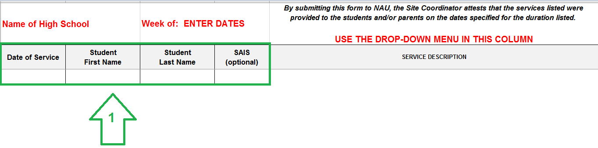

- Click on the dropdown menu in Column E to choose the Service (Description, NOS Code and Mode). Use the scroll bar to scroll down to see all the services.
The NOS codes are in numerical order.

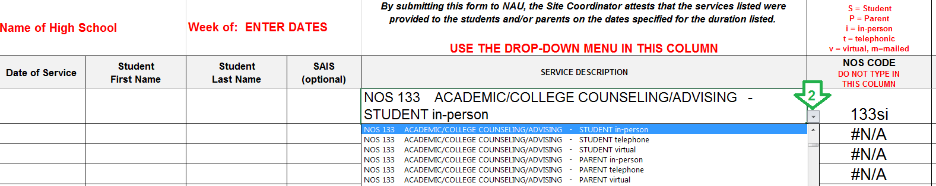

The NOS code fills in automatically in Col F. Please do not type in Col F.

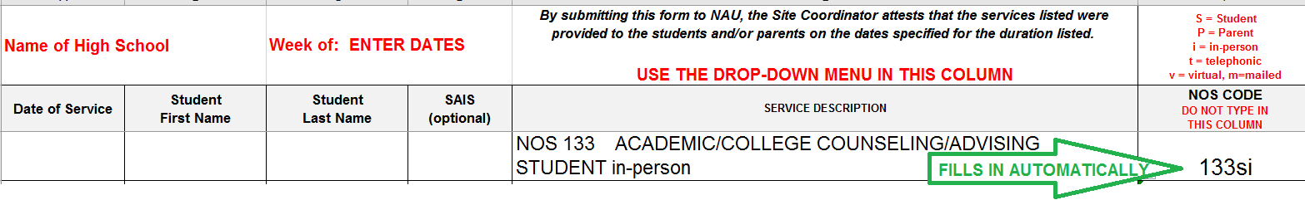
You will see that the NOS code in Column F indicates who was served (s = student or p = parent). It also indicates how the service was delivered (i = in-person, t = telephonic, v = virtual, m = mailed, ADMIN = administrative).
- Column G, the “Hours” column is prepopulated with “0.” Do not delete this unless you are entering services over 55 minutes in which case you would enter the number of hours in Column G and the number of minutes (rounded to 5-min mark) in Column H. When you enter services that are an hour or longer do not enter the word “hours”, you only enter the number of hours. See the examples below.

  - Example: Service was 5 minutes long:

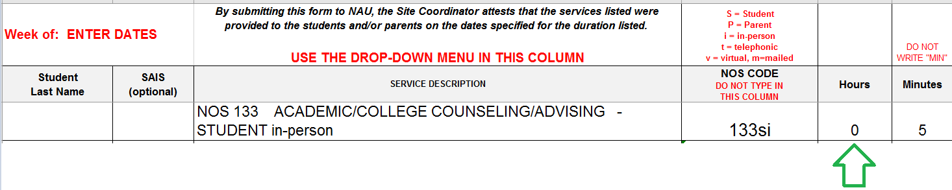

  - Example: Service was 3 hours and 25 minutes:

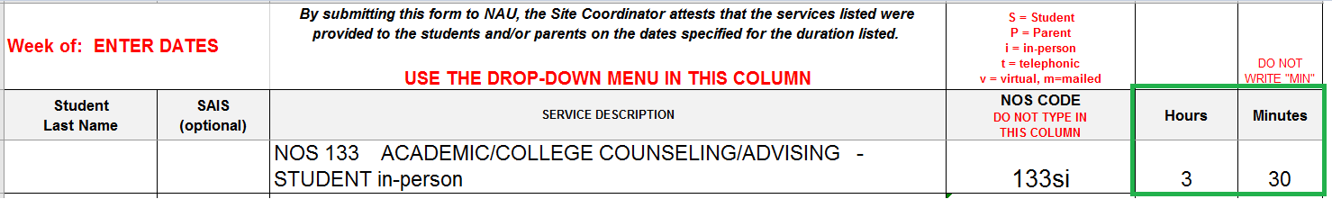

- You may use the comments cells for reminders for yourself or additional details for your Site Support Specialist (which do not get entered into SCRIBE) or to communicate specific “additional” information which is sometimes required, such as the name of a college that was visited.
- Entering the Work Plan Task number is very helpful to your site support specialists in reviewing data and for searching for progress toward workplan tasks for the Quarterly Progress Reports.

