EXAMPLE

8

9

7

2

4

5

8

6

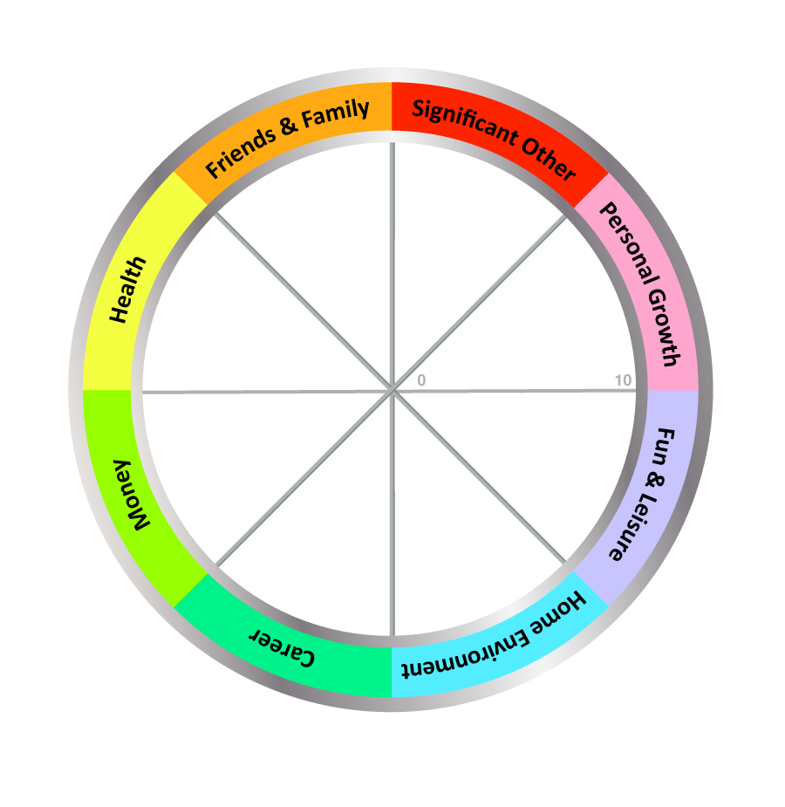

TODAY'S DATE: ____________________

COMPLETE THE WHEEL:

1. Review the 8 Wheel Categories - think briefly what a satisfying life might look like for you in each area.

2. Next, draw a line across each segment that represents your satisfaction score for each area.

- Imagine the centre of the wheel is 0 and the outer edge is 10
- Choose a value between 1 (very dissatisfied) and 10 (fully satisfied)
- Now draw a line and write the score alongside (see example above)

IMPORTANT: Use the FIRST number (score) that pops into your head, not the number you think it should be!

The Wheel of Life Exercise – Instructions

Notes:
- Balance is personal and unique to each individual - what may be satisfying or balanced for some may be stressful or boring for others.
- This exercise is meant to raise awareness and allow you to plan a life that is more satisfying and closer to your definition of balance. It also helps clarify priorities for goal-setting. There are no right answers!
- Balance must be assessed over time. A regular check-in (e.g., with this exercise) can highlight useful patterns and help you learn even more about yourself.
- Another option is for you to ask someone who knows you well to complete the scores for you (sometimes it's helpful to see an outside perception of your life 'balance'). Important: This must be someone you trust and whose opinion you value - and remember that others may have hidden agendas! ;)

Detailed Instructions:
- Review the 8 categories on this Wheel of Life. The categories should together create a view of a balanced life for you. Feel free to split category segments to add in something that is missing, or re-label an area to make it more meaningful for you. Examples of changes are:
  - Family and Friends: Split "Family and Friends" into separate categories.
  - Significant Other: Changing the category name to "Dating", "Relationship" or "Life Partner".
  - Career: Changing the category name to "Motherhood", "Work", "Business" or "Volunteering".
  - Finances: Changing the category name to "Money", "Financial Security" or "Financial Wellbeing".
  - Health: The category name could be split or changed to "Emotional", "Physical", "Fitness", "Spiritual" or "Wellbeing".
  - Home Environment: The category could split or change to "Work Environment" for career or business clients.
  - Fun & Leisure: The category name could change to "Recreation"
  - Personal Growth: The category name could change to "Learning", "Self-Development" or "Spiritual"
  - Other categories to add could include "Security", "Service", "Leadership", "Achievement" or "Community".
- Think about what success or satisfaction would feel like for each area.
- Now rate your level of satisfaction with each area of your life by drawing a line across each segment. Place a value between 1 (very dissatisfied) and 10 (fully satisfied) against each area to show how satisfied you are currently with each category in your life.
- The new perimeter of the circle represents your Wheel of Life.
- Now, looking at the wheel here are some questions to ask yourself or begin to journal about:
  - Are there any surprises for me?
  - How do I feel about my life as I look at my Wheel? Am I living consistent with my values?
  - How do I currently spend time in these areas? How would I like to spend time in these areas?
  - What would make that a score of 10?
  - What would a score of 10 look like? What are my goals, dreams?
  - Which of these categories would I most like to improve?
  - What are my assets? How could I make space for these changes in my life?
  - What assets would I have to draw on? What would suffer as a result of asset redistribution?
  - What change should I make first? And what change do I want to make first?
  - What help and support might I need from others to make changes and be more satisfied with my life?
  - If there was one key action I could take that would begin to bring everything into balance, what would it be?
- Taking action - the final step. To wrap-up the exercise, identify one action for each area, and then pick 1-3 actions to get started. You could also choose the 3 areas you most want to work on and identify an action for each. TIP: If you are extremely busy or stressed try asking yourself, "What is the smallest step I could take to get started?"

