

Reports to Approvers Setting up a Proxy

This set up will allow the proxy to approve both Time off Requests from Exception Employees and All Time Requested and Reported by Positive Pay Employees.

*Note: if you previously set up a proxy for the ROA they will come into time and Labor.*

Setting up a proxy is optional; however, we do recommend selecting a proxy if you will be on vacation or away from your email for more than a week. By selecting a proxy, you are authorizing the other supervisor designated as your proxy to approve all timesheets that would otherwise be routed to you for approval. You maintain ultimate responsibility for the process and are responsible for ensuring that the proxy is trained on how you wish to handle approvals or changes and that the proxy understands the need for appropriate confidentiality and follows all applicable NAU polices for leave. Please communicate the name of the person(s) that you have assigned as a proxy to your employees so that they know who is approving and reviewing leave requests and time worked on your behalf. Even though you have designated a proxy you will still receive email notifications when your employees submit a ROA via their timesheet. You will also receive the calendar invites that you may choose to add to your calendar even if it is your proxy that approves the absence request.

To setup a proxy, navigate to:

Manager Self Service> Time and Labor WorkCenter – Select the Links tab and Proxy Setup is under Manage and Secure Timesheets

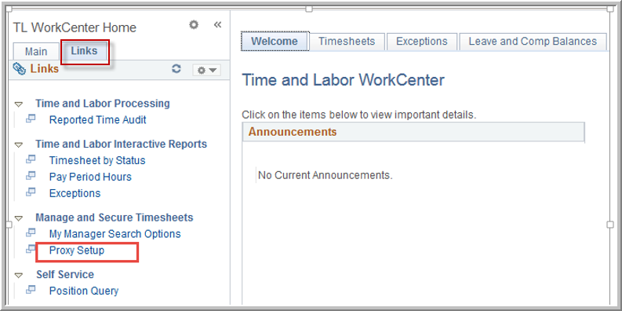

Enter the start/end dates and the empl ID of the other supervisor you would like to delegate the authority to approve all timesheets in your absence. If you assign multiple proxies at one time, all timesheets will route to each proxy. This authority will be ongoing if no end date is supplied. A proxy should only use this authority when you are out of the office. Proxies are intended to be in place in the event that the supervisor is unable to review and approve Timesheets, such as hours worked, time away for vacation or other type of leave. You should periodically review your proxies to ensure it is up to date and in compliance with NAU policies. Please remove any proxies that are no longer needed. The proxy you choose cannot further delegate this responsibility.

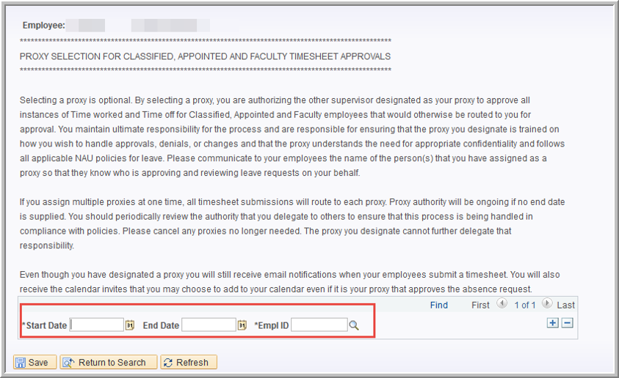

The key to having proper routing for the timesheet is keeping the ‘Reports To’ up to date. The Timesheet will automatically route to the next manager in the ‘Reports To’ chain if a position is vacant. If someone has taken over the supervising temporarily while the position is filled, then we suggest updating the ‘Reports To’ via the ‘Reports To’ form.