

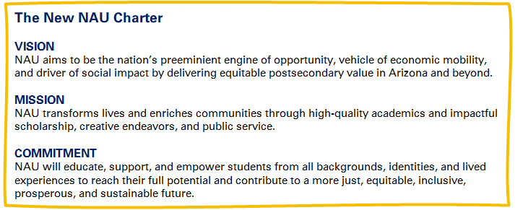

Academic Program Review
Self-Study Template

AY 2026 – 2027

Kerry F. Thompson [replace this information with the Dept Chair/Sch Director & Dean]
Associate Vice Provost for Curriculum, Assessment, and General Studies
928- 523-0712
Kerry.Thompson@nau.edu

Executive Summary
(A concise summary, no more than one and a half pages, highlighting the program’s mission, key achievements, challenges, and strategic priorities.)
- Program Mission & Purpose
- Key Achievements Since Last Review
- Primary Challenges
- Strategic Priorities Moving Forward

Table of Contents

Core Sections (Required for All Units)

1. Program Overview & Alignment
- Briefly describe the program’s mission and how it aligns with NAU’s strategic goals.
- Highlight unique aspects of the program, such as serving non-traditional students or addressing workforce needs.

2. Student Enrollment & Success Trends
(Use the data provided in the Academic Program Review dashboard in Tableau; programs should interpret and reflect on trends.)
- Trends in Enrollment & Degree Conferral (Identify significant changes and contributing factors.)
- Retention & Graduation Rates (Discuss key factors affecting student success.)
- Demographics & Student Needs (How is the program adapting to serve its student population effectively?)
- Career & Post-Graduation Outcomes (If available, summarize employment trends or graduate school placements.)

3. Curriculum & Assessment
For each academic program under review provide the following:
- Provide a curriculum map showing alignment between courses and student learning outcomes (Appendix A).
- Reflection: How does the curriculum ensure skill development and academic progression?
- Recent Changes: Summarize major updates and their impact on student learning (e.g., anything the unit has done to address issues of curricular complexity or other programmatic challenges).
- Assessment Findings: Identify key takeaways from ongoing annual assessment reports and actions taken (Appendix B)
- Describe how career readiness has been incorporated into student success initiatives.

4. Faculty & Resources
- Faculty Composition & Teaching Capacity: Are faculty resources sufficient for program needs? (Appendix C)
- Faculty Development & Support: What efforts exist to support faculty growth and innovation?
- Facilities, Technology & Library Resources: Brief evaluation of adequacy and gaps. Cline Library has created a narrative that can drop in to the self-study, AVP-CAGS will make it available to you.
- Budget: Provide an analysis of the unit’s budget over the review period. Discuss trends in base and discretionary funding, including any shifts in allocations, expenditures, or sources of revenue. Identify how the budget has supported—or constrained—program delivery, faculty work, student support, and strategic priorities. Highlight any challenges or opportunities related to resource planning and sustainability.

5. Research & Scholarship
- The Provost’s Office will provide a report of what is availabe in FAAR for faculty information (SOEs, Teaching, and Scholarship).
- Overview of faculty and student research efforts.
  - Summary of research mentoring activities (e.g., 485 and 685 classes)
- Funding sources and research priorities.
OR, if your unit/program does not engage in heavy research & scholarship activities
- Overview of program activities you would like to highlight (in collaboration with your Dean).
- Summary assessment of this area of your program.
- Priorities & goals for this area of your program

6. Service & Community Engagement
- Contributions to NAU’s General Studies or other academic programs, such as Statewide, Yuma, Educational Partnerships, and/or Continuing Education Outreach, partnerships, or service-learning initiatives (if not addressed in the Curriculum and Assessment Section).

7. Strategic Planning & Future Directions
- Summarize progress / changes to previous action plan (Appendix D).
- Based on the data and reflections above, identify anticipated challenges and plans to address them.
- With your dean, formulate strategic questions (see attached Recommendations for Developing Strategic Questions for External Review), outline specific goals, and suggest strategies for improvement.
- If applicable, discuss planned or anticipated partnerships, grants, or external initiatives.
Appendices (Attach others as Needed)
- Curriculum Map(s)
- Assessment Data Summary
- Faculty Roster & Qualifications
- Action Plan from Previous Review

Recommendations for Developing Strategic Questions for External Review
External reviews offer valuable insights into the strengths, challenges, and opportunities for growth in academic programs. To maximize the usefulness of these reviews, it is essential to develop strategic questions that focus on critical issues affecting a program’s future direction. Each department should develop 5–7 strategic questions that will frame the external review discussions. These questions should be:
- Open-ended and forward-thinking
- Actionable—able to generate concrete feedback and recommendations
- Relevant to the program’s specific challenges and opportunities
Below are key considerations and guidelines for crafting these questions.
1. Align with Institutional and College Priorities
- Consider how your program supports NAU’s mission and strategic goals.
- How does the program contribute to university-wide initiatives (e.g., student success, workforce alignment, community engagement)?
- How does your program’s structure and offerings support the priorities of the college?

2. Focus on Program Identity and Purpose
- What distinguishes your program from similar programs at peer institutions?
- How does your program address regional, national, or global needs within its discipline?
- In what ways does the program align with workforce demands or emerging trends in the field?

3. Examine Student Success and Learning Outcomes
- How well does the program ensure student learning and skill development?
- What evidence suggests that students are achieving desired learning outcomes?
- How do advising, mentoring, and co-curricular opportunities contribute to student success?
- What factors contribute to or hinder student retention and graduation rates?

4. Evaluate Faculty Development and Research
- How does the program support faculty in maintaining research, creative, or professional excellence?
- What are the primary challenges in recruiting and retaining faculty?
- How does the program encourage faculty collaboration, interdisciplinary work, and external partnerships?

5. Assess Resource Utilization and Infrastructure
- Are current resources (faculty, facilities, technology) sufficient to support the program’s mission?
- How does the program ensure effective use of financial and operational resources?
- What additional resources would enhance the program’s impact?

6. Consider External Stakeholder Perspectives
- How does the program engage with employers, alumni, and community partners?
- How do external stakeholders perceive the quality and relevance of the program?
- What recommendations might they have for strengthening the program’s impact?

7. Anticipate Future Directions and Innovations
- How is the program preparing for changes in student demographics, market trends, and technological advancements?
- What new curricular innovations, pedagogical approaches, or delivery models should the program explore?
- What are the biggest risks and opportunities for the program over the next five years?

