Template for Submitting Undergraduate Policy Proposals to the ASC.

Step 1: Provide a short summary of what you are proposing.

Step 2: Submit policy in the formats exemplified below.
- Submit policy using Track Changes and comment functions to indicate changes:
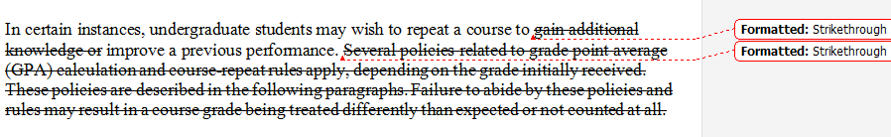
Or

- Use format below to show comparison of changes:

Old Policy: | New Policy:
 | Please Note: For easier reading, a “clean” copy of how the policy would read if these changes are approved is attached at the end of the proposal
In certain instances, undergraduate students | In certain instances, undergraduate students
may wish to repeat a course to gain | may wish to repeat a course to gain additional
additional knowledge or improve a previous | knowledge or improve a previous
performance. Several policies related to | performance. Several policies related to grade
grade point average (GPA) calculation and | point average (GPA) calculation and course-
course-repeat rules apply, depending on the | repeat rules apply, depending on the grade
grade initially received. These policies are | initially received. These policies are described
described in the following paragraphs. | in the following paragraphs. Failure to abide
Failure to abide by these policies and rules | by these policies and rules may result in a
may result in a course grade being treated | course grade being treated differently than
differently than expected or not counted at | expected or not counted at all.
all.
 | Please be aware credit is only earned once for
Please be aware credit is only earned once | a course that is repeated; if you take a 3 unit
for a course that is repeated. | course and repeat it, you will earn 3 units of
 | credit, not 6.
 | Unit Limits

Step 3: Provide rationale for why this new/changed academic policy is being proposed.

Step 4: Complete the Comparison Group table.

University | Policy Similarities or Differences
State Institutions:
1. Northern Arizona University
(Current form of policy)
2. Northern Arizona University
(Proposed form of policy)
3. Arizona State University
4. University of Arizona
Peer Institutions:
5. Ball State University
6. Central Michigan University
7. East Carolina University
8. Illinois State University
9. Mississippi State University
10. Old Dominion University
11. Sam Houston State University
12. Townson University
13. University of Akron-Main
14. University of Louisiana at Lafayette
15. University of North Georgia
16. Virginia Commonwealth University
17. Western Michigan University
18. Western Michigan University

Step 5: If appropriate, include any other data or information relevant to this proposal. (This might include retention or student success data from NAU or examples of policies from schools not included in the Comparison Group Table).

Step 6: Indicate any stakeholders, groups or individuals that have been part of the development of this proposal.

Step 7: Please provide your contact information:

Name:
Department and position:
Group you are representing (if applicable): Email:
Phone: Campus mail:

