X-Ray Safety Manual

Revised: June 5, 2024

Table of Contents

Scope and Applicability………………………………………………………………..3 Section I – Overview of Safety Requirements for Analytical X-Ray Equipment.…3 Section II – Radiation Safety Organization at NAU………………………………...4 Section III – Registration and Use of Equipment….………………………………...5 Section IV – Personnel Dosimetry….…………………………………………………5 Section V – Radiation Control Measures for Analytical X-Ray Equipment..……...8 Section VI – Emergency Procedures…………………………………………………12 Appendix A – U.S.N.R.C INSTRUCTION CONCERNING PRENATAL
RADIATION EXPOSURE……...……………………………….……………….…...13

Appendix B – U.S.N.R.C INSTRUCTION CONCERNING OCCUPATIONAL
RADIATION EXPOSURE……………………………………………………………22

*Contact and additional program information for the NAU Radiation Safety Officer and X-ray safety program are available on the NAU EH&S website: https://in.nau.edu/environmental-health-and-safety/

Scope and Applicability

NAU procures and operates analytical x-ray equipment under regulations issued by the Bureau of Radiation Control (BRC) in the Arizona Department of Health Services. Use of x-ray equipment at NAU is subject to inspection and review by personnel from the BRC and regulations require that NAU personnel use BRC approved procedures for the control of all analytical x-ray equipment. BRC also requires the registration of all analytical x-ray equipment prior to operation on campus. If BRC determines that NAU is not in compliance with state regulations, they may issue fines, or in the case of serious infractions, suspend or revoke analytical x-ray equipment use campus-wide. In order to ensure compliance with Arizona regulations for the control of ionizing radiation, it is essential that NAU personnel understand and follow the provisions of NAU’s x-ray safety program.

This Program applies to all personnel working at or visiting NAU who procure or utilize analytical x-ray equipment. The BRC defines analytical x-ray equipment as any device which utilizes x-rays for examining the structure and/or composition of materials. This includes x-ray diffraction and x-ray fluorescence analysis equipment.

BRC Rules and Regulations, and supporting documentation are on file in the NAU Department of Environmental, Health & Safety (EHS) and are available for review by NAU personnel. The NAU EHS web site is located at: https://in.nau.edu/environmental-health-and-safety/.

Section I - Overview of Safety Requirements for Analytical X-Ray Equipment

Acquisition and registration of X-Ray Equipment
Registrants seeking to purchase or acquire X-Ray equipment must either purchase this equipment using the NAU purchasing codes below, or independently contact NAU EHS for guidance before proceeding. Registration for all Analytical x-ray equipment must be kept on file within the NAU EHS office who will facilitate the registration of equipment with the BRC. The registrant must be a full-time faculty, academic professional, or staff member at NAU who bears overall responsibility for safe use of registered equipment. New equipment must be registered prior to operation. The NAU codes for ordering new x-ray or X-Ray Equipment are:

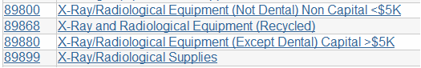

Training
All individuals operating analytical x-ray equipment must obtain training on the hazards associated with the equipment and proper safety control measures. NAU EHS offers an online training for general X-ray safety and is located at: https://in.nau.edu/environmental-health-and-safety/safety-programs/radiation/. Completion of this training plus any equipment or department specific training must be completed prior to operation of the equipment by an individual.

Safety Control Measures
Analytical x-ray equipment must be operated under administrative and/or engineering control measures approved by NAU EHS or the Radiation Safety Officer. Where applicable, these measures shall include written procedures for operation and alignment, periodic testing of interlocks and safety devices, proper labeling of equipment and posting of rooms, and limits on radiation fields produced by the equipment.

Safety Surveys
Periodic safety surveys (“Use Surveys”) of analytical x-ray equipment will be conducted by NAU EHS staff using calibrated instruments.

Section II - Radiation Safety Organization

Radiation Safety Committee
NAU governs the use of analytical x-ray equipment through the Radiation Safety Committee (RSC). This committee is a group of professionals at NAU to establish policy and regulations for the use of radiation sources and to oversee all aspects of radiation safety. The committee meets at least annually or when necessary to review activity or changes to the university's radiation safety program.

Radiation Safety Officer
The Radiation Safety Officer (RSO) is responsible for designing and implementing the radiation safety program elements as decided upon by the RSC.

Specific duties of the RSO include:

    - Providing consultative services on all aspects of radiation safety and protection.
    - Conducting surveys and making hazard evaluations for analytical x-ray equipment.
    - Assuring that the prescribed control measures are in effect, recommending or approving substitute or alternate control measures when primary controls are not feasible or practical, and periodically auditing the status of those control measures in use.
    - Approving standard operating procedures, alignment procedures, and other procedures that may be part of the requirements for administrative and procedural control measures.
    - Distributing and processing personnel monitoring devices and maintaining personnel exposure records.
    - Ensuring that personnel are properly instructed in the appropriate procedures for using analytical x-ray equipment.
    - Maintaining a current inventory of all analytical x-ray equipment at NAU.
    - Ensure that NAU maintains compliance with all applicable state and federal laws related to X-ray and radiation safety.

The RSO has the authority to restrict or terminate use of X-Ray Equipment in cases where use is determined to be in violation of regulations or otherwise represents a radiological hazard. Such actions may be reviewed by the RSC when needed.

Registrants
All analytical x-ray equipment at NAU must be registered with the RSO, who in turn maintains the required device registrations with the BRC. All analytical x-ray equipment must be registered to a faculty, academic professional, or staff member of NAU who maintains responsibility for all aspects of safety for the registered equipment. Specific responsibilities of the registrant include:

    - Registration of new equipment with the RSO within 30 days of receipt and prior to operation.
    - Ensuring that operators are properly trained and made aware of hazards associated with the equipment prior to operation of the equipment. Required training may require EHS administered online or in person training for x-ray devices as well as lab specific training administered by the registrant.

Operators
Individuals who operate analytical x-ray equipment must obtain safety training from NAU EHS prior to use of the equipment. They must also obtain instruction from the registrant on specific operating procedures for the equipment.

Section III – Registration and Use of Equipment

Registration of Analytical X-Ray Equipment
All analytical x-ray equipment at NAU must be registered with the RSO. Registrants must be full time faculty, academic professional, or staff of NAU.

Analytical x-ray equipment is registered by contacting the RSO, who will schedule a site inspection/consultation before filing the required equipment registration with the BRC. Registration shall be completed within 30 days of receipt of new equipment or reconfiguration of existing equipment, and prior to operation of the equipment.

Training Required for Operators
NAU EHS offers online X-ray Safety training which is mandatory for all authorized equipment operators. This training is designed to cover basic safety issues which are consistent with all x-ray equipment. This training is intended to be complemented with equipment or site-specific training which is performed by the Registrant for all authorized users on equipment.

Operators must receive training in the following topics:

    - Types and amounts of radiation to which workers could be exposed;
    - Health effects of exposure to doses of ionizing radiation;
    - Precautions and procedures to minimize exposure to ionizing radiation;
    - Applicable provisions of BRC and NAU Rules, Regulations, SOPs;
    - Responsibilities of personnel using X-Ray Equipment including the need to bring violations of BRC and NAU SOPs to the attention of NAU RSO/EHS;
    - Response in the event of exposures to radiation and other emergencies;
    - Rights of workers to have access to radiation exposure records.
    - Correct procedures for safe and effective operation of the analytical x-ray equipment.

Section IV - Personnel Dosimetry

In instances which operators may be partially or completely within the regulated area during operation or maintenance of x-ray equipment (i.e., no shielding between equipment and operator), exposure monitoring may be required. Determination of the need for exposure monitoring will be made by the RSO at the time of the initial registration, during consultation for changes to device or safety equipment configuration, or during periodic audits.

TLD Badges
Thermoluminescent (TLD) badges are used at NAU to monitor personnel for exposure of the body to penetrating ionizing radiation such as gamma and x-rays, and exposure of the skin to less penetrating radiation such as beta particles. For most individuals, results of the TLD badge readings are also used as estimates for the exposure of the lens of the eye. TLD badges are required for operators of most analytical x-ray equipment at NAU. They are not required for some cabinet type equipment.

TLD badges must be worn on the trunk of the body at or above the waist. Dosimetry devices must not be taken home or left in laboratory areas where they may be exposed to radiation or excessive heat or humidity.

Extremity Dosimetry
Ring dosimetry devices are used at NAU to monitor for radiation exposure to the hands are issued to some personnel using analytical x-ray equipment. Ring badges must be worn with the sensitive portion of the ring towards the source.

Dosimeter Exchange
TLD badges and rings are exchanged on a quarterly basis. The NAU RSO will hand deliver badges and rings to department offices during the last few days of each quarter. Used dosimetry devices must be picked up by, or hand delivered to the NAU RSO. Dosimetry devices should be returned to the NAU RSO during the first 5 working days of the new quarter. Campus mail must not be used. This policy has been established to avoid exposure of TLDs and rings to sources of radiation, heat, and humidity during transit and maintain the chain-of-custody.

Lost or Damaged Dosimeters
Periodically, dosimetry devices are lost or damaged. This should be reported to the NAU RSO immediately so that replacement dosimeters can be issued.

Regulatory Dose Limits
    - Limits for Radiation Workers
BRC has imposed limits on the dose of ionizing radiation which may be received by individuals working with sources of ionizing radiation. These limits are shown in Table 4-1.

Annual Limit, whichever is the more limiting between:

      - Total Effective Dose Equivalent
      - Sum of the deep dose equivalent and committed dose equivalent to any organ or tissue other than the lens of the eye

Annual Limit, which is the more limiting of:  - Total Effective Dose Equivalent  - Sum of the deep dose equivalent and committed dose equivalent to any organ or tissue other than the lens of the eye | 5 rem (0.05 Sv)  50 rem (0.5 Sv)
Eye Dose Equivalent | 15 rem (0.15 Sv)
Shallow Dose Equivalent to the skin or to each of the extremities | 50 rem (0.5 Sv)

Table 4-1 Regulatory Dose Limits

    - Limits to the Embryo-Fetus of Declared Pregnant Workers
Due to concerns about prenatal radiation exposure (See Appendix A), BRC regulations provide separate limits for the embryo/fetus of Declared Pregnant Workers. The limit is 0.5 rem dose equivalent to the fetus during pregnancy. This limit applies only for workers who have formally declared pregnancy. In addition to other recipients, declaration of pregnancy should be sent to the RSO and include the estimated date of conception.

Individuals concerned about radiation and pregnancy should feel free to speak to the RSO.

4.5.3. Limits for Members of the Public
The regulatory limit for members of the public is 0.1 rem total effective dose equivalent per year. This limit applies to all individuals who are not trained to work with sources of ionizing radiation. At NAU this includes most faculty, staff and students.

ALARA
In view of uncertainties that exist concerning the health effects of exposure to low doses of Radiation (see Appendix B), it is prudent to keep doses to personnel "as low as is reasonably achievable" (ALARA). Each user of radiation sources at NAU has the responsibility to incorporate shielding and protective devices, and to take any other steps required to keep doses ALARA.

Investigation Levels
In order to maintain ALARA levels of exposure, investigational levels have been established at NAU. These dose levels are shown in Table 4-2.

Personnel exposures equal to or greater than investigational Level I, are reviewed by the RSO, who reports the results to the RSC at their next regularly scheduled meeting. The RSC may require corrective actions on the part of the RSO or registrant.

Personnel exposures equal to or exceeding Investigational Level II are investigated in a timely manner by the RSO who takes immediate action if warranted. A report of the investigation, actions taken, and a copy of the individual's radiation dosimetry history is included in that individuals records, and a report with personal data redacted may be presented to the RSC at their next scheduled meeting following completion of the investigation. The RSC may impose restrictions on future use as warranted.

Investigational limits exceeding those listed in Table 4-2 may be established by the RSC for a worker or group of workers when the higher investigational levels are consistent with good ALARA practice for the work being conducted by the individual or group.

Limit | Level (rem/quarter)
 | Level I Level II
Total Effective Dose Equivalent | 0.065 0.200
Eye Dose Equivalent | 0.180 0.600
Shallow Dose Equivalent to the Skin or to each of the Extremities | 0.625 2.000

Table 4-2 Investigational Dose Levels

  - Reports to Workers on Radiation Dosimetry
The NAU RSO maintains records on results of radiation dosimetry for personnel enrolled in the NAU dosimetry program. Individual records are available for review by these personnel.

Review of Records
Personnel issued dosimeter devices are welcome to review dosimetry results on file with the NAU RSO. This review should be arranged with the RSO. Personnel must present positive identification before gaining access to dosimetry results since these records are covered by state and federal privacy laws.

Annual Dosimetry Report
During the spring of each year, a report on dosimetry results for the previous calendar year is sent to each individual issued dosimeters at NAU. A summary of dosimetry results with personal information redacted is also sent to the registrant responsible for supervising the work requiring dosimetry.

Notification of Results Exceeding Investigation Limits

Personnel are notified quickly of results which exceed Investigation Levels listed in Table 4-2. Personnel are not notified quarterly of routine dosimetry results which do not exceed the Investigation Levels.

Radiation Dosimetry Units
The following paragraphs explain the dosimetry units used in this chapter.

Absorbed Dose
The amount of energy absorbed by irradiated tissue is an important variable in the assessment of radiation risk and damage. The absorbed dose is defined as the energy absorbed per unit mass of tissue. The traditional unit for absorbed dose is the rad.

1 rad = 100 erg / gram

The rad is being replaced by a new unit based on the International System of Units (SI). The new unit is the Gray.

1 Gray = 1 joule / kg

Spending a little time with the units will reveal that 1 Gray = 100 rad

Dose Equivalent
Alpha, beta, gamma/x-radiation, and neutrons differ in the damage produced for a given absorbed dose. Special units of dose equivalent are used to adjust the absorbed dose for this difference. The traditional unit of dose equivalent is the rem.

1 rem = 1 rad x Q

Q is called the quality factor and is assigned to radiation based on the relative risk for a given dose. Currently, a quality factor of 1 is used for photons, electrons, and positrons. A quality factor of from 2.3 to 10 is used for neutrons, depending on their energy, and a quality factor of 20 is used for alpha particles. The SI unit for dose equivalent is the Sievert.

1 Sievert = 1 Gray x Q

RADIATION TYPE | Q
x and gamma rays | 1
beta particles | 1
alpha particles | 20
neutrons | 2.3 to 10

Table 4-3 Radiation Quality Factors

    - Exposure
The energy absorbed by irradiated tissue is rarely measured directly. Most radiation detection instrumentation used in radiation protection measures the number of ion pairs produced in a volume of gas. The traditional unit used to measure ionization in air is the roentgen:

1 Roentgen = 2.58 x 104 coulombs / kg air

The roentgen is defined only for x-rays and gamma rays. It is not used for beta, alpha, or neutron radiation.

Exposure of 1 roentgen of radiation results in an absorbed dose to tissue of 0.97 rad. For purposes of radiation protection and dosimetry, it is usually assumed that the roentgen, rad, and rem are numerically equivalent for gamma rays and x-rays.

Effective Dose Equivalent
The various organs and tissues in the body differ in their sensitivity to radiation. The bone marrow and other blood forming tissues of the body are much more sensitive to radiation than the skin. In order to quantify the risk from radiation exposure when the body is not irradiated uniformly (different doses are delivered to different organs or tissues) a unit called the effective dose equivalent has been developed. The effective dose equivalent is given the symbol H and is defined as:

Where DI is the dose equivalent received by the ith tissue or organ, and WI is a weighting factor which is assigned to the ith tissue or organ depending on its sensitivity to radiation. Weighting factors currently in use are listed in the accompanying table. The units of the effective dose equivalent are the rem and the Sievert depending on which is used for the individual tissue or organ dose equivalent.

TISSUE | WEIGHTING FACTOR
Gonads | 0.25
Breast | 0.15
Red Bone Marrow | 0.12
Lung | 0.12
Thyroid | 0.03
Bone Surfaces | 0.03
Remainder | 0.30
Whole Body | 1.00
The 0.30 for remainder results from 0.06 for each of 5 remaining organs, excluding the skin and the lens of the eye, that receive the highest doses.

Table 4-4 Effective Dose Equivalent Weighting Factors

    - Committed Effective Dose Equivalent
When radioactive materials are inhaled, ingested, or otherwise internalized, they may be retained in some tissues for a long period of time. In some cases a fraction of the material may remain in the body for years. The committed effective dose equivalent is the effective dose equivalent that will be received from an intake of radioactive material by an individual during the 50 year period following the intake.

Deep Dose Equivalent
The deep dose equivalent is the dose equivalent at a tissue depth of 1 cm.

Shallow Dose Equivalent
The shallow dose equivalent is the dose equivalent at a tissue depth of 0.0007 cm averaged over an area of 1 square centimeter.

Eye Dose Equivalent
The eye dose equivalent is the dose equivalent to the lens of the eye.

Total Effective Dose Equivalent
The total effective dose equivalent is the sum of the committed effective dose equivalent for all intakes of radioactive material and the deep dose equivalent to the whole body resulting from exposure to external sources of radiation.

Section V - Radiation Control Measures for Analytical X-Ray Equipment

5.1 Administrative Requirements for Use of Analytical X-Ray Equipment 5.1.1. Registration
Analytical x-ray equipment at NAU must be registered to a single member of the faculty, academic professional, or staff who bears responsibility for safe use of the equipment by all other individuals (Refer to Section III).

Notification of Receipt of Equipment
The NAU RSO must be notified within 30 working days of the receipt of analytical x-ray equipment or reconfiguration of existing equipment (Refer to Section III).

Radiation Surveys of Equipment
After initial installation, and upon completion of alterations or maintenance, the NAU RSO must conduct a survey for radiation leakage before the unit may be placed in service. Surveys may be scheduled through by contacting the RSO within EHS.

Maintenance
Only maintenance personnel with adequate training to perform the task may install, repair, or make other than routine changes to the x-ray generating apparatus and the tube housing apparatus.

5.1.5 Testing of Safety Devices
Safety interlocks and other safety devices will be tested semi-annually by registrants. Records of these tests should be kept with the equipment by the registrant for review by the RSO or BRC personnel. Device interlock inspections forms may be downloaded from the EHS website:
https://in.nau.edu/environmental-health-and-safety/x-ray-compliance/.

Emergency Procedures
Written emergency procedures pertaining to radiation safety shall be established for each x-ray producing apparatus. Emergency procedures must be approved by the RSO and posted in a conspicuous location. These procedures shall list the telephone number(s) of the RSO, telephone number of the responsible registrant for that equipment, and at a minimum include the following actions to be taken in case of a known, or suspected accident involving radiation exposure:

      - Notify the Radiation Safety Officer, and
      - Arrange for medical examination.

In the event of a known or suspected accidental exposure exceeding established exposure limits, operators must immediately follow the posted emergency procedures. If medical attention or treatment is required,

arrangements for medical intervention shall be made first. Notifications to the Radiation Safety Officer and Registrant may be made once the medical needs of the exposed party are met.

Unattended Use of Equipment
Analytical x-ray equipment must not be left unattended while energized unless:

      - An interlock device is provided to prevent accidental entry into the primary beam, and
      - The stray radiation at any accessible point at a distance of 10 inches from the tube housing containment, as measured with monitoring instrument appropriate for the energy range generated, is no greater than 2 mR per hour.

Equipment Requirements 5.2.1. Labeling
All analytical x-ray equipment must be labeled with a readily discernible sign or signs bearing the radiation symbol and the words:

    - "CAUTION - HIGH INTENSITY X-RAY BEAM", or words having a similar intent, on the x-ray source housing; and
    - "CAUTION - RADIATION - THIS EQUIPMENT PRODUCES RADIATION WHEN ENERGIZED", or words having similar intent, near any switch that energizes an x-ray tube.

Visual Indicators
      - The primary on-off switch for each tube must include a visual indication of the tube status, in the form of a warning light on the control console and a warning light on the tube housing, wired so that the x-ray tube cannot be energized if the warning light fails. Such lights must operate at all times when the tube is energized and must light at no other times.

      - A shutter status (open or closed) indication must be provided in the area adjacent to the tube head so that the position of the shutter is readily discernible.

Interlocks
      - An interlock device which prevents entry of limbs, fingers, hands, wrists, etc., into the primary beam or causes the primary beam to be shut off, must be utilized, unless otherwise approved by the RSO.
      - In the event that an interlock is activated, it must not be possible to resume operation without resetting the beam "ON" switch at the control panel.

Beam Shutters
On open-beam configurations, each port on the radiation source housing must be equipped with a shutter that cannot be opened unless a collimator or a coupling has been connected to the port.

Facility Requirements
    - Dedicated Work Space
      - X-ray diffraction and spectrographic equipment must be operated in a dedicated work space/room separate from other work areas, unless otherwise approved by the RSO.
      - Access to rooms containing analytical x-ray equipment must be secured, or the unit itself must be secured to prevent unauthorized use of equipment.
      - All installations must display warning signs on the outside of all entrances to the room. Warning signs may be requested by contacting the RSO.

Radiation Limits
    - General
The local components of an analytical x-ray system must be located and arranged, and must include sufficient shielding or access control such that no radiation levels in excess of 80 mR per hour will exist in areas accessible to the fingers, hands, or forearms, or in excess of 5 mR per hour will exist in areas accessible to the whole body, lens of the eyes, blood forming organs, or gonads. When analytical x-ray equipment is placed in a room utilized by personnel other than operators of the x-ray producing equipment, the limits for these radiation levels will be reduced by a factor of twenty.

Other Radiation Limits
      - Each x-ray tube housing must be so constructed that with all shutters closed the leakage radiation measured at a distance of 5 cm from its surface is not capable of producing a dose in excess of 2.5 mrem in one hour at any specified tube rating.
      - Each x-ray generating device must be supplied with a protective cabinet which limits leakage radiation measured at a distance of 5 cm from its surface such that it is not capable of producing a dose in excess of 0.25 mrem in one hour.
      - Any apparatus utilized in beam alignment procedures must be designed in such a way that excessive radiation will not strike the operator. Particular attention should be given to viewing devices, in order to ascertain that lenses and other transparent components attenuate the beam to an acceptable level.

Requirements of Users
    - Training and Other Responsibilities
No individual will be permitted to act as an operator of a particular instrument prior to completing an acceptable amount of training in the correct use of specific equipment and in radiation safety (refer to Section III). Operators are responsible for:

      - Keeping radiation exposure to themselves and others as low as is practical.
      - Being familiar with safety procedures as they apply to each instrument.
      - Wearing of personnel monitoring devices, if required.
      - Notifying the RSO of known or suspected excessive radiation exposures.

Bypassing or Altering Interlocks and Safety Devices
If it becomes necessary to temporarily intentionally alter safety devices, such as bypassing interlocks or removing a shield, such action shall be:

      - Specified in writing and posted near the x-ray tube housing so that other persons will know the existing status of the machine.
      - Approved by the RSO prior to proceeding.
      - Terminated as soon as possible.

Other
      - Personnel must not expose any part of their body to the primary beam.
      - Unused tube head ports must be secured in the closed position. These must be checked prior use when the machine has been left unattended.

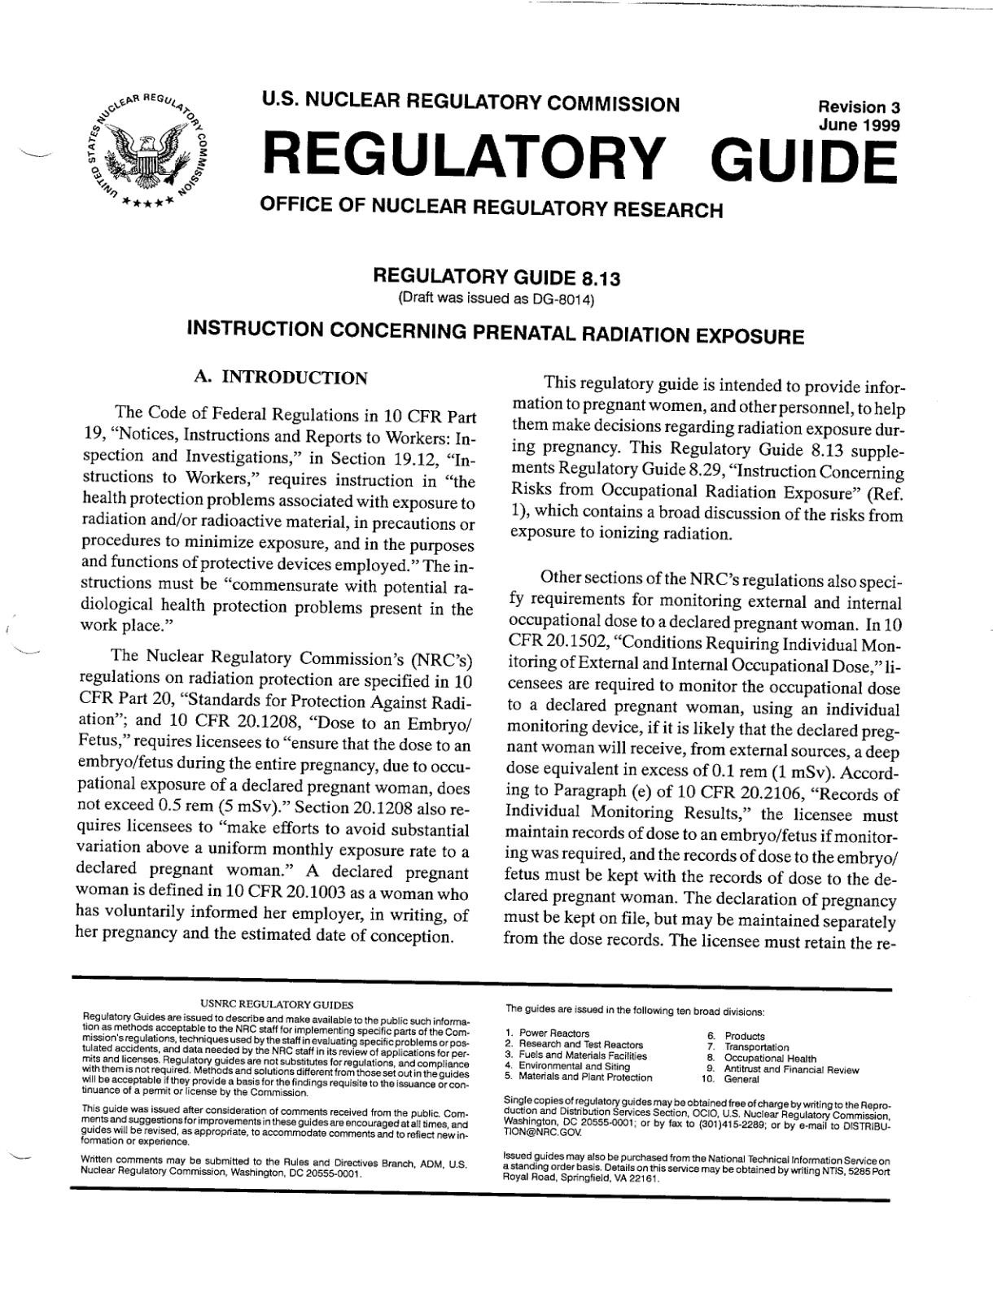Appendix A: U.S.N.R.C INSTRUCTION CONCERNING PRENATAL RADIATION EXPOSURE

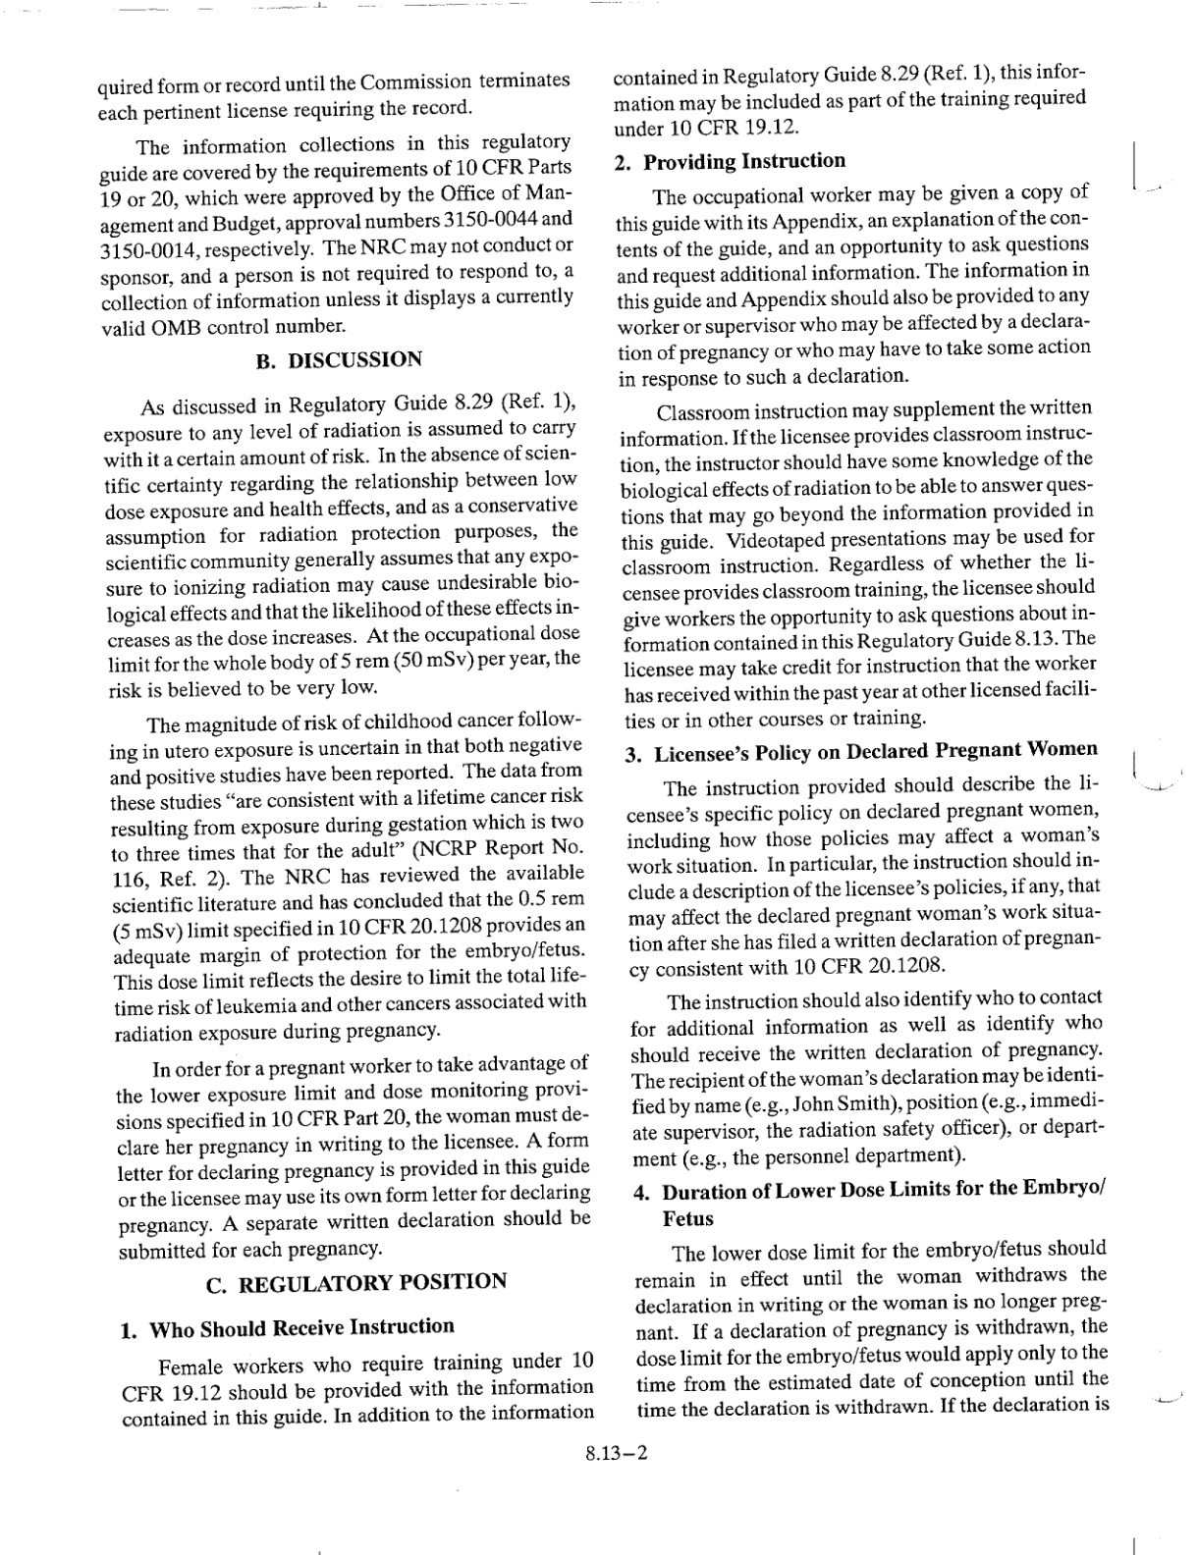

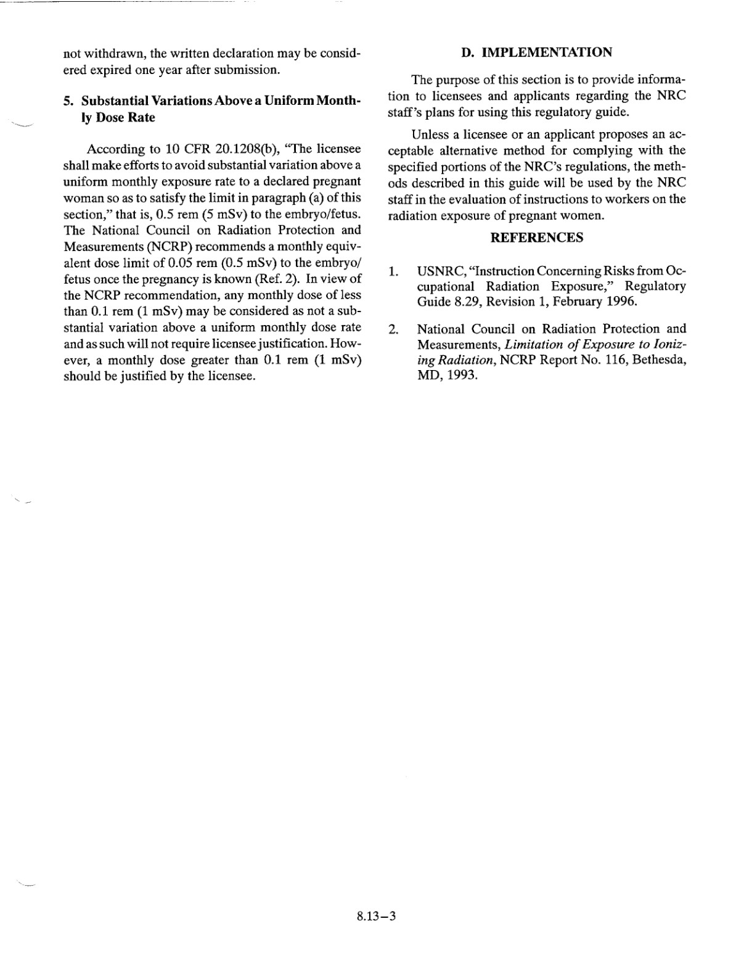

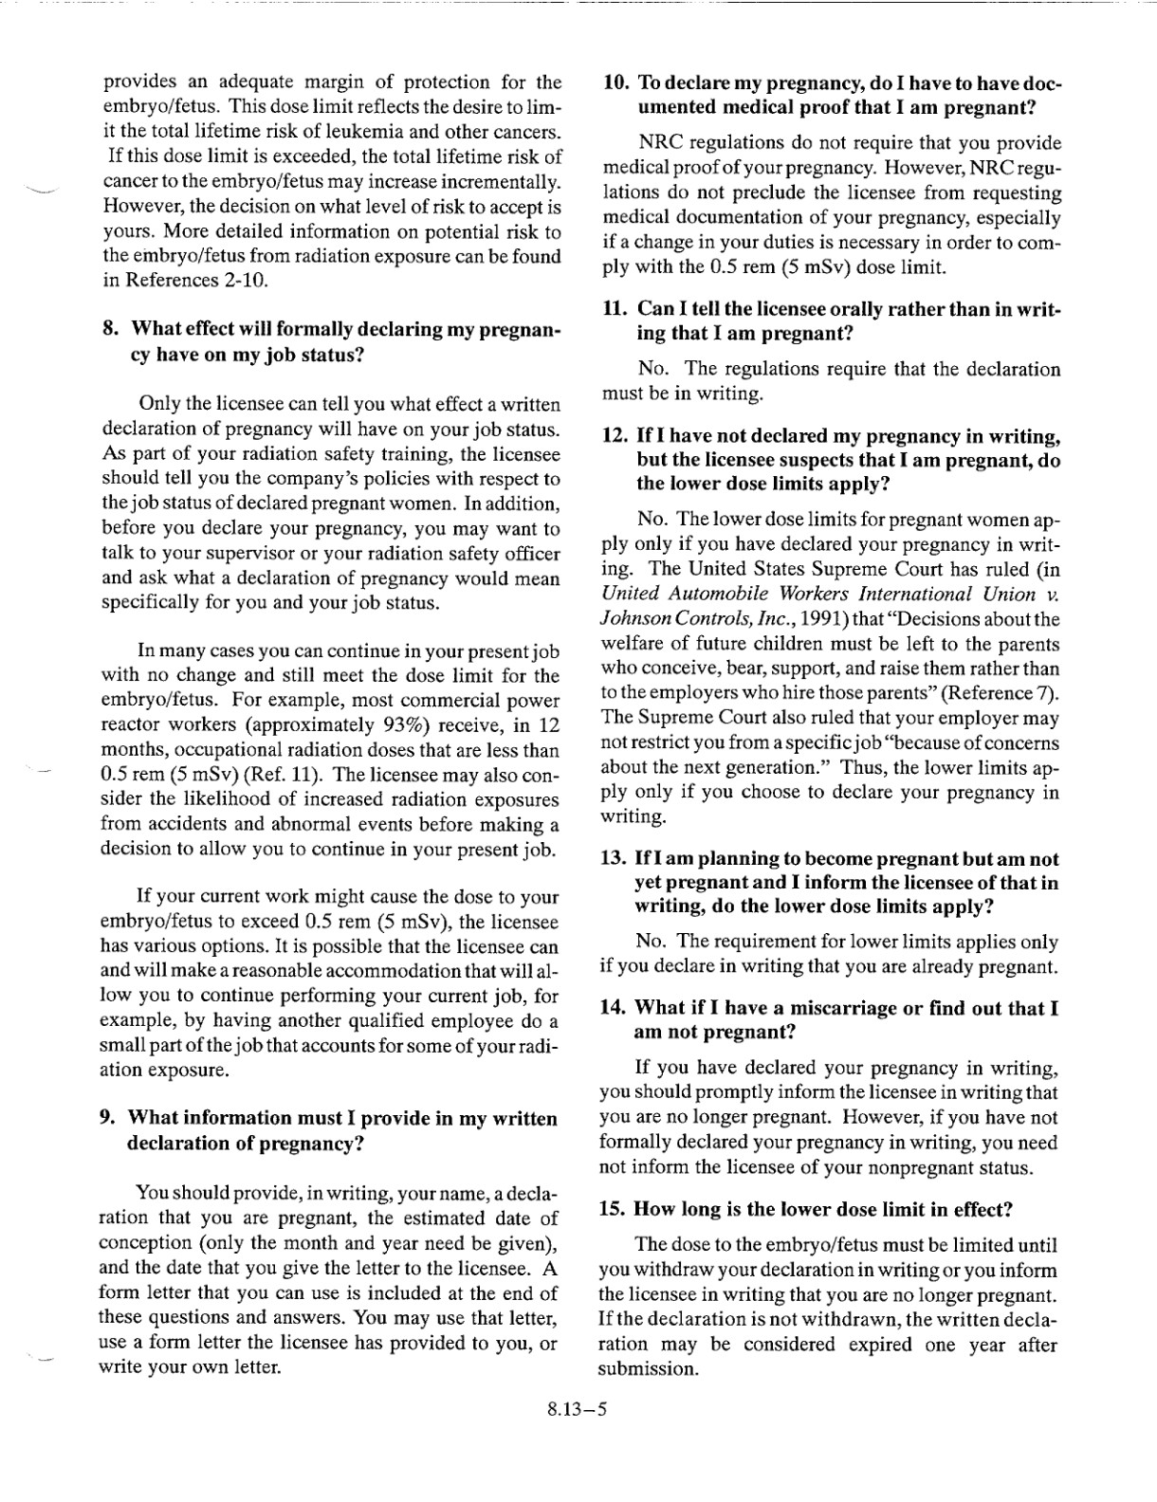

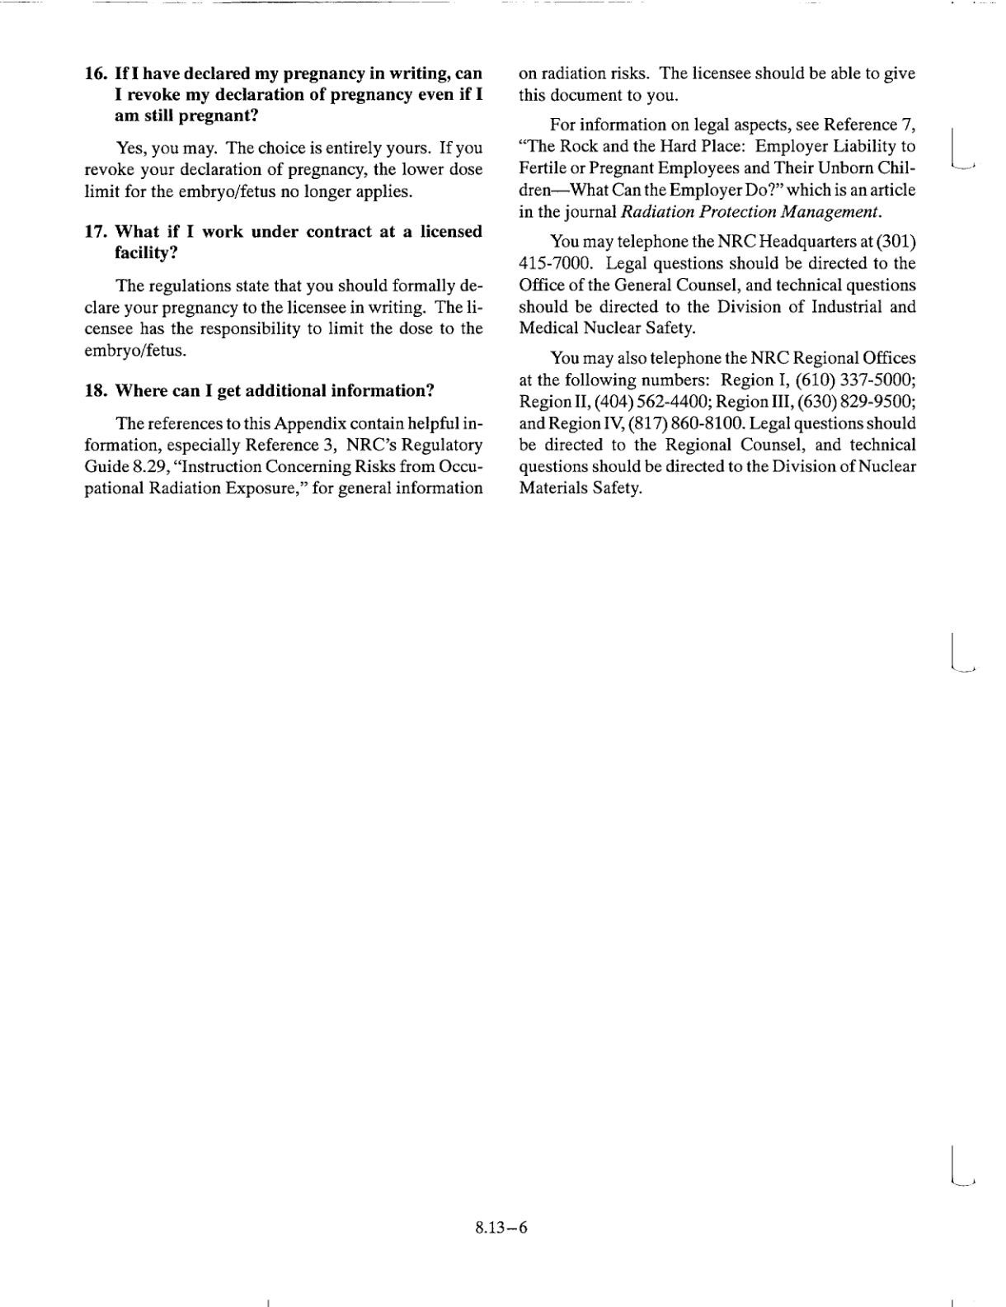

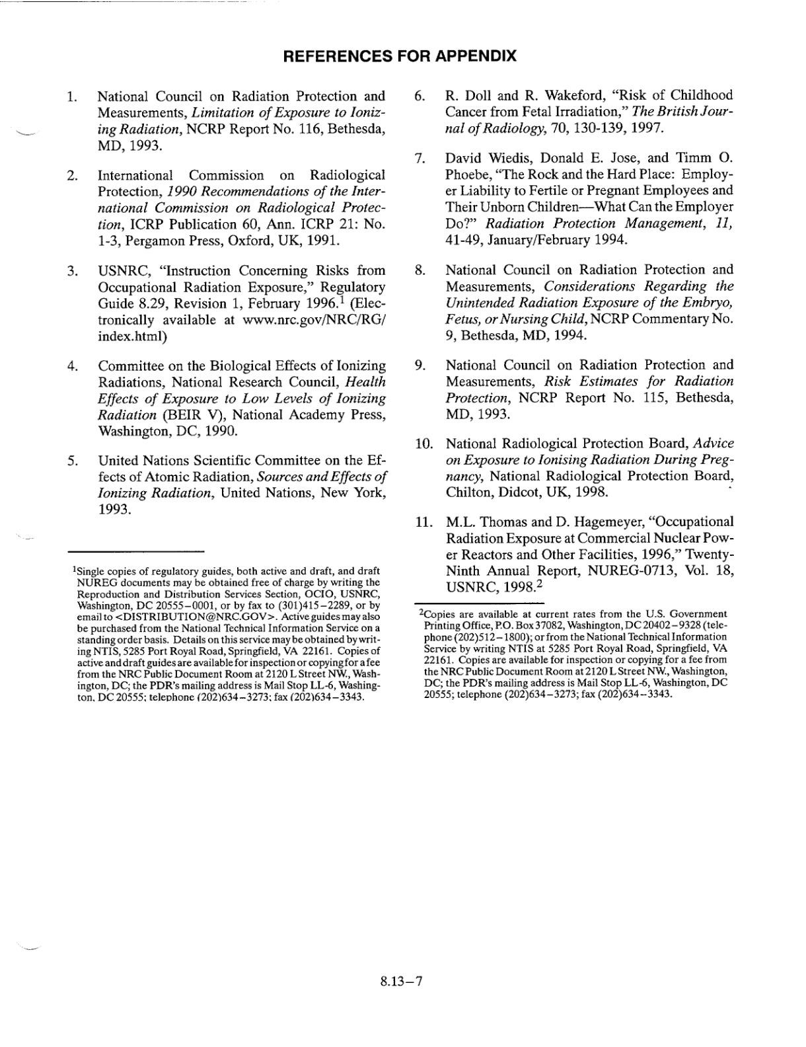

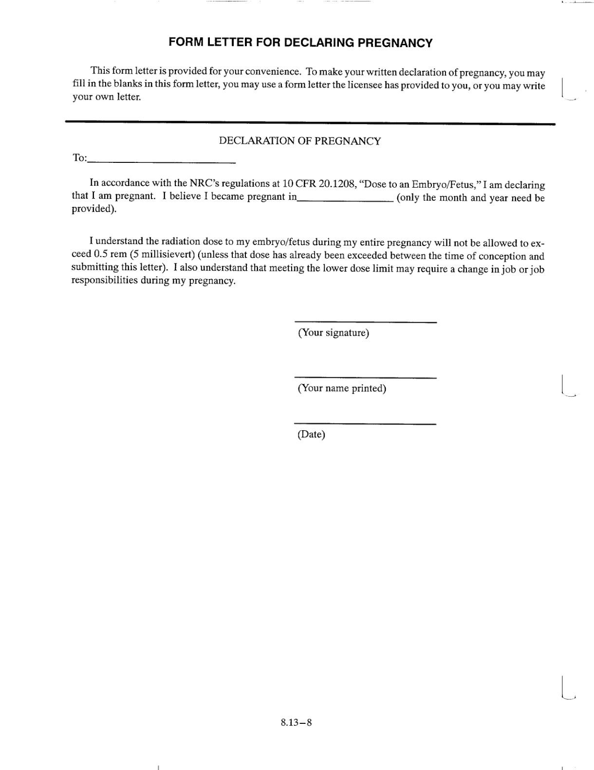

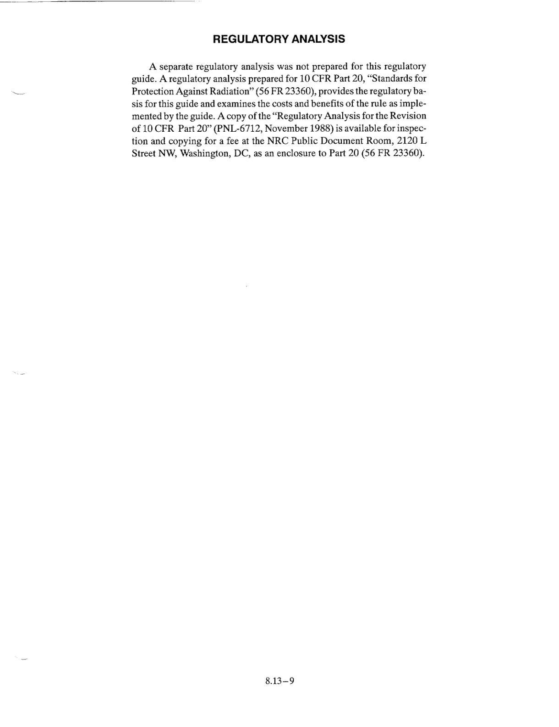

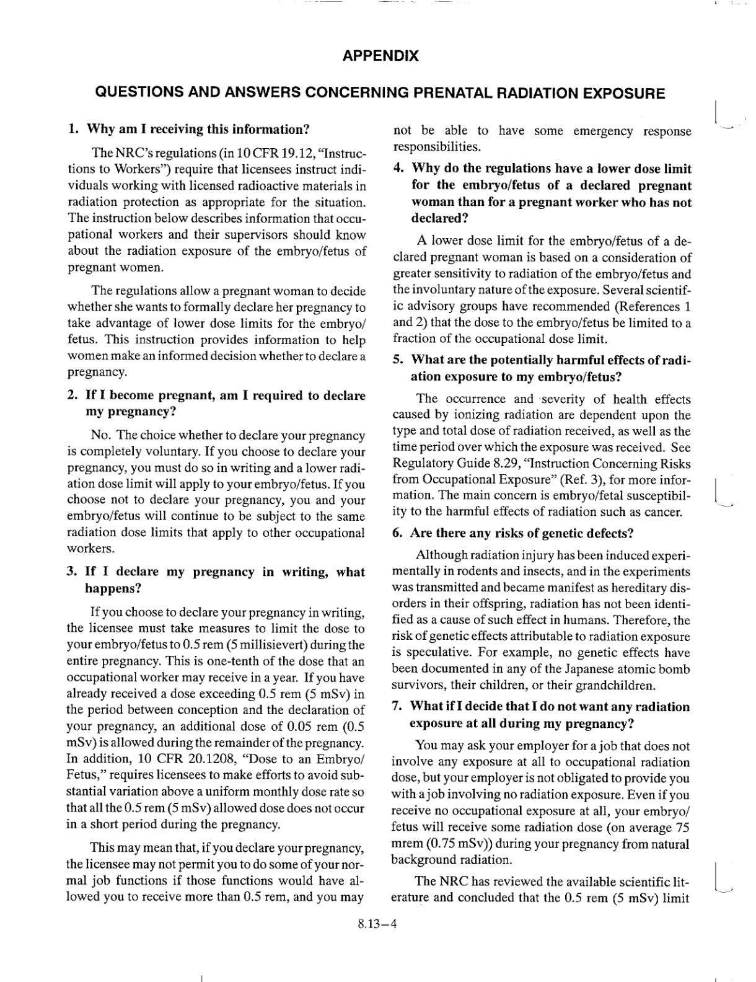

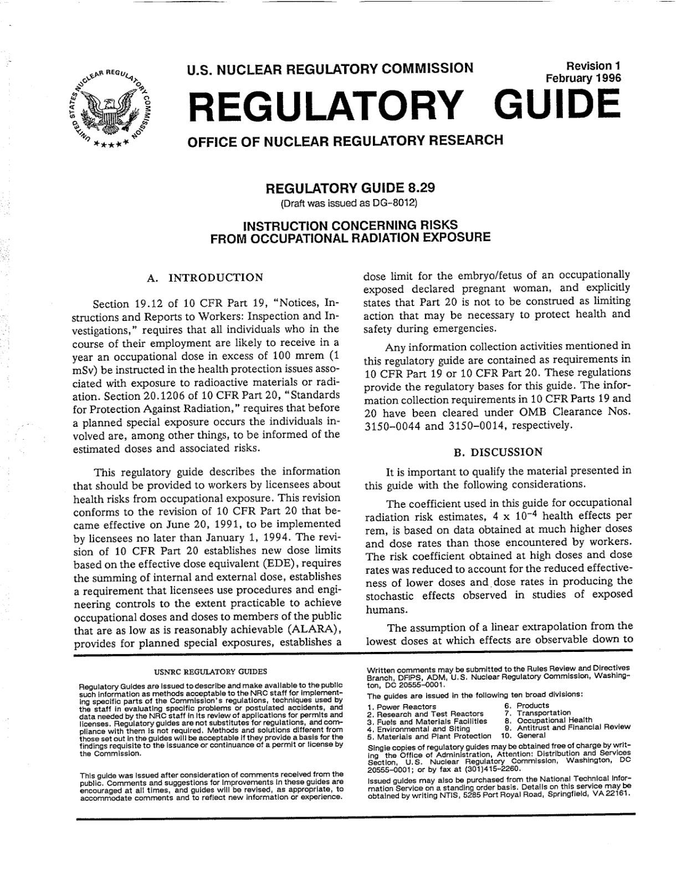Appendix B: USNRC INSTRUCTION CONCERNING RISKS FROM OCCUPATIONAL RADIATION EXPOSURE

