SciShield Access Instructions
For more information contact OcSafety@nau.edu

Table of Contents
How to log onto SciShield 3
How to access training 5
How to manage group (for department managers and PIs) 7
How to Set SciShield Defaults 13
Additional Information 17

How to log on to SciShield:
- Go to nau.edu/ehs 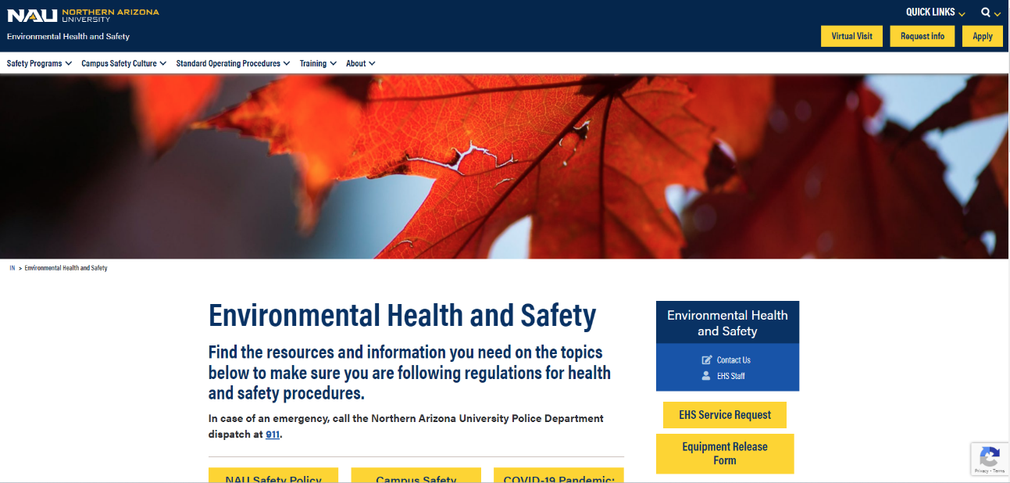
- The red arrow shows the SciShield link after scrolling down. Select this link. 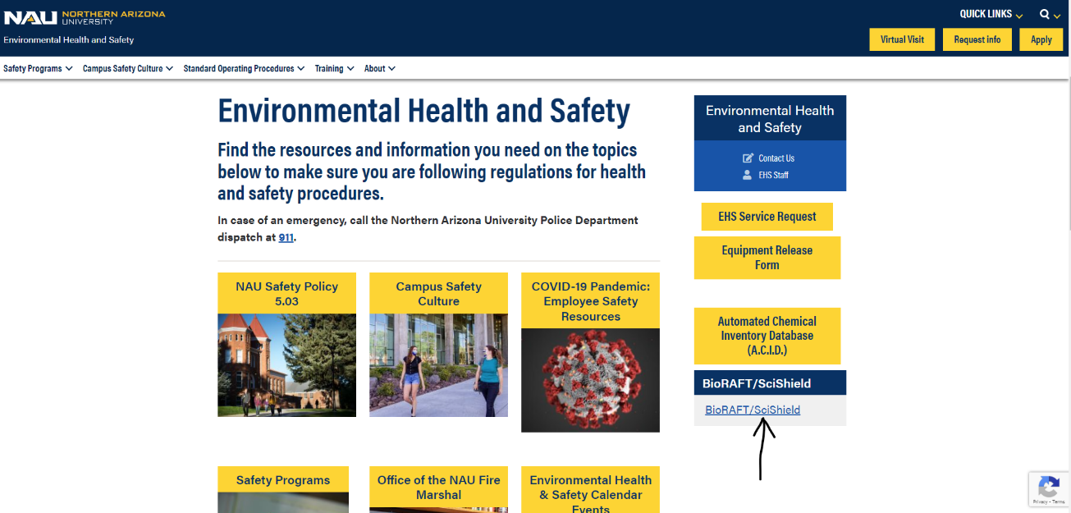

- The red arrow shows the link to log in. Select this link and log in using your NAU credentials.
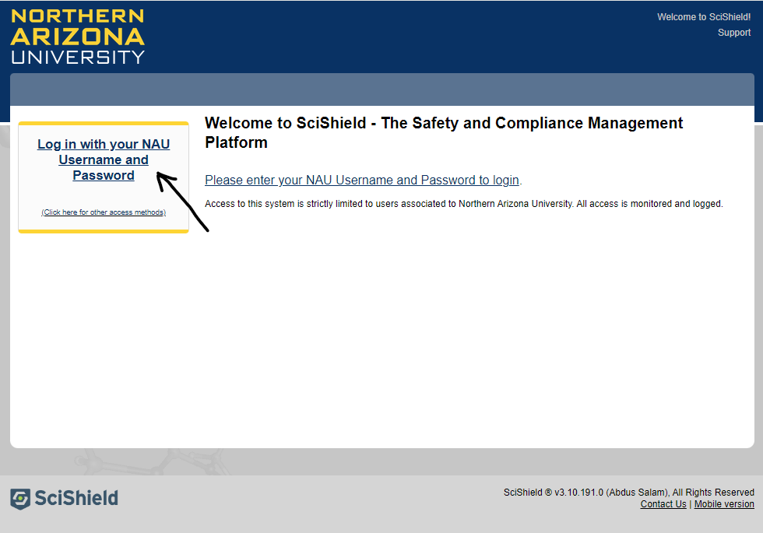

How to access training
- The red arrow shows the training link. Click on the link and a drop-down menu will appear. The blue arrow shows the link for individual training titled “My Training”. Click on the link.
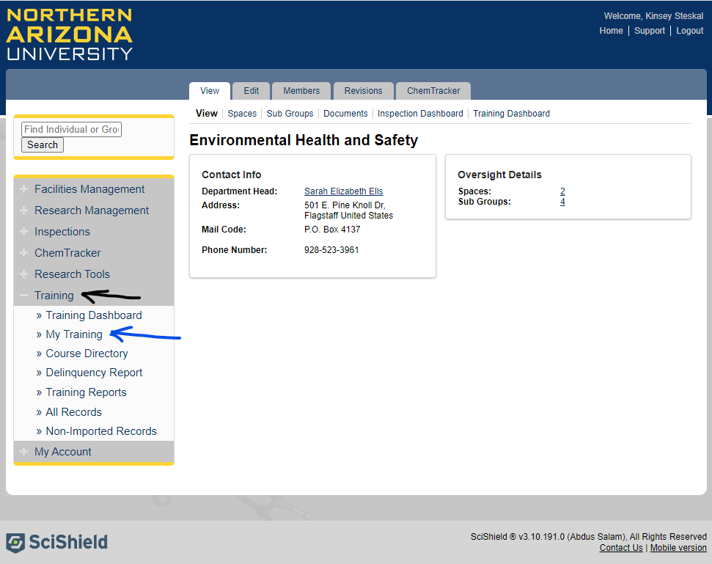

- The red arrow shows the training name as a link. To open the training click on the appropriate link. The column with the blue arrow shows the date taken. The column with the green arrow shows the expiration date of the training. If it says “N/A” then the course does not expire. The column with the yellow arrow shows a link to see the certificate.
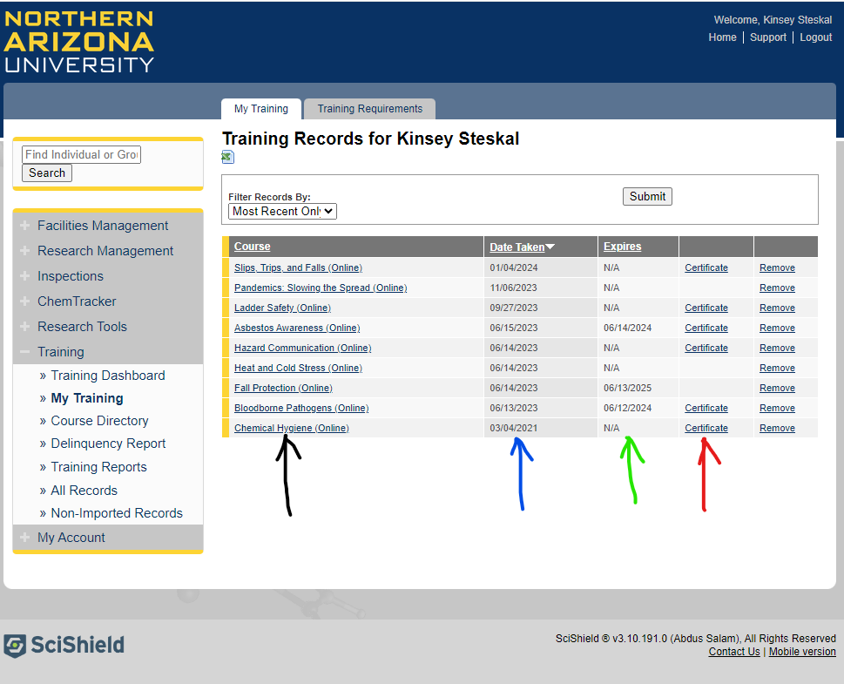

How to manage group (for department managers and PIs)
- Click on your group, and a drop-down menu will appear. Then click on “View Subgroup” profile. This is the view of the administrator, as a department manager or PI where it says “Facilities Management” and “Research Management” shown by the red arrow is where your group name will be.
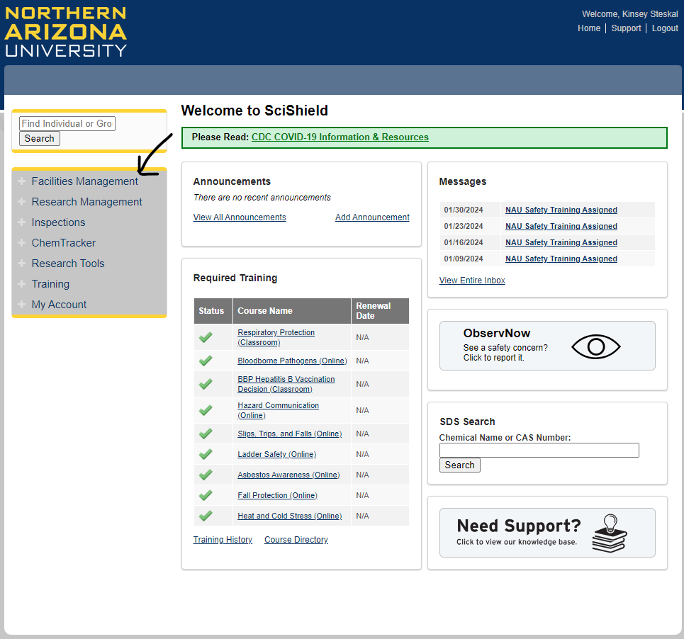

- To view training click “Training Dashboard”.
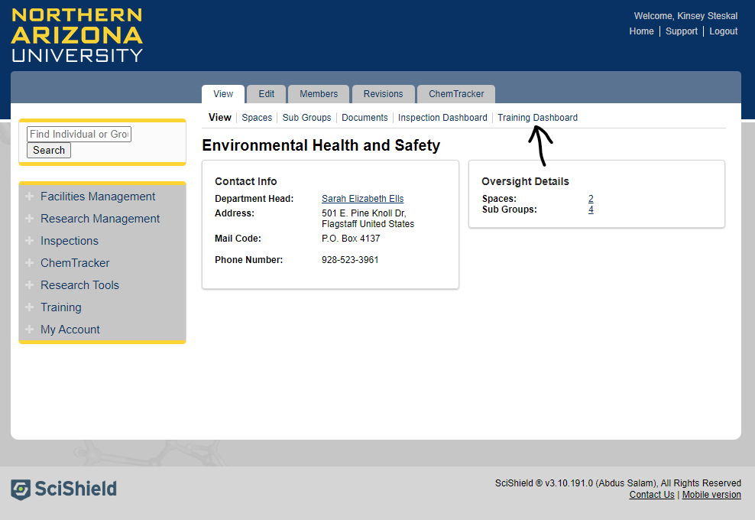

- To add members, click “Members” shown in the red arrow, then type in the name of the member OR the NAU email address to add in the box shown with the black arrow. Do NOT press enter. Wait for it to load and click on the correct name below. Then click on the designation box, as shown in the blue arrow, and select the type of member this person is. Afterwards scroll down to the bottom and click “Lookup/Add”, as seen in the bottom of the second image below in the orange arrow. Enrollment is an onboarding requirement for employees who work in physical environments such as labs, shops, or skilled trades.
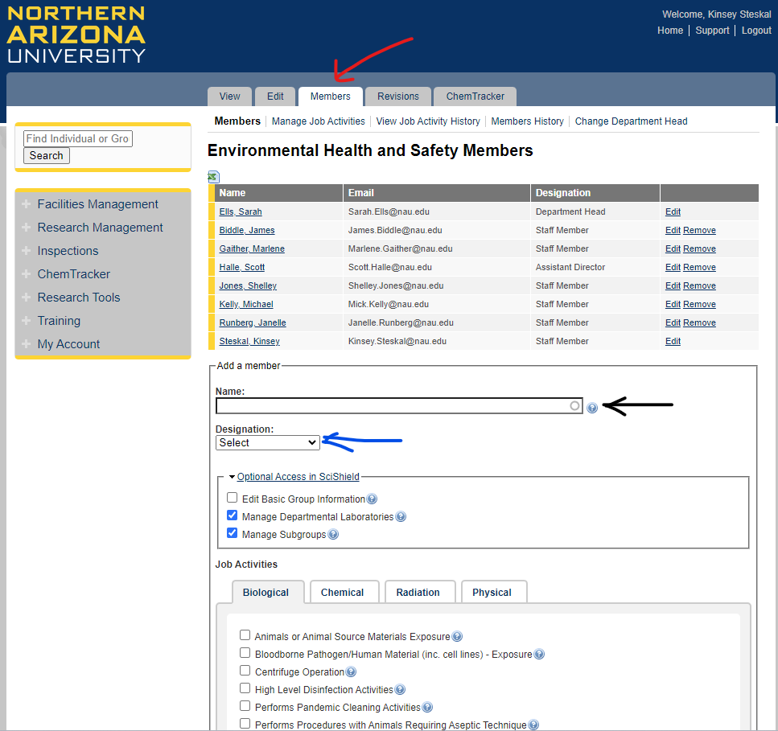
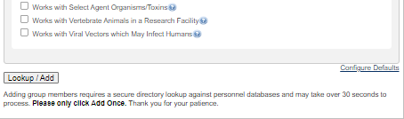

- The red arrow shows a remove link. To remove a member, click “Remove”. Unenrolling employees upon transfer and separation is a required off-boarding step. Removing does not delete any information, it only removes the person from your group.
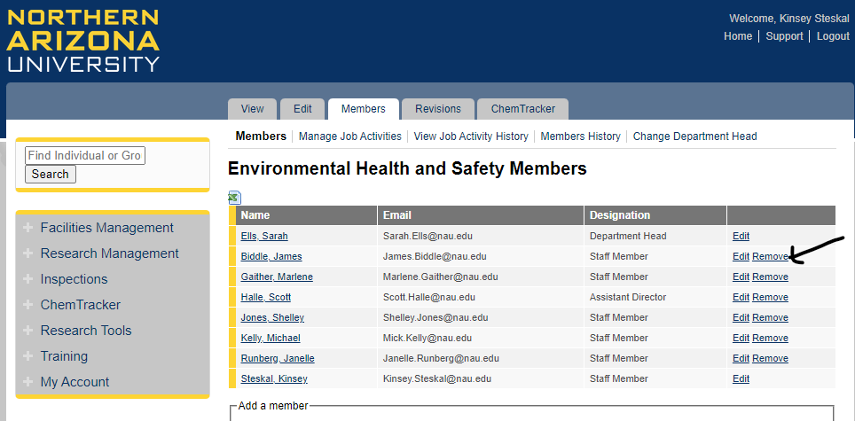

- The red arrow shows the “Members” tab. To change job tasks, click this tab. Then click “Manage Job Activities” as shown with the blue arrows. As a supervisor, assigning the job tasks are a required step, and the job task selection process is how the supervisor enrolls employees in required training. It is important to ensure all your employees have the proper job trainings.
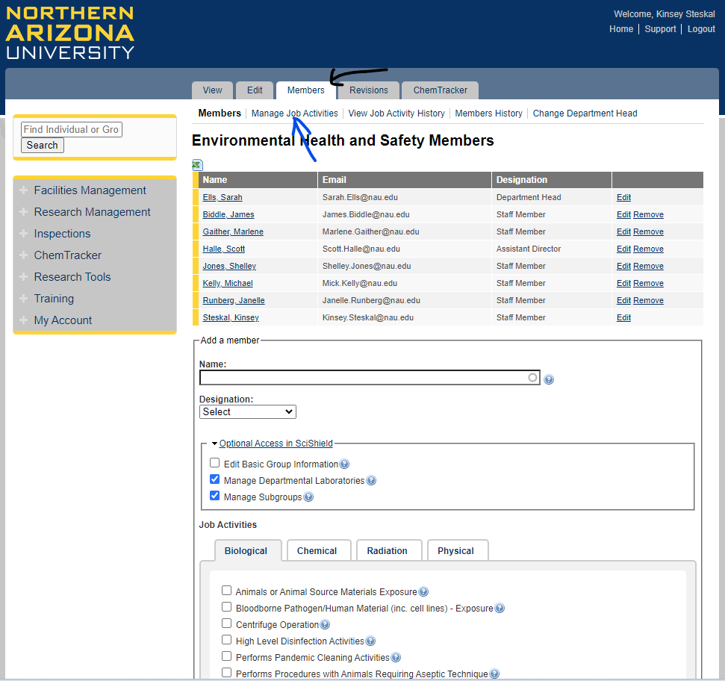

- Click on the appropriate job tasks, and then click “Submit”. It is important to click “Submit” roughly every 20 minutes as failure to do so may result in the work not being saved.
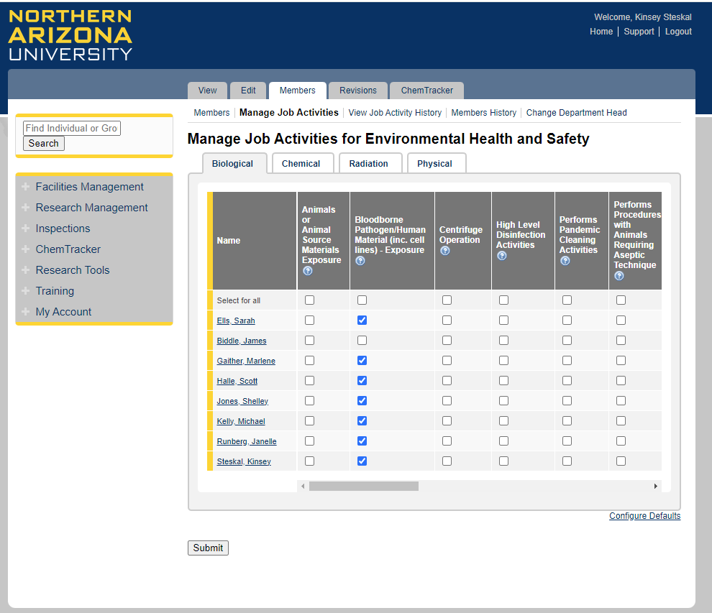

How to Set SciShield Defaults
- Go to your group and click on “Members” shown by red arrow.
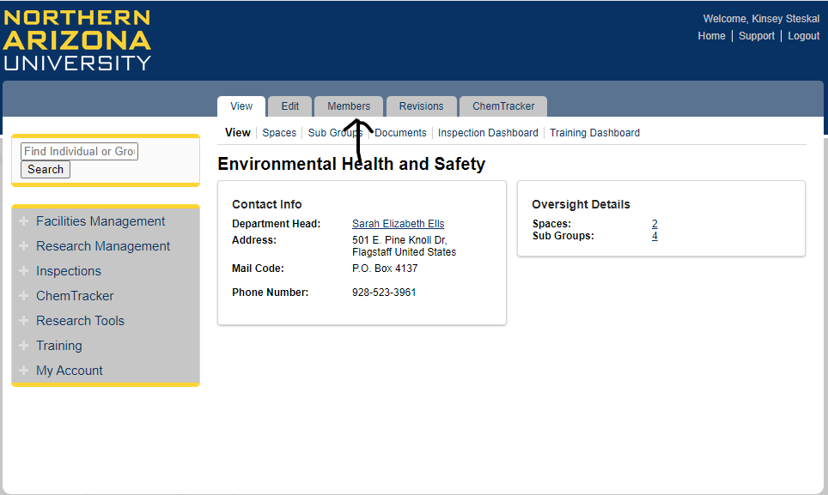

- Click on “Manage Job Activities”.
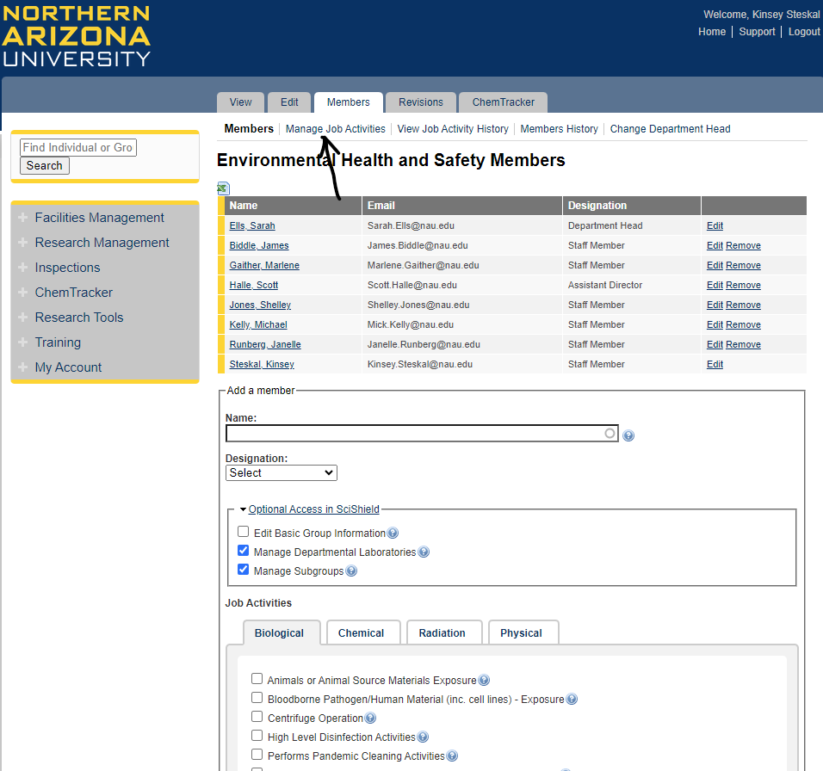

- Click on “Configure Defaults”.
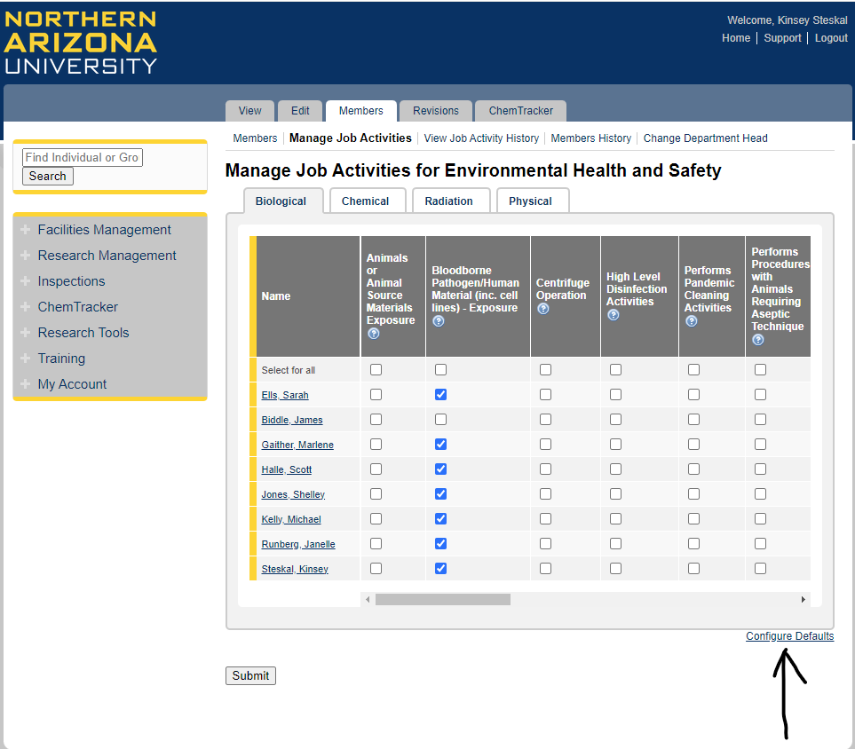

- The categories can be changed within the area indicated by the red arrow.
  - The “Hidden” tab (highlighted yellow) should be ignored. Hiding task will remove the task from view and may be forgotten.
  - The “Available” tab (highlighted blue) is typically the default. By setting the task of available it will be seen but not assigned.
  - The “Default” tab (highlighted green) would assign the task as the default. This would automatically add all employees to this task, but this can be changed on a case-by-case basis by a SciShield group manager (supervisor).
  - The “Required” tab (highlighted orange) will assign the task automatically but CANNOT be overridden ever. Because this cannot ever be overridden, we do not suggest using this tab.
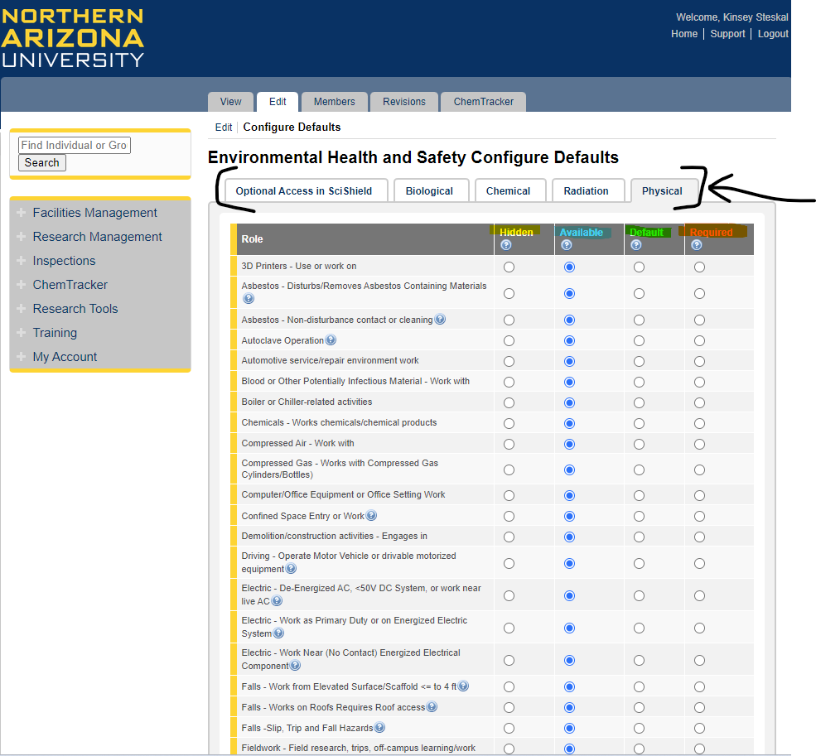

It is important the job tasks should be revisited yearly, as jobs do change overtime and training should accommodate that. Some individuals may have tasks that are unique to them, so supervisors must also review and assign job specific training on an individual-by-individual basis. Defaults are unlikely to be adequate for an entire department.
The SciShield platform has many more screens and functions. These instructions will get you started but feel free to explore or contact EHS if you have any questions regarding the use of the platform.

