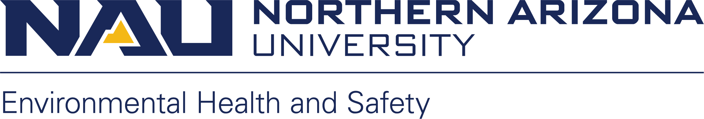

NIH Guidelines rDNA Training Quiz

Name: Date:

NIH Guidelines rDNA Training Quiz

- Use of rDNA is regulated by..?
  - USDA
  - CDC
  - NIH
  - EPA

- All research with rDNA at NAU needs to be registered with the..?
  - Institutional Biosafety Committee
  - Fire Department
  - President’s office
  - Safety Compliance Officer

- Who is responsible for the NIH system of oversight of rDNA in research?
  - NIH Office of Biotechnology Activities (OBA)
  - The Office of Recombinant DNA
  - The office of NIH Oversight
  - The rDNA Committee

- rDNA research that is non-compliant with NIH Guidelines can result in termination of funds for the non-compliant research project and termination of NIH funds to other rDNA research projects at NAU.
  - True
  - False

- Your experiments fall under which section of the NIH Guidelines?
  - Section I
  - Section II
  - Section III
  - Section IV

- Who makes the initial risk assessment for rDNA research?
  - The EH&S safety officer
  - The IBC
  - The Principal Investigator
  - The Fire Marshal

- NAU applies NIH Guidelines to all research, regardless of funding.
  - True
  - False

- Registration with the IBC is required at NAU for all rDNA research, regardless of whether or not it is exempt from the NIH Guidelines.
  - True
  - False

- According to the NIH Guidelines, the determination and understanding of which classification covers your rDNA research is a..?
  - PI responsibility
  - NIH responsibility
  - OBA responsibility
  - Fire Dept responsibility

- Any incidents involving rDNA should be reported to the Biosafety Officer and the Institutional Biosafety Committee.
  - True
  - False

- Bonus: Which classification covers most rDNA research in E. coli?
  - Section III-C-1
  - Section III-F-8 Appendix CII
  - Section III-B-1
  - Section III-E-3

