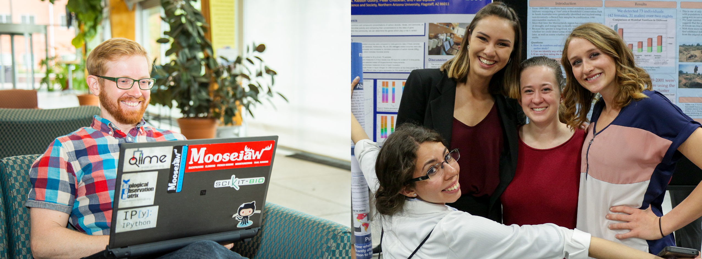

PMI Undergraduate Application
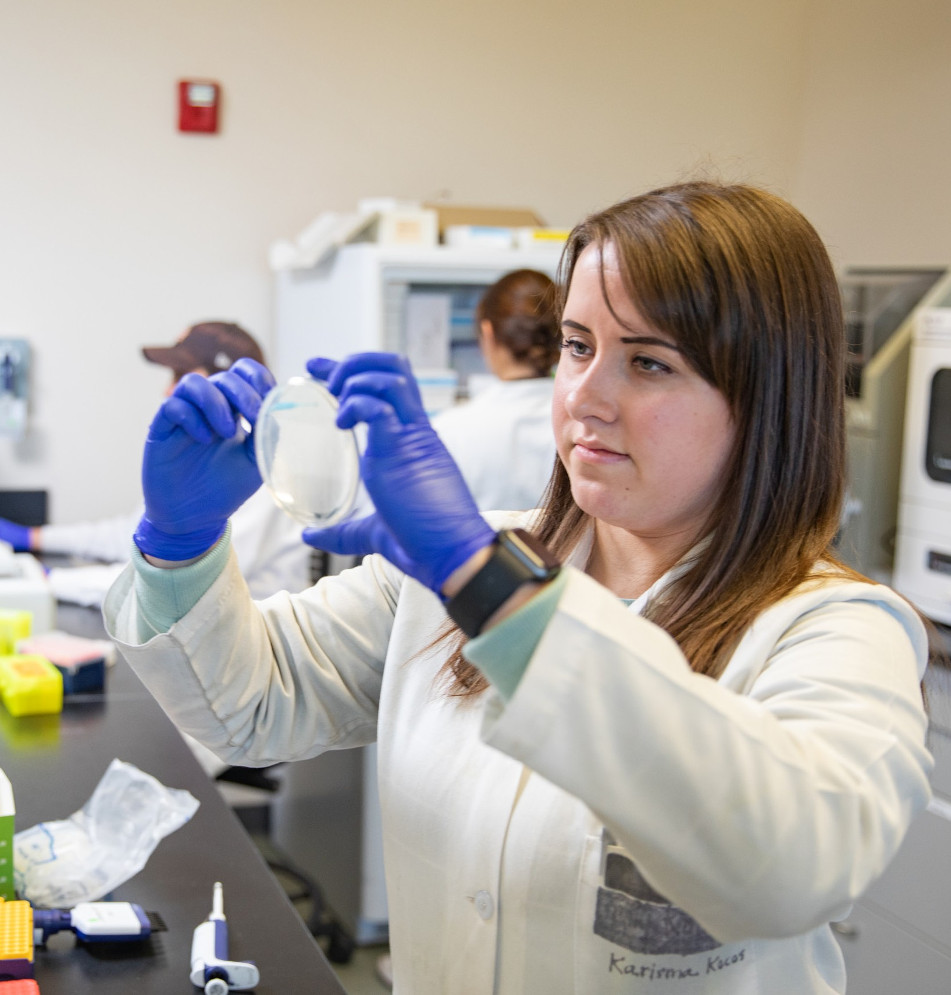The Pathogen & Microbiome Institute (PMI) at NAU is an internationally recognized research facility focused on developing technologies to better understand and manage pathogens that affect humans and wildlife.

PMI is committed to the professional development of undergraduate student employees and accepts students from diverse disciplines (biology, chemistry, computer science, business, graphic design). Students in our program work on exciting research projects (as an undergrad research assistant in the laboratory or bioinformatic assistant) or provide logistical support (business administration office) under the careful mentorship of faculty, staff, and directors at PMI.

There are over 100 faculty, full-time staff, graduate and undergraduate students currently employed at PMI. Don’t miss this opportunity to apply and expand your horizons.

For more information, visit us on https://joinpmi.com/job/

JoinPMI.com | Vimeo

or Instagram.

Instagram.com/nau.pmi

Working at PMI provides opportunities to:
- Do cool science research.
- Get paid to learn.
- Experience professional mentorship.
- Build your professional skills and networks.
- Expand your professional opportunities.

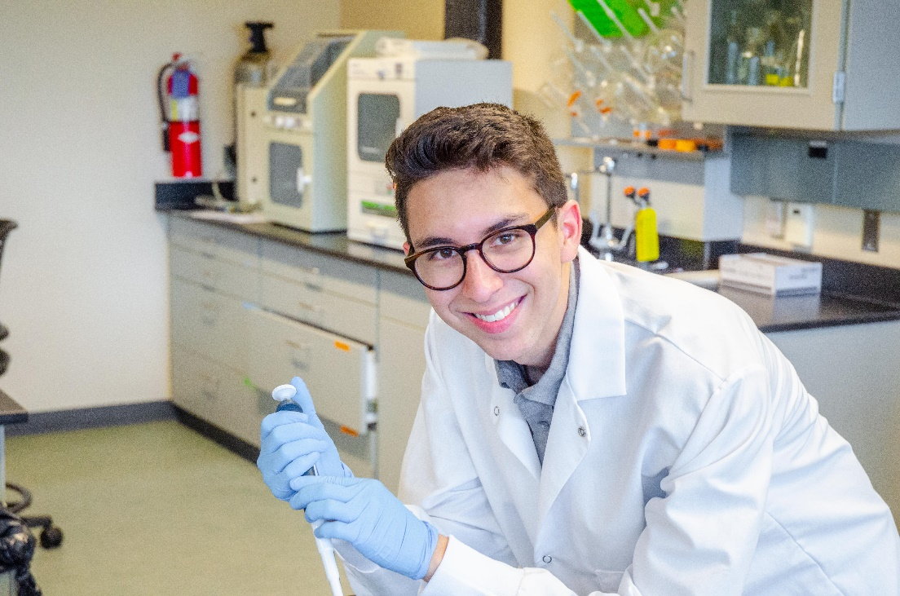
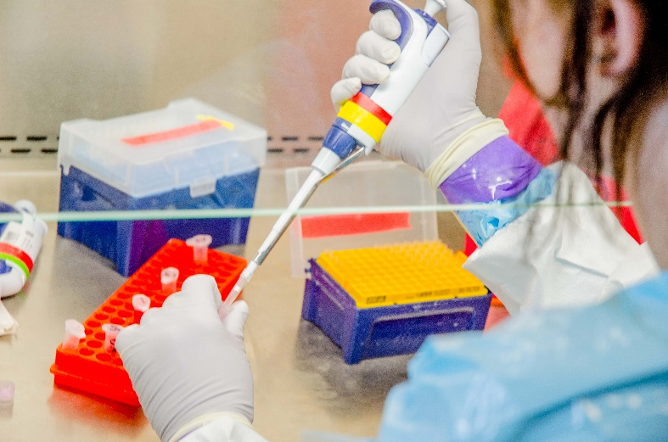
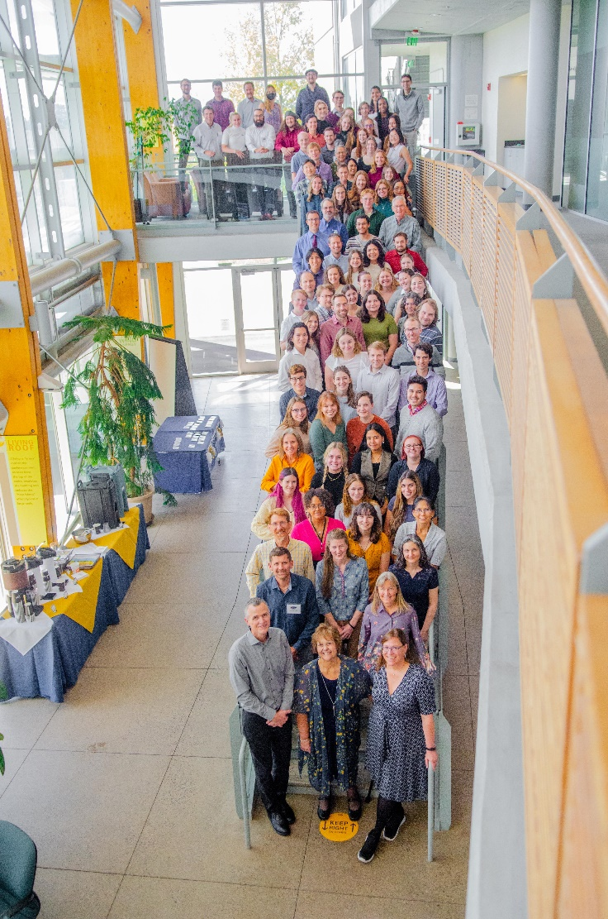

General Prerequisites

Should You Apply?
We’re an equal opportunity employer. All applicants will be considered for employment without attention to race, color, religion, sex, sexual orientation, gender identity, national origin, veteran or disability status.

Regardless of academic year or area of study, we encourage all undergraduates to apply.
- Must be a full-time NAU undergraduate student in good academic standing.
- Must commit to a minimum of 10 full months of employment.
- Must be willing to submit to a background check (if hired).

Professional Mindset:
- Be committed and dedicated to the job.
- Be prepared for training and evaluation.
- Be open to instruction and feedback.
- Be self-motivated, responsible, and accountable.
- Be proactive. Think ahead towards logistical processes, technical challenges, and professional relationships.

Professional Conduct:
- Fulfill job commitments.
- Communicate with supervisor all relevant work-related information in a timely manner (project or logistical information, project progress, planned or unexpected absences, and other relevant topics deemed important by your supervisor).
- Work as a team with colleagues. Communicate clearly, agree on plans, provide support
on multiple projects and follow through on commitments.
- Practice an effective personal organization strategy. Focus on tasks at hand.
- Interact in a respectful and positive manner with other members and teammates.



Undergrad Research Assistant

Life Science Emphasis Expectations:
Research Project Duties:
General Job Description:
- Perform research to support grant-funded projects at PMI from fields such as:
  - Genetics/genomics
  - Protein/immunology
  - Bioinformatics/ computational analysis
- Undergraduate research is conducted under the direction of an immediate supervisor

- Students will be given the opportunity to present a research poster
at the annual NAU Undergraduate Symposium.
- Perform research to support grant-funded projects at PMI.
- Perform specific molecular techniques that are dependent on supervisor’s project needs (examples include: PCR, DNA sequencing, protein techniques, bioinformatics computational analyses, preparation of chemical stock solutions, and other highly specialized procedures required by your project).
- Conduct computer data entry while maintaining a detailed and organized lab notebook, writing protocols, and performing calculations for lab work.
- Follow technical procedure protocols; trouble-shoot technical problems.
- Comply with all biosafety and security protocols.

General Laboratory Duties:
- Conduct tasks related to upkeep of lab instruments and computers.
- Contribute to routine lab cleaning every 2 weeks or as needed.
- Resupply lab reagents and supplies by placing orders as needed.
- Lab maintenance (washing laboratory glassware and equipment, recycling cardboard
and styrofoam).
- Take out lab trash (on a rotation basis).

Positional Duties:
- Work with supervisor to setup a weekly work schedule and commit to work those dedicated hours.
  - No less than 15 hrs per week. The most successful students engage in 20-25
hrs of research weekly
  - Summertime work is also important for success.
- Attend weekly lab meetings.
- Attend and actively participate in undergraduate meetings that cover professional
development topics that occur every 2 weeks.
- Sign up for BIO485 to receive research credits during fall and spring semesters.
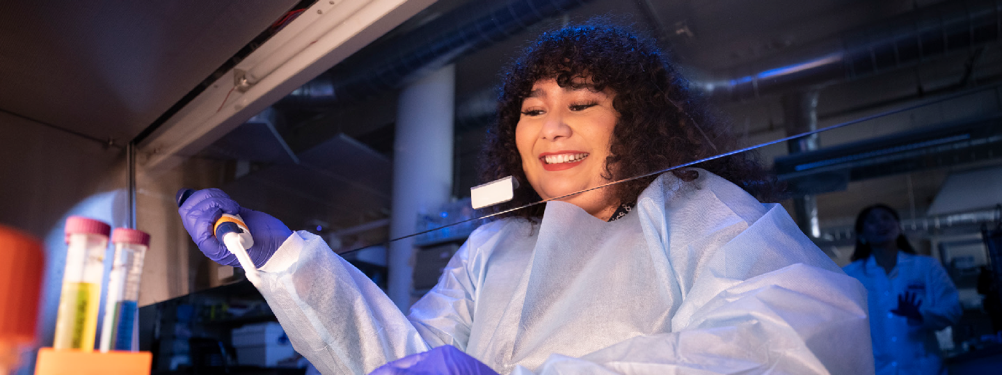

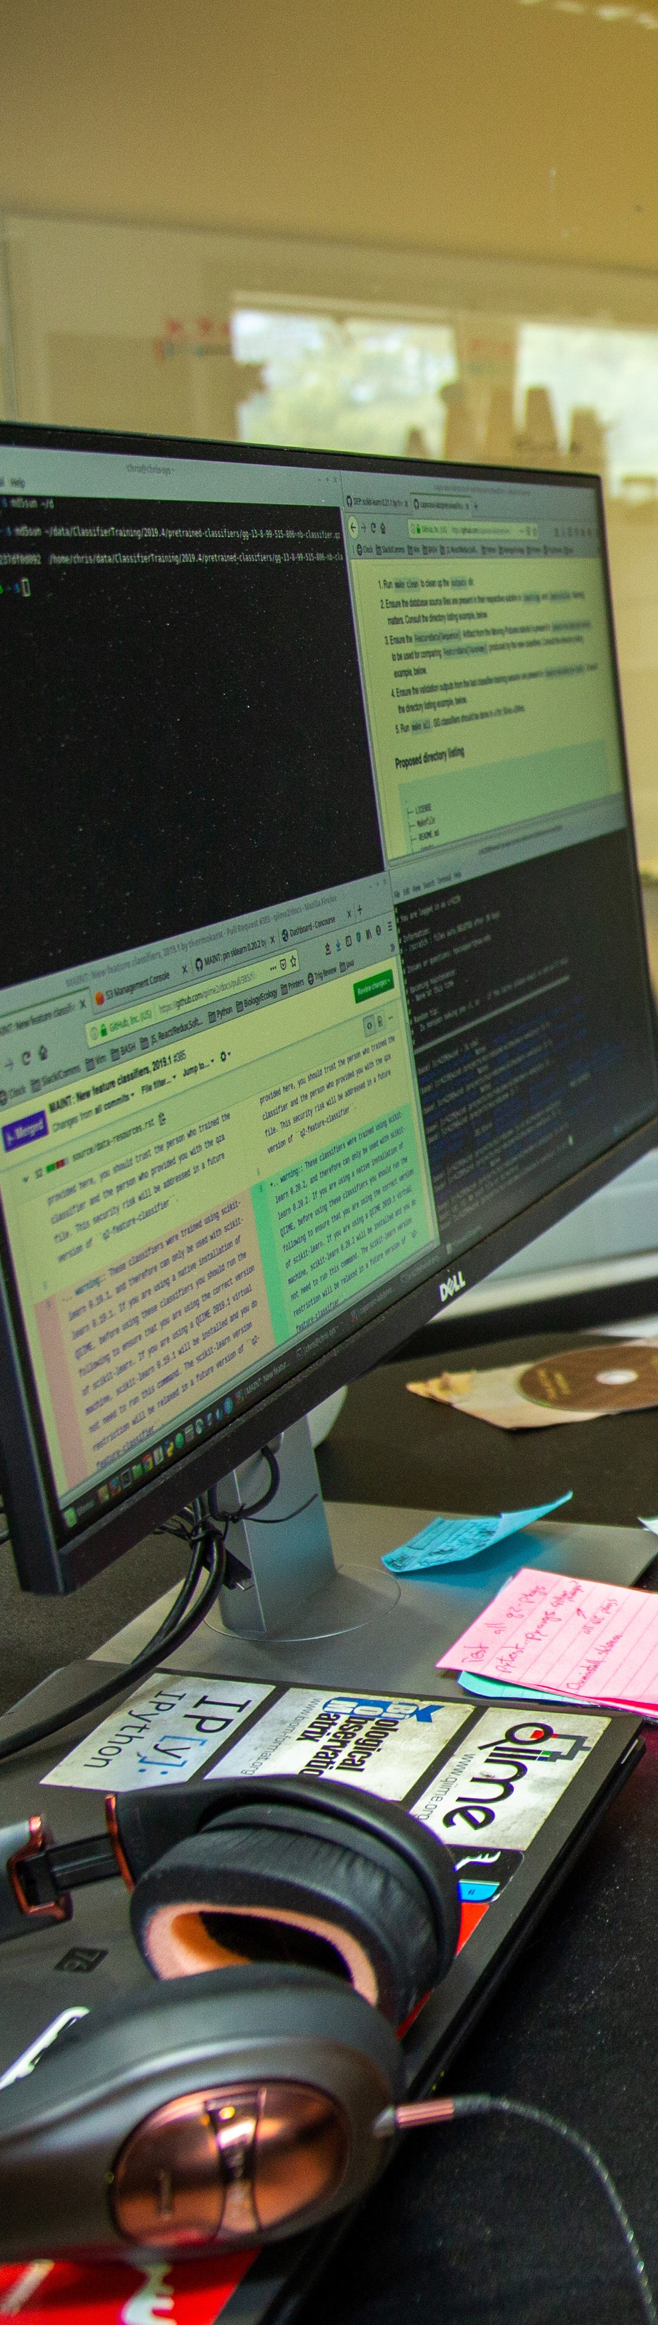

Bioinformatics/Software Engineering Emphasis Expectations:

Position #1 Student Bioinformatician/Data Scientist: Bioinformaticians at PMI play essential roles in turning data into knowledge. This generally involves working closely with labs generating DNA sequence or other data and running software on the monsoon supercomputer to address import research questions.

General Office Duties:
- Application of bioinformatics software to perform microbiome, genomics, and other analyses as a member of a multidisciplinary team.
- Assist with bioinformatics analyses.
- Assist with vetting of analyses results prior to publication.
- Communicate analysis steps and results to other researchers and provide assistance with preparing results for publication.
- Automate analyses using scripting languages.

Preferred Qualifications:
- Experience writing software in Python and/or R, or using data analysis tools such as Jupyter Notebooks or R Studio.
- Experience working with command line software in Linux or macOS environments.
- Some undergraduate statistics coursework.

Position #2 Student Research Software Engineer:
Research Software Engineers at PMI develop software to be used in-house and by research teams around the world. In addition to software development, software engineers are closely involved with user support, education, and review of code developed by others.

General Office Duties:
- Develop, test, and document software as a member of a multidisciplinary team.
- User support via online forums, hands-on workshops, email, and in-person or virtual meetings to assist users of software developed at PMI. Occasional travel may be required to assist with teaching bioinformatics workshops, attend conferences or software development “sprints/hackathons”, or visit collaborators.
- Detailed iterative code review of software developed by others.
- Periodic pair-programming with other team members.
- Assistance with development of software design plans.
- Preparation and testing of software releases.

Preferred Qualifications:
- Experience with developing and testing software, or integrating with third-party APIs, or with web application development.
- Experience working with command line software in Linux or macOS environments.
- Experience using GitHub.


PMI business support team

Business Administration Emphasis Expectations:
General Duties:
- Package/mail management
- Ordering supplies
- Filing/database management
- Running errands
- Office supplies/equipment management
- Electronic database filing
- Department plant care

Specialized Office Duties:
- Invoice payment
- Reimbursement of purchases
- Create quarterly PMI magazine
- Graphic Design for institute needs and special projects
- Maintain a business purchasing card
- Coordinate meetings and events
- Assist with arrival of guest speakers, research collaborators, and PMI interviewees.

Additional Materials Required for Application Packet (see page 9)

Date:

Name:
(Last) (First) (MI)

Phone:
NAU Email:
NAU ID:

Local Address:

Permanent Address:

Major:
Minor:
Cumulative GPA:

Credits Completed:

Current Class Status:
Freshman
Sophomore
Junior
Senior
Other

Anticipated Graduation Date: How did you learn about this job?

Can we make copies of your NAU transcripts? Yes No

Which Campus do you prefer to work at?

Are you eligible for Federal Work Study?
Go here to determine your eligibility.

Will you agree to a background check?
NAU Campus Only

Yes No

Yes No
TGen North Campus Only
Either

Select the emphasis that interests you:
(you may select multiple options)
Life Sciences

Business Administration
Bioinformatics / Software Engineering IT Support

Signature:

Previous Employment Experience:
Employer:

Supervisor:

Job Title: Supervisor Contact:

Employment Dates:

Job Description/Responsibilities

Employer: Supervisor:

Job Title: Supervisor Contact:

Employment Dates:

Job Description/Responsibilities

Employer: Supervisor:

Job Title: Supervisor Contact:

Employment Dates:

Job Description/Responsibilities

References:

Name: Contact:

Name: Contact:

Name: Contact:

Additional Materials Required for Application Packet:
Things to Consider:
- Email your completed application packet to the dawn.birdsell@nau.edu

- Ensure that you have all required items in your packet!

- For questions, direct your email to dawn.birdsell@nau.edu and copy ugjobs-pmi@nau.edu.
- Include a weekly schedule of hours that you are available for work.
(example: Mon-Fri schedule when you are available for work).
- Include a copy of your resume with your application.
- Include unofficial transcripts of all college courses you have taken to date (or high- school transcripts if incoming freshman).
- Optional: Cover letter
- Optional: A Letter of Recommendation
The completed application packet (pages 7-9) can be emailed to UGJobs-PMI@nau.edu and copy Dawn.Birdsell@nau.edu.

Incomplete packets will not be reviewed or made available to hiring committees. All applications are held for one year from the date you submitted it to the front office. At any time after submitting your application, you may update documents in your packet if you wish or apply again after the one-year mark.

OFFICE STAFF USE ONLY
Stamp Received

Unofficial Transcripts
Resume
Availability Schedule

INTERVIEWER USE ONLY (mark one box per interview)

References Checked? References Checked?

Applicant Interview Date: Applicant Interview Date:

References Checked? References Checked?

Applicant Interview Date: Applicant Interview Date:

