CMP Justification for Exception to Policy request
User Guide
February 26, 2020
Northern Arizona University
Comptroller’s Office (CMP)
Created by Sharon D Jackson

Table of Contents

- Faculty and Staff Reimbursement Accountable Plan Policy 2
- Use of the Justification for Exception to Policy Request Form 2
- Access the Justification for Exception to Policy Request Form 3
- Complete a Accountable Plan Reimbursement Justification Request Form 4
- Complete a Blanket/One-Time Justification for Exception to Policy Request Form 9
- Submit an Justification for Exception to Policy Request Form 15
- Process Overview – Accountable Plan Reimbursement Justification Request Form 16
- Process Overview – Blanket or One-Time Exception Request Form 18
- Justification for Exception to Policy Signer Process a Blanket or One-Time Justification for Exception to Policy Request 20
- Correction to a Accountable Plan Reimbursement Justification Request Only 23
- Retrieve Justification for Exception to Policy Request Forms 23
- Reimbursement or Justification for Exception to Policy Request Manual Cancellations 24
- Reminder 7 and 14 Day Notifications before Auto Cancellation of Request Form 24
- Appendix – Examples of Email Notifications 25

- Faculty and Staff Reimbursement Accountable Plan Policy
  - Click Accountable Plan to view policy.
- Use of the Justification for Exception to Policy Request Form
  - The CMP Justification for Exception to Policy Request Form is used for an Accountable Plan Reimbursement Justification Request or an Exception to NAU Comptroller’s Policy and Procedures Request.
  - You can click the ? button to show and hide help for the type of justification that needs to be completed.
  - Complete the form as an Accountable Plan Reimbursement Justification Request for an exception to the Accountable Plan policy to allow a reimbursement to be processed. It needs to include Department information, who needs the exception, why the exception is needed, the amount and any supporting documentation.
  - Complete the Justification for Exception to Policy Request form for an exception to a NAU Comptroller’s or Travel Policy and Procedures. It needs to include Department information, Policy or Procedure that the exception is requested for, exception detail, speedchart(s) for the department and unit affected by the Justification for Exception to Policy and the designated Justification for Exception to Policy Signer. When completing the form for this section, there must be an original approved Justification for Exception to Policy Signer Authorization Form on file with the Comptroller – Financial Controls Office. A copy of the approved form must be filed with the applicable Department/Unit. There are (2) types of Justification for Exception to Policy Request:
    - Blanket – This exception occurs frequently within an operating unit. It is valid from the date specified until the end of the current fiscal period.
    - One-Time – This exception occurs one-time within an operating unit. It is valid from the specific effective date until the end date within the current fiscal period.
  - The form will be completed and submitted by a Requestor.
  - Once the form is submitted, a submission confirmation page will appear and an email notification will be sent to the Requestor.
  - A Comptroller’s (CMP) approver will process the submitted request.
  - Note: When going through this User Guide, hovering over a Title will give a hand icon showing it has a hyperlink. Click on the Table of Content Title to go to the hyperlink in the guide. When on a Title in the guide, click on the Title to go back to the Table of Content.

- Access the Justification for Exception to Policy Request Form
  - Click the Justification for Exception to Policy Form link on the Comptroller’s page to open the form.
  - Type in user’s NAU CAS credentials.
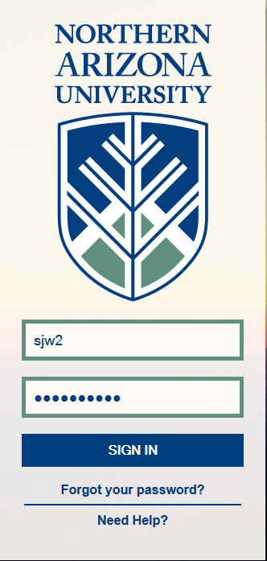
  - The form allows tabbing through it when completing.
  - All fields with the * are required and must be populated as below.

- Complete an Accountable Plan Reimbursement Justification for Exception to Policy Request Form
  - Click the Help button ? for help with the type of request that needs to be completed.
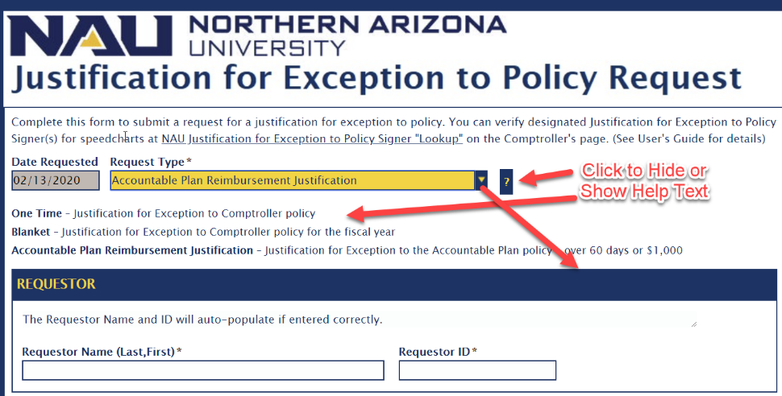
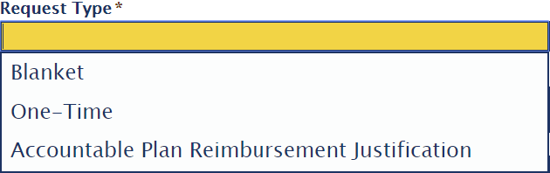
  - Select Accountable Plan Reimbursement Justification from the Request Type drop-down list.
  - Enter the Requestor ID or the Requestor Name. (See Steps 3 and 4)
  - Enter the Requestor ID. Tab out and the Requestor Name will automatically populate.
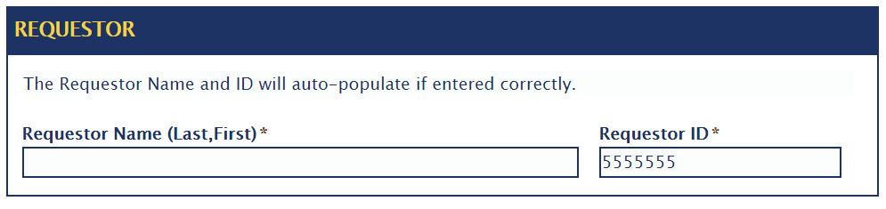
  - Enter the Requestor Name. Type in the Requestor Last Name followed by a “,” and a full First Name or a partial First Name and TAB out, (See Figure 1 below). If a partial First Name is typed, a Select Keyset pops up which allows the option to select the correct person. (See Figure 2 below). If the partial name only matches one person, the Requestor ID will automatically populate.
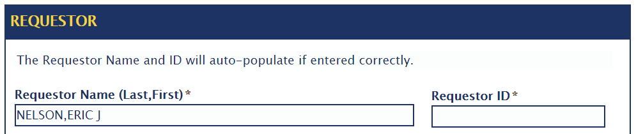
Figure 1
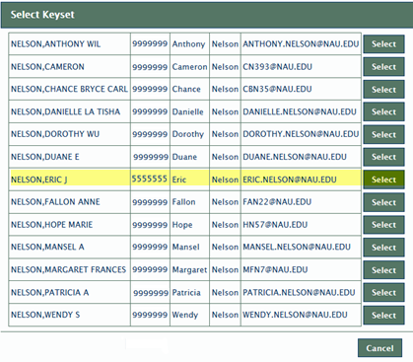
Figure 2
  - Click Select on the correct name.
  - The Requestor ID will auto populate.
  - If an incorrect Requestor Name and/or ID is entered, one of the following messages appear:

  - Enter the Expense Report #, if available.
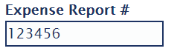
  - Click the Reimbursee Same as Requestor checkbox, if the person being reimbursed is the same as the Requestor. This will populate the Reimbursee Name and Reimbursee ID.
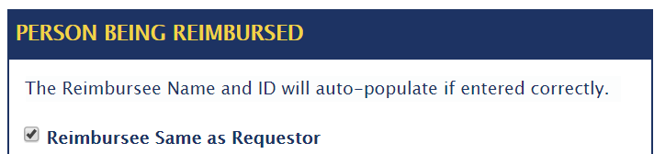
  - Enter the Reimbursee ID and the Reimbursee Name will automatically populate.
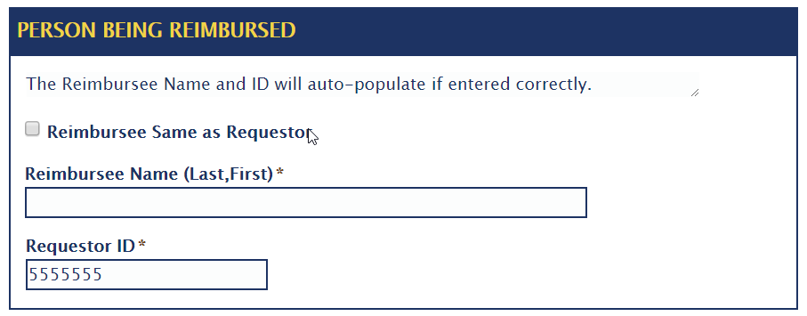
  - Enter the Reimbursee Last Name followed by a “,” and a full First Name or a partial First Name and TAB out (See Figure 3 below). If a partial First Name is typed, a Select Keyset pops up which will allows the option to select the correct person (Same as above in Figure 2). If the partial name only matches one person, the Reimbursee ID will automatically populate.
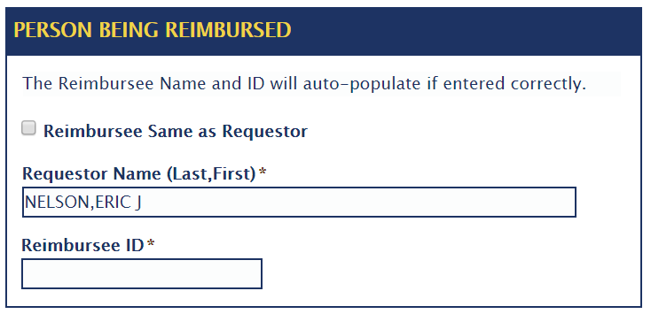

  - If an incorrect Reimbursee Name and/or ID is entered, one of the following messages appear:

  - Complete the Reimbursement Details.
  - Select the Accountable Plan Reimbursement Justification Type from the drop-down list.
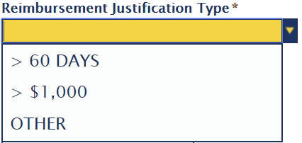
  - If OTHER is selected, enter the required details for the Other Accountable Plan Reimbursement Justification Type.
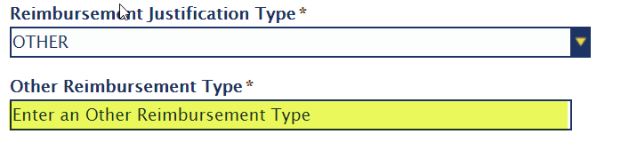
  - Select the Reimbursement Reason from the drop-down list.
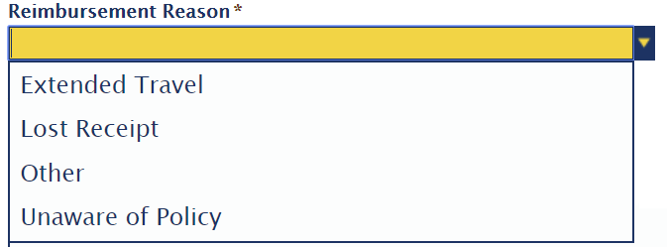
  - If Other is selected, enter the required details for the Other Reimbursement Reason.
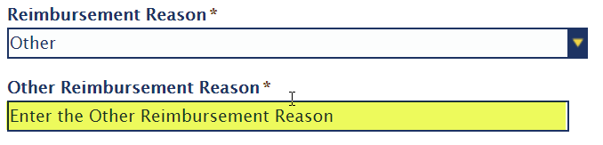

  - Enter the Amount.
  - Enter the Explanation of Circumstances details.
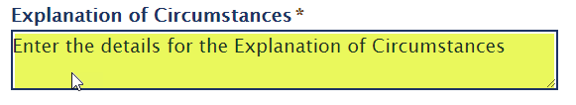
  - Enter the Actions to Prevent Future Violations. After this information has been entered, the Submit button will be enabled.
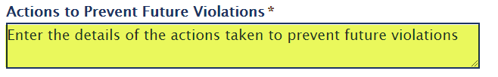

  - Click Attach to add any supporting documentation to the form. It will open a window to select a file to upload.
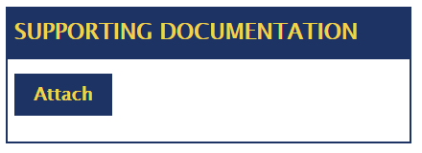

  - Select the file name and click Open. This will place the file to upload on the form. If there is a need to remove the file, click the Remove link.
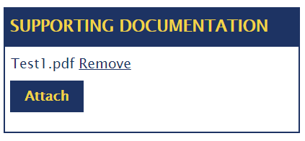
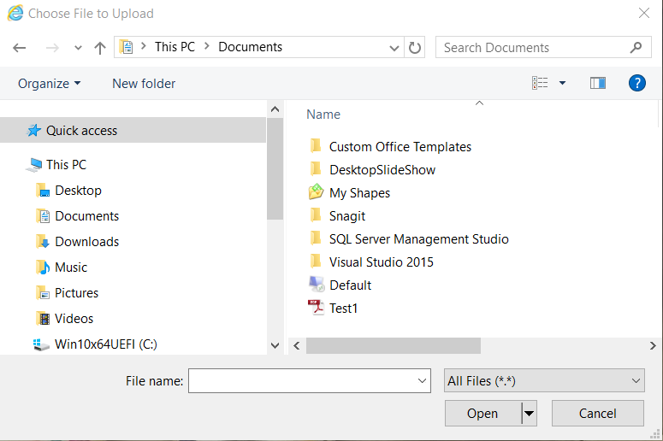

  - The Accountable Plan Reimbursement Justification Request form has been completed.

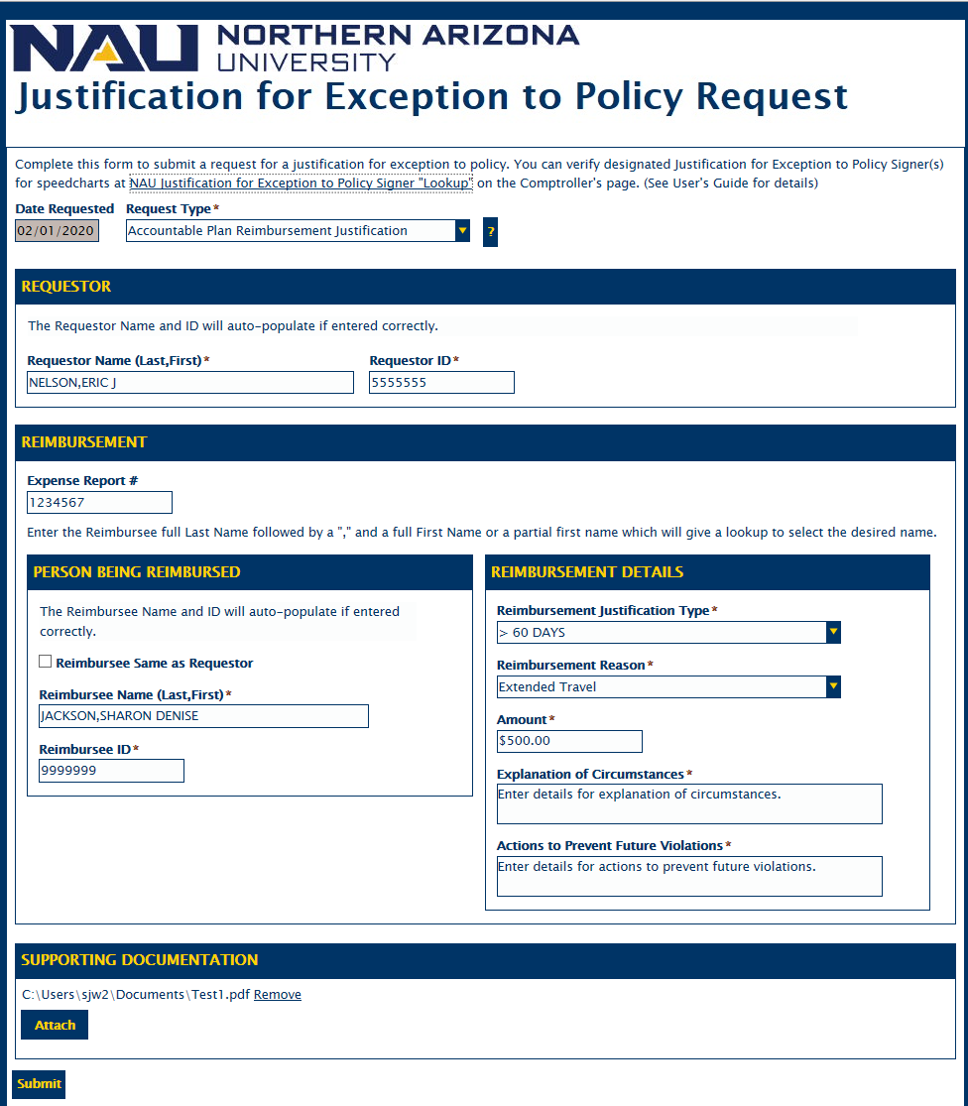
  - Click Submit to complete the form process.

- Complete a Blanket or One-Time Justification for Exception to Policy Request Form
  - Select Blanket or One-Time from the Request Type drop-down list.
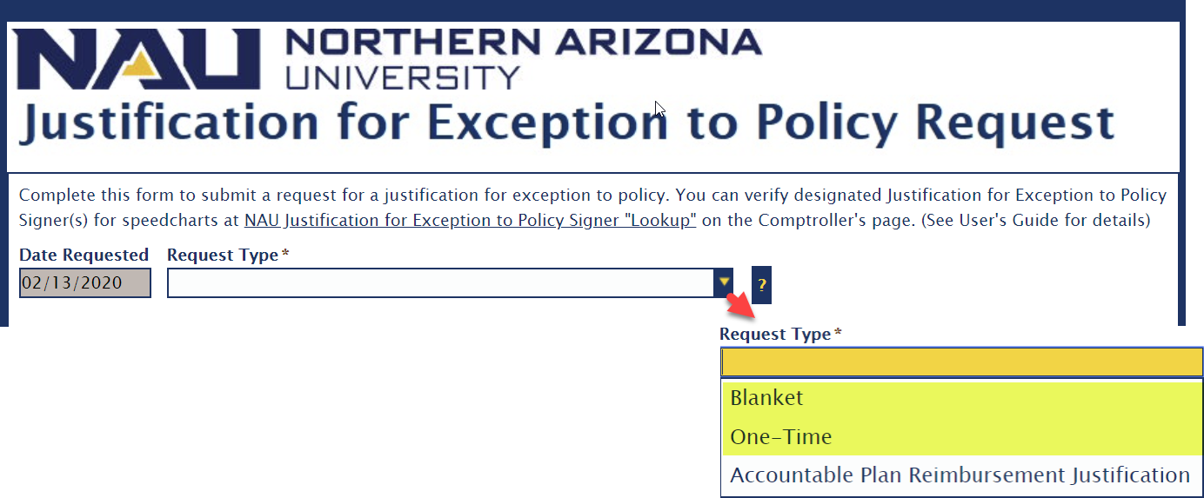
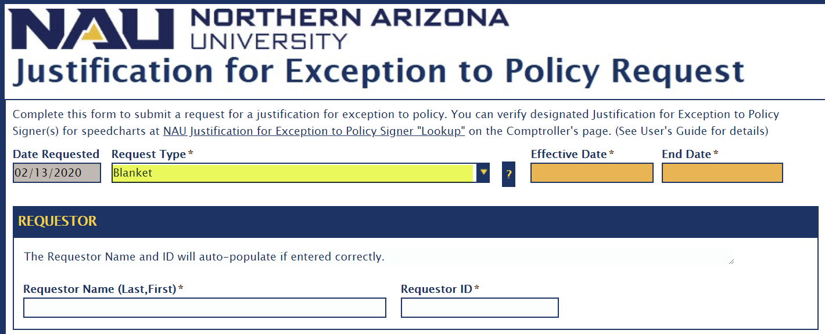
  - Enter the Effective Date that the exception begins. This date must be greater than or equal to the current date and less than or equal to the end of the current fiscal period.
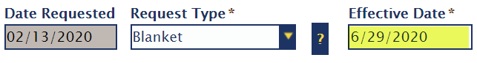

  - Enter the End Date that the exception ends. This date must be greater than or equal to the current date and less than or equal to the end of the current fiscal period.

  - Enter the Requestor ID or Requestor Name. (See Steps 5 and 6)
  - Enter the Requestor ID. Tab out and the Requestor Name will automatically populate.
  - Enter the Requestor Name. Type in the Requestor Last Name followed by a “,” and a full First Name or a partial First Name and TAB out, (See Figure 1 below). If a partial First Name is typed, a Select Keyset pops up which allows the option to select the correct person (See below). If the partial name only matches one person, Requestor ID will automatically populate.

  - Click Select on the correct name.
  - The Requestor ID will automatically populate.
  - If an incorrect Requestor Name and/or ID is entered, one of the following messages appear:

  - Complete the Justification for Exception to Policy section.
Note: For any speedcharts selected in this section, there must be designated Justification for Exception to Policy Authorized Signers on file with the Comptroller’s Office. If no Signer is available in the drop-down list, a Justification for Exception to Policy Authorization Form must be completed for the Speedchart. The form is located on the NAU Comptroller's Form page.
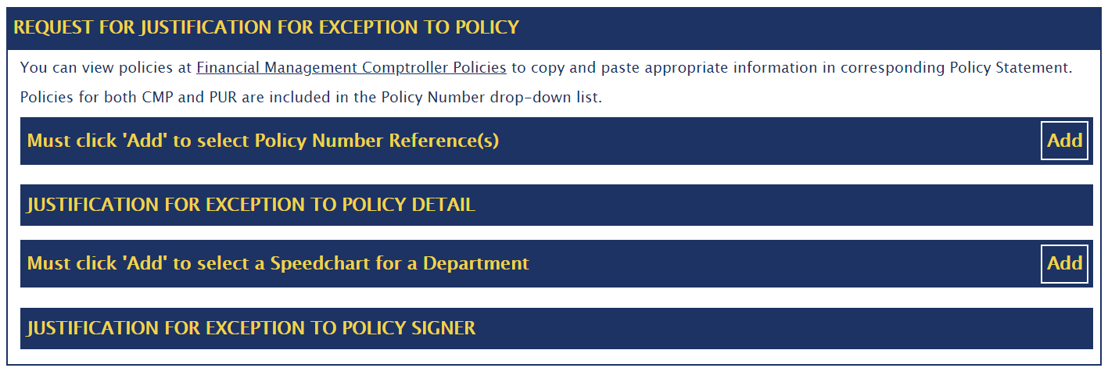
  - Click Add which will expand the section and allows adding Policy Number Reference(s). Repeat clicking Add as needed.
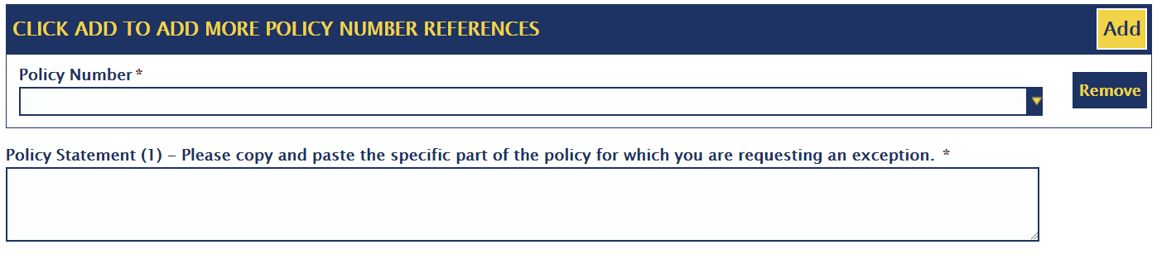
  - Select the Policy Number needed for the exception from the drop-down list.
  - Type or copy and paste the appropriate policy information in the Policy Statement number.
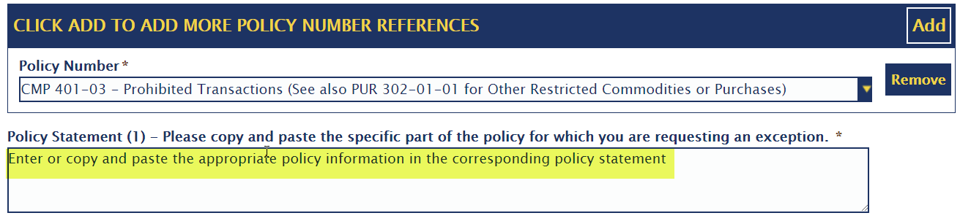
  - Repeat Steps 11-13 as needed.

  - Complete the Exception Detail section.
  - Enter the Business Need or Circumstances requiring the Justification for Exception to Policy.
  - Enter the appropriate Additional procedures.
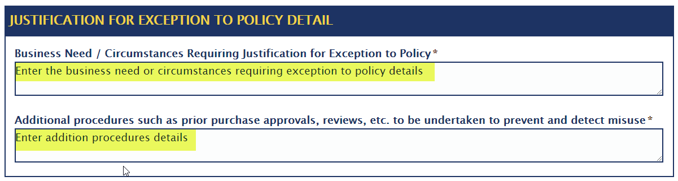
  - Click Add to expand the section and allows adding a speedchart for a Department/Unit affected by the Justification for Exception to Policy.
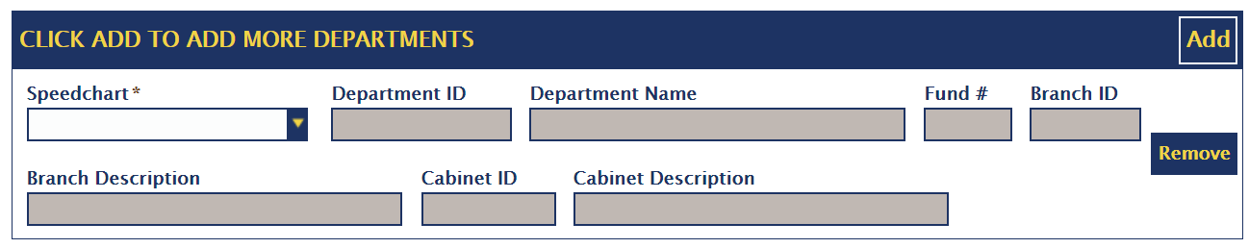

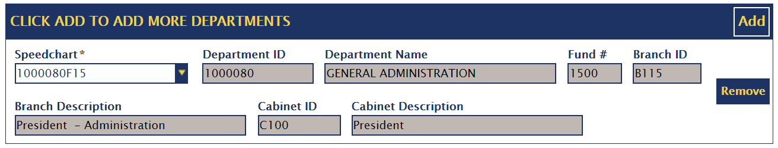
  - Select a Speedchart which must be in the list from the drop-down list. Once a speedchart is selected, the other fields in the section will automatically populate. The designated Justification for Exception to Policy Signer(s) drop-down list will be updated. Repeat Steps 18 and 19 as needed.

  - Complete the Justification for Exception to Policy Signer section.
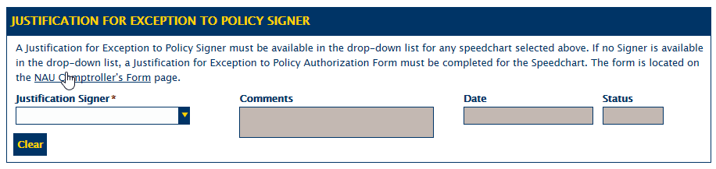
Note: To complete this process, a Justification for Exception to Policy Signer must be in the drop-down list.

  - Select a Justification for Exception to Policy Signer from the drop-down list.
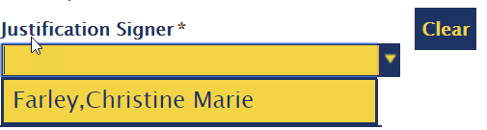
  - After the Justification for Exception to Policy Signer has been selected, the field will be disabled. To change the selection, click Clear to clear and enable the Justification for Exception to Policy Signer field. Re-select a signer from the list.
  - Click Attach to add any supporting documentation to the form. It will open a window to select a file to upload.
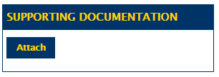

  - Select the file name and click Open. This will place the file to upload on the form. If there is a need to remove the file, click the Remove link.
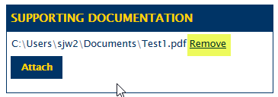
  - The Blanket or One-Time Justification for Exception to Policy form has been completed.
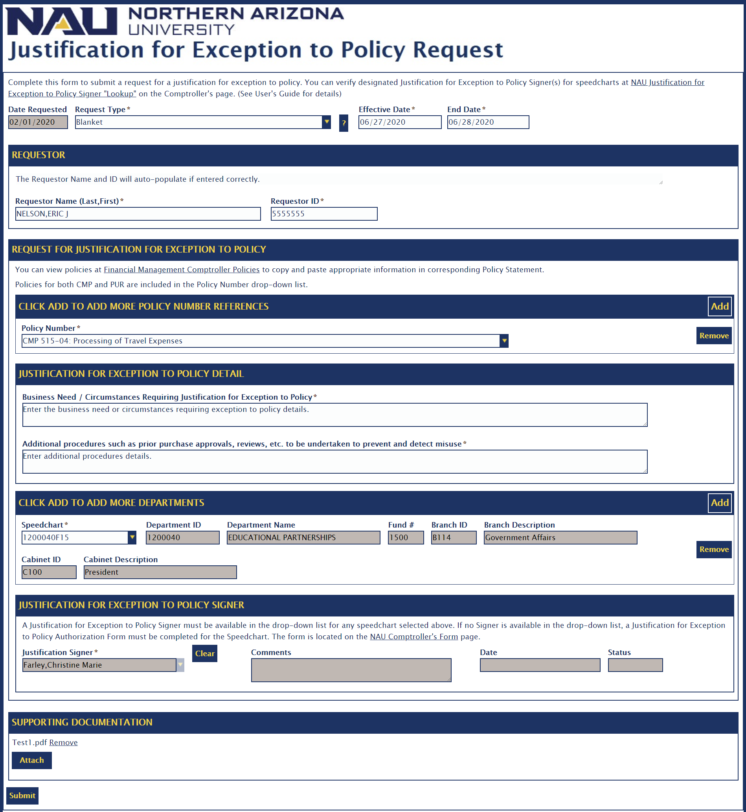
  - Click Submit to complete the form process.

- Submit an Justification for Exception to Policy Request Form
  - Click Submit to complete the form process. The following message will display that the form is being saved.
  - The form is submitted. The Confirmation Page below will display.
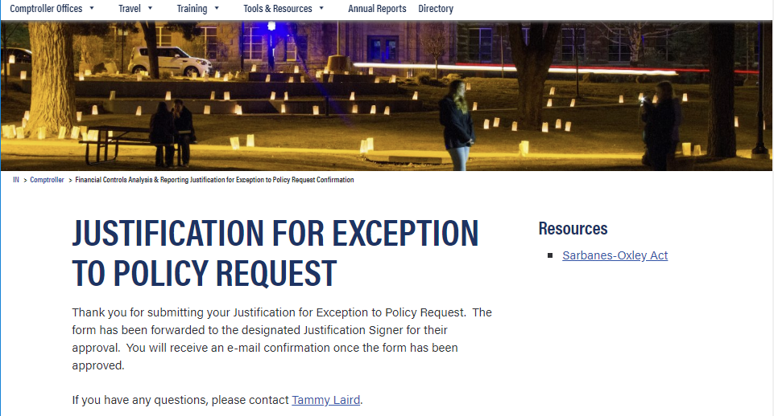

- Process Overview – Accountable Plan Reimbursement Justification Request Form
  - An email notification with a link to the form will be sent to the Requestor that the request has been received. (See G.1 Notification)
  - Click on the link to the form, which signs in to OnBase through NAU CAS, to see updated information on the request form.
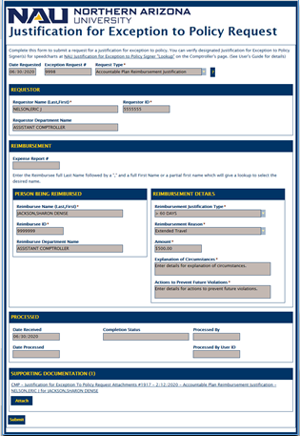
  - An email notification with a link to the form will be sent to the Comptroller’s Office Approver Team that a new request has been submitted.(See G.3 Notification)
  - The Approver’s Team will process the request within a reasonable time with the following status of Approved, Denied, Pending or Cancelled. (See Steps 5-7)
  - Approved – The request has been approved. An email notification with a link to the form will be sent to the Requestor and/or Reimbursee that the request was approved. (See G.5 Notification)
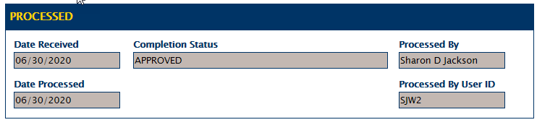
  - Denied – The request has been denied. An email notification with a link to the form will be sent to the Requestor and/or Reimbursee that the request was denied. The denial reason will be on the Request form. (See G.6 Notification)
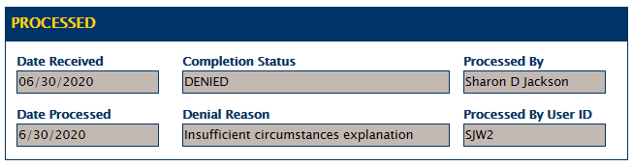
  - Pending – The request is pending because additional information may be needed. An email notification with a link to the form will be sent to the Requestor and/or Reimbursee that the request is pending. The pending reason will be included in the email as well as on the form with what is needed. Once the requested information is received, the Comptroller’s Approver Team will continue the review process to either approve or deny the request. (See G.7 Notification)
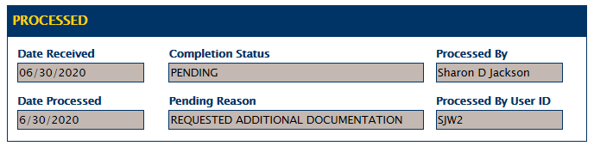
  - Cancelled – The request has been manually cancelled. An email notification with a link to the form will be sent to the Requestor that the request was cancelled. If the cancelled request was a valid request, a new request form will have to be submitted. (See G.8 Notification)
  - After the Requestor has received the email notification from the Comptroller’s Office Approver Team that the Reimbursement Request Exception has been approved, the Requestor will need to follow-up with Accounts Payable that the Expense Report is ready for processing. The Exception Request Number or email will need to be included with documentation submitted to Accounts Payable. If the documentation has been submitted to Accounts Payable, the email notification with the Exception Request Number link needs to be forwarded to them. Note: Accounts Payable receives email notifications for approved Reimbursement Request. (See G.9 Notification)
- Process Overview – Blanket or One-Time Exception Request Form
  - An email notification with a link to the form will be sent to the Requestor that the request has been received. (See H.1 Notification)
  - Click on the link to the form, which signs in to OnBase through NAU CAS, to see updated information on the request form.
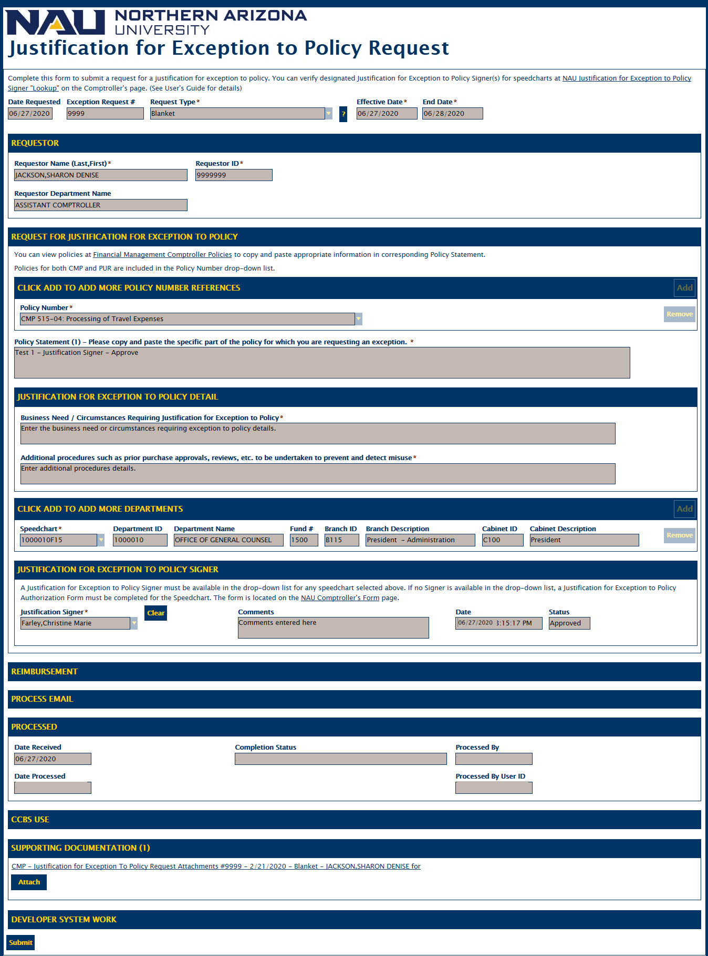
Figure 3
  - An email notification with a link to the form will be sent to the designated Justification for Exception to Policy Signer that they have a new request to review.(See H.3 Notification)
  - The designated Justification for Exception to Policy Signer will process the request within a reasonable time with an Approved or Denied.
  - For Blanket or One-Time Justification for Exception to Policy Request forms that have been approved by the Justification for Exception to Policy Signer, they are routed to the Comptroller’s Office Approver Team. They will process the request within a reasonable time with the following status of Approved, Denied or Pending. (See Steps 13-18) (See H.5 Notification)
  - Approved – The request has been approved. An email notification will be sent to the Requestor with a link to the form that the request has been approved by both the Justification for Exception to Policy Signer and the Comptroller’s Office. (See H.6 Notification)
  - Click the link to the form, which signs in to OnBase through NAU CAS, to see updated information on the request form. (See Figure 3 above)
  - Denied – The request has been denied. The denial reason will appear on the Request form. An email notification with a link to the form will be sent to the Requestor that the request was approved by the Justification for Exception to Policy Singer but denied by the Comptroller’s Office. (See H.8 Notification)
  - Click on the link to the form, which signs in to OnBase through NAU CAS, to see updated information on the request form. (See Figure 3 above)
  - Pending – The request is pending because additional information is needed. An email notification with a link to the form will be sent to the Requestor that the request is pending with the Comptroller’s Office. The pending reason will be included in the email and on the form what is needed. Once the requested information is received, the Comptroller Office Approver Team will continue the review process to either approve or deny the request. (See H.10 Notification)
  - Click on the link to the form, which signs in to OnBase through NAU CAS, to see updated information on the request form. (See Figure 3 above)
- Justification for Exception to Policy Signer Process a Blanket or One-Time Exception Request
  - After the designated Justification for Exception to Policy Signer receives the email notification of a new request form and clicks the link to the form, it signs in to OnBase through NAU CAS and goes to the new request form in Workflow to process. (See I.1 Notification)
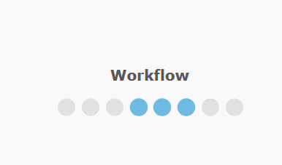
  - It goes to the CMP – Justification for Exception to Policy Request Workflow Life Cycle.
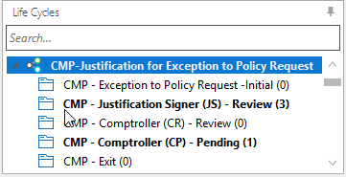
  - Click on the CMP – Justification Signer (JS) – Review Queue. (See above)
  - Justification for Exception to Policy signers can only see requests for which they are the designated Signer.
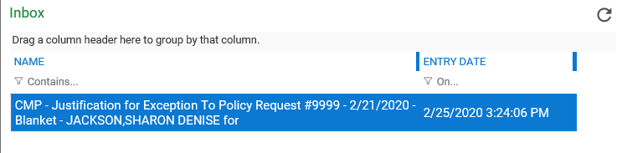
  - In the Documents window, designated signers will see a list of forms waiting to be processed including the form from the email link that was clicked.

  - Click on the appropriate form to view it. There are five sections of the form as shown below:
Requestor, Request for Justification for Exception to Policy, Processed and Supporting Documentation. Click on a section to expand it if it is not already expanded.

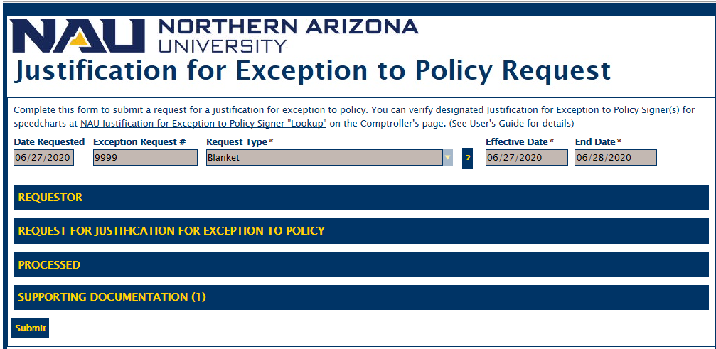
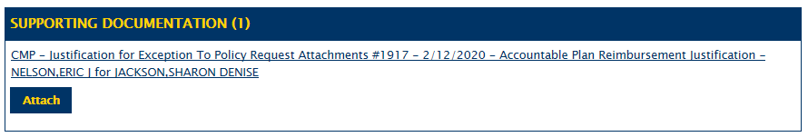
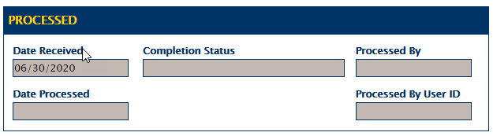

  - The request needs to be processed within a reasonable time with the following Ad Hoc task options of Approve or Deny. The Ad Hoc tasks will open a HTML form that allows comments to be entered. (See Steps 8 - 13 ) Note: If an Ad Hoc task is selected and needs to be changed, click Cancel and re-select the appropriate ad-hoc task.
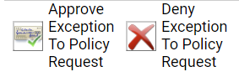

  - Click the Approve Exception Request Ad Hoc Task to approve the request. The HTML Comments form will open to add comments. Click Submit to process and update the form or Cancel to cancel the process.
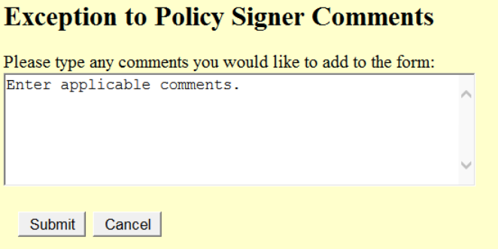
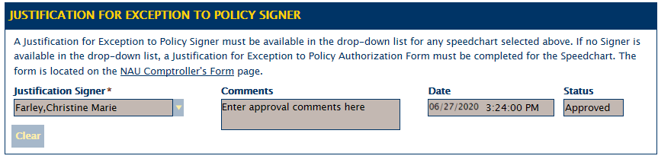
  - An email notification with a link to the form will be sent to the Requestor that the Justification for Exception to Policy Signer approved the request and that it has been routed to the Comptroller’s Office Approvers Team to review. (See I.9 Notification)
  - Click on the link to the form, which signs in to OnBase through NAU CAS, to see updated information on the request form. (See Figure 3 above)
  - Click the Deny Exception Request Ad Hoc Task to deny the request. The HTML Comments form will open to add comments. Click Submit to process and update the form or Cancel to cancel the process.
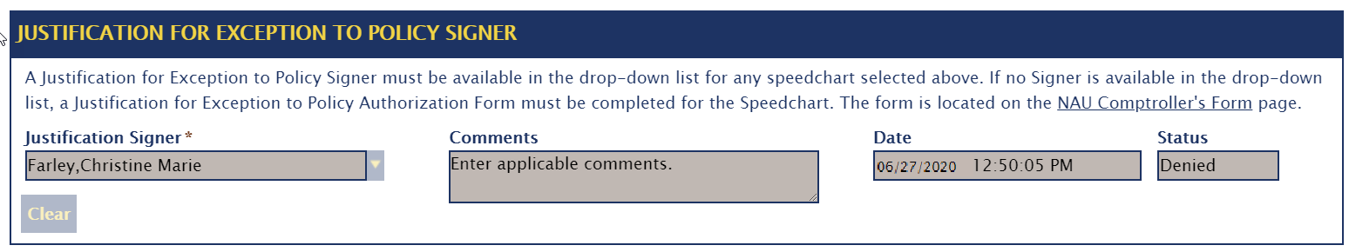
  - An email notification with a link to the form will be sent to the Requestor that the request has been denied by the Justification for Exception to Policy Signer. (See I.12 Notification)
  - Click on the link to the form, which signs in to OnBase through NAU CAS, to see the updated information on the request form. (See Figure 3 above)
- Correction to a Accountable Plan Reimbursement Justification Request Only
  - After receiving the email notification and clicking on the link to review the form, there is a change needed to the Reimbursement Type and/or Reimbursement Reason, don’t worry. It can be corrected without having to submit another Request Form.
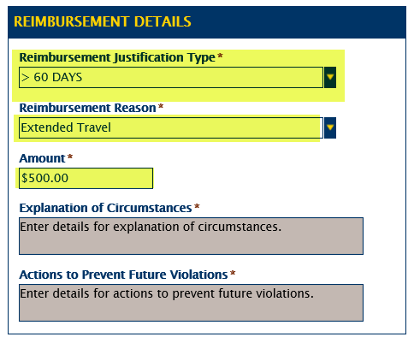
  - Immediately, email FinControls with the Exception Request Number and the correct information for the Accountable Plan Reimbursement Justification Type and/or Reimbursement Reason and a brief explanation of why the correction is needed.
  - The Comptroller’s Office Approvers Team will be able to make the correction while processing the form.
  - An email notification will be sent with the status of the Request.
- Retrieve Justification for Exception to Policy Request Forms
  - Specific Request form can be retrieved by clicking on the link provided in the email notification received. (See G.1 Notification)
  - This allows the ability to see the status of the Request at any point.
  - After submission, all Justification for Exception to Policy Request forms will be read-only.
  - A request form can be retrieved by Opening the OnBase Unity or Web Client.
  - Click on Home | Retrieval. Select Document Types and Groups | Compliance & Controls.
  - Click on CMP – Justification for Exception to Policy Request.
  - Enter the Exception Request Number in the Keywords | Exception Request # which will retrieve the form or any keyword can be used to retrieve forms.
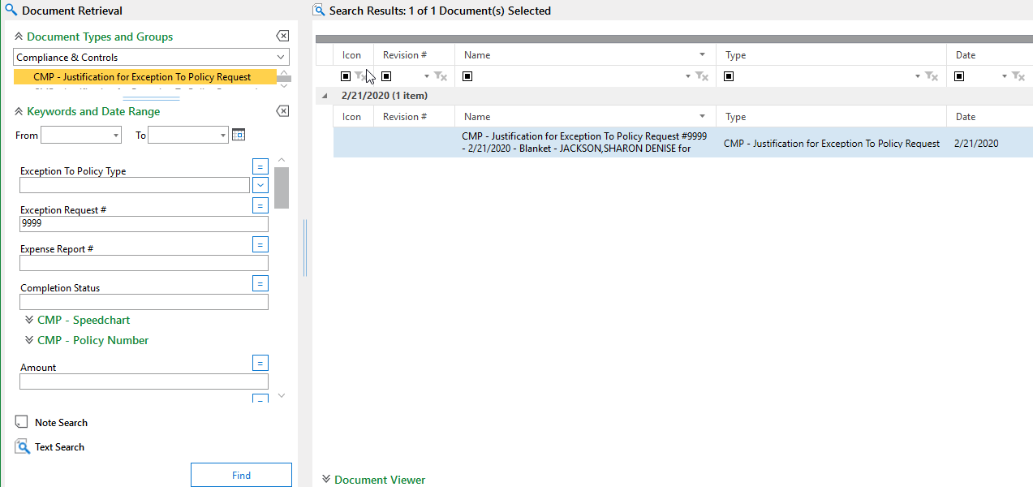
- Reimbursement or Justification for Exception to Policy Request Manual Cancellations
  - Accountable Plan Reimbursement Justification Request forms can be manually cancelled by the Comptroller’s Office Approvers Team. A cancellation notification will be sent to the Requestor. (See L.1 Notification)
  - Blanket or One-Time Justification for Exception to Policy forms can be manually cancelled by the Comptroller’s Office Approvers Team. A cancellation notification will be sent to the Requestor. (See L.2 Notification)
  - If the cancelled request was a valid request, a new request form will have to be submitted.
- Reminder 7 and 14 Day Notifications before Auto Cancellation of Request Form
  - For Justification for Exception to Policy Request forms in the Justification for Exception to Policy Lifecycle User’s Queue for seven (7) days, a 1st Reminder notification will be sent to the Justification for Exception to Policy Signer that they have a request form to review and process. (See M.1 Notification)
  - For Justification for Exception to Policy Request forms in the Justification for Exception to Policy Lifecycle User’s Queue for fourteen (14) days, a 2nd Reminder notification will be sent to the Justification Signer that they have a request form to review and process. This notifications includes a date that the request needs to be processed by so that it does not get auto cancelled. (See M.2 Notification)
  - For Justification for Exception to Policy Request forms in Justification for Exception to Policy Lifecycle Users Queues for twenty-nine (29) days will automatically be cancelled by the system. A cancellation notification which includes the cancellation reason will be sent to the Justification Signer and the Requestor. (See M.3 Notification)
  - If a cancelled request was a valid request, a new request form will have to be submitted.

- Appendix – Examples of Email Notification
Section Number | Example Screen Print
G.1 | 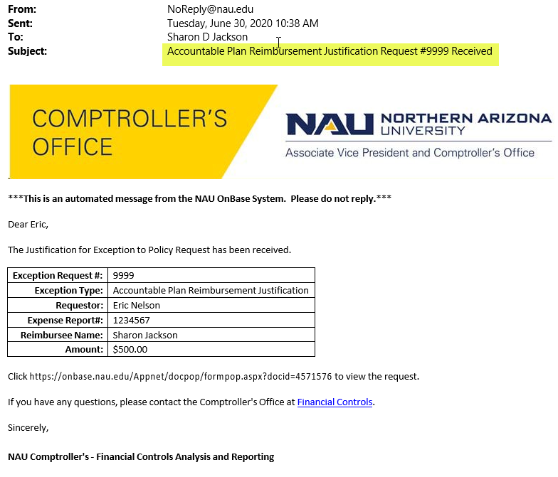

G.3 | 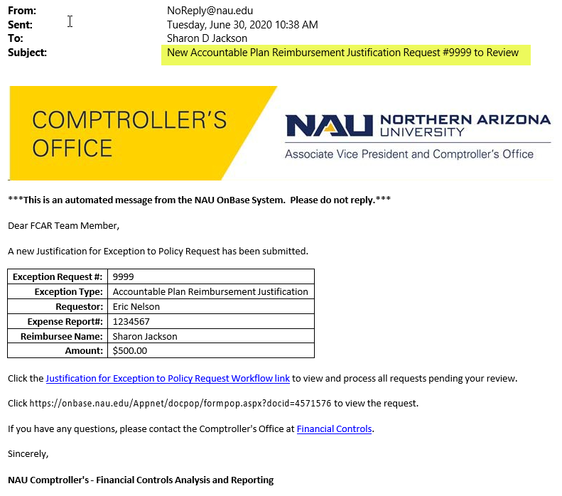

G.5  G.9 | 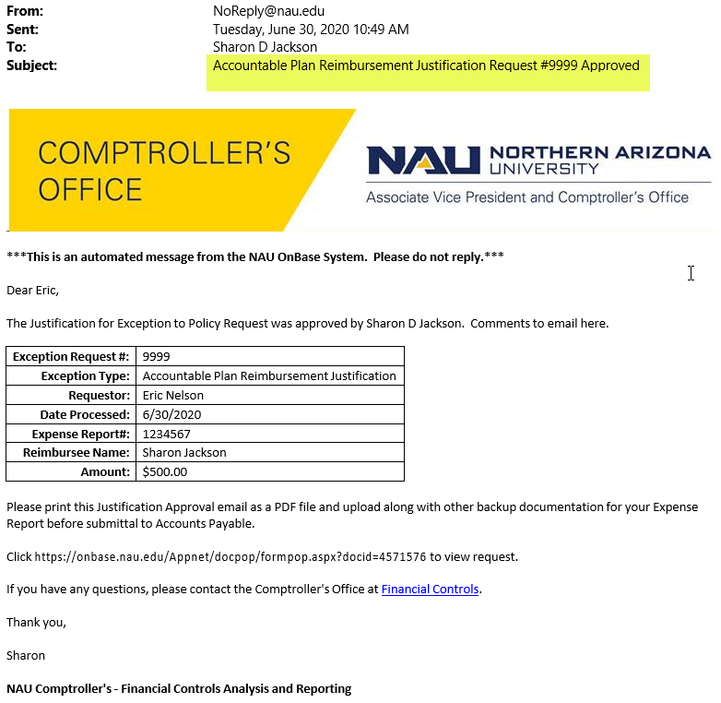

G.6 | 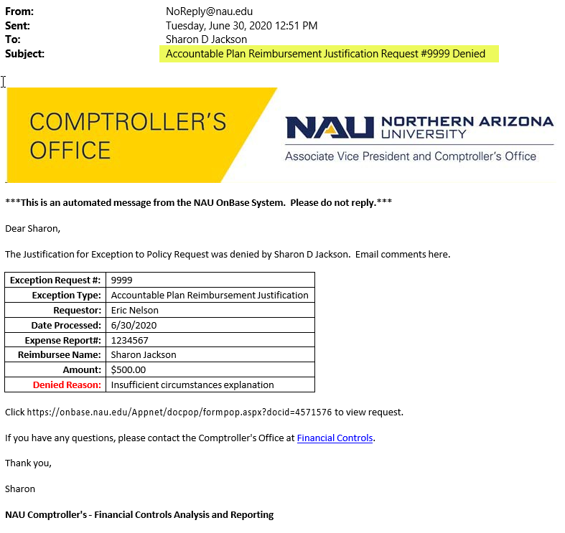

G.7 | 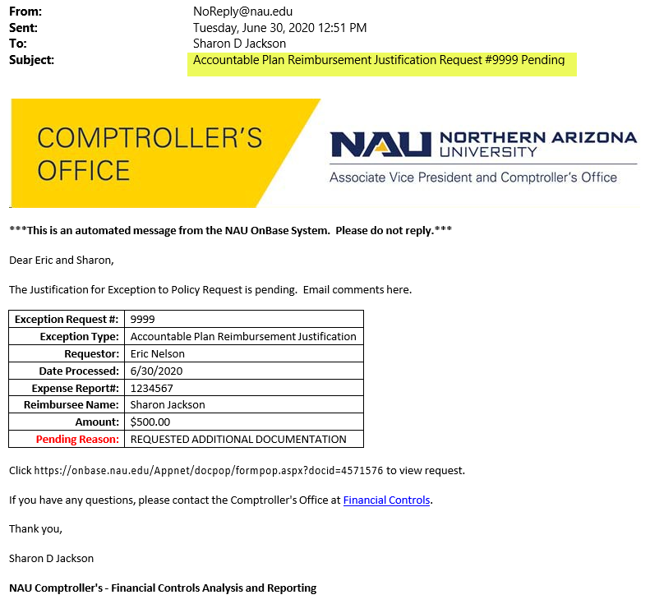

G.8  L.1 | 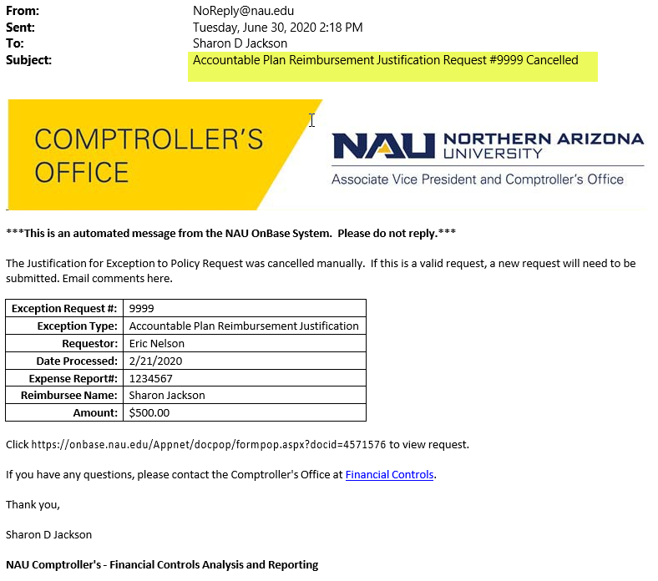

H.1 | 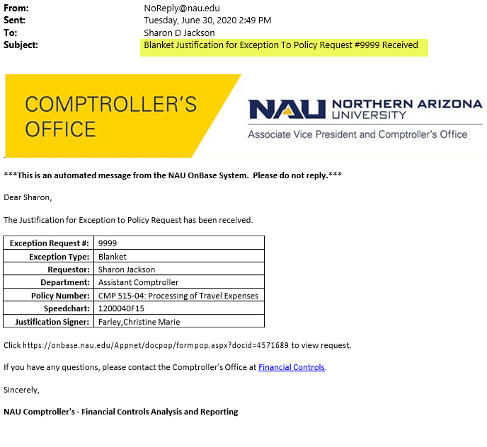

H.3  I.1 | 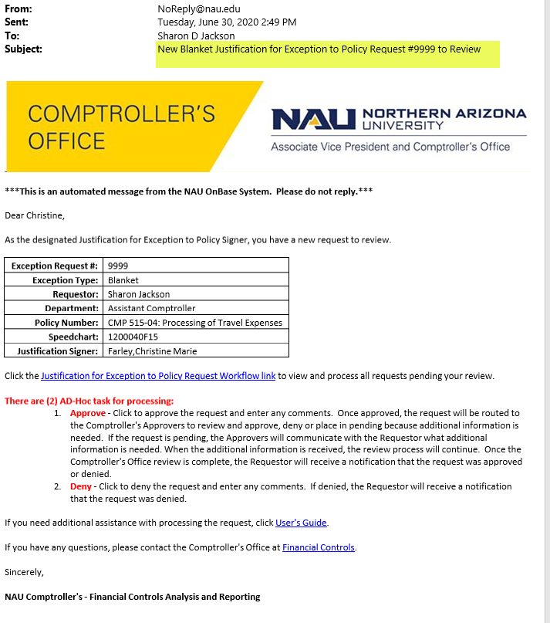

I.9 | 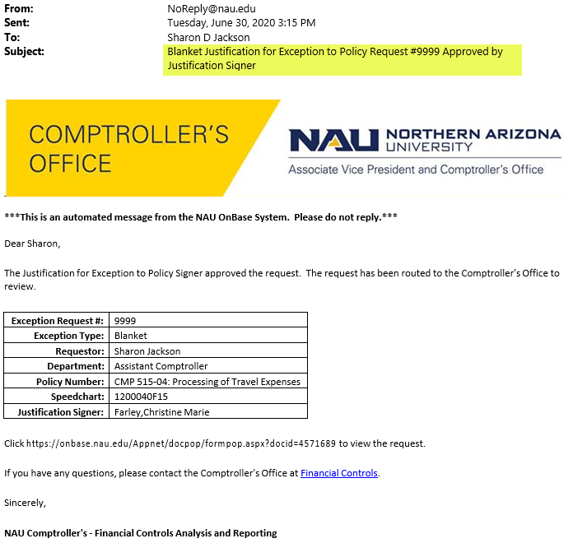

I.12 | 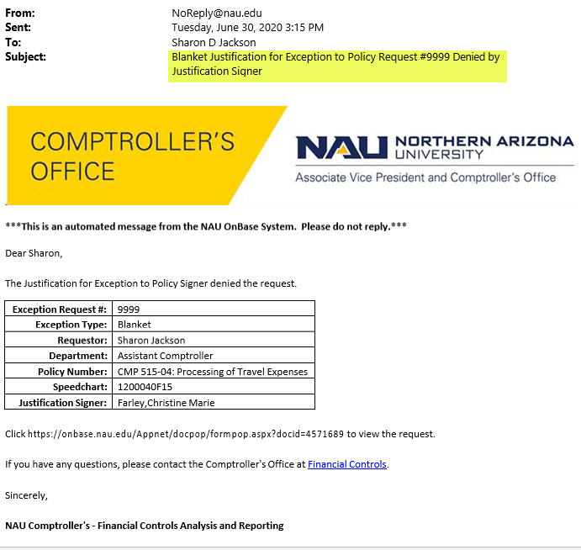

H.5 | 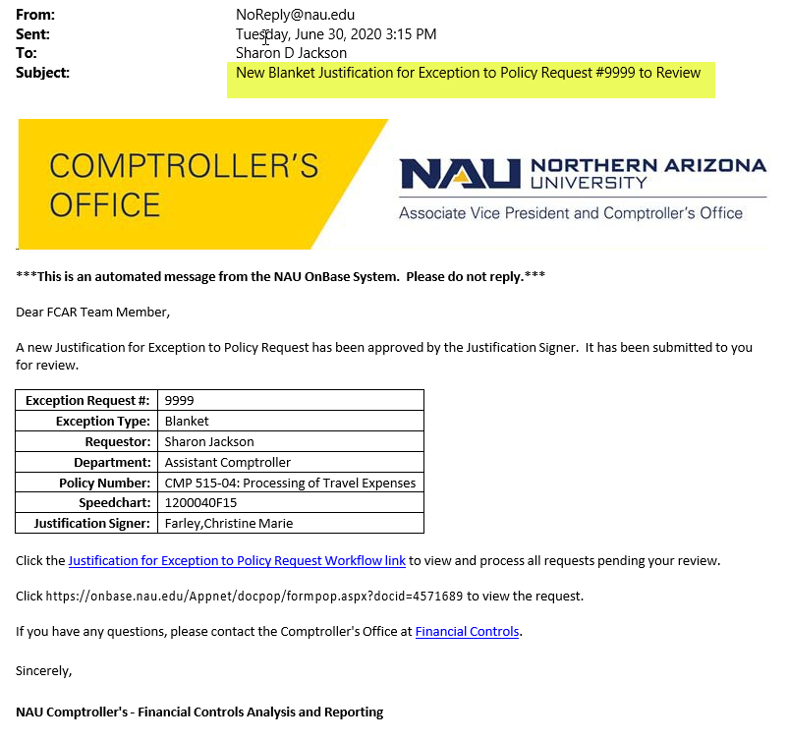

H.6 | 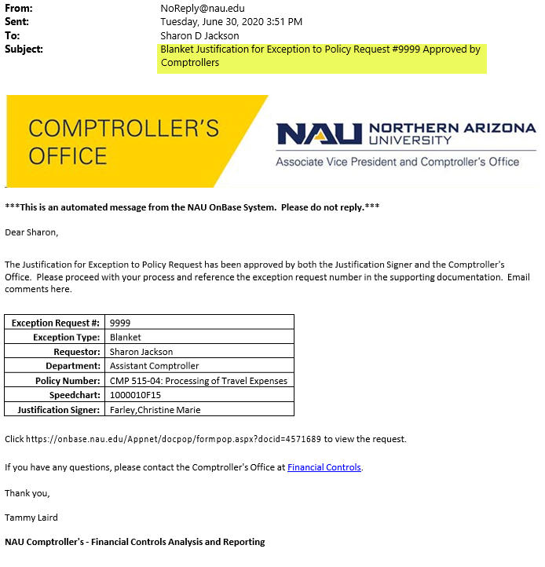

H.8 | 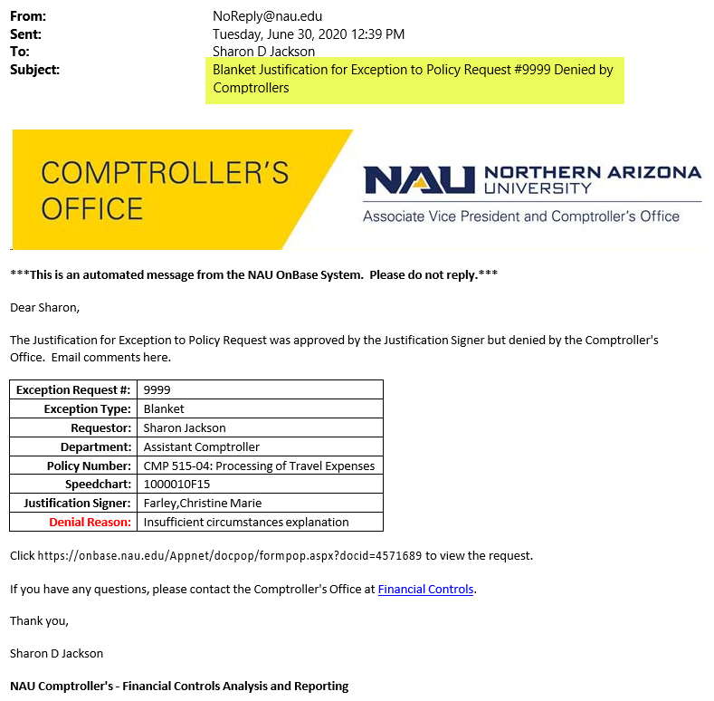

H.10 | 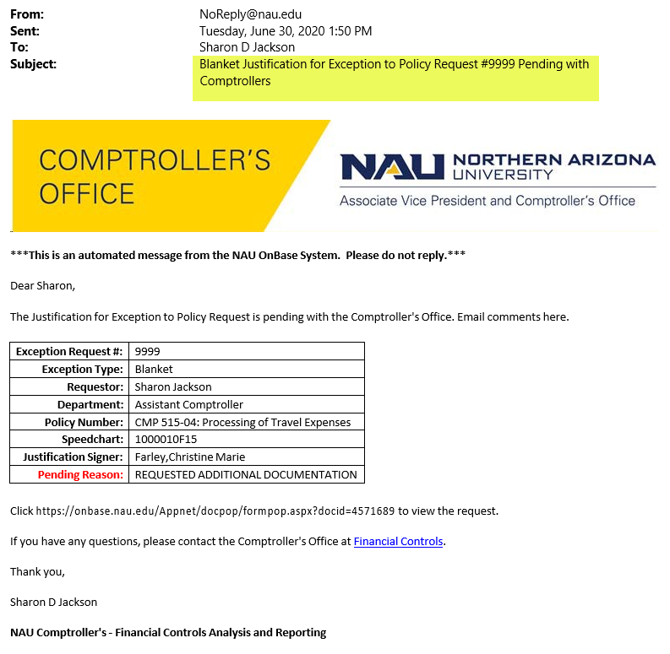
L.2 | 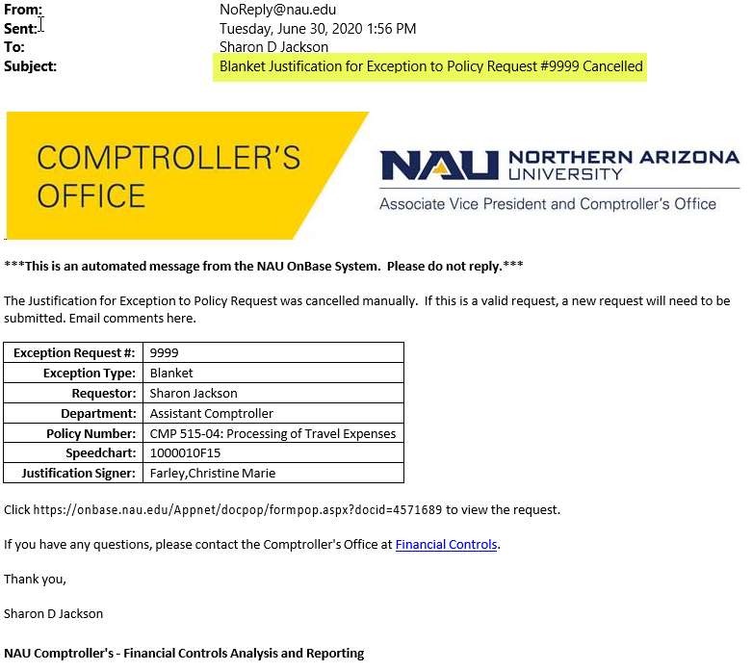

M.1 | 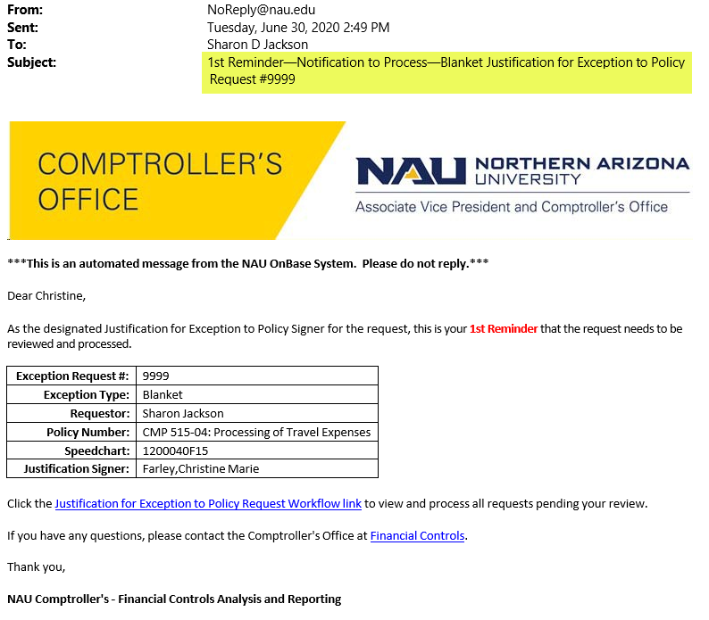
M.2 | 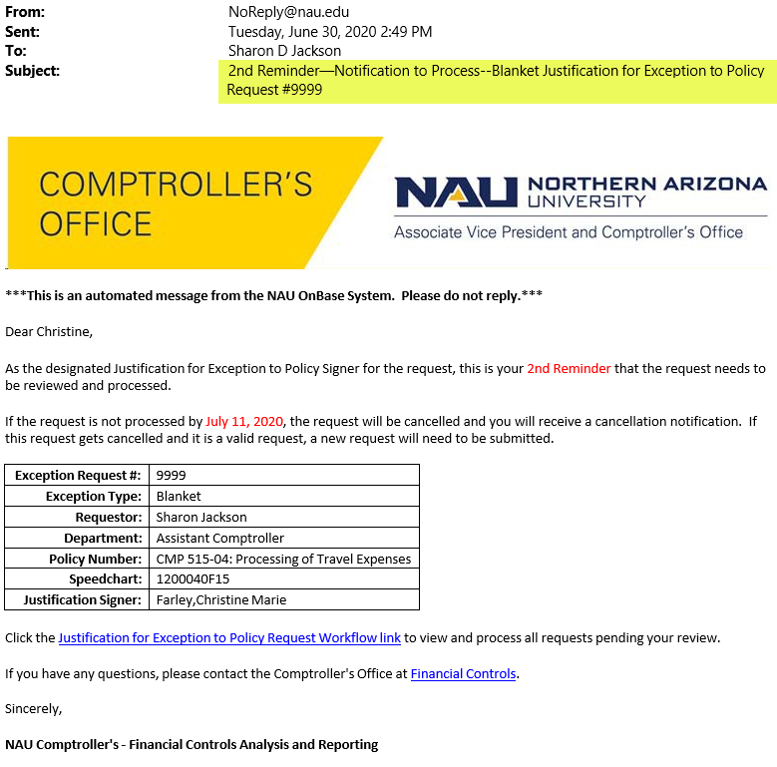
M.3 | 