2020-2021 Student Organization Re-Registration Instructions

If you use a screen reader or other device to access the registration website and/or need assistance completing the registration process please contact Michelle Gardner at Michelle.Gardner@nau.edu or 928-523-1145.

- Go to https://nau.edu/trueblueconnects. Click the blue “Sign In” button at the top of the screen and use your NAU userid and password to log in.

2) Click the menu icon on the top right and choose “Manage.”
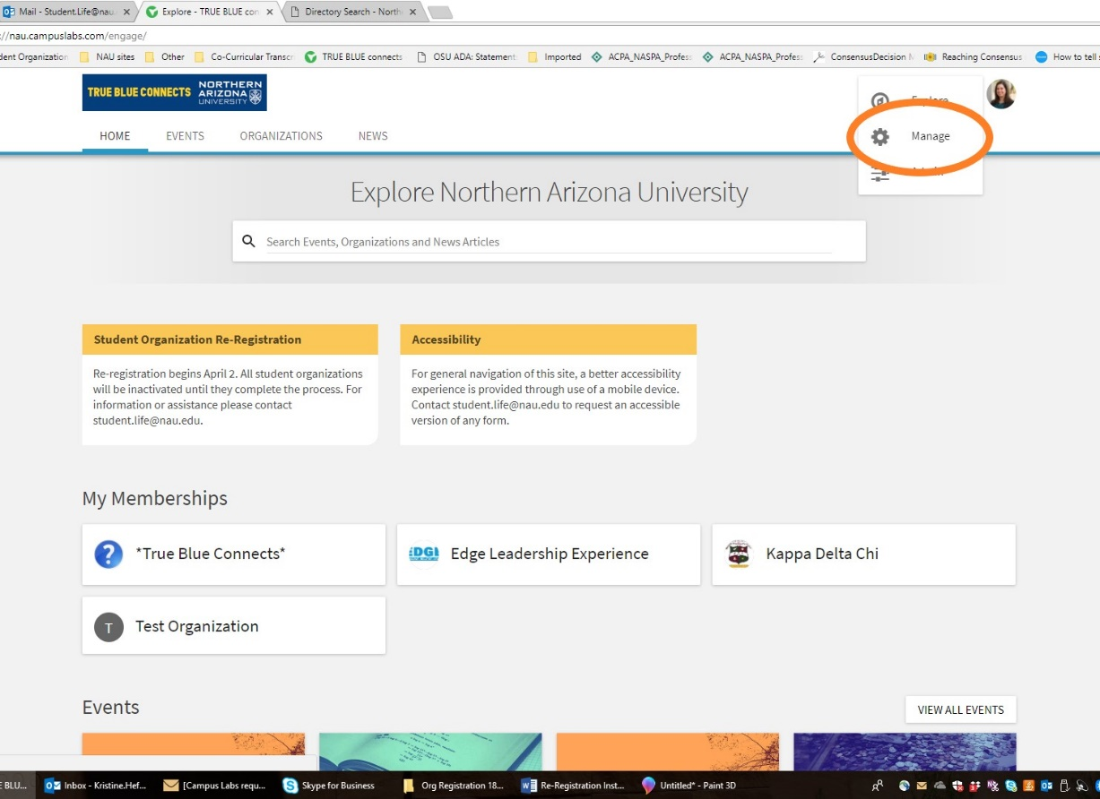

3) Select the organization you want to re-register under “My Memberships” then click on “Re-Register this Organization.” If the organization you are looking for does not appear please contact the Office of the Dean of Students.

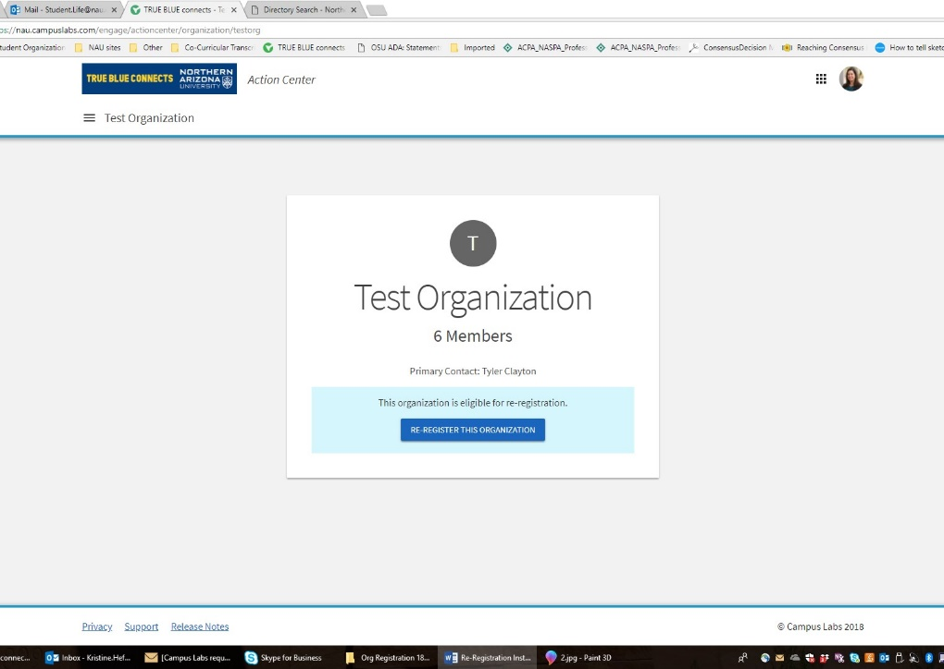
4) Read the instructions and then hit “Next.”

5) Review the existing information about your organization and update as needed. You are especially encouraged to enter an organization contact email even though the field is not required—this ensures that prospective students and others that are not logged in users have a way to contact you to learn more about your organization. Then hit “Next” (you will not be able to move forward until all required fields are completed).

6) Review the category or categories currently assigned to your organization and change if desired, then hit “Next.”

7) Update your roster—first remove members who are no longer part of the organization by checking the boxes next to their names and then click “Remove.” Then change former officers back to members by clicking the button that says “Edit Position Assignment” and checking or unchecking the appropriate boxes. Use the same button to assign positions to new officers that are currently members.

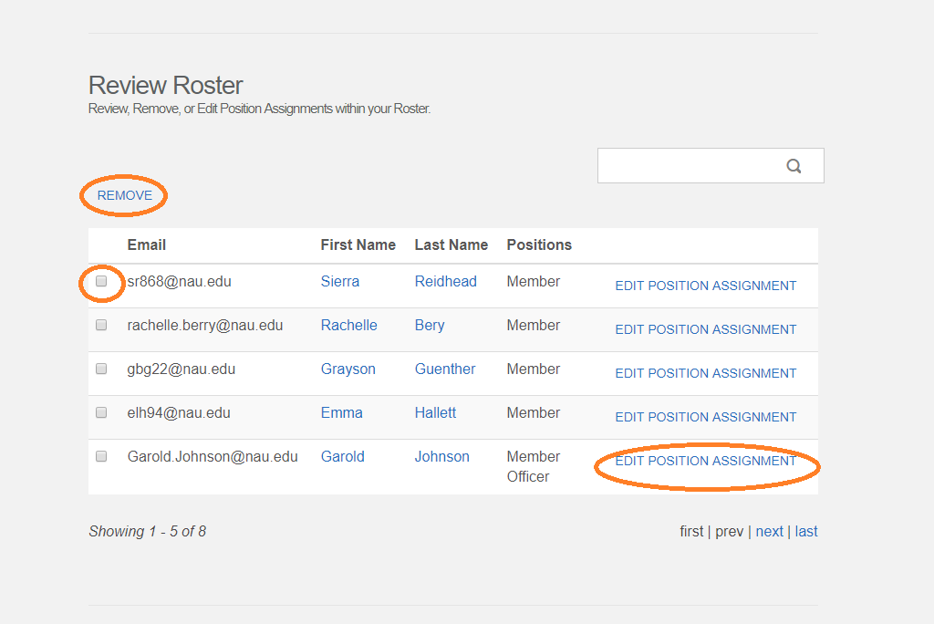
8) Add new members to your roster—you can do this one at a time on the “Add Individual Members or Positions” tab to assign officer positions. You can also add multiple members on the “Add Multiple Members in Bulk” tab using a list of the members’ NAU email addresses. You must use NAU email addresses to add all officers and members or the system will not recognize them.

You must have at least five members with at least two officers on your roster. When both of those requirements are met you will see two green check marks indicating you can move to the next step.

Remember that new members and officers will need to accept their invitation to the group before they will show up on the roster so please remind them to do this. When you are finished updating your roster, hit “Next.”
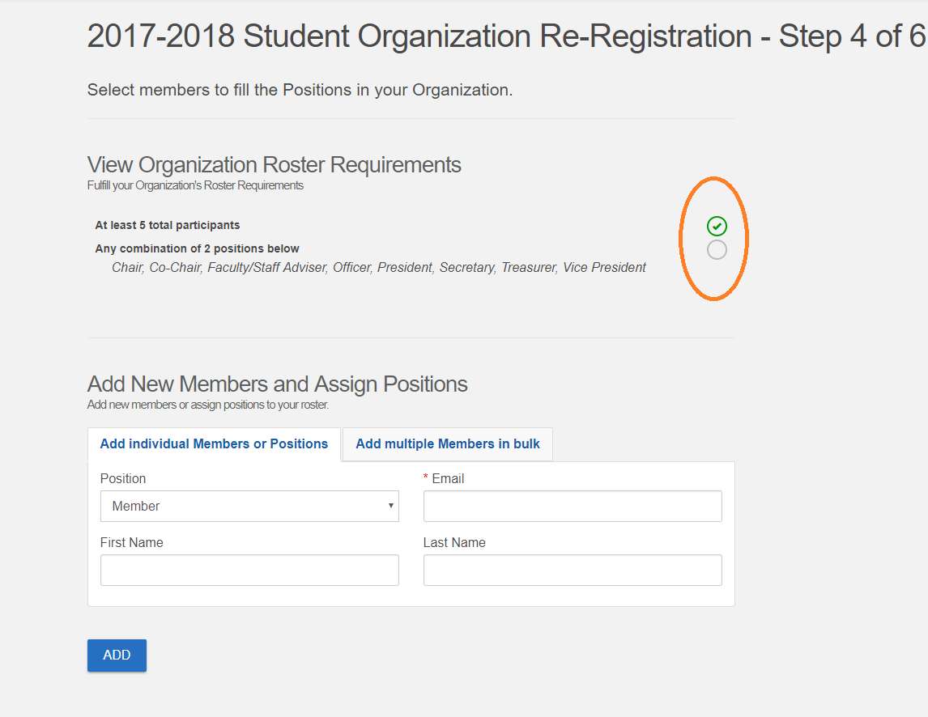
9) Associate interests with your organization. When both students and organizations specify “interests” they are used to recommend organizations to students who want to get involved. If you don’t add any interests your organization will not be recommended to any students. Add interests by clicking on the category and then on the plus sign to add. Rank or remove interests by hovering over the list with your mouse and using the “move up,” “move down,” or “remove” choices that will appear. Then hit “Next.”

10) Upload a profile picture. You can use your existing picture or upload a new one. Keep in mind that it will appear in a circular area on your organization’s page so you may want to format it accordingly. Then hit “Next.”

11) Click the “Submit for Approval” button. Office of the Dean of Students staff will review your request and, if it meets all requirements, approve it. You will receive an automatic notification in your NAU email. Once your request has been approved your organization is considered registered and active for 2020-2021 pending your successful completion of the mandatory President and Treasurer trainings.

Please direct any questions to:
Michelle Gardner
Assistant Director, Student Organization Development
Michelle.Gardner@nau.edu
928-523-1145

