About the Anxiety Workshop

- This is a 6-session workshop intended to provide information about anxiety, help you explore how anxiety shows up for you, and to gain tools to manage the anxiety
- The workshop runs on a “loop” and all 6 sessions are offered twice per semester
- You can join at any time—you do not need to join at session 1
- As long as you come to all 6 sessions you will have completed the workshop
- If you miss a session, you can elect to make it up when it loops back around

What to expect
- For best results, participants are asked to apply the information and practice the skills between sessions
- You only share what you’re comfortable sharing
- This is a skills-based group, meaning that it will have a “classroom-y” format
- There is a maximum of 11 members in the workshop with 2 co-facilitators
- Each session is structured with the following activities:
  - Introductions & ice breaker
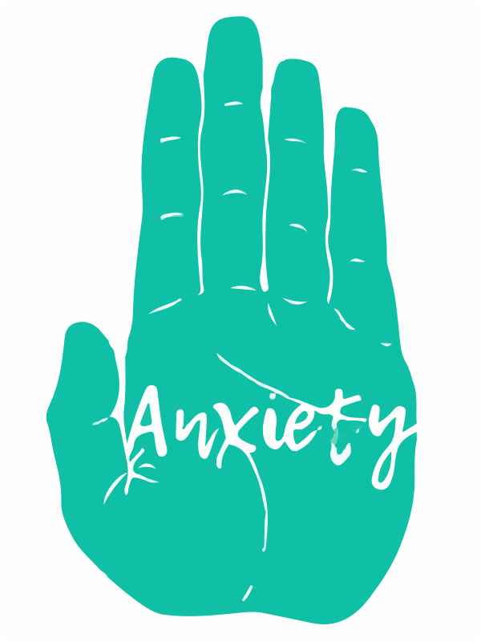
  - Mindfulness activity
  - Skills review & troubleshooting from last week’s skills
  - Teaching the topic and skills of the week
  - Practicing of new skills, time permitting
- We ask participants to try the workshop for 3 sessions before exiting if they do not wish to complete the workshop

Anxiety Workshop
6-week anxiety skills group

- Biological Focus: Function & Biological Factors
Goal: Members will learn about the evolutionary roots and functions of anxiety and explore biological factors that influence anxiety.
  - Provide information on evolutionary nature of anxiety
  - Provide information on the function of anxiety and fight/flight/freeze response
  - Provide information on vulnerability factors and members will consider and build awareness and impact of their own vulnerability factors
  - Members will learn PLEASE skills for reducing vulnerability factors
- Biological Focus: Panic Attacks & TIPP Skills
Goal: Members will learn about panic attacks from a biological/evolutionary perspective, and learn basic distress tolerance skills
  - Discuss reading on biological foundation and symptoms of panic attacks
  - Teach and practice basic TIPP Skills, discuss their application
  - Provide information on triggers & help members reflect on their own anxiety triggers
- Psychological Focus: Building Awareness
Goal: Members will develop an awareness of their own experiences of anxiety using a CBT framework
  - Discuss the importance of building awareness of anxiety in coping
  - Provide information on the CBT Model using worksheets
  - Provide brief introduction to cognitive distortions
- Psychological Focus: Defusion Techniques & Mindfulness
Goal: Members will begin to challenge and change the relationship to thoughts that contribute to anxiety. Members will also learn basic mindfulness skills
  - Members will learn basic ACT thought defusion techniques
  - Provide an introduction to mindfulness and teach basic skills
- Psychological Focus: Check the Facts, Container, & Calm Space
Goal: Members will challenge interpretations, thoughts, and assumptions that contribute to anxiety
  - Provide information and teach the DBT skill “Check the Facts”
  - Provide information and teach the skills “Container” and “Calm Space”
  - Guide students through a practice of these skills
- Psycho-Social Focus: Self-Talk, Self-Compassion, & Social Anxiety
Goal: Members will gain awareness of their self-talk and how it shows up in social situations. Members will learn to replace negative self-talk with self-compassion.
  - Discuss and explore the role of past experiences on the formation of current self-talk
  - Build awareness of own self-talk and help members move toward self-compassion
  - Discuss social anxiety and Understanding Self & Others (USO) groups as a mode of treatment

