Alcohol Awareness Bulletin Board – Quick Facts

Suggestions for creating this bulletin board:

- Use Health Promotion’s “Alcohol Quick Facts” handout as inspiration
- Include a few resources where your residents can learn more. Considering creating a QR code for each resource or using some other method to make it as easy as possible for residents to access the resources.
  - NAU Health Promotion: Alcohol & Drugs: https://in.nau.edu/campus-health-services/alcohol-and-other-drugs/
  - The Virtual Bar: http://virtualbar.responsibility.org/virtualbar/
  - National Institute on Drug Abuse: Alcohol: https://www.drugabuse.gov/drug-topics/alcohol
  - National Institutes of Health: College Drinking: https://www.collegedrinkingprevention.gov/parentsandstudents/students/default.aspx

- Use the content on the following pages to get you started. Change the fonts, colors, etc. to make it your own!
- Contact Nikki.Meline@nau.edu with the Health Promotion office for BAC cards if you’d like to include some on your board for residents to take

Standard Drink Sizes
- The amount of liquid in your glass, can, or bottle does not necessarily match up to how much alcohol is actually in your drink. -
- Do you know how much alcohol is in your drink? (Consider re-creating the info-graphic in an interactive way. You could have the standard drink size for each beverage covered by a flap of paper that residents can flip up to reveal the answer.)
- Did you know? A standard solo cup is 16 oz! This means that you may be drinking more than 1 “standard drink” per cup.
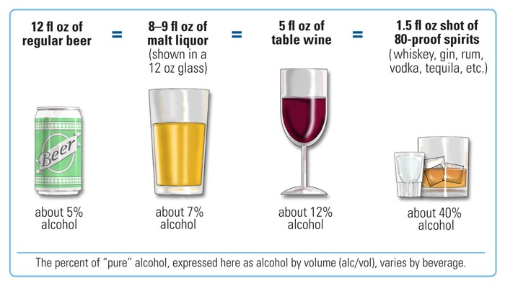

Binge Drinking: How Much is Too Much?
- Binge drinking is drinking an excessive amount of alcohol in a short amount of time or drinking to get drunk
- Binge drinking can have harmful short- and long-term impacts on physical and mental health
- For women: 4 or more drinks in one sitting
- For men: 5 or more drinks in one sitting
- Women on average can process 1 standard drink per hour
- Men on average can process 2 standard drinks per hour

Blood Alcohol Content (BAC): Know Your Limit
- BAC is the amount of alcohol in a person’s blood. Weight and sex are two factors that impact a person’s BAC.
- Take a BAC card to keep in your wallet! Stay in the green zone to maximize your fun while minimizing your risk! (Staple a paper pouch or small basket to the bulletin board with BAC cards for residents to take)

Signs of Alcohol Poisoning
- Use the CUPS acronym to help you remember the signs of alcohol poisoning:
  - C: COLD SKIN
  - U: UNRESPONSIVE
  - P: PUKING
  - S: SLOW BREATHING
- What to do if you suspect someone has alcohol poisoning:
  - Call 911
  - Roll the person on their side
  - Stay with the person until help arrives
- What NOT to do if you suspect someone has alcohol poisoning:
  - Leave them to “sleep it off”
  - Try to force them to throw up
  - Try to force them to eat or drink something

Maximize Fun, Minimize Risk!
Most NAU students who drink, choose to party safe!
- Eat food before and during drinking
- Alternate non-alcoholic drinks in between your alcoholic drinks
- Drink water!
- Have a sober DD
- Avoid drinking games
- Before going out decide how many drinks you plan to have
- Keep track of your drinks (using standard drink sizes!)
- Pace your drinking to one drink per hour

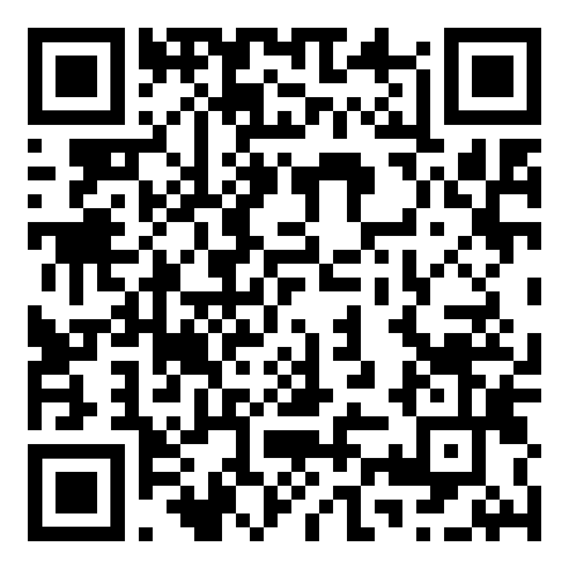
ScreenU: Check in on Your Alcohol Use
- Scan this QR code to access ScreenU
- Receive non-judgmental, personalized feedback about your alcohol use with this confidential online tool!

