PeopleSoft PCard Reconciliation
EMSA Financial Services

Purchasing Services downloads PCard purchases daily. The expectation is that cardholders will review, reconcile, upload receipts, and verify transactions daily.

Contracting & Purchasing Services reconciliation deadlines are as follows: ALL monthly transactions must be reconciled, approval & receipt documentation uploaded, and verified by the 3rd of the following month. EMSA Financial Services must have all transactions reviewed, expenses redistributed and approved by the 5th of the following month!!

Cardholders that have not completed their reconciliations by the 3rd of the month will receive a Notice of Violation.

- Login to PeopleSoft Financials: https://cas.nau.edu/cas/login?service=https://financials.peoplesoft.nau.edu/

- Purchasing > Procurement Cards > Reconcile > Reconcile Statement

Locating a Statement:
Reconcilers and Approvers can locate an entire statement or a specific transaction on a statement via the Reconcile Statement Search screen. The two most common search fields are the Employee ID and the Employee Name.

Select the Search button
NOTE: The statement will show all charges that have not been approved. To view only those transactions you have not yet verified, use the Statement Status drop down on the Reconcile Statement Search page and change to “Staged” – then click Search.
Reviewing the Bank Statement Page:
The system automatically displays the first (9) transactions for the selected Employee ID.
Click View All, if you have more than (9) transactions for that billing cycle.

Transaction Tab:

Billing Tab:
The Billing Tab displays the Reference, Billing Date (the date that the bank billed your VISA card), Billing Amount, Currency (always USD), Prepaid Ref.

Select Billing tab

NOTE: Dispute and Credit Collect features are not applicable and these fields need to be left blank. Disregard all fields boxed in orange above.

Enter Description: Enter a description for the goods purchased in 5-6 words.
The description entered here will appear on the monthly Budget Transaction Detail report, so please be as descriptive as possible!

Save!

Example#1:
RT Flight to Portland, OR: March Yield Events

Example#2:
(3) Background Checks, INV#0467562-IN

Adding Public Purpose under Comments:
The Line Comments is where the public purpose is recorded by the Reconciler.
The Comptroller’s office would like to see the word “for” included for audit purposes; i.e. “This item was purchased for…”
This is also where you will indicate what speedchart the expense should be charged to and if a transaction is to be split between 2 or more speedcharts.

For grants, be sure to include the grant Project ID# and expense account code you want charged for each transaction. Sponsored Projects is really cracking down on secondary transfers of expenses, and are reviewing all for expense transfers from local/state speedcharts to grants.

Comment Icon: Select to access the Line Comments page.

Enter public purpose: Enter a detailed description of what was purchased. Don’t forget quantity – how many did you purchase??
Please include the full vendor name, the name (first initial, last name) of the individual(s), as it applies, that a purchase is made on behalf of – even if it’s yourself. Dates & location-city, state for conference registration, hotel stays, flights, etc.

Select OK

Example#1:
US Airways: RT flight to Portland, OR from Flagstaff, AZ for A. Smith to host presentation encouraging students, which have already been admitted to NAU, to accept their offer of admission, apply for housing and register for Orientation. Note that checked baggage fees will be charged separately on the day of the flight(s). Trip: March 8-10, 2018.

Example#2:

Example#3:

Documentation (Approvals & Receipts) Upload Process:
Approval documentation in the form of an email or signed Payment Request form should be saved as a .PDF and uploaded for the following transactions:
- Purchases over $1,000: Email approval or signed Payment Request Form from AVP (when applicable) & VP
- Travel Purchases, any dollar amount: Email travel approval from Executive Director and/or AVP (when
applicable), and VP. Travel purchases include conference & event registration.
An itemized receipt is to be uploaded to PeopleSoft Financials, via OnBase, for each transaction. PCard Reconcilers are responsible for completing this task as part of their PCard verification.
If you are unable to upload a receipt, because you do not have access to a scanner you can submit them to EMSA Financial Services for upload. If you receive a receipt via email, save the file to your hard drive as a .PDF and upload.
Food items purchased for consumption: A completed and signed EMSA Business Food/Meal Purchase Authorization form must be uploaded for each food purchase.
IMPORTANT! Please do not hold up completing your reconciliations because you are waiting on receiving a receipt. Contact the vendor/company and request an itemized receipt/invoice stamped PAID be emailed to you. Complete your description, public purpose - indicating that you are waiting on the receipt and will upload once received, and change Status to Verified. NOTE: Receipts can still be uploaded after month end close, but no other edits can be made!
Scan your receipts and save each receipt individually on your hard drive.
Label the receipt with the VendorName_Amount_Date (i.e. Target_99.25_05.01.2018).
If there is a refund add “Credit” to the title (i.e. Target_99.25_05.01.2018_Credit)

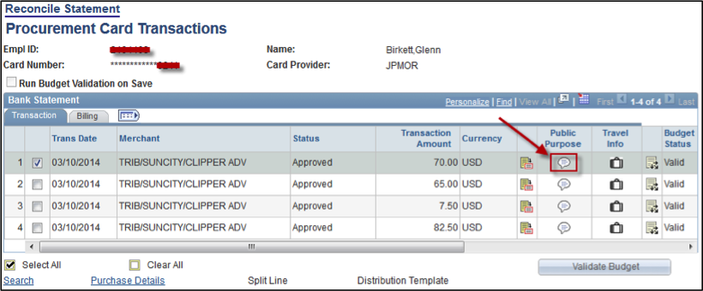
Click on the Comments bubble titled “Public Purpose” for the corresponding transaction/receipt.

Click on the “Documentation” button in the upper right hand corner of the Public Purpose (Comments) screen. The OnBase Viewer Window will open. If it is your first time logging into OnBase, see the section below entitled “First Time Login.” NOTE: Best viewed in Internet Explorer (IE).
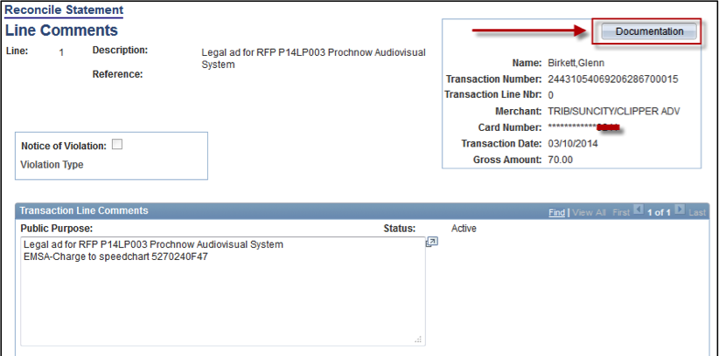

First Time Login:
If it is the first time that you are logging into OnBase, you may receive an error message:

If you receive the above error message – logout of PeopleSoft Financials (SAVE! first), close your browser down completely and start over. If you still receive an error, email Ask-FAS@nau.edu to have your permissions checked. Otherwise, proceed with the below steps.

Click the grey up-arrow near the top of screen to upload/import your receipt(s).

NOTE: The transaction information is automatically populated from PeopleSoft and is read only. Use in verifying that you are uploading documentation for the correct transaction. If the information does not look correct, contact ASK-FAS@nau.edu with the details.

Click the Choose File button in upper left to browse for the receipt file you will upload.

Verify that the Document Type selected shows
“PCARD – Transaction Documentation” and let the File Type automatically select for you.
NOTE: Please upload all documents in .PDF format. Please convert all emails to .PDF prior to uploading, this can be done by printing the email as a .PDF.

Verify that the transaction information and file name are correct.
Click the Import button at the bottom left to import the file.
Be VERY conscientious when uploading documents.
If you upload the wrong one, you will have to contact Ask-FAS@nau.edu to have it removed…there is no end user delete or over-write option.
Be sure to upload the correct document, and then email FAS to have the document(s) uploaded by mistake removed.

When the import finishes, a note in the upper left will indicate the Imported Successfully as shown below. If you have more receipts/documents, proceed as indicated above until finished.

When you are finished uploading, you can click the blue Exit button in the upper right hand of the OnBase screen to return to the “Reconcile Statement” page.

Reviewing Uploaded Documentation:
After uploading, to verify the imported documents are correct, click the folder icon in the upper left of the OnBase Viewer window.

NOTE: At any time following a successful upload, you can view uploaded documents by clicking the “Documentation” button in the upper right hand corner of the Public Purpose (Comments) screen in PeopleSoft Financials.

After clicking the folder icon in the OnBase Viewer window or the “Documentation” button on the Public Purpose (Comments) screen in PeopleSoft Financials, OnBase Viewer window will open. If there is just one document, it will automatically show in the viewer window.

When multiple documents have been uploaded for a transaction, it will look like this – note each line below represents (1) document; in this case, the same document was uploaded twice.

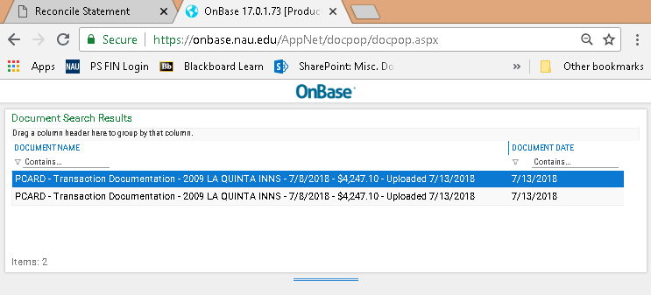

Entering Traveler Information:
Travel Info Column…
Click the white suitcase, this is only to be used for NAU students and staff (i.e. individuals with an EMPL ID). Should PCard transactions occur for non-University affiliated travelers (e.g. Interviewees, University Visitors, etc.), document the traveler’s name and dates of travel in the Public Purpose field.

Trip dates are to be for the entire duration of the travel period – departure & return, not just the date the transaction occurred.

List all travelers that the PCard transaction pertains to, for example: (3) employees using the same taxi to get from the airport to the hotel. Click on the + sign at the end of the first line to add additional travelers.

You can search for a Traveler’s EMPL ID by clicking on the and following the prompts.

Examples:

- Hotel Receipt: Five people traveled, three people stayed in the room - list the three individuals who stayed in the room.
- Taxi Cab receipt: List all travelers that rode in the cab.
- Conference Registration: List each traveler who in registered under that conference receipt.

Credit & Refund Reconciliations: Cardholders are required to reconcile any credit and/or refund that “hits” the PS Financial PCard statement. Reconciliation includes completing the Description (Billing Tab), the Public Purpose statement and uploading any corresponding documentation, including the original sales receipt.

Credits & Refunds:
Description: If possible, copy the same description from the original purchase reconciliation, proceeded by the word CREDIT. In the rare case that you are completing a credit reconciliation at the same time as you are reconciling the original purchase, use the same description for both, and add the word CREDIT: in front of the corresponding description .
Example: CREDIT: (1) night lodging – ABOR, E. Grisham

Public Purpose: If possible, copy the same public purpose statement from the original purchase reconciliation, proceeded by the word CREDIT. Include a brief description of what occurred – over charged, returned item and why, etc.

Please include the speedchart to be credited back – should be the same one originally charged!

Example: CREDIT: Spring Hill Suites (1 of 2) nights lodging for Erin Grisham to attend ABOR meeting in Tempe, AZ from 2/2-4/2016.

**There were no rooms available when Erin tried to check in, hotel was over booked. Hotel credited back one night lodging. Erin stayed with J. Kuhn in her hotel room for the first night.
Speedchart: 5220210F25

Documentation to Upload: A copy of the original sales receipt should be uploaded along with, any credit memos/receipts provided by the vendor, email chain with the vendor and/or additional related information.

NOTE: This includes fraudulent charges that appear on your monthly statement.

Fraudulent Charge:
Description: Fraudulent Charge: [Police Report# XXX-XXXX] or Fraudulent Charge: [Vendor Name]

Public Purpose:
Example #1: Fraudulent Charge: [Police Report# XXX-XXXX]. See attached for additional information.

Example #2: Fraudulent Charge: [Vendor Name]. See attached for additional information.

Documentation to Upload: A copy of the police report (if available) should be uploaded along with, any credit memos/receipts provided by the vendor, email chain with the bank verifying the fraud.

NOTE: As with any PCard purchase, do not hold up reconciling credits/fraudulent changes because you are waiting on documentation. Complete as much as possible prior to the monthly deadline and include a note in the Public Purpose statement that you are waiting on documentation.
Verifying Transactions: Once all transactions have been reviewed and the appropriate entries for description and public purchase have been completed, you will complete *Status.

You can check box each purchase individually and click the Verify button or use the drop down menu in the *Status column.

Select All: Click on this link to display all transactions on a single page or to change the Status.
Clear All: Click on this link to clear Select All.

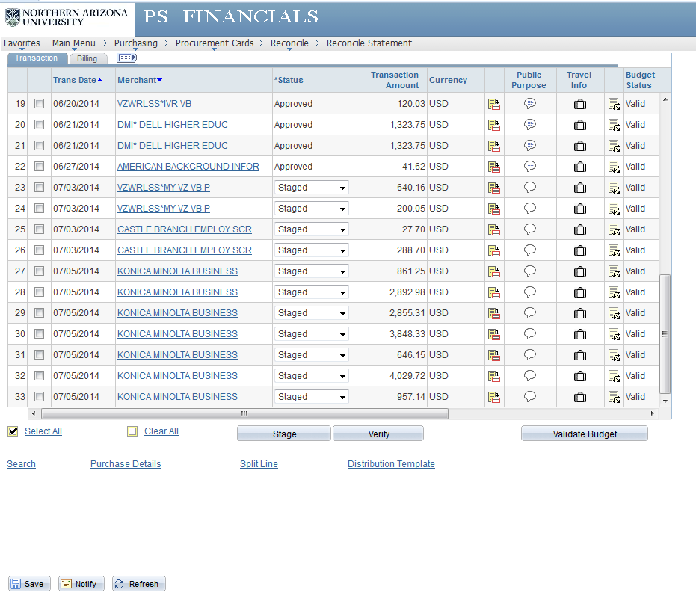

Select All

Click Verify button

Select Save

QUICK REFERENCE:
- Click View All
- Click Billing Tab – enter brief description of item(s).
- Click Transaction Tab
- Click Comments Icon – enter public purpose; include the word “for”, invoice #’s and dates as applies.
- Scan & Upload Receipts
- Click on Suitcase: Travel Info – enter all travelers’ EMPL ID’s and trip dates associated with purchase.
- Click Select All
- Click Verify button
- SAVE!!! SAVE!!! SAVE!!! – Anytime you see the Button…Click it!!

MISC Notes:
- Credits & Refunds: Cardholders are required to complete reconciliations for credits and/or refunds that “hit” on the PCard in PS Financials – description, public purpose & uploaded receipts/credit memo/email/etc. Reference the above reconciliation example from page.
- Chase International Fees: For the Description & Public Purpose, enter “Bank Imposed Fees”. No other explanation or documentation required.

- Item Description: To be entered on the Billing Tab, a brief description of what was purchased.
Example: RT Flight to Portland, OR for Yield Event March 2018

- Public Purpose Descriptions: Enter a detailed description of what was purchased. Don’t forget quantity – how many did you purchase? Please include the full vendor name, the name (first initial, last name) of the individual(s), as it applies, that a purchase is made on behalf of – even if it’s yourself. Dates & location-city, state for conference registration, hotel stays, flights, etc.
Example: US Airways: RT flight to Portland, OR from Flagstaff, AZ for Charles Just to host presentation encouraging students who have already been admitted to NAU to accept their offer of admission, apply for housing and register for Orientation. Note that checked baggage fees will be charged separately on the day of the flight(s). Trip March 8-10, 2018.

- SAVE! SAVE! SAVE! – Every chance you get, click the Save button at the bottom left hand side of the Transaction tab screen.

- Approval Documentation: Purchases over $1,000: Email approval or signed Payment Request Form from AVP (when applicable) & VP. Travel Purchases, any dollar amount: Email travel approval from Executive Director and/or AVP (when applicable), and VP. Travel purchases include conference & event registration.

- Receipts: Must be itemized for what you bought and indicate that payment was received. An invoice alone, “order confirmation”, packing slip, or credit card slip is NOT sufficient. Please be sure that the receipt(s) you uploaded into OnBase are legible!! We are also looking for shipping charges & tax.
We recommend that you keep your original receipt(s) for at least 30 days after purchase. After which they can be discarded.
- Cardholders with Multiple Speedcharts: Those cardholders with multiple speedcharts associated with their PCard, PLEASE indicate for each purchase which account should be charged.
Need further assistance? EMSAFinancialServices@nau.edu
https://nau.edu/its/learn/emsa/pcard

