NAU Online Tutoring Instructions
- Go to nau.edu/onlinetutoring

- Click on the link, matched with subject you have scheduled an appointment for.*
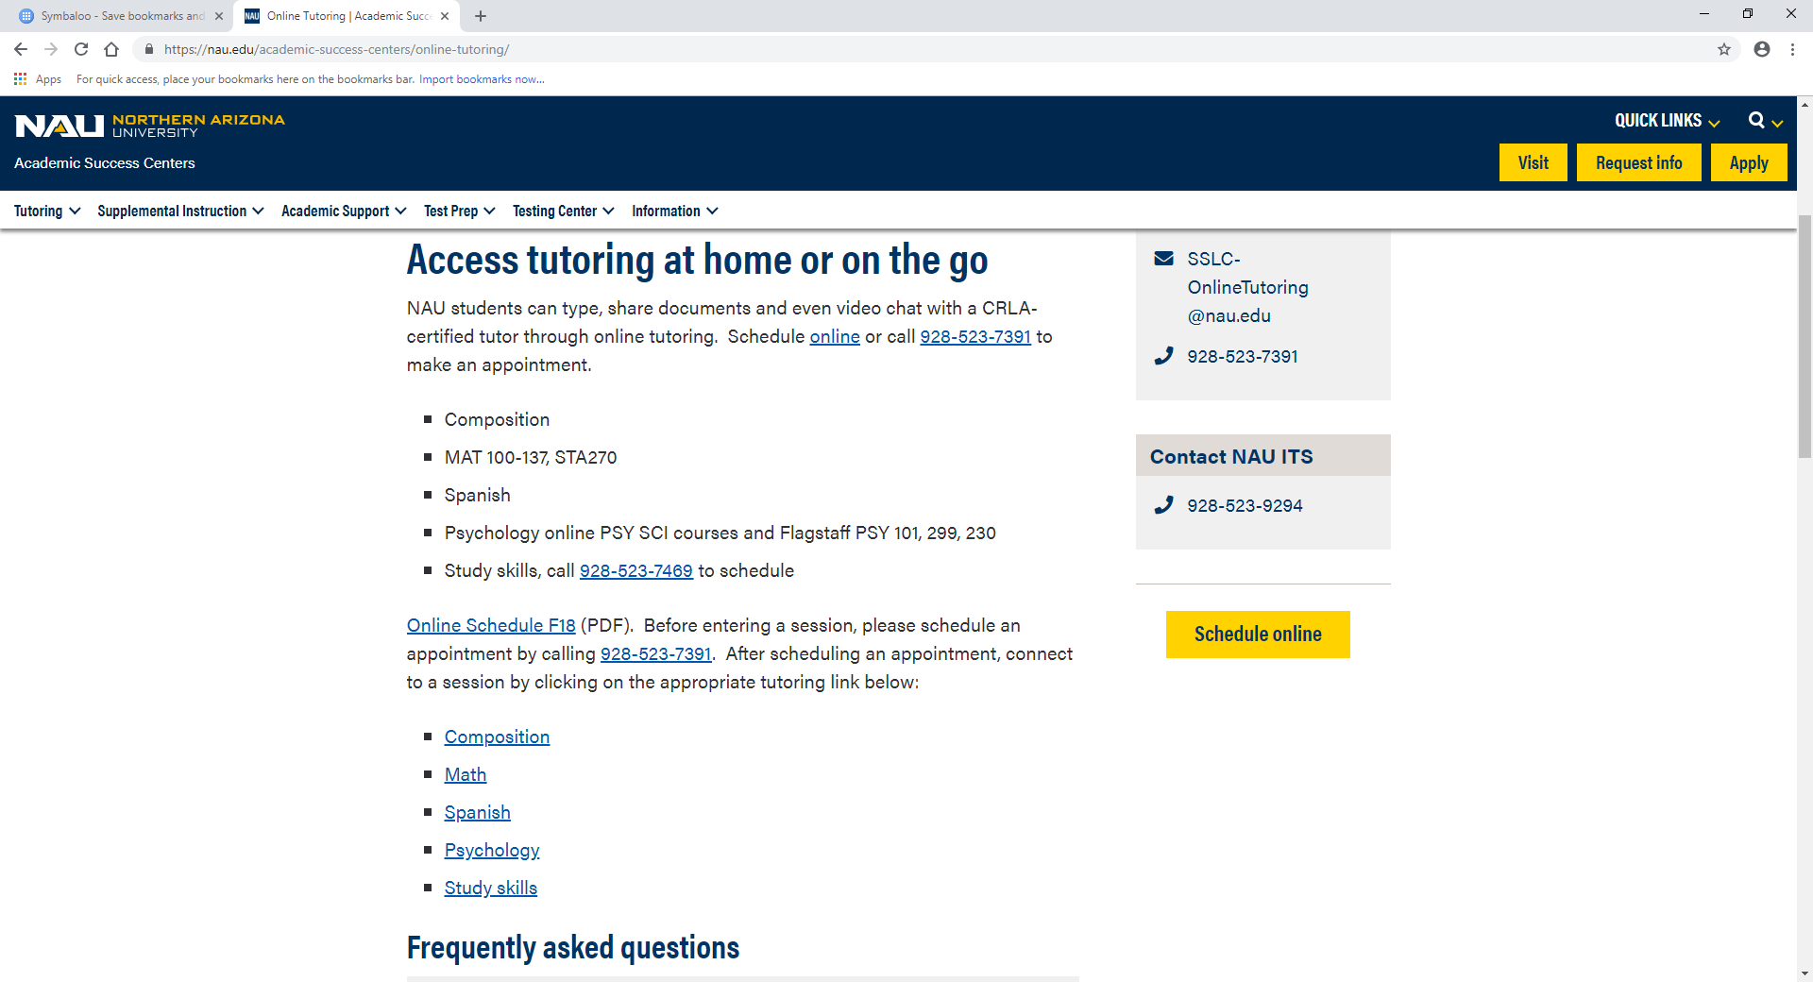

- The tutoring room will open. Enter your name and you are ready to go!
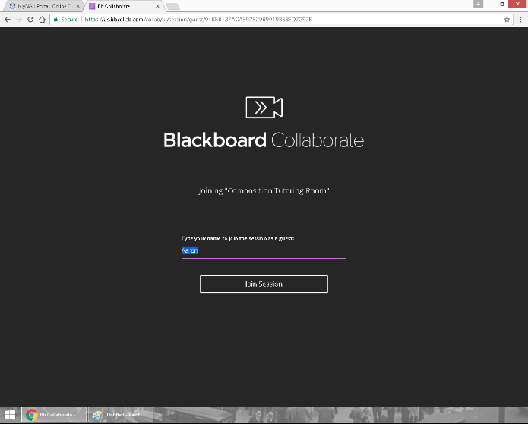

*BbLearn cannot be open while using online tutoring. If you recieve the message "Not Found" please quit your browser, restart it and attempt re-enter the tutoring room.

For Questions, please call 928-523-7391 or email SSLC-OnlineTutoring@nau.edu

