LGBTQIA Commission
Meeting Agenda
09/8/2021
12:30PM-2:00PM
Join Zoom Meeting
https://nau.zoom.us/j/87507418888
Meeting ID: 875 0741 8888
Password: September
- Introductions:
  - Names,
  - Pronouns,
  - pick 1: Why are you with us? How are you feeling? Something else?

Land Acknowledgement: Northern Arizona University sits at the base of the San Francisco Peaks, on occupied lands sacred to Native Americans throughout the region. We honor their past, present, and future generations, who have lived here for millennia and will forever call this place home.

- Co-Chair update
  - Sean Parson
  - Marian Griffin

- Diversity Awards Celebration, (Back Page has Map)
  - September 14, 5:30pm – 7:00pm,
  - Aquatic and Tennis Center Fields: 705 S. San Francisco St
- Student Award: Rachel Krell, undergraduate student, majoring in Strategic Communication and minoring in Queer Studies
- Staff Award: Martin Tease, coordinator, Office of Inclusion: Multicultural and LGBTQIA Student Services (IMQ)
- Faculty Award: Heather Martel, associate professor, History
- Ally of the Year: Felicia Fiedler, Flagstaff Community Library

- Approve Minutes from April
  - Any discussion about April Minutes
  - Request for confirmation of minutes
  - Vote to confirm

- Curriculum Committee Announcement: (Ari Burford)
  - Brandon Killby
  - Cole Eskridge
  - Amanda MacNair

- Budget:
  - Last year - ($4,000.00) - spent on All gender bathroom signage project
    - project update: (Rick Michaels, Grace Ditsworth, Calvin Legassie)
  - This year - ($4,000.00) - The committee did great in accomplishing this last year!
  - Committee Volunteers: folx interested in making sure the budget gets spent this year!

- LBGTQIA Scholarship fund:
  - Phone bank on converting the remainder of donators. (Current Use->Endowment)
  - ASNAU Donation Drive. (Katie Cinader & Jacob Kyle Carter)

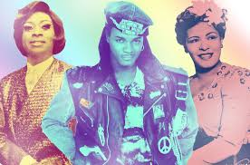
- LGBTQIA Social Gathering Revival (Grace Ditsworth)
  - Vote by email survey (Forthcoming)

- Co-Comm update:
  - Diversity Fellows have been elected:
    - Luis Fernandez, Chair CJ
    - Jani Ingram, Chem/BioChem
    - Catherine Lockmiller – Librarian/Cline/PHX Biomed Campus
    - Eric Otenyo – Pol. & Int’l Affairs
    - Marcela Pino Alcaraz – VP enrollment Management, AIA Fellow
    - Frances Reimer – College of Ed
    - Martin Tease – IMQ
    - KT Thompson – English
  - Marketing Nametag Conflict: pronouns on nametags (Marian)

- Pronouns on Zoom: Knowledge base – NAU ITS Self-Service
  - (https://nau.service-now.com/sp?id=kb_article&article=KB0016843)

- Covid Protocol for this commission:
  - ZOOM,
  - In-person,
  - Both (if so, how?)

- IMQ Check-in: upcoming events.

- Community Check-in: Flag Library book club, Flag Pride, any other community updates.

- Student Orgs Check-in: Who’s active this year? How can we help?

- Any Other Announcements?

- THANK YOU EVERYONE! You are amazing!

- Adjournment!

NAU Diversity Awards Celebration
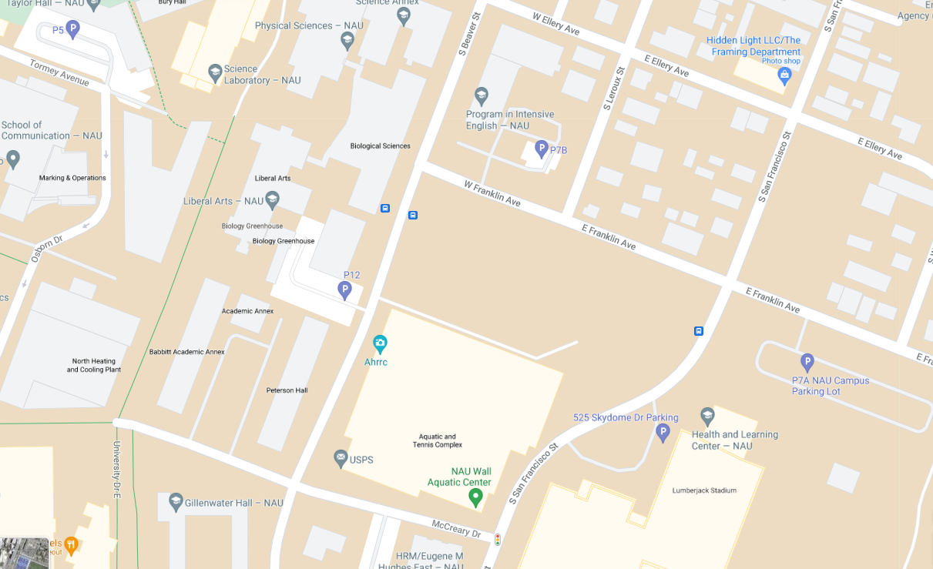
Diversity Awards Celebration
Tuesday, Sept. 14th
5:30pm
BYOPicnic

