LGBTQIA Commission
Meeting Minutes
09/8/2021
12:30PM-2:00PM
Join Zoom Meeting
https://nau.zoom.us/j/87507418888
Meeting ID: 875 0741 8888
Password: September
- Welcome
  - Chelsea Green opened the meeting at 12:37 p.m.
  - Chelsea welcomed members of the LGBTQIA Commission and read the Land Acknowledgement

- Introductions:
  - Chelsea Green, Amanda MacNair, Grace Ditsworth, Shane Canitz, Shelby Reid, Robert Estrada, Tina Sutton, Cole Eskridge, Rachel Krell, Jeremy LaBuff, Maria Seewaldt, Marian Griffin, Brandon Killby, Dilofarid Miskinzod, Calvin Legassie, Cher Has No Horse, Jesse Zukosky, Irene Wise, Hannah, Rachell Krell, Lauren Copeland-Glenn, Felicia Fiedler

Land Acknowledgement: Northern Arizona University sits at the base of the San Francisco Peaks, on occupied lands sacred to Native Americans throughout the region. We honor their past, present, and future generations, who have lived here for millennia and will forever call this place home.

- Co-Chair update
  - Sean Parson
    - Had to step out this semester as the LGBTQIA Commission faculty co-chair due to family emergencies
      - May be back next semester
  - Marian Griffin
    - Is graciously filling in for Sean this semester as an interim co-chair

- Diversity Awards Celebration (Back page has map)
  - September 14, 5:30pm – 7:00pm
    - Commission members should have received an invite, if not, email Chelsea
  - Location: Aquatic and Tennis Center Fields: 705 S. San Francisco St
    - (Behind Natatorium)
    - Bring your own picnic (style chosen to prevent spread of COVID-19)
    - Chelsea also proposed arranging small groups, so individuals do not have to sit alone during the ceremony
  - Awardees:

- Student Award: Rachel Krell, undergraduate student, majoring in Strategic Communication and minoring in Queer Studies
- Staff Award: Martin Tease, coordinator, Office of Inclusion: Multicultural and LGBTQIA Student Services (IMQ)
- Faculty Award: Heather Martel, associate professor, History
- Ally of the Year: Felicia Fiedler, Flagstaff Community Library

- Approval of Minutes from April
  - Jeremy LaBuff made a motion to approve the minutes. Grace Ditsworth seconded the motion. A vote was made, the vote was unanimously affirmative, and the motion passed.
- Diversity Curriculum Committee Announcement: (Chelsea Green)
  - Lauren: the curriculum is going to encompass many more aspects of diversity, which will entail hard work, but the integration of these diversity areas into the general liberal arts curriculum is extremely important and has been something the commissions have been striving toward for a long time
  - Vote of confidence is now completed:
    - The new faculty advisors representing the LGBTQIA Commission are Brandon Killby and Cole Eskridge
    - Amanda MacNair was supported by the commission as well but there could only be two representatives from the LGBTQIA Commission, and as Lauren Pointed out, those on the Committee were required to be faculty per the faculty governance body rules.

- Budget:
  - Last year - ($4,000.00) - majority was spent on All gender restroom signage project
    - Project update: (Rick Michaels, Grace Ditsworth, Calvin Legassie, Lauren Copeland-Glenn)
      - Website created and almost finished
        - Lauren presented three images to possibly use as a banner for the website
          - The first combined images of a figure in a wheelchair in motion with a cape flying behind it inside of a black raised fist, and overlayed on an LGBTQ+ flag (with added black and brown stripes, as well as transgender color stipes), and the last two were pictures of NAU students posing with various Pride flags
          - Discussion:
            - Overwhelming support for the first image
            - One concern: cape iconography can be problematic for the disability community because an individual in a wheelchair shown wearing a cape can be misconstrued as “inspiration porn”
              - However, the cape could be edited out, as one commission member suggested
              - This topic will be further discussed with members of CDAD
      - Need to check about status of signs
        - Lauren: concerns about wording making signs too long delayed the printing of the signs
          - However, since the money is encumbered, after this obstacle is resolved, will be ready to print the signs
  - This year’s budget - ($4,000.00)
  - Call for Budget Committee Volunteers: folx interested in making sure the budget gets spent this year!
    - Please reach out to Chelsea or Marian if interested
      - Topic will be revisited at next LGBTQIA Commission meeting
    - Ideas for educational and outreach activities:
      - Co-sponsored Discussion on usage of pronouns suggested during CoCom by CSW CoChairs

- LBGTQIA Scholarship fund:
  - Stalled- waiting for endowment
    - Phone bank on converting the remainder of donators. (Current Use->Endowment)
      - Have around $15,000, but need around 25,000 to be endowed
        - About 1,000 in current use funds now (cannot contact donors)
      - Need to contact rest to determine if can use their donations as endowed money, or if use limited to current use

    - Lauren inquired about the scholarship criteria
      - Chelsea: all students can apply (criteria now includes graduate students) and need to write one page essay
      - Lauren recommended forming a small committee to formalize the verbiage and requirements of the fund if planning to award money this year

  - ASNAU Donation Drive
    - Katie Cinader and Jacob Kyler Carter from ASNAU have reached out and have proposed drafting a bill to raise the remaining money to meet the endowment minimum.
      - Chelsea and Marian will meet with ASNAU Thursday (tomorrow).

- LGBTQIA Social Gathering Revival (Grace Ditsworth)
  - Grace plans to organize
    - Shooting for monthly meetings, but can be more frequent if someone else wants to host additional events
  - Vote by email survey is forthcoming – Grace will send it out in next few days
    - Please provide information about favorite places, preferred activities, and preferences safety requirements (COVID)
    - Accessibility considerations will be a priority

- Co-Comm update:
  - Diversity Fellows have been elected:
    - Luis Fernandez, Chair CJ
      - (Replaced Angela Enno who left the university)
    - Jani Ingram, Chem/BioChem
    - Catherine Lockmiller – Librarian/Cline/PHX Biomed Campus
    - Eric Otenyo – Pol. & Int’l Affairs
    - Marcela Pino Alcaraz – VP enrollment Management, AIA Fellow
    - Frances Reimer – College of Ed
    - Martin Tease – IMQ
    - KT Thompson – English
  - CoCom will call for more nominations this semester and then select the last two current Diversity Fellows
  - First Diversity Fellows meeting is this Friday
  - 3-year plan announcement from President Cruz Rivera has been established and is very extensive
  - Contact email for Diversity Fellows has been established
  - Marketing Nametag Conflict: pronouns on nametags (Marian)
    - Brought to university marketing multiple times over 5 years
      - With the previous leadership, the answer was always no because the current template is not changeable and due to hesitancy to get involved in social dilemmas
      - CoCom wants to write a unified letter about why it is important to have an option for pronouns
        - Marian is currently in charge of the draft
          - Themes of letter so far:
            - Demand for it—Lots of departments are asking for it
            - Incorporating aspects of Safe Zone trainings and asking NAU to ‘put its money where its mouth is’ in terms of DEI work
            - Know it is possible
              - Departments have done it for themselves (by not going through marketing and not using their template)
          - Marian wants to bring a draft of the letter to next CoCom meeting
            - Asked commission members for stories, examples, or any other information they want to be included in the letter
      - Commissioner asked question about whether same problem exists with getting one’s chosen name on one’s nametag
        - Marian: preferred name/asserted name should be the only name listed on the nametag
          - If having problems, reach out to Marian or to the LGBTQIA Commission for help
        - Question about if name needs to be changed on nametag, do you always need to change it officially through the registrar?
          - In some situations, may not be able to change it through the registrar for privacy or safety reasons. Ex: If individual has a FERPA release on file and are not out to family.
          - Answer unclear, and Lauren will investigate

- Pronouns on Zoom: Knowledge base – NAU ITS Self-Service
  - Article to show how to add pronouns

- Covid Protocol for this Commission:
  - Zoom, in-person, or both?
    - Discussion:
      - Several commissioners mentioned benefit of Zoom meetings for those joining outside of Flagstaff and/or juggling meetings
      - No decision made
      - (Contact Co-Chairs with concerns/opinions about this before the next meeting. Wed. Oct. 13th)

- IMQ Check-in
  - Upcoming events:
    - This Thursday (September 9th) from 5:00 to 7:00 p.m.: Qmmunity Welcome in the IMQ Center
    - Ongoing Zone trainings this semester
  - To join IMQ Instagram (nau_inclusion) or email list please email Marian or Martin

- Community Check-in:
  - Coconino Country Health and Human Services (Cher Has No Horse, Program Manager)
    - County Health Services Testing event tentatively planned for October 18th (questionable if can be held with current COVID situation) for HIV/STI testing to take place in (possibly in the IMQ office)
      - If not, will happen in the spring semester
      - HIV and STI testing still available year-round at Campus Health Services
    - Testing on campus
      - HIV testing is free, full panel is typically $20 for ages 18+ (for ages 13-17, it is free)
        - If cannot afford, can talk to staff at testing events who may be able to waive those fees
  - Flagstaff Public Library Representative Felicia Fiedler was unable to make it to the meeting but contacted co-chairs to ask for feedback on Book recommendations for the LGBTQIA book club at the library. (Chelsea did not see this email until after the meeting, unfortunately, and will instead send an email to the listserv)

- Adjournment
  - Chelsea adjourned the meeting at 1:53 p.m.

NAU Diversity Awards Celebration
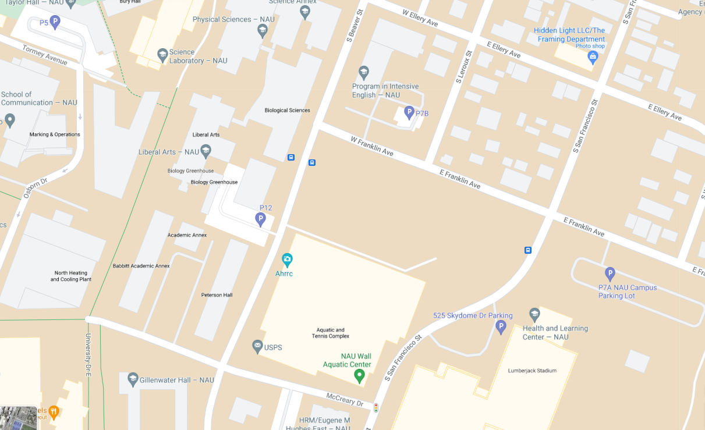
Diversity Awards Celebration
Tuesday, Sept. 14th
5:30pm
BYOPicnic

