University Writing Commons WCONLINE User Instructions

The University Writing Commons uses WCONLINE to schedule appointments and host all of our one-on-one online tutoring sessions. You can easily schedule your next appointment with a Writing Assistant by following the steps below.

Register for a WCONLINE Account
Make an Appointment with a Writing Assistant
Modify or Cancel an Existing Appointment
Join Our Waiting List
Join Your Online Appointment Session
Appointment Limits & Missed Appointments Policy
UWC Feedback Survey
Need Help?

Register for a WCONLINE Account
Visit https://nau.mywconline.com. Create a login and a password by clicking on ‘Register for an account.’ Complete the registration form using your NAU email address, click ‘Register,’ and you will have successfully registered for a WCONLINE account. You can now login from the home page.

Northern Arizona University ITS recommends the following security guidelines for users creating logins on WCONLINE: 1) Use your NAU email address (i.e. abc123@nau.edu or first.last@nau.edu) 2) Do NOT, for any reason, use the same password you use for CAS 3) Choose a long password, 12 or more characters that is easy to remember and type (like a phrase) 4) Do not share accounts or credentials with anyone.

Make an Appointment with a Writing Assistant
Locate the date and time you would like to schedule an appointment on the ‘University Writing Commons S20 Schedule.’ You can select different weeks or use the calendar icon at the top of the page to find an appointment time in the future.

You can schedule a half hour or full hour appointment. Due to current COVID-19 restrictions, you are only able to schedule an online appointment with a Writing Assistant. We suggest you make a full hour appointment in case you and your Writing Assistant need time to troubleshoot technical issues.

The University Writing Commons tutoring schedule is color coded as follows:

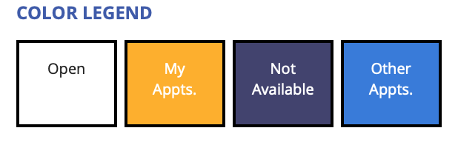
Click on a white ‘Open’ square during the date and time you prefer and complete the appointment form.

Be sure to upload your draft of your writing assignment (and any relevant assignment prompt, rubric, outline, etc.) to your appointment form so that your Writing Assistant can better assist you during your online session.

Modify or Cancel Your Existing Appointment
Locate your existing appointment specified by a yellow ‘My Appts.’ square on the schedule grid and click on it. Or, you can select the appointment from ‘My Appointments’ under the ‘Welcome’ menu on the upper left. This will allow you to modify or cancel your appointment.

When cancelling an appointment, please try to do so as early as possible, ideally 12 hours in advance, so that another writer can book that session.

Join Our Waiting List
If you need an appointment during a day and time when our tutoring schedule is full, you can join our waiting list. The waiting list allows you to be notified of an opening in the schedule for that day in WCONLINE.

You can click on the ‘WAITING LIST’ link at the lower right of each day to join the waiting list. The waiting list link always shows the date (i.e. ‘WAITING LIST: FEBRUARY 14, 2019’).

As soon as an appointment is canceled, everyone on the waiting list is notified via text message or email of the opening, and the time slot is "up for grabs." Whichever writer makes an appointment first is the one who gets that appointment.

Join Your Online Appointment Session
To join your online session with your Writing Assistant, log in to WCONLINE at the start of your session, open your yellow ‘My Appts.’ square on the schedule grid and click on it. Or, you can select the appointment from ‘My Appointments’ under the ‘Welcome’ menu on the upper left. Then click the red ‘Start or Join Online Consultation’ link.

Online sessions are synchronous, which means you and your Writing Assistant will work together, at the same time, in a digital space on your writing project. For synchronous online meetings, you and your Writing Assistant can use a text chat, document-sharing whiteboard area, drawing tools, and audio/video to collaborate.
Appointment Limits & Missed Appointments Policy
Writers can schedule up to one hour of writing tutoring in a day and up to three hours of writing tutoring in a week, depending on availability. Writers may not schedule more than three consecutive appointments with the same Writing Assistant in a semester (unless enrolled in ENG 100/405).

If you miss (without canceling), you will be marked as a ‘no show.’ If you miss three of your scheduled sessions without canceling, WCONLINE will block you from making additional appointments. If this happens, you will need to contact the University Writing Commons to explain your situation.

University Writing Commons Feedback Survey
After you meet with a Writing Assistant, an anonymous survey will be emailed to you. Please tell us about your experience so that we can best support you in the future and improve our services.

Need Help?
If you need help using WCONLINE, you can always email the University Writing Commons at iwriting@nau.edu.

*These instructions were adapted from The Ohio State University Center for the Study and Teaching of Writing, Loyola Marymount University’s “Making Appointments” guide, and WCONLINE’s product manual.

University Writing Commons WCONLINE Writing Assistant Instructions

The University Writing Commons uses WCONLINE to schedule appointments and host all of our one-on-one online tutoring sessions. You can easily track your UWC schedule and facilitate synchronous online sessions with writers by following the steps below.

Register for a WCONLINE Account
Checking Your Daily/Weekly Schedule
How to Check if Your Student Has Registered for a WCONLINE Account
Setup a Repeat Appointment for a Writer
Tracking Cancelled or Missed Appointments
Tracking Walk-In/Drop-in Appointments
Placeholder Appointments
Client Report Forms
Joining an Online Session as a Writing Assistant
Using Online Appointment Tools

Register for a WCONLINE Account
Visit https://nau.mywconline.com or click on the administrator registration WCONLINE link sent to your NAU email. Create a login and a password by clicking on ‘Register for an account.’ Complete the registration form using your NAU email address. If a question does not apply to you, you can type "N/A" or "Staff." Click ‘Register,’ and you will have successfully registered for a WCONLINE account. You can now login from the home page.

Northern Arizona University ITS recommends the following security guidelines for users creating logins on WCONLINE: 1) Use your NAU email address (i.e. abc123@nau.edu or first.last@nau.edu) 2) Do NOT, for any reason, use the same password you use for CAS 3) Choose a long password, 12 or more characters that is easy to remember and type (like a phrase) 4) Do not share accounts or credentials with anyone.

Checking Your Daily/Weekly Schedule
You can login to your WCONLINE account at the start of your shift to view all of your scheduled appointments or openings for the day. As an administrator, your University Writing Commons tutoring schedule is color coded like this:
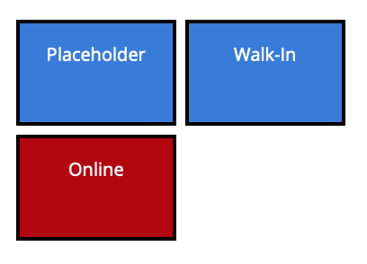
Additionally, open appointments are signified by a white ‘Open’ square. A light grey square signifies that the appointment time has passed. A dark purple square signifies that the day/time is ‘Not available.’ You can click on the boxes for more information about each appointment.

How to Check if Your Student Has Registered for a WCONLINE Account
Hover over the ‘Welcome, [Your Name]’ icon on the WCONLINE platform. Click ‘Client & Record Management.’ Type in the student’s email in the ‘Client Search’ field and click ‘Search.’ If their name appears, they have registered.

Setup a Repeat Appointment for a Writer
To schedule an ENG 100/405 student with recurring appointments, click on the white ‘Open’ square during the date and time they have chosen to “Create New Appointment.” Type the students’ NAU email in the ‘Client’ tab. Be sure the appointment duration is one hour. Click on the ‘Show REPEAT Options’ button in the upper right next to the ‘Appointment Date’ field. Select the desired schedule from the ‘Repeat every [week] until [May 1, 2020].’ Fill out as much of the form as you can; students can add relevant information and upload documents later by clicking on their yellow ‘My Appts.’ square before their appointment each week.

Tracking Cancelled or Missed Appointments
WCONLINE does not allow writers to ‘cancel’ an existing appointment if it’s less than 12 hours before the appointment. If a writer asks you to ‘cancel’ an appointment for them, you can click on the appointment in the schedule block and click ‘Cancel Appointment.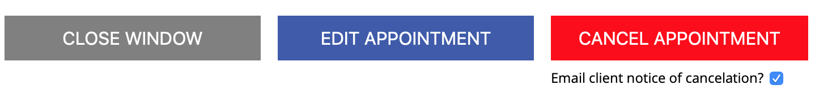
If a writer does not contact you and simply does not show up to their scheduled appointment, they should be marked as a ‘no show’ for their appointment. To do this, click on the appointment that was missed in the schedule block, and click on the link ‘Mark Missed’ next to the ‘Appointment Date’ on the form. Or, you can click ‘Edit Appointment’ on the bottom of the schedule form, and then check ‘Missed’ in the red ‘Administrative Options’ box.
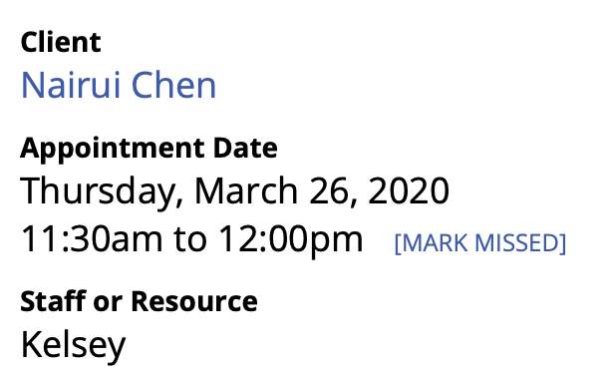
or
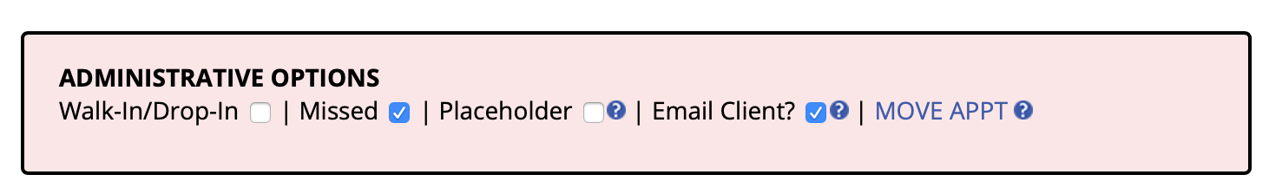

Tracking Walk-In/Drop-in Appointments
If a writer does not make an appointment in advance, but arrives for tutoring at one of our UWC sites, they should be marked as a ‘Walk-In/Drop-In.’ To do this, click on the white ‘Open’ square during the date and time they are joining a session, fill out the appointment form with them, and then check ‘Walk-In/Drop-In’ in the red ‘Administrative Options’ box.

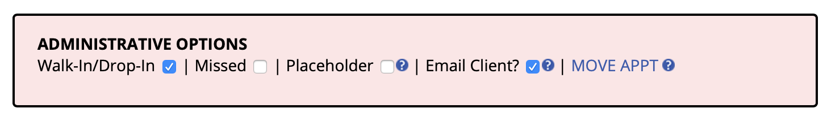

Placeholder Appointments
A "placeholder" is an appointment for something other than a meeting with a writer (e.g. staff meeting, IWP workshop, mentoring observation, doctor’s appointment, unexpected absence, etc.). To blockout time in your schedule that is not already booked, especially if you don’t want to change your entire schedule, you can click on the white ‘Open’ square during the date and time you need to block out time. Complete the appointment form and type ‘placeholder’ under any fields with required information. In the red ‘Administrative Options’ box, you will check ‘placeholder’ to signify that it is ‘used’ time, but that the placeholder ‘appointment’ will not count in our appointment statistics. Then click ‘Create Appointment’ to save the placeholder.
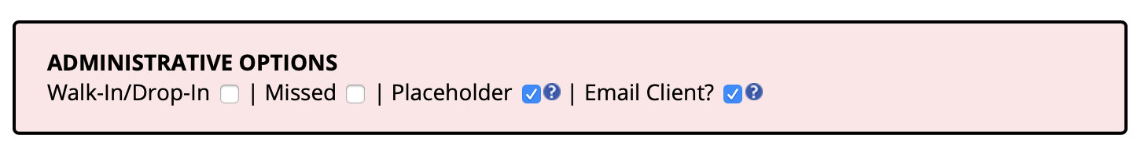

Client Report Forms
Once you have finished your appointment with a writer, you will fill out the ‘Post-Session Client Report Form.’ To do this, click on the appointment box in the schedule and click “Add New” under the ‘Post-Session Client Report Form.’
You should fill out the form to record information about your session with the writer and click ‘Save Report’ when you are done. There is an option to email the report to the writer and/or a teacher, advisor, other Writing Assistant, etc. You can also attach a file that the writer might find useful. WCONLINE will save this information for data collection. Additionally, any Writing Assistant can access previous post-session reports for past appointments.

Re-Assigning a Student to Another Writing Assistant
If

Joining an Online Session as a Writing Assistant
You will receive an email when a writer books with you. If you do not want email notifications, please let Andie know and she can disable this feature for you.

When an appointment is booked with you, a red appointment box will appear on the line where your appointments are scheduled for that day. If you click on the appointment box the appointment information will appear.

Click on the appointment box in the schedule grid. Find the red link ‘Start or Join Online Consultation’ and click to begin the session.

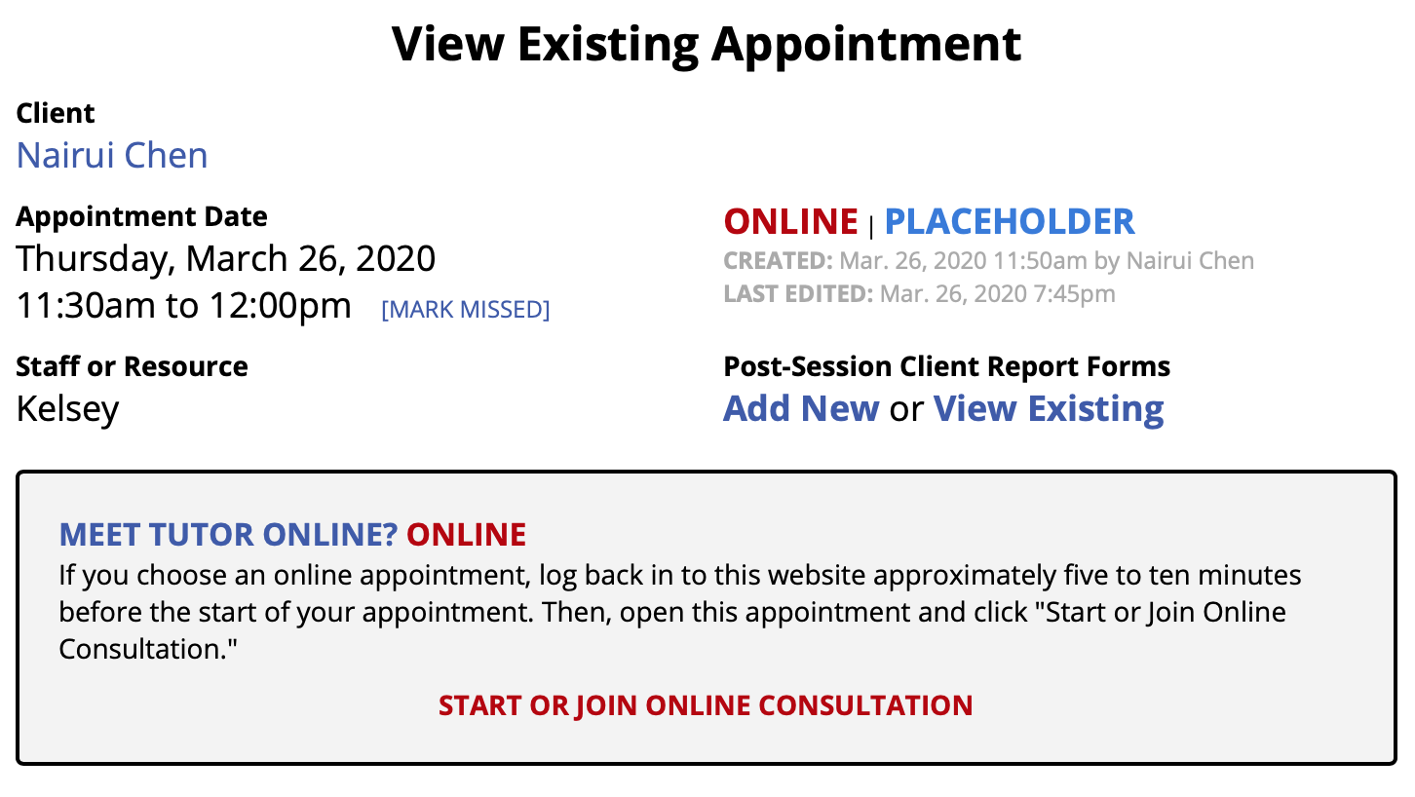

Using Online Appointment Tools
Document upload: Students have the option to pre-load a paper when scheduling an appointment.
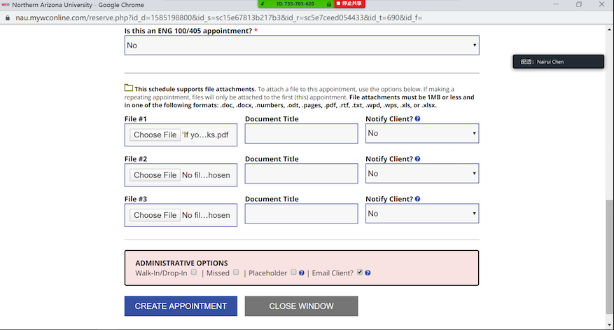

Copy & paste: If students did not upload a document when making the appointment, they can copy and paste their document into the whiteboard.

Audio & Visual: Once the appointment has started, the audio and video will automatically start and will appear on the left hand side of the screen. You can then turn the audio and visual on and off as needed by clicking either icon.

Chat Feature: Once the appointment has started, a chat feature will appear on the right hand side of the screen. Feel free to use this feature if you are having issues hearing/seeing the student.

Draw tool: In the upper right corner of the whiteboard, there is a pencil icon that allows you to draw on the whiteboard. You can change the color if you desire.

Saving work: Work automatically saves as you go. However, before ending the session, the writer may want to copy and paste their work into a document outside of WC Online or they can use the “print” feature in the right hand corner of the screen and save the work as a pdf.

Sessions timing out: When the session time is up, the writer may be dropped from the appointment, so keep track of your timing and make sure that you end the appointment with enough time that the writer can save their work.

Connectivity issues: If you or the writer are unable to hear or see one another, simply exit the session and re-enter and both functions should reboot.

Joining an Online Session as an Observer / Mentor
TBD….

Creating a Session for a Workshop or Group Appointment
If you are giving workshops, small group tutoring, study or review groups, etc., Andie will set the ‘Number of Appointments per Time Slot’ for your user profile to allow for group appointments set at a specific capacity. Writers will see a white space on the schedule grid--just like open individual slots--until the appointment is filled and simply make their own appointment as normal until the group appointment is filled. Since each appointment in a group is separate (and each appointment form and client report form is private for each writer), you can fill out a separate ‘client report’ form (if needed) on each appointment, not the entire group at once.

Holding Asynchronous Appointments On WCONLINE

Frequently asked questions
Q: Why is the essay automatically highlighted?
A: Click on the eye symbol on the upper column of your screen, the color of highlighting is random.

Q: What if the student does not know how to upload his/her files?
A: Kindly ask the student to copy and paste the essay onto your classroom blank area. This will save you both time in training the student.

Q: What if the student could not hear me, see me or I could not hear him/her?
A: The first recommendation was using Chrome for WCOline, if the student was using Web, Safari, or Internet, please kindly suggest them to change and avoid future problems. In Chrome, please check with the student and make sure the WCOline web page is given access to video and microphone.

Q: What if the student was experiencing connection problems?
A: You could always ask the student to close Chrome and reopen it. For some international students who were using VPN, make sure the WCOline was the only web page running on Chrome and no downloading, unknown firewall, or online games running as the session goes.

