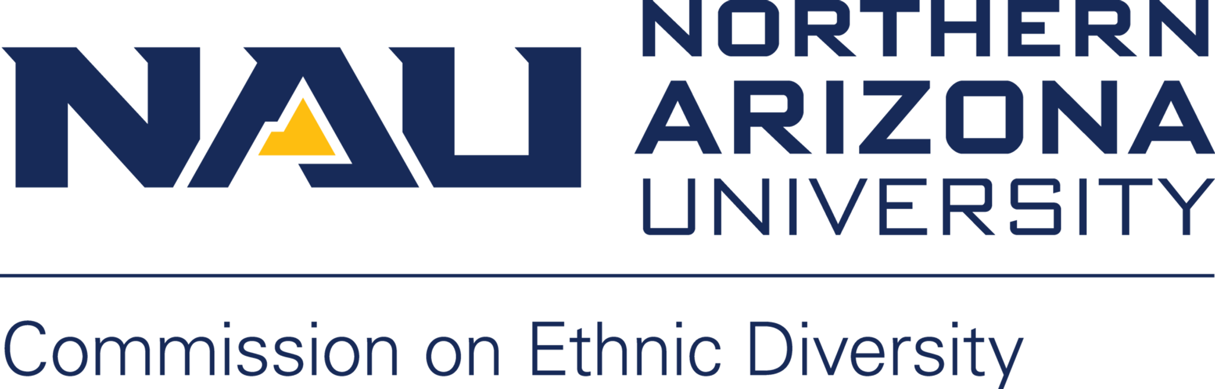

Northern Arizona University sits at the base of the San Francisco Peaks, on homelands sacred to Native Americans throughout the region. We honor their past, present, and future generations, who have lived here for millennia and will forever call this place home.

Virtual Meeting:
Join Zoom Meeting
https://nau.zoom.us/j/82523029857

Meeting ID: 825 2302 9857
Password: 154112

MEETING INFORMATION:

Date: Monday, March 1st
Time: 12:30PM – 2:00PM
Facilitator: Lorena Lechuga Gutierrez
AGENDA

- Call to Order (Lorena)
- Roll Call and Introductions
- Approval of CED minutes from February meeting

- Inclusion Multicultural LGBTQIA Student Services (IMQ)

- Community Updates (CED Family)

- CoComm Update (Lauren Copeland Glenn)

- Unfinished Business
- Co-chair (Faculty) Nomination Explorations
- Diversity Awards (moving to Fall 2021?)
- Diversity Fellows
- Liberal Studies Program Forum Updates from CED Members
- Bylaws Editing Update
- CED Budget: The LGBTQIA Commission and the Commission on Disability Access and Design are partnering on informational signage for the all gender restrooms. Vote on funding project.
- Goal Setting Discussion
- CED Recruitment

- New Business
- NAU President: Jose Luis Cruz

- Updates and Announcements (CED Family)
- Next Meeting: Monday April 5th, 2021

- Adjournment

