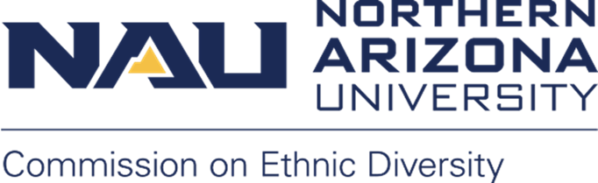
Northern Arizona University sits at the base of the San Francisco Peaks, on homelands sacred to Native Americans throughout the region. We honor their past, present, and future generations, who have lived here for millennia and will forever call this place home.
MEETING INFORMATION:
Date: Monday, February 6, 2023
Time: 12:00 p.m. – 1:30 p.m.
Room: In-person at the Union Oak Creek Room or Zoom
Join Zoom Meeting
Meeting ID: 850 9921 5800
Password: 967175
AGENDA
- Call to Order, Land Acknowledgement and Introductions

- Approval of January 23, 2023 minutes

- Campus Resource Highlight: Cline Library, Kevin Ketchner, Librarian

- Co-Chairs Updates
  - Update on CED letter and meeting with President on 2/1/23
    - Review response letter
    - Goldwater Institute policy report, The New Loyalty Oaths
  - Campus Interviews with VP of IDE Candidates in next two weeks
    - Members highly encouraged to attend
    - Meet candidates, ask questions, and provide feedback to the search committee
    - Lauren will let us know what the dates are to meet the candidates
  - CED faculty co-chair for Fall 2023 start (replace Gretchen)
  - CED Award Nomination form - deadline 2/20/2023

- Announcements:
  - Happenings at the IMQ
  - CSW film, “Break the Silence: Reproductive and Sexual Health Stories” on February 9, 6:30 PM, Cline Library Auditorium or via Zoom (bit.ly/CSWFilm), PW: 462883. Event is free!
  - HSI Panel Discussion: Complexities and Nuances in Understanding Latinx Identities, 2/15/23, 3:30-4:30 PM, online, info here.

- Next Meeting and Adjournment
  - March 6, 2023

