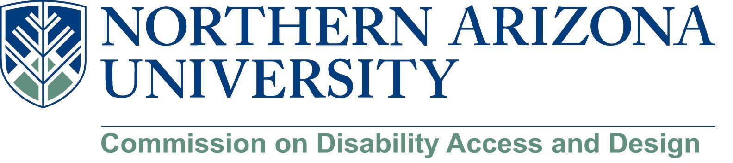

Meeting Minues

Wednesday, September 19, 2018
12:00-1:30 pm, University Union, Sycamore
Meet Me Line – (928) 523-6629

Meeting Began at 12:05 PM

- Call to Order
  - Roll Call and introductions
  - Approval of minutes from August meeting
    - No minutes to approve at this time. Will have them next time.

- Update on DSP (Lauren)
  - Task force opportunities
    - Will create 3 task forces
      - Diversity Committee members on facility search process
      - Measuring Diversity
      - Prioritizing what we can do first.
  - Had a little hiatus over the summer.
  - DSP plan is still online for viewing

- Co-chairs meeting update (Chris/Jamie)
  - Meeting with President Cheng
    - Concern over half-time release with the Chief Diversity Officer position (CDO).
    - Co-chairs discussed doing events together.
    - Discussed change in banquet format.

- PhotoVoice and Disability (Heather Williamson)
  - A Photo storytelling process.
  - The specific project focused on individuals with an intellectual disability and who are Native American.
    - Health and wellness connected with being involved the community.
  - Currently working on finding locations to partner with.

- DHM (Disability Heritage Month)
  - Sitting volleyball
    - Tentative Date is October 10th.
  - Amanda Kraus
    - Director of Disability Research Center at University of Arizona
    - Presentation is on October 5th, 3-5 PM in the SAS auditorium.
  - Scavenger Hunt
    - October 12th, 11:30 - 1:30 PM on North Campus
    - Students explore North Campus to learn about the areas that are inaccessible and difficult to navigate.
    - Will look into having the same events across the campuses.
    - Will need volunteers with disabilities to help facilitate the scavenger hunt.
  - Matthew’s talk, “Everything You Want to Know About Disability But Were Afraid to Ask.”
    - October 18th
    - Will possibly be livestreamed.
    - Will request to have it recorded for the CDAD site to allow for future viewing.
  - Faculty Panel on infusing disability into the curriculum.
    - October 22nd, Will get exact room number. 2 - 3:30 PM
    - Will invite people from different departments.
    - Will focus on how teachers are putting disability into the subject matter of the courses they teach.
  - Erin Callinan and bookstore event
    - October 29th. Exact time TBA.
    - Speaker confirmed we just need to find a location.
    - There potentially will be a book signing by Erin.

- Looking ahead to spring events
  - Screening of Intelligent Lives with panel discussion
    - Variety of scales available to put on for this event.
    - If we bring Dan, it is expensive.
  - Feranmi Okanlami from University of Michigan Medical school
    - Represents different intersectionality of disability and race, would like to bring Feranmi in the spring.
    - Would be discussing how disability is viewed in the medical community.
    - Will look into having Feranmi spend some time at the Biomedical center.
  - Possible intermural sitting volleyball team/tournament
    - Looking at expanding the scale of the event.
  - Scavenger hunt on South Campus
  - “Furiously Happy”, look into bringing the author, Jenny Lawson, next October.

- Invite Brian Levin-Stankevich, Interim Provost to an upcoming meeting
  - Might be a good person to bring who has an outside perspective.
    - Will send him a version of the Memo that we sent to the provost before.

- Discussion of invigoration the commission’s work with students and student climate considerations
  - Will focus on how we are considering the climate issues around disability involving students.
  - Will look into ideas to think about, possibly look at doing a PhotoVoice project here.
  - We shall see if we can get data from some of the questions we have incorporated into the surveys.
    - Should we have the Metrics Taskforce discuss this?

- Construction update
  - Recital Hall is finishing up, mostly work being done on the interior.
  - Please let Andrew know about any concrete projects that you would like them to consider for the future.
    - Sidewalk by P16 should be widened.
    - Please let them know if there are any areas that you would like them to repair.

- Old/New business
  - IHD in first stage of review, got approval to push forward.
    - Establishing a certificate in Disability Resource Specialists
    - Got a Federal 3 year grant, partnering with Navajo Technical Institute.
  - Matthew’s film has been accepted into the Denver Film Festival.

Meeting Ended at 1:33 PM

