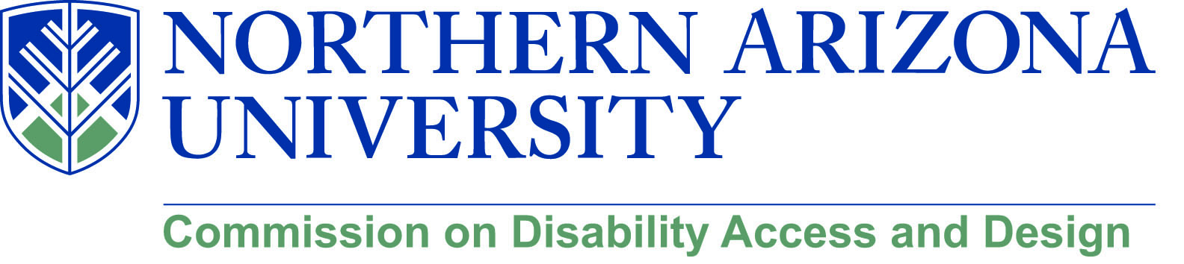

MINUTES

Wednesday, May 16, 2018
12:00-1:30 pm, University Union, Havasupai C
***Please note: There will not be a MeetMe line for this meeting.***

- Call to Order – 12:01 p.m.
  - Roll Call and introductions
  - Approval of minutes from April meeting
    - Sean Kugler moved, Dorianne Pollack seconded, all in favor, motion approved

- Facility Services updates (Andrew Iacona, Facility Services Project Manager)
  - Summer construction
    - Provided overview of all summer projects and which project manager is assigned to which project
    - To find the latest construction map and information visit https://nau.edu/Facility-Services/Planning/Design---Construction/ (NOTE: map is not accessible)

- Engineering accreditation
  - ABET is the accrediting body for engineering programs. They have recently proposed changes to their criteria that will include accessibility be taught within courses (infused throughout the curriculum)
    - This provides opportunities for CDAD to support and resources to the engineering program
  - Chris reached out to Diana Elder to meet about the new accreditation since our program will be up for review in the next couple of years. With the engineering becoming its own college, she referred us to Cornel Ciocanel because she is not an engineer and will stay with CEFNS
    - Chris, Lauren, and Jamie will meet with him on May 21st
  - Jason has some curriculum ideas as well
    - Bridget Bero put together a grant a while ago and she asked Jason and David Richter to put together an ethics module for the practice series on the ethics of technology
      - Through this, she asked them to design an entire course, Jason infused disability
    - There is a new chair of the philosophy department and they would be interested in offering this course regularly
      - He can pack the course with whatever CDAD recommends
  - Feedback:
    - Agnes – there is an equivalent course to her CM120 course in engineering that would be a good place to begin to introduce information around disability and design
    - Chris – CDAD will provide the conceptual importance of disability inclusion but engineering will provide the expertise in the technical
    - David – Sees two issues: What does infusion mean? Hopes that they are taught that disability access is the right thing to do
      - We need to teach the philosophy of the why and let engineering teach the technical

- Disability Heritage Month
  - Updates from April discussion
  - David suggested that perhaps through Faculty Development we can put together a series about how to infuse disability within a course
    - Provide some examples of how this can be done through experiences of those who are already doing it
    - Perhaps use those who have already participated in the learning communities or other sessions on UD/UDL who could come back and talk about what they’ve done
      - This can be a recurring topic/session
    - Chris will reach out to Larry Gallagher
  - Matthew suggested taking a look at a film he saw at Calgary film festival recently. It’s a film from Kenya about CP and attempting to remove the cultural stigma around disability there. He will send the name

- New/Old business
  - Matthew W. – Starting in spring 2020 there will probably be a class in the journalism program about journalism and disability. It will be a part of the DIS minor and also count toward the journalism degree
  - Matthew’s film was accepted into the San Francisco film fest

Meeting end: 1:11 p.m.

