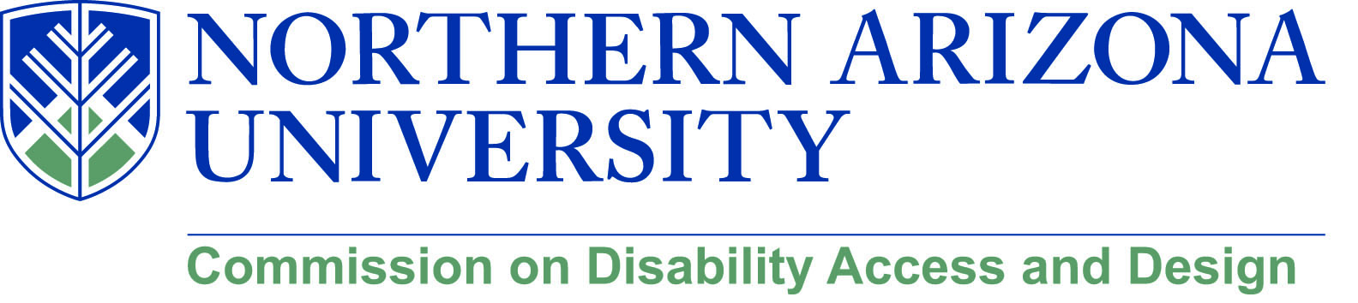

MINUTES

Wednesday, June 20, 2018
12:00-1:30 pm, University Union, Sycamore
Meet Me Line – (928) 523-6629

- Call to Order – 12:00 p.m.
  - Roll Call and introductions
  - Approval of minutes from May meeting
    - Calvin motioned to approve, Sean seconded, all in favor, motion passed

- Chris took some time to recognize two members who are retiring and their contributions to the commission’s work: Matt Minister and Pat Crist are both retiring from NAU this month. Chris also recognized Lauren Copeland-Glenn’s work as co-chair reminding everyone that this is her last meeting as co-chair.

- Update on DSP (Chris and Lauren)
  - Lauren provided an overview of where we are with the DSP process. The most recent version of the plan is on the Center for University Access and Inclusion’s website and feedback is still sought and welcome. Prioritizations in particular are needed. There will be another stakeholder meeting sometime this summer, in particular because the folks at Ethnic Studies and Women’s and Gender Studies had their end of the year retreat during the same time as the last meeting.
  - An announcement of the meeting will be sent to the commissions.
  - Feedback can be sent directly to Lauren (lauren.copeland-glenn@nau.edu or to the Center’s email CUAI@nau.edu)

- Update on Engineering (Lauren and Jamie)
  - Civil engineering course panel
    - Jamie Axelrod and Lauren Copeland-Glenn were invited by Andrew Iacona to participate in a senior level, pilot course for site layout in the civil engineering program. The students were given a real-world design problem and asked to provide solutions that also incorporated Universal Design. Jamie, Lauren and folks from FS provided critique and suggestions for improvement one week and then the following week were presented with the final projects. It was a great opportunity to teach these students about how to interpret and incorporate UD into their design process and how to be advocates with their clients to show them that UD is good design. The faculty (Mark Lamer and Kai Kaoni) were so pleased that they have asked them to continue to participate and hope that the class becomes a standard offering.
    - Andrew pointed out that the plans that the students created are great for programming purposes at Facility Services because the students produced usable data that can be used for funding proposals. This type of collaboration is a benefit to the university but also is a great opportunity to teach students about real world interactions with clients and projects and to teach about Universal Design (an understanding of which, he pointed out, is lacking with most design professionals that bid for jobs at NAU). The plan is to identify other locations across campus where design is needed to solve an issue and give those projects to the students to solve.
  - Accreditation discussion
    - Chris, Jamie, and Lauren met with Cornel Ciocanel and Diana Elders to discuss the upcoming changes to the engineering accreditation that has language that specifically includes accessibility as a part of the course outcomes. Cornel was very receptive and could already imagine how this could be incorporated into the mechanical engineering curriculum.
    - They are just finishing their reaccreditation cycle but this is the perfect time to begin to think about how accessibility will be incorporated and taught going forward for the next accreditation cycle. We will reconvene in the fall for continued discussions. CDAD was offered as a source of expertise and assistance through this process.

- Update on Personnel changes (Chris and Lauren)
  - FS is in negotiations with the finalist candidate for the building inspector position. Lauren commented that it will be good to have our own building inspector again that we can work with. Andrew pointed out that we haven’t been without a building inspector, but they have been contracted as opposed to in-house.
  - Welcome to James Ingram who is now faculty in COE and German Ferman who has joined ITS.
  - A new Honors Dean was selected. Kevin Gustafson comes from UT Arlington and brings a diverse academic background. The college is excited about what he brings. David asked that we send calendar of events to him for inclusion as Explorations for the honors students

- Summer Events and Presentations
  - Matthew just got back from a film festival in San Francisco and also had a special screening for kids at the Flagstaff Public Library.
    - This brought up the idea of showing it to K-12 classrooms.
  - Dorianne Pollack and Jamie Axelrod will have a break-out session presentation at the upcoming AHEAD conference in Albuquerque on modified attendance
  - Chelsey Tarazi (graduate student), Sean Kugler, Dorianne Pollack, Matthew Wangeman, and Chris Lanterman will present a poster at the AHEAD conference entitled “From Madhouse to Schoolhouse: Disability culture in Education”
  - Chris and Lauren will also be presenting on the accessibility scavenger hunt and Lauren will present on accessible mapping with Jim Kessler from AHEAD at the AHEAD conference
  - James Ingram will be presenting at the OSEP conference in July on his dissertation topic
  - Sean Kugler will present at the AZTAP conference on accommodations after high school
  - David suggested that we submit all of these presentations to NAU News and reference CDAD for visibility
    - Lauren will submit them

- Update on Disability Heritage Month and call for volunteers
  - Mental health symposium
    - Planning for this to happen in September. Lauren and Sharon Gooding are planning to pull together stakeholders from across campus as well as those who have expressed interest in helping to work on the symposium for an initial meeting in July.
  - David Camacho and Jason Matteson volunteered to work with Faculty Development to pull together a panel of faculty who have successfully incorporated teaching around disability issues into their courses. These will be faculty who are not from DIS or COE who can provide practical guidance and show others how this can be accomplished within a range of disciplines.
    - Ray Chaira also volunteered to work on this from the technology side. Matthew offered his support
  - Matthew briefly discussed the film from Kenya. This seems like a film that would be best used in a course. Perhaps Leila Monaghan in anthropology would be interested?
  - We will keep people updated as we get closer to the August deadline for event proposals (we need to have our funding proposal ready to submit the first week of September and need to begin marketing)
  - Please send any ideas to Lauren, Chris, or Jamie

- Old/New business
  - Calvin Legassie updated the group on the recital hall construction. It is coming along nicely. They have an official open date of January 2019. The classrooms are well underway and the façade is taking shape. The main performance hall is still just a concrete box but that will change soon.
  - Jason asked that we get the word out for his co-convened course PHI/DIS 335: Ethics and Disability

Meeting End: 12:56 p.m.

