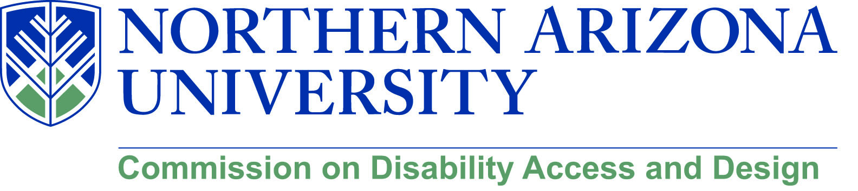

Minutes
Wednesday, August 15, 2018
12:00-1:30 pm, University Union, Havasupai C
MeetMe Line – (928) 523-6629

1. Call to Order
a. Roll Call and introductions
b. Approval of minutes from June meeting
1) Sean Kugler moved, tom Uno seconded
2) Minutes approved unanimously

2. Disability Heritage Month
a. Disability Biases and Microagressions – Amanda Kraus (October 5)
b. NAU 4 All Scavenger Hunt (October 12)
c. Sitting Volleyball (date TBD)
d. Goalball (date TBD)
1) Suggestion for Goalball to be in a quiet space, maybe South Gym
e. “Everything You Always Wanted to Know about Disability (date TBD)
f. Faculty Panel – Infusing Disability into the Curriculum (date TBD)
(David)
g. Disability in Theater – Regan Linton (Phamaly Theater in Denver (date TBD…likely 11/1 or 11/2)
h. Intelligent Lives screening (date TBD)

1) Intent expressed to have Athletics more involved with DHM
2) Suggestion to bring a speaker on mental health issues
a) Follow up on Mental Health Symposium; regroup for spring 2019 or fall 2019
3) Virtual Scavenger Hunt on the table, but not fal
4) Plan to recruit with Greek Life for attendance and participation at DHM
5) N4A also workig with Health Promotions

3. Construction Updates
a. Pedway around Honors opening
b. Concrete for recital hall and fences coming down

4. Building Qmmunity Forum (see attached)
a. Call for proposal due September 5
b. Building Qmmunity – October 6 (Family Weekend)
c. All sessions to be universally designed

5. Marketing CDAD
a. NAU News postings
1) Discussion about creating an “annual report” to share
a) think about complexity of processes and structures
b) initiative with other commissions (“Diversity Annual Report?”)
c) “this is what we are doing and what we are doing within our respective areas to advance diversity agenda
d) Consequently, without CDO, we are doing this piecemeal
e) It will be a major initiative to do this
f) Take an inventory of diversity efforts
g) This could create a baseline on which to report additional growth and effort
h) Explore patterns that we might find?
i) How might this inform the DSP

b. “From Madhouse to Schoolouse” and “Disability History Timeline” (post in IMQ)

6. Possible Initiatives for 2018-2019
a. Disability within Diversity Symposia
1) connect wit GLI
a) how do we align CDAD with GLI

b. “Mini” Disability Cultural Center
1) work with UofA to discuss possibilities
a) UofA is developing a disability cultural center through a grant

c. Dr. Feranmi Okanlami (University of Michigan )
1) PBC has day in Feb. when discuss disability
a) Maybe coordinate with UofA and PBC to bring Dr. Okonlani

d. Blackboard Ally
1) DR coordinating Training for help desks and faculty
2) Don Carter heading Academic and Research Technology Services (ARTS)
a) Responsible for all academic computing and classrooms
b) Ally tutorials in BBL

e. Other suggestions
1) Reach out to Faculty Professional Development for tabling at NFO
a) Information on CDAD, UMC., Ally

7. Old/New Business
a. IHD working with SBS on degree in Diversity Leadership
1) DS, WGS, ES programs
2) Concept paper developed out of IHD

b. IHD also working to create POS for future DR officers in higher ed
1) Concept paper developed
2) Planning for Masters and certificate, but only certificate moving forward right now
3) Go to PALC this fall with DR program

c. Faculty adoption of course materials is an issue
1) Encourage digital courseware as text replacement
2) No process for adopting digital courseware or e-text

Meeting adjourned at 1:35

