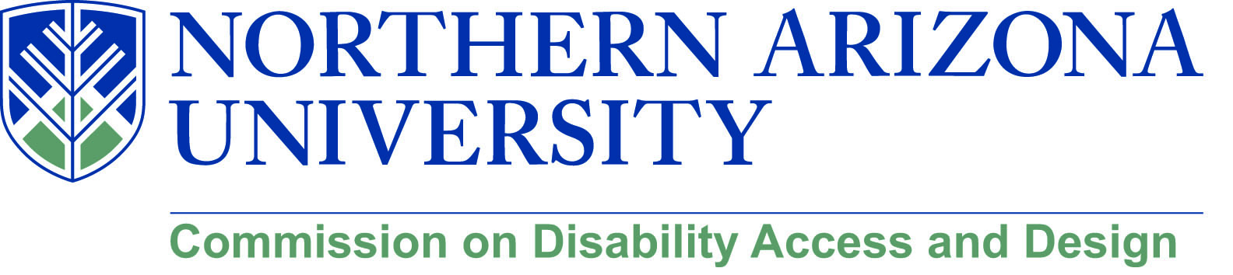

MEETING MINUTES

Wednesday, April 18, 2018
12:00-1:30 pm, University Union, Havasupai C
***Please note: There will not be a MeetMe line for this meeting.***

Meeting Began at 12:02 PM

- Call to Order
  - Roll Call and introductions
  - Approval of minutes from March meeting
    - Motion by Jamie Axelrod, Seconded by Sean Kugler. Minutes approved

- Leadership Award
  - Awardees
    - Andrew Iacona, Facility Services
    - Charlese Bedford, EMSA Communications
    - Lauren Graves, NAU 4 All President
    - John McDermott, IHD
  - Diversity Banquet on May 2, 5:30 pm at High Country Conference Center – Please RSVP by April 27th
    - Please RSVP if you have not yet. Registration available online
  - New award style
    - Acrylic material and in the shape of the San Francisco Peaks
    - Will have the new ISA and new text

- NAU 4 All Scavenger Hunt
  - Recap of the event – Lauren Graves
    - Event went well, had a good turnout
    - Students seems to gain some good information from the event
    - A system still needs to be developed so that we can follow up with what issues people may find during the scavenger hunt
      - Maybe use photography to highlight the issues along with a text description
      - The results from this system could then be easily provided to facility services for fixes
      - Maybe have the scavenger hunt teams tweet what they find using a special scavenger hunt hashtag so that they may be collated easier and faster. Maybe use Instagram instead?
        - Lauren CG will look into that for the fall
      - There will be a webpage for reporting accessibility issues after the web migration is over on the Disability Resources, Accessibility, and Equity and Access Office sites
    - Virtual Scavenger Hunt will occur in the fall semester

- Human Library event
  - Summary – Chris Lanterman and Matthew Wangeman
    - Matthew and Chris were books in the project
    - Good experience, most attendees seemed to be students or staff or facility who worked at NAU
    - 22 books and 120 readers who came to the event
    - Planned to be an annual event

- Disability Heritage Month
  - Possible speakers
    - Kay Barrett
    - Amanda Kraus from UA
      - Has agreed to attend, we just need to give her a date.
    - Jamie will look into arranging another speaker he saw at a conference
  - Panel: Media portrayals of disability
    - Maybe look at the film A Quiet Place as a possible showing option – talk with SUN Entertainment?
    - Talk to Paul Helford & Paul Donnelly about partnering with the CAL film series for the month of October – Jamie will contact
  - Stephen Hawking discussion
    - Possibly have some sort event around Stephen Hawking.
      - Not a lot of interest in this
  - Recurring events
    - Scavenger hunt
    - Sitting volleyball tournament
    - Goal Ball
    - Matthew’s talk

- Facility Services updates
  - Building Inspector search
    - Not sure if a building inspector is hired yet
  - Summer construction
    - Not a lot of construction that will impede people over the summer
    - They will realign the sidewalk south of Cline library
    - Will continue working on the recital hall
    - Honors College is still under construction but will be completed by August
    - Old chemistry building is being redone on the third and fourth floors
      - Sidewalk on Beaver right behind chemistry will also be closed due to the renovation

- New/Old business
    - Blackboard Ally
      - Provides a great administrative overview of accessibility issues for courses and course files
      - Allows faculty to see what needs to be fixed in their courses
      - Breaks down what parts of a course is accessible
      - Allows one to track the progress of accessibility over time
    - Next week Matthew will hold his spring talk Everything you wanted to know about disability… at the HLC.
    - Possible film festival
      - Would need to work out the logistic problems surrounding this
      - Maybe utilize a traveling film festival?
      - Will look at maybe at having it in Fall 2019
    - ASU is launching a new Disability Studies Major
      - With the existence of ASU’s disability major where does that leave NAU, with our minor?
        - There’s room and need for both

Meeting Ended at 1:05 PM

