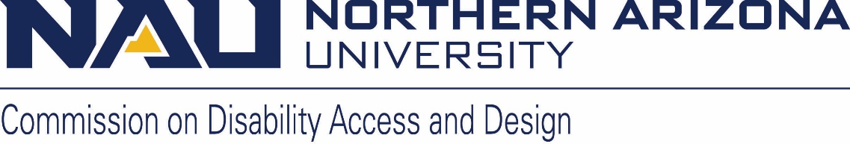

Commission on Disability Access and Design
DRAFT MINUTES

Wednesday, May 15, 2024
12:00-1:30 pm
Zoom link: https://nau.zoom.us/j/89090161783
Meeting ID: 890 9016 1783
Password: 142696

- Call to Order John Schaffer 12:04

- John Schaffer read NAU’s Land Acknowledgement

- Roll Call and introductions John Schaffer Lauren Copeland Glenn Jesse Zuk Laurie Jordon Gabriel Wheeler Jamie Axelrod Matthew Van Schoick Damon Burke, Juana Martinez, Anora Tilman, Nathan Pullen, Warren Clifford, Justin Mallett

- Approval of minutes from April meeting Jamie motioned Gabe seconded Laurie abstained, the rest in favor

- Announcements and Information Items (10 minutes)
  - Co-chair election
    - Lauren Copeland-Glenn has been voted in to serve a two-year term beginning July 1st. Thank you all for taking the time to vote
    - Lauren looking forward to continuing the work we’ve been doing- events plus other areas we can dig in on & appreciates the strength of votes she received
  - CoCom update
    - Discussion about protests- Lauren
      - Student protests throughout the year concerning the Israeli/Palestinian conflict, protests escalating, event on lawn on north campus union was dispersed by police, have been continuing protests, ongoing conversations, including within Jewish communities
      - John approached as co-chair of CDAD recently for a statement from CDAD but signed letter personally rather than representing CDAD; people in disability rights movement used protest to move their issues forward so we see it as a valuable tool but respect rules & have respect for current systems
        - Recommend CDAD should determine how it feels regarding protests, civil disobedience etc. given how these forms of speech have helped the cause of disability rights
      - Discussed opportunities provided to students
    - Lauren- Next year we may have $500 in local funds ($4,500 in state and $500 in local)- could provide some funding for food
    - Lauren- LGBTQIA Commission will have a new faculty co-chair, Megan McCoy
    - Lauren- Dr. Munene from the CED will be on a Fullbright for the academic year- Dr. Munene will be in Africa- CED seeking a faculty co-chair (election in the fall)
    - Lauren- Leadership development for commissioners from all of the commissions will be designed over the summer and rolled out in the fall- hoping folks from CDAD will take opportunity- what it means to be a co-chair but also committee assignments- more updates in fall
      - This will be a wonderful opportunity for folks who are interested in taking on a larger role but aren’t sure what that means
  - Reminder: June meeting will be June 18th from 12-1:30.

- Action and Discussion Items
  - Ask Jamie - ADA Coordinator/ 504 Compliance Officer update (Jamie Axelrod) (20 minutes)
    - May Topic – MOU, summer construction projects, and commencement ticketing- paths of travel, concrete projects designed to enhance paths of travel around campus- report concerns- pavement projects- mechanical, HVAC, fire life safety
    - Commencement update- excellent ceremonies- accessible seating area ticketing was helpful, ticketed accessible seating for the first time, more people respectful of the accessible seating as a result, discussion
    - MOU between facility services and CDAD allows us to be at the table for discussions about projects, design, and plan review. How space designed and who space will work for, how we can improve existing space through renovation, sharing ideas about design, usability, important contribution, MOU has been important over time
    - Warren- importance of being involved in design- 4 stages- Blue Beam reviews CDAD involvement would be helpful. Discussion
    - John question- how accessible is the NAU campus? Primary paths of travel around campus are quite accessible, continue to improve that over time. When I think about spaces that are completely unusable, there are very few- particular individuals may not be able to use every space but we would work to address those needs- go to old campuses and you will see things are less accessible than NAU
    - Question about stairway behind IHD connecting to Cline- not accessible path of travel- it’s coming out this summer- it’s not an accessible path regardless because can’t send someone into a parking lot- so putting someone at the top of those stairs, or the grade down to the sidewalk isn’t compliant, multiple methods of getting to sidewalk along Knoles, equitable ways for people to get to the same spaces- IHD, COE, highly used route
    - Please send us questions you have about disability, the law, how NAU meets our requirements, anything you don’t understand about how our compliance obligations work and we’ll have Jamie address a topic each month
  - Spring Events –
    - CODA screening update- John- disappointing audience- 2 panelists on zoom- 1 deaf woman who runs Deaf Center for University of Chicago- the other CODA- child of deaf adult- works for company who works who makes adaptive technology- panelist was asked if he thought ASL would be obsolete, he said opposite, more technology around ASL, ASL growing, more people communicating via ASL by technology- that movie is SO GOOD!!! Figure out how to get more people to attend these events
  - DPHM – start to plan
    - List of events ideas (X indicates we know it will happen but needs planning)
      - Honoring Judy Heumann (goal is October 1) X John- speakers, 1 day conference, activities
        - Planning committee will meet over the summer
      - Tom Olin photographer- Ability 360- outfitted with his artwork- he’s likely to come up and speak- we’d like to buy a piece of his artwork
      - Accessibility workshop series X
      - Accessibility Expeditions (virtual and physical) X
      - Sitting Volleyball Tournament X
      - A film with CAL film series- hopefully CAL can recommend a film with disabled characters
      - Human Library (need to come up with a different title as this is proprietary)
      - Alaqua Cox (Marvel Universe - Echo) X
      - Need help with planning/committee assignments
    - Other ideas for events/topics- 25 days- each ways assigned group of readings and short videos- October pride event- acceptance and ally challenge- videos, readings, prize for who attended most events-

- Old or New Business
  - Member announcements

- Next meetings (all times 12-1:30 p.m.):
  - June 18th
  - July – no meeting
  - August 21st

Meeting adjourned by John at 1:17

