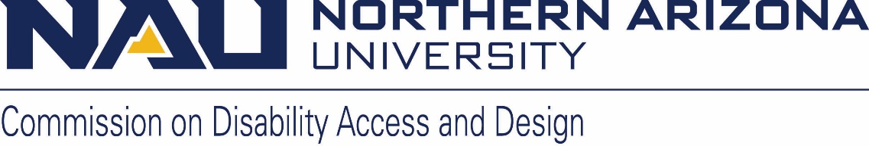

Northern Arizona University sits at the base of the San Francisco Peaks, on homelands sacred to Native Americans throughout the region. We honor their past, present, and future generations, who have lived here for millennia and will forever call this place home.

Commission on Disability Access and Design
Minutes

Wednesday, February 21, 2024
12:00-1:30 pm
Zoom link
Meeting ID: 86710289001
Password: 254454

- Call to Order
  - Lauren welcomed everyone and called the meeting to order at 12:02 p.m.
- Land Acknowledgement
  - Lauren read the Land Acknowledgment

- Roll Call and introductions
Lauren Copeland-Glenn, John Schaffer, Jeremy Musgrove, Anora Tillman, Gabriel Wheeler, Jamie Axelrod, Elizabeth Mennow, Charlese Bedford, Jade Metzger, Don Carter, Sean Krugler, Warren Clifford, Clayton Guffey, Camellia Moore, Prince Osei Agyemang, Nathan Pullen, Daniel Chodos, Barbara Dapcic

- Approval of minutes from the January meeting
  - Lauren called for a motion to approve the minutes
  - John made a motion to approve the minutes
  - Sean seconded
  - A vote was made to approve the minutes
  - All voted in affirmative
  - January meeting minutes approved

- Announcements and Information Items
  - Executive Committee meeting update (Jamie/Lauren/Gabe/Sean/John)
      - Looking at early March for the next meeting
      - We have a couple of topics to discuss at meetings
        - We will discuss whether the mission and vision of CDAD is in alignment with what CDAD wants to accomplish on campus
        - We will discuss whether the name of the Commission is still in alignment with the Commission’s purpose
        - Contact Lauren or John if there is any other topic you would like the committee to look review
  - The CDAD Leadership Award nomination form is open until Friday, February 23rd!!
    - A Qualtrics ballot for voting will go out on February 26th and close on March 4th
      - Currently have nine nominees
  - President’s Diversity Awards Celebration – April 16th at 5:30 p.m., at Ashurst Auditorium
    - Invitations will go out from University Events
    - Be sure to RSVP
  - Bylaws revisions
    - Bylaws revisions are complete
    - Qualtrics ballot to approve bylaws revisions will go out March 4th and close March 8th
  - CoCom update
    - New name for “Diversity Awards Celebration”
      - Suggested names
        - The President’s Diversity Awards Celebration
        - NAU Diversity Awards Celebration
        - The President’s Inclusive Excellence Award
      - Lauren suggested we settle on ‘The President’s Inclusive Excellence Award
      - The ‘President’ piece needs to be included to reflect its importance
      - Inclusive Excellence may not be familiar to many people
        - There should be a clear understanding of what ‘Inclusive Excellence’ is
      - More discussions will be held at the next CoCom meeting
      - Email Lauren or John if you have any suggestions or comments
    - Annual Report from Justin
      - Dr. Mallett is working on a report on his tenure so far, as Vice President for Inclusive Excellence
    - Campus Inclusion Team (CIT)
      - CIT is a group designed to provide support and resources to faculty, staff, students, and visitors who may have experienced actions that have left them feeling unwelcome or excluded.
      - Lauren to invite Lee to speak more on CIT
  - ASA – Arizona Student Association – update from their NAU meeting, February 13th (Sean and John)
    - Provided a platform for people with disabilities to share their stories
    - Had a great turn-out and was very interactive
    - Students want to know more about CDAD
    - Some topics discussed
      - Media Representation of Disability
      - Social model of disability
  - Inclusive Excellence book collection at Cline Library
    - New items have been purchased for the collection including disability-related items
    - Contact Lauren and John if you know of any items that could be added to the collection

- Action and Discussion Items
  - ADA Coordinator/ 504 Compliance Officer update (Jamie Axelrod)
    - February Topic - The ADA and Section 504
      - A couple of civil rights laws related to disability non-discrimination
      - A major piece of this is nondiscrimination in employment, primary, secondary, and post-secondary education
      - The Americans with Disability Act (ADA), amended in 2008, makes some changes to the intent of what the law should do
      - The ADA and Section 504 provide what we must do but give room for us to do more
      - Sections of the ADA talk about requirements for physical and digital accessibility
      - Section 504 and ADA are harmonized in the definition of disability and disability-related terms
      - There is a website to report access issues on the NAU campus (on the CDAD home page and Disability Resources website) but it has not been incorporated into the NAUGo App
      - ADA provides comprehensive information on workplace accommodations
    - Please send us questions you have about disability, the law, how NAU meets our requirements, or anything you do not understand about how our compliance obligations work, and we will have Jamie address a topic each month
  - Construction update (if any, Jamie Axelrod, or Warren Clifford)
    - Tabled for the next meeting
  - Spring Events – Lauren Copeland-Glenn, Sean Kugler, August Gerlach, and Danielle Contreras
    - Sitting Volleyball – March 21st at 5:30 p.m.
      - Please consider putting together a team!
    - Celebrating Judy Heumann: The Work Continues
      - The proposed outline of the event will be communicated
- Old or New Business
  - Member announcements
    - Move United Education Conference
    - Special population enrollment
      - Monday, February 26th; 8:30 to 9:30 a.m.
- Adjournment
  - Lauren thanked everyone for showing up for the meeting and adjourned the meeting at 1:30 p.m.
  - The next CDAD meeting will be held on March 20th, 2024

