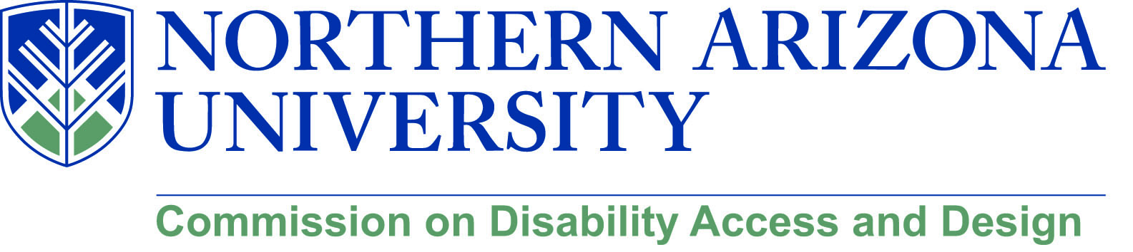

AGENDA

Wednesday, December 12, 2018
12:00-1:30 pm, University Union, Havasupai C
Skype Phone: (928) 523-0078 (Conference ID#: 5667562)

Meeting Began at 12:02 PM

Attendance:
Samuel Hemsley
Chris Lanterman
Jamie Axelrod
Lauren Copeland-Glenn
Jennifer Huber
Tom Uno
Sean Kugler
Jason Matteson
Melissa Griffin
James Ingram
Sharon Gooding
Calvin Legassie
Kathy Mahosky
Heather Williamson
Judy Manor
Dorianne Pollack

- Call to Order
  - Roll Call and introductions
  - Approval of minutes from November meeting
    - Motion by Sean, Calvin Seconds for approval.
      - Unanimous ayes, motion passes
- Update on Diversity Strategic Planning and Taskforces
  - Task forces have met several times
    - First few meetings were for getting people up to speed and creating strategies
    - Metric Task Force will meet after the break, so they can reflect on what data to include in the baseline. Will also allow them to research how to tie these metrics to priorities.
    - Prioritization Task Force is going through the goals and decided which time frame they would like to see for each goals.
    - Faculty Search Committee Task Force. Will meet after break.
    - Task Forces plan to meet roughly every other week.
    - If you are interested, please email Lauren.
- Faculty, Staff and Student Searches
  - There has never been a process or requirements for documentation for student workers, particularly in the Affirmative Action process.
  - Student process of collecting data is beginning now.
  - What comes out of the Faculty Search committee will help inform the other processes.
  - Will Faculty search task force take on the other searches or will that be for some other group?
    - For now it is just for Faculty, but would like to see it expand.
- Update on Diversity Fellow process
  - Chris is on the hiring committee.
  - Not heard from Joan or Dan since invitation to appear on committee.
  - Invited Co-Chairs to give feedback on process
    - Have not had further feedback besides initial feedback.
  - Should get an update on applicants.
    - A couple dozen applicants exist.
      - Surprising number of applicants given needed qualifications.
  - Hopeful for the future of the Diversity Fellow position, despite rocky road.
    - Will help guide the Plan through the university.
- Diversity Symposium and Future Initiatives
  - Successful symposium
    - Had lots of good feedback and was well received.
  - The planning process continues, largely from CED
    - Had good conversation about direction of Symposium.
    - Depending on resources might happen two times a semester.
      - Consisting of 6 anchor groups, one group will plan. The 6 groups are the commissions and the Global Learning Initiative.
      - Each anchor group can come up with a theme but the expectation is the theme is intersectional across all areas.
    - Student perspective is important.
  - The GLI is spearheading the Spring symposium, CDAD is working on the Fall symposium.
- Discussion with Amy about Faculty development.
  - Conversation being spearheaded by Gerald Wood
  - Making sure we are on Amy’s calendar
    - Contact with Amy is an important resource which we would not like to lose.
  - Should write Amy a letter to update her on our work on Universal Design.
    - A meeting also might work.
- DHM Planning 2019 including Spring events
  - Currently no commitments, but lots of good ideas.
    - Repeat of items which we have done successfully.
    - Should look at calendar now so we can plan for logistics and funding.
      - Will allow us to get the information out or at least make our mark on people’s calendars.
  - The Fermi event might need to be delayed to Fall.
  - Looking into the Arizona Liaison group
    - Would be a good fit for CDAD.
  - In January we should begin to plug things into the calendar.

- Mental Health Symposium update/planning
  - Looking at inviting other groups to come together to plan one event every month, beginning in the Fall with planning in the Spring.
    - Sent out email interest check and invite to a sit down meeting to plan out the events.
      - Lots of positive response, will be a smaller sit down meeting on the 14th to look at a calendar and plan out the events.
  - Look at having Trauma Informed Care as a topic for the symposium.
- Overview of Health Promotion services and activities- Melissa Griffin
  - Provides a variety of TF on campus
    - The prevention arm of student health services.
      - Supporting our students.
    - Collegiate recovery program
      - Space on 3rd floor of the HLC for students.
      - Regular meetings and support groups such as AA and secular options.
      - Support students who chose a sober lifestyle.
    - Created a more comprehensive approach to sexual violence on campus.
      - A tiered approach to sexual violence prevention education.
      - Bystander training is an important new training and concept.
      - Tier 1 is culture of understanding.
      - Tier 2 is around healthy relationships and consent
      - Tier 3 is based on Bystander training
      - Tier 4 is looking at sex in the media and creating activists to change the culture.
    - Will work on getting the materials and resources accessible.
    - Ulifeline has an online self-assessment for a students mental health.
    - Stressbusters provides a free backrub, helps with stress and relaxation.
    - Dietitian on staff to help students.
    - Feel free to send students towards the Health Promotion Services,
      - 1st floor of HLC, across from the escalator.
      - Melissa.Griffin@nau.edu
- Capital Projects on the Horizon
  - No real update from last meeting.
  - Recital hall opening
    - Weekend of January 18,19,20th there will be three performances.
    - The one on the 18th will be the higher profile donor event, the other two will be more open.
    - Will be ticketed for $10.
- Old/New Business
  - Provost Search
    - Should have someone from CDAD representing us with the search.
    - Could touch base with John and discuss it with him.

Meeting ended at 1:28 PM

