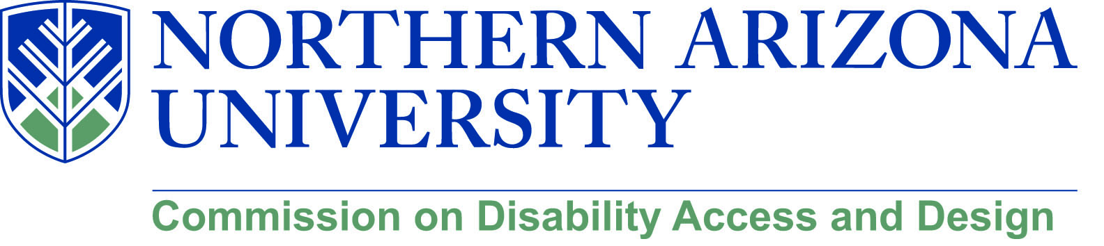

AGENDA

Wednesday, June 20, 2018
12:00-1:30 pm, University Union, Sycamore
Meet Me Line – (928) 523-6629

- Call to Order
  - Roll Call and introductions
  - Approval of minutes from May meeting

- Update on DSP (Chris and Lauren)

- Update on Engineering (Lauren and Jamie)

- Update on Personnel changes (Chris and Lauren)

- Summer Events and Presentations

- Update on Disability Heritage Month and call for volunteers

- Old/New business

