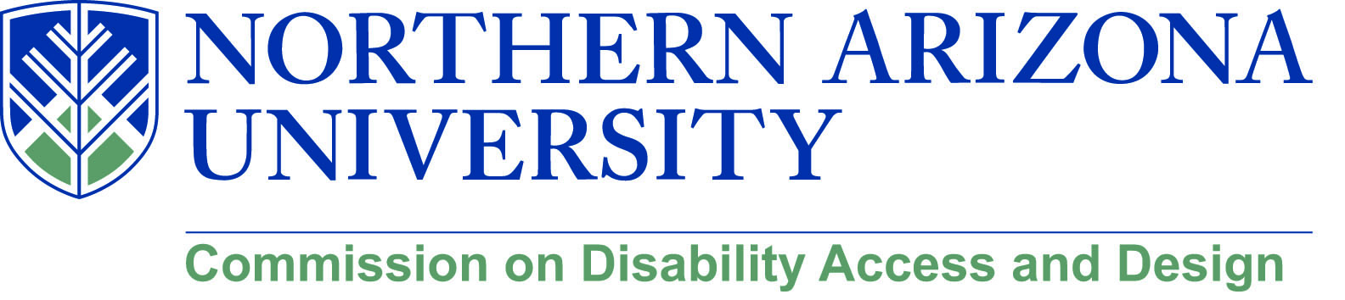

AGENDA

Wednesday, April 18, 2018
12:00-1:30 pm, University Union, Havasupai C
***Please note: There will not be a MeetMe line for this meeting.***

- Call to Order
  - Roll Call and introductions
  - Approval of minutes from March meeting

- Leadership Award
  - Awardees
    - Andrew Iacona
    - Charlese Bedford
    - Lauren Graves
    - John McDermott
  - Diversity Banquet on May 2, 5:30 pm at High Country Conference Center – Please RSVP by April 27th
  - New award style

- NAU 4 All Scavenger Hunt
  - Recap of the event – Lauren Graves

- Human Library event
  - Summary – Chris Lanterman and Matthew Wangeman

- Disability Heritage Month
  - Possible speakers
    - Kay Barrett
    - Amanda Kraus from UA
  - Panel: Media portrayals of disability
  - Stephen Hawking discussion
  - Recurring events
    - Scavenger hunt
    - Sitting volleyball tournament
    - Goal Ball
    - Matthew’s talk

- Facility Services updates
  - Building Inspector search
  - Summer construction

- New/Old business

