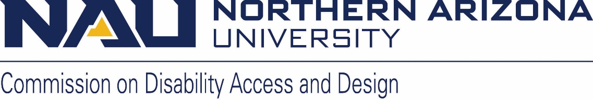

*Northern Arizona University sits at the base of the San Francisco Peaks, on homelands sacred to Native Americans throughout the region. We honor their past, present, and future generations, who have lived here for millennia and will forever call this place home.*

**Commission on Disability Access and Design**

**AGENDA**

Wednesday, August 21, 2024

12:00-1:30 pm

[Zoom link](https://nau.zoom.us/j/85250409953?pwd=Zwg2nAZwuMkzqG58TZaVs0FmvY6Bth.1)

Meeting ID: 852 5040 9953

Password: 634544

1. Call to Order
2. Land Acknowledgement
3. Roll Call and introductions
4. Approval of minutes from June meeting
5. Announcements and Information Items
   1. Marketing Mural project - Charlese Bedford
   2. IHD Film Festival
   3. DS minor video
6. Action and Discussion Items
   1. Ask Jamie - ADA Coordinator/ 504 Compliance Officer update (Jamie Axelrod)
      1. August Topic – Cline Library sidewalk project
      2. Please send us questions you have about disability, the law, how NAU meets our requirements, anything you don’t understand about how our compliance obligations work and we’ll have Jamie address a topic each month
   2. New employee appraisal process update
   3. DPHM
      1. Planning committee volunteers
      2. List of events ideas (X indicates we know it will happen but needs planning)
         1. Celebrating Judy Heumann: The Work Continues (October 8) X
            1. Rough outline of the day

Registration opens 8:30 or 9:00

Keynote – Paul Grossman (1 hour)

Break (10 minutes)

Research presentations (1 hour 20 minutes)

Lunch (1 hour)

Disability Timeline and game, possibly trivia

Highlight good work across campus

Club ADA, CDAD, and DR panel (1 hour)

Break (10 minutes)

Screen *Crip Camp* and discussion (2.5 hours)

* + - 1. Accessibility workshop series (Sean) X
         1. Fridays all month long: October 4th , 11th, and 25th)
      2. Accessibility Expeditions (virtual and in person) X
         1. Virtual will open on October 1, in person will be October 18
      3. Sensory craft night with IMQ X
         1. TBD
      4. Sitting Volleyball Tournament X
      5. CAL film series will screen *Freaks* X
         1. October 8, 7:00 pm, Cline Library
      6. Tom Olin photographer
      7. Alaqua Cox (Marvel Universe - Echo) X
         1. October 25, however, we may have a contract barrier
         2. Partner with IMQ to screen Echo throughout the month
    1. Other ideas for events/topics for DPHM
       1. Human Library (need to come up with a different title as this is proprietary)
       2. 25 days- each ways assigned group of readings and short videos- October pride event- acceptance and ally challenge- videos, readings, prize for who attended most events
  1. CDAD name

1. Old or New Business
   1. Member announcements
2. Next meetings (all times 12-1:30 p.m.):
   1. September 18th
   2. October 16th
   3. November 20th
   4. December 18th