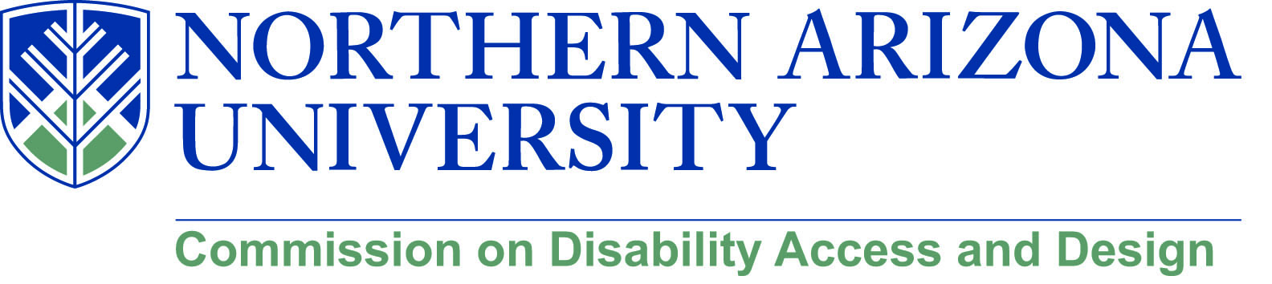

AGENDA

Wednesday, August 15, 2018
12:00-1:30 pm, University Union, Havasupai C
MeetMe Line – (928) 523-6629

1. Call to Order
a. Roll Call and introductions
b. Approval of minutes from June meeting

2. Disability Heritage Month
a. Disability Biases and Microagressions – Amanda Kraus (October 5)
b. NAU 4 All Scavenger Hunt (October 12)
c. Sitting Volleyball (date TBD)
d. Goalball (date TBD)
e. “Everything You Always Wanted to Know about Disability (date TBD)
f. Faculty Panel – Infusing Disability into the Curriculum (date TBD)
g. Disability in Theater – Regan Linton (Phamaly Theater in Denver (date TBD…likely 11/1 or 11/2)
h. Intelligent Lives screening (date TBD)

3. Construction Updates

4. Building Qmmunity Forum (see attached)
a. Call for proposal due September 5
b. Building Qmmunity – October 6 (Family Weekend)
c. All sessions to be universally designed

5. Marketing CDAD
a. NAU News postings
b. “From Madhouse to Schoolouse” and “Disability History Timeline” (post in IMQ)

6. Possible Initiatives for 2018-2019
a. Disability within Diversity Symposia
b. “Mini” Disability Cultural Center
c. Dr. Ferme (University of Michigan )
d. Blackboard Ally
e. Other suggestions

7. Old/New Business

