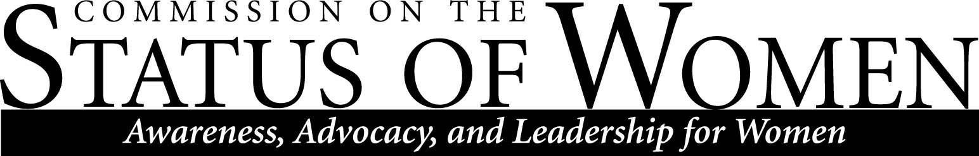
Monday, November 25, 2019, 12:00 – 1:30 p.m. | Havasupai A/B

Minutes
Meeting called to order by 12:00
Introduction
Sanjam Ahluwalia
Frances Riemer
Alison Pickett
Kayea Oshita
Judene Mclane
Gabriel Montano
Monica Jamson
Amanda Rosas
Lauren Copeland-Glenn
Theresa Prefontaine
Heidi
Briana Adusei
Agenda
- Diversity Awards
  - Lauren: diversity awards-April 30, 2020
  - There is an online nomination form on the CSW website
  - Nominations will need to be in by the end of February
  - Criteria is on the nomination form
    - Suggested to upgrade the awards
      - There is an awards budget for the plaques
      - Discussion on changing plaque design
    - University events is going to take care of all the ordering this year
  - There is usually about three awards
  - Every commission has been in charge of conducting their own voting
  - Frances suggested talking about it on the February meeting
    - Nominating faculty, student, group
- ASIF: Associated students for intersexual feminism
  - Lost their space and funding
    - How did they lose this?
    - Where does their funding come from?
    - If it is a university club, they usually receive a funding from the university of students
    - 65% women

- Pipeline for CSW leadership
  - Does this count as service for faculty?
    - These rules are interpreted at the Chair level
  - Service may be overextended by faculty
  - 10% has to come from departmental services
  - This has to be an extra 10% service for staff
  - This can include staff as well
  - We need to make sure that everybody is allowed and encouraged to participate
  - Suggested by Frances: Is it possible to ask the Deans if there can be at least one of person from each college as a representative
  - Sanjam: suggested that the president can possibly mention and encourage this in the next meeting
  - This should be instituted (all agree)
  - If this is a university priority, make it a priority. Empower commissions.
  - Gabe Montano: best path to do this,
    - Ex. Make a commitment of at least three years; learn the process, not overwhelmed, serve the process. This was done in the previous years, but was unsuccessful.
  - Lauren: Maybe helpful to draft up a description that states the benefits of becoming a co-chair
  - Discussion on centralized statement stating the co-chair benefits; SOE
  - Frances: putting this out there and mentoring others that they can do this. Some see others co-chairing this, but don’t know how to get there. If there can be a mentoring or leadership to push others to be in this position.
  - Leadership meetings: Hoping to get back on board with this.
    - Lauren, inviting the co-chairs come to the meetings and share what they are doing
- Diversity Strategic Plan
  - Co-chairs all have it and will review it for edits.
  - There is going to be a summary version of the strategic plan
  - Something that people can digest in a reasonable amount of time
  - Appendices
  - Target date-should be ready to go by the end of the calendar year
    - Just depending on feedback and editing
  - About a 10-12 page range
  - Working with marketing to make this a nice document
  - This document is going to be housed somewhere; still trying to determine where this is going
    - On the bottom of every single page in the blue area, under policies, the links are directed to Diversity:
    - 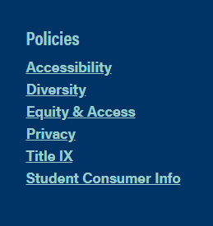
  - Right now the DSP just needs the comments of the chairs to modify the content
  - Gabe is the person to contact for questions

- Pay Equity report
  - Consensus was to not drop: Chief Human Resources Officer Josh Mackey is the best person to contact for the data.
  - It was shut down because the data was not reliable, enough
  - Frances: the problem was the data was the only data that could be collected. The people that want the data, don’t have the data. Shouldn’t the people that have the data be able to read and access, as well as break it down.
  - It’s not that the argument is invalid in regards to the pay or salaries
    - Depends on discipline
    - How do we gather this data?
      - Comparisons within a college vs. across the institution
    - Two issues with this
      - There may be personal data
      - There will be different pay within the colleges
    - There are methods to do this
    - Where is the data located
    - There can be discrepancies
    - There is a lot more that goes into this, more than pay, but also diversity
  - Frances: We need a small group of people that are serious in taking on this project to gather the data
  - Budget information is no longer available publicly
  - Is there a way to write a small grant to reach out in regards to collecting this data?
  - Roger Bounds is the contact person for the data
  - Pay Equity
  - Once this data is collected, this should be somebody’s job to keep the data updated
    - Assessment to make sure that the policies are adhered to
- Collaboration with AAUW
  - Retired faculty within Flagstaff
    - Would like to do a yearlong event regarding women’s right to vote
    - Town and gown
    - Having a proclamation from the mayor’s office
    - Inviting President Cheng
    - Having CSW do something
    - A large series of events with large publicity
    - This would be for all of 2020
    - WGS classes will be addressing this issue
    - Can CSW do something now?
    - Extremely important because we are going into an election
      - What it means to run for office
      - Getting involved with politics
      - Getting younger women to run for political office—non-partisan
      - PIA
      - We don’t want these events to happen in isolation, more visible
      - IEQ has a calendar of events
    - Think about things we can do for this collaboration

- Program
  - Find out the budget for this film
  - Bangkar sisters in the UK

- Other

Meeting adjourned 12:33 pm

