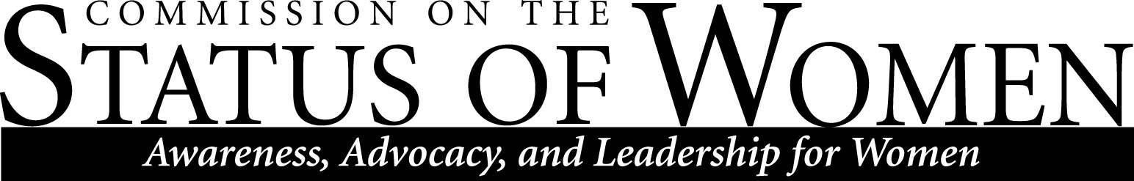
CSW Meeting
University Union, Havasupai A/B | January 27, 2020, 11:30pm-12:30pm
- Meeting started at 11:35 am
- Introductions: Frances Riemer, Paul Jagodzinski, Gabe Montaño, Chelsea Green, Jill Christensen, Yvonne Luna, Madrone Schutten, Brooke De Heer, Lawrence Lenhart, Lauren Copeland-Glenn, Grace Okoli, Heidi Feigenbaum, Heather Coate, Shar Jenniges

- The Price of Nice funding request
- Angelina Castagno published an edited volume called The Price of Nice: How Good Intentions Maintain Educational Inequity, focusing on niceness in the classroom and the results of avoiding hard topics such as race. She will be holding a book event with a panel of authors who contributed to the text
- Angelina needs funding to pay for the panel’s travel expenses as well as food for the reception. The total cost of the event is $1600; $200-300 per commission will fund the event
- The event will be held on April 24
- Angelina wants the commissions to be active at the event
- Madrone motioned to give $300 to the Price of Nice event
- Brooke seconded the motion
- Motion carried

Diversity awards 4/30

The nomination form is available online. The form is set to close on February 10. The link will be sent out to commissioners
- Awards are meant for faculty, staff, students, and organizations. The Commission on the Status of Women will be giving out up to four awards. There’s a list of previous awardees on the commission’s website
- Discussion on changing the design of the awards. Frances suggested going to the artist coalition and choosing an award designed by a female artist
- Commissioners discussed potential nominees
- Frances suggested nominating Karen Renner for her work on the Equity Report
- Jill suggested nominating Cathy Proper for the work she did with NAU RISE
- Frances: Sanjam suggested the Associated Students for Intersectional Feminism (ASIF) as a possible organization nomination
- Commissioners discussed flexibility around nominations. In the past CSW has doubled up on awards (ex. two students and two organizations). Madrone suggested giving flowers to people CSW wants to recognize, if there’s more than four nominees
- Lauren: Keep in mind you can submit nominations for other commissions
- Gabe: Consider reaching out to other organizations for input as well (ex. IMQ)
- Awardees must be decided by March 23rd. CSW needs to make a decision by next meeting

Diversity strategic plan
- Gabe will be meeting with Frances and Sanjam this week. After that, the document will be sent out to the commissions. The current state has been sent out to the president’s office. It has been restructured significantly.
- Strategic plans are meant to be a foundation; they should allow us to start making progress through goals
- The DSP has been reorganized in a digestible framework
- The DSP will be a living document that is continually updated

Pay Equity report
- Francis: Last year the co-chair Karen Renner collected data and did a preliminary analysis on pay inequities at NAU. It's been circulated but not widely. The provost was not interested. The hope is to get it into special collections. Frances is going to drop it in the library so that it will be available to everybody.
- The commission discussed making it available on the CSW website so it could be accessed by the public
- Consensus that the Pay Equity Report should be put on the CSW website
- Discussion on the importance of the Pay Equity Report for this year’s agenda
- Discussion on dissatisfaction around the Provost’s response
- Discussion on how to move forward with the Pay Equity Report
- Lauren: Part of the issue is that in order to do a real analysis you need private information. What does the commission actually have access to? CSW can look at SOEs and see how they are set up and how they contribute to inequity
- Frances: Ideally NAU would take the information provided by the report and move it forward institutionally
- Gabe: This report is a beginning not an end. Where do we go from here? CSW needs to make a substantive argument that there’s things that need to be looked into. Ask questions: What has the university done to look at inequities? Can you explain that process? What information are we allowed to have?
- Brooke: The report covers things that would cross over numerous commissions. Having it backed by multiple commissions might build strength to move it forward
- The document has not yet been sent out to other commissions
- Lawrence offered to take on an administrative role moving forward with the report
- Gabe suggested looking into national level data on salaries and gender at other universities
- Discussion on gender inequities with non-tenure track positions
- Although there’s been a rise in women in higher education, there’s also been a rise in non-tenure track positions. Women disproportionality fill these positions and are being paid less
- Commission reviewed the following goals
- Making sure everyone has an electronic copy of the report
- Linking the report to the website
- Sending the report to the other commissions
- Adding the response from the Provost to the document sent out to commissioners (not to the website document)

Collaboration with AAUW: City of Flagstaff Suffrage Proclamation
- CSW should invite AAUW members to events such as the Price of Nice panel. A collaboration with AAUW may provide fundraising opportunities for scholarships
- The City of Flagstaff Suffrage Proclamation will be put on the CSW website

Commission on the Status of Women
- A lot of staff aren’t encouraged or allowed to participate in commissions
- Gabe: This issue is being worked on. The DSP addresses allowing staff to participate in commissions without it having to be voluntary. There needs to be a policy change, otherwise supervisors will prevent participation

Meeting adjourned at 12:41 pm

