- 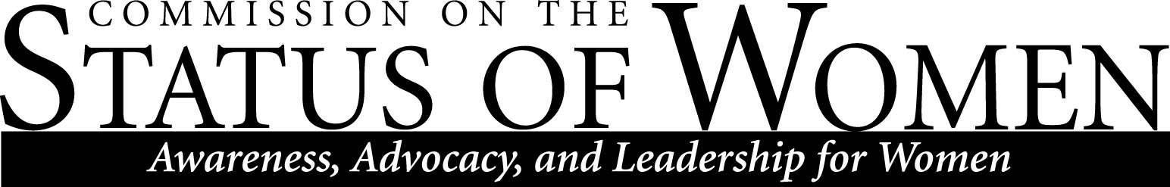
Monday, September 23, 2019, 12:00 – 1:30 p.m. | University Union Havasupai A

M I N U T E S
Welcome and Roll Call

Calvin Legassie
Priscilla Mills
Theresa Prefontaine
Georgia Wanger
Frances Riemer
Sanjam Ahluwalia
Julie Piering
Tyler Barnard
Jill Christensen
Heidi Feigenbaum
Erika Hess
Monica Jamison
Briana Adusei

Agenda
- The wage report compiled by CSW last year
- Discussion on revisiting last year’s research report and working on discrepancies in the report
- Discussion on finding a way to work with Dr. Montan͂o to push out the revised research report
- Discussion on working with Roy St. Laurent in the future to address statistical best practices
- Discussion on disseminating the report - limited recipients versus campus-wide

- Flexibility work hours for NAU operations and maintenance employees
- Discussion on addressing any gender wage gap in salaries
- Possibility of supporting a 24-hour lactation room in Cline library
- Discussion about lack of work flexibility being a factor in low participation in the commission
- Discussion of using a more organic “feminist organizing” model for CSW. For example, instead of committees and committee chairs, spread duties out amongst interested commission members and have a point of contact for things like the website. This may involve amending the bylaws.
- Discussion on ways to promote work life flexibility for women at NAU

- Leadership pipeline for CSW
- Diversity strategic plan
- Ways to get more volunteers involved in the commissions
- Possibility of inviting an international speaker on campus to talk more on gender equality
- Discussion on teaming with other commissions for larger events

- Doing more work in the community
- Discussion on policies to permit staff to come to commissions meeting
- Plans to reach out to sexual feminism society (fka ASWI) to offer help
- Discussion on making CSW documents more accessible to people
- Discussion of having free menstrual health products for students on campus

Welcome Tea Party updates
- October 8th in the Grand Canyon room. Tentative time: 3:30- 5:00pm
- Discussion on inviting Gabe Montan͂o and Karen Renner to speak and AAUW representative Harriet Young.

Meeting ended at 1:05 pm

